THE CURRENT USE OF PHYSICAL AND NUMERICAL MODELS FOR COASTAL APPLICATIONS
Matthew J. Blacka, James T. Carley, Ronald J. Cox, and Brett M. Miller
Water Research laboratory, University of New South Wales
King Street, Manly Vale NSW 2093
E-mail: M.Blacka@wrl.unsw.edu.au
Phone: 02 9949 4488

Abstract
The use of models for simulation of many aspects of environmental conditions on the open coast, and within the estuarine environment has been undertaken for many years. Engineers, managers, and decision makers have been using information obtained from both physical and numerical models to better understand environmental processes occurring within the coastal zone, and the influences which development may have on these processes. Advances in computing technology and a more comprehensive understanding of environmental issues, has seen both physical and numerical modelling become more refined and optimised for various specific applications within coastal engineering. These models are often efficiently developed, so that they can be applied to aid day to day decision making.
This paper summarises the current use of both physical and numerical models as tools for simulating aspects of the coastal environment, in order to make quantified and sensible decisions for future management strategies. A brief but up to date discussion of the typical costs and time frames associated with building and running physical models is presented. The required information for calibrating and validating different models, and the influence of calibration on the expected level of accuracy is explained. The advantages, disadvantages, and recommended applications of various types of models within the coastal field are also discussed with examples of case studies from significant coastal projects.

Introduction
The application of coastal models within the coastal engineering field has been occurring for many years, with varying levels of success. Primarily, models are used as a part of the coastal engineering problem solving process. Engineers, managers, and decision makers use information obtained from both physical and numerical models to better understand environmental processes occurring within the coastal zone, and the influences which development may have on these processes.
The coastal engineering problem solving process has been broken into six key steps in the flow chart shown in Figure 1. Coastal models are some of the tools selected and implemented in steps 3 and 4 of this problem solving process. This paper provides guidance for identifying when a model may be a useful analysis tool, which type of model would be suitably applied to which type of problem, and the types of issues which may undermine model validity. The paper also discusses why physical models are still often able to produce more reliable results with better efficiency than numerical models, when applied to certain problems, and provides broad up-to-date cost estimates for a range of physical model applications.

Coastal Processes and Problems
Table 1 below provides a summary of the various coastal environments, the processes which may be occurring within each of the environments, and the management issues which can require attention. Typically coastal problems fall under one of the issues identified in this table.
Table 1. Coastal environments, processes, issues, and modelling applications
Environment | Important Processes | Management Issues | Modelling Applications
Tidal Lakes, Coastal Lagoons, Coastal Wetlands | Tidal forcing,  stratification,  wind mixing,  freshwater inflows | Nutrient levels,  biochemical state,  geochemical state,  thermal loading, acid sulphate soils, flow controls, entrance conditions | Numerical hydrodynamic, water quality, and sediment transport modelling. Physical modelling of waves, sediment transport, and hydraulic structures. Analytical modelling
Marinas,  Harbours | Tidal forcing, wave penetration,  wave damage,  Circulations,  freshwater inflows, seiching | Point discharges,  storm damage,  wave climate,  navigation, maintenance | Numerical hydrodynamic, water quality, and wave modelling. Physical  flume and basin testing of structures and waves
Canal  Estates | Tidal circulation,  density flows,  Freshwater inflows,  wind mixing,  sediment transport | Point discharges,  circulation,  scour velocities,  Navigation,  siltation | Numerical hydrodynamic and  water quality modelling
Estuaries | Density flows,  tidal forcings,  wave penetration,  sediment transport,  saline dynamics | Point and multipoint discharges,  overland inflow, environmental flows, circulations, channel dredging and navigation,  wave climate, harbour beaches | Numerical hydrodynamic, water quality, sediment transport and wave modelling. Physical basin testing of waves and sediment transport. Analytical modelling
Ocean  Waters | Stratification, wind shear, upwelling and downwelling, internal tides, regional processes, coriolis effect | Outfalls,  point discharges,  plume discharges,  floatable material,  settleable materia,  turbulent mixing | Numerical modelling of hydrodynamics,  water quality, and  particle tracking
Beaches, Dunes | Currents, wave climate, erosion/accretion, aeolian sediment transport | Erosion rates, longshore current movement,  beach variability,  beach stabilisation,  foreshore protection | Flume and basin testing of waves and sediment transport.  Numerical wave and sediment transport modelling. Analytical modelling
Coastal Aquifers | Recharge, tidal flows, density flows | Saline intrusion, pollutant injection, dewatering | Numerical modelling of groundwater flows

Coastal Problem Solving Techniques and Tools
Hughes (1993) identifies that coastal engineers primarily rely on three techniques for analysing complicated fluid regimes typical of many coastal situations, namely:
- Laboratory measurements and observations
- Mathematical calculations
- Field measurements and observations
Within these three techniques there are several problem solving tools, of which the most common are:
- Experience
- Field data
- Empirical relationships
- Numerical models
- Physical models

Overview of Coastal Models
A model in its simplest sense can be considered as any representation of a process that may be occurring. Ideally this representation would completely simulate all aspects of the process, but typically this is not practical, as we either do not have a sufficient understanding of all aspects of the process, or because the process is too complex. For this reason, a model is almost always a simplified representation of a process. An empirical relationship may be considered as the simplest form of analytical model, derived from previous experience and observations. A numerical model may be described as a set of principles compiled in a mathematical formulation, intended to simulate a certain process. Hughes (1993) defines a physical model as “…. a physical system reproduced (usually at a reduced size) so that the major dominant forces acting on the system are represented in the model in correct proportion to the actual physical system.”
From Table 1 it can be seen that in recent years within the coastal field, application of models has generally been for solving problems involving:
- Coastal structures
- Wave mechanics
- Sediment transport
- Hydrodynamics/Water quality
- Coastal aquifers/groundwater

Typically in assessing the type of model which will be the most applicable for simulating one or several of these processes, consideration needs to be given to the following questions:
- What is the required information?
- How well quantified is the problem?
- How well do mathematical relationships represent the processes?
- Can the processes by scaled?
- What level of accuracy is required?
- Should the problem be subdivided and several smaller or hybrid models be used?
- What are the available funds?
Empirical relationships simulate a process and make predictions based on previously collected laboratory and field data, as well as past experience. An example of coastal engineering empirical relationship models are the techniques set out in the Shore Protection Manual (SPM, 1984). These are the more traditional form of mathematical coastal models, used widely in desktop studies where numerical analysis techniques are not yet developed or not applicable. Inherent in the method in which empirical relationships are developed, is the problem that they are based off specific circumstances. This results in a compromise of how well a physical system is simulated by the mathematical description. These types of coastal models are most applicable to problems where higher levels of complexity are not required, not available, or where only broad estimates are required.
Numerical models simulate a process by solving mathematical descriptions of the process through some form of numerical approximation scheme. Generally the mathematical descriptions are applied over a discretised temporal and/or spatial domain, in one, two, or three dimensions, depending on the complexity of the process. Compromise on the accuracy of the simulation occurs as a result of the level of accuracy of the mathematical descriptions describing the process, and the discretisation resolution of the problem domain. Numerical coastal models are suitable problem solving tools where mathematical relationships are known to represent the processes well, the area over which the model is to be solved is large, and/or there is sufficient data to calibrate and verify the model performance.
Physical models involve the reproduction of real life processes at a reduced scale. The model is designed so that the dominant forces affecting the system are reproduced in correct proportion, by satisfying one of several mathematical scaling criteria. Unlike numerical models which are required to be calibrated prior to being used as an accurate prediction tool, if a physical model is scaled appropriately, the results are expected to be representative. Cases where physical models may be the only suitable investigative tool, or at least the most accurate and efficient tool are:
- Problems where mathematical descriptions are not yet developed to adequately describe the process
- Problem complexity exceeds simplifications made in mathematical descriptions
- A design has been estimated using mathematical relationships, and can be further refined and optimised using a physical model
- Insufficient data is available to calibrate/validate a numerical model
- Where visual association with a proposed design is useful
- Construction and operation of a physical model is cheaper than compiling and running the equivalent numerical model
The results from empirical, numerical, and physical coastal modelling applications are commonly used for:
- Design optimisation
- Risk assessment
- Comparison of options
- Forming management strategies
- Research and investigation
- Predicting previous, current, and/or long term response
- Demonstration/education

Numerical Models

Current Applications of Numerical Models for Investigation of Coastal Problems
Numerical models are currently applied as tools for solving the following problems in the coastal field:
- Hydrodynamics
- Pollutant transport and water quality
- Wave mechanics
- Sediment transport and morphology
- Groundwater flows
The following section of the paper provides several case studies where numerical models were applied in the coastal engineering field, and discusses why a numerical model was adopted as the investigative tool.

Cross-shore Numerical Modelling of Storm Erosion, Northern Gold Coast Beaches
As a part of the Northern Gold Coast Beach Protection Strategy, it was recommended that beach nourishment be undertaken for the Northern Gold Coast Beaches, to provide increased storm erosion buffer, and increased public amenity. The Water Research Laboratory (WRL) of the University of New South Wales (UNSW) were engaged to assess the ability of the nourished Gold Coast beaches to withstand erosion during major storm events, and recession due to long term sea level rise (Carley et. al, 1998). There was approximately 30 years of regularly recorded beach profile data, and 20 years of wave rider buoy data available for the study area.
A range of numerical models including SBEACH and UNIBEST-TC, as well as other empirical models were implemented to simulate the beach erosion during storm events. Due to the availability of extensive recorded beach profile and wave climate data, the numerical models were able to be well calibrated, and validated for a range of historical storm events. In this case, the application of numerical modelling methods was successful primarily due to the processes being relatively well described by mathematical approximations, and due to the extensive data set available for calibrating the model parameters. Generally, the current understanding of cross shore sediment transport processes allows these problems to be solved adequately using numerical techniques, and accurately if calibration data sets are available.

Hydrodynamic Modelling of Dredging Influences at Oaky Island, Wallis Lake
As a part of a proposal to develop further oyster leases just north of Oaky Island, Wallis Lake, dredging of a small section of the estuary was proposed. WRL were engaged to assess hydrodynamic and potential sedimentation changes that may occur as a result of the proposed dredging, near the confluence of the Wallamba and Cooloongolook Rivers (Miller et. al, 2006). WRL were able to adopt a previously developed RMA-10 three-dimensional finite element hydrodynamic model of the estuary, for undertaking the investigation. The model was refined with increased bathymetric resolution in the vicinity of the study area, and was able to be calibrated against measured water levels, velocities, and discharges, collected from 32 different locations throughout the estuary. The model was operated in two dimensional depth averaged form, and used to asses changes in estuarine hydrodynamics and bed shear potential.
For this particular investigation, the use of the already existing numerical hydrodynamic model as the assessment tool was the most efficient method for analysis. Currents throughout the estuary are driven by tidal water level fluctuations, and are able to be well simulated by the mathematical relationships solved by the numerical model. The model parameters were able to be well calibrated to observed field data, to ensure reasonable reliability of model predictions. Figure 2 shows examples of the predicted pre and post dredge velocities throughout the estuary.

Levels of Numerical Model Capability and Accuracy
The application of a numerical model in simulating a coastal process will inevitably lead to some prediction about the process behaviour. Whether the model predictions are remotely similar to how the real world process behaves is an entirely different matter. The level of accuracy and consistency of a numerical model is a function of how well the governing mathematical principles are able to describe the process being simulated, and how well the model parameters are able to be estimated. Model parameters are the constants and coefficients of a mathematical relationship, that can be adjusted so that the relationship is refined to apply to a specific situation. The adjustment of model parameters to improve a model’s prediction of an observed data set is known as calibration. A well calibrated model will be able to predict the observed data set to which it was calibrated, accurately. However, this does not necessarily mean that it can consistently predict other situations with the same level of accuracy. To improve or check model consistency, a secondary process of model validation can be applied, where model predictions are verified against other sets of recorded data to the calibration data set.
There are four basic levels of numerical model refinement:
- Pilot Model
- Verified Model
- Calibrated Model
- Calibrated and Verified Model

Pilot Modelling
Pilot modelling involves the use of a numerical model, where the model parameters are based off empirical predictions only. A pilot model is not calibrated to predict accurately some previously observed data, and is not verified for its accuracy and consistency. Results from a pilot model should not be considered to be what will occur in the predicted situation, but are an indication of what may happen only. This is one of the most common areas for misinterpretation of numerical model results.
Predictions from pilot model studies can be used for:
- Assisting with process understanding
- Identifying the relative importance of several processes
- Assisting in the design and planning of more detailed investigations

Verified Modelling
Verified modelling involves the use of a numerical model, where the model parameters have been estimated from empirical predictions only, but the model predictions have been checked for accuracy and consistency against observed data. Predictions from a verified model may or may not be accurate, but the level of accuracy is understood.

Calibrated Modelling
Calibrated modelling involves the use of a numerical model, where the model parameters have been adjusted so that the model is able to reproduce accurately an observed data set. The model should be able to make reasonable predictions for similar conditions to the calibration data set. However, the accuracy of the model for reproducing conditions which are different to the calibration data set is unknown.

Calibrated and Verified Modelling
A model that has been calibrated using an observed data set, and that has been verified against other observed data sets is known as a calibrated and verified model. A model with this level of refinement can be used to predict independently the behaviour and response of the simulated system for a range of different circumstances. This form of numerical model can be applied for:
- Investigating “what if” scenarios
- Extrapolating observed data over larger temporal and spatial ranges
- Infrastructure design

Data Requirements for Implementing Numerical Models
The reliability of numerical model predictions is almost entirely a function of the extent of observed data available for refining the model parameters. Where extensive observed data sets are available, the numerical model can be an extremely powerful investigative tool. However, extensive observed data sets are not frequently available, and field data collection is an expensive and timely process. The types of data that are often required to compile, calibrate and/or verify a coastal numerical model include:
- Bathymetry/topography
- Ocean and estuarine water levels and tidal fluctuations
- Currents
- Waves
- Water chemistry
- Geology/hydrogeology

Physical Models

Current Applications of Physical Models for Investigation of Coastal Problems
Physical models are currently applied in the coastal field for investigation of:
- Wave – structure interactions
- Hydraulic structures
- Hydrodynamics
- Sediment transport
The sections of the paper below provide several case studies where physical models were successfully applied, and discuss the reasons why a physical model was adopted as the investigative tool, as opposed to other methods.

Application of a Two-Dimensional Wave Flume Model for Seawall Toe Protection Design
As a part of upgrading a large reinforced earth concrete panel seawall, submerged rubble was required to be placed in an apron at the seawall toe. The rubble apron was to aid geotechnical stability, and prevent undermining of the seawall. Initial design estimates for required rubble size and apron dimensions were made using extremely limited empirical relationships. Analysis using three different empirical techniques resulted in required rubble armour mass varying between 53% and 190% of the mean predicted mass. The reason for the large variation in predicted mass, was due to the different conditions for which each individual empirical relationship was developed.
To refine the apron armour design, and to investigate the possible application of an innovative armour material, a two-dimensional physical modelling investigation was undertaken. Figure 3 shows the two-dimensional wave flume model used in this investigation. The physical model was able to provide design estimates for the specific environmental conditions, with the designers able to rely on the results more heavily than the empirical approximations. In this case, the physical model was applied, as there were only limited mathematical relationships available, none of which were properly applicable to the case at hand, and which gave widely varying results.

Application of a Two-Dimensional Wave Flume Model for the Koniambo Wharf, New Caledonia
Koniambo is located in the Northern Province of New Caledonia, an area subject to intense tropical cyclones. A wharf was proposed for construction at Koniambo, for which initial design estimates predicted significant wave overtopping and wave uplift force. A Computational Fluid Dynamics (CFD) model was compiled for simulating wave overtopping and uplift forces for the wharf structure. To validate the CFD model, and to have more confidence in design estimates, a 1:20 scale two-dimensional physical model was constructed of a section of the wharf. Figure 4 shows the wharf physical model.
The physical model was used to make measurements of wave uplift pressure distributions across the underside of the wharf deck, measurements of overtopping wave depths and velocities, and armour size confirmation for a revetment under the wharf. These measurements were made for a variety of wave and water level conditions, using both monochromatic and irregular wave sequences. The results from the physical modelling investigation contributed to significant optimisation of the wharf structural design, and provided the designers with more confidence in design loadings than was able to be obtained from the CFD model alone.

Application of a Two-Dimensional Hydrodynamic Physical Model for Brine Diffuser Design
Numerical relationships are generally developed from a mathematical basis such as dimensional analysis, or an empirical basis such as previously collected field or laboratory data. Physical models and field data collection provide estimates for the mathematical model parameters, that are required for solving numerical models.
An example of the application of a physical model to confirm a mathematical relationship is the investigation of a brine outfall diffuser design. Brine, a byproduct of the desalination of sea water, is often disposed of through an ocean outfall. A two dimensional physical modelling investigation has recently been undertaken at the Water Research Laboratory (WRL) of the University of New South Wales, which investigated a range of diffuser design parameters, with recorded data being used to develop a mathematical relationship for future diffuser designs. Figure 5 shows the physical model application for this case study.

Model Scaling Principles
The basic principal behind a physical model is that the aspects of interest within the model will behave similarly to the prototype (real world scale), at least within some prescribed range of applicable conditions. The result of this is that a properly designed physical model can be used simulate and predict what could be expected to occur in a real world situation. The rules governing the mathematical design of a physical model are known as scaling laws or similitude criteria. Ideally a physical model would have complete similitude (geometric, kinematic, and dynamic similitude), which would imply that all linear dimensions, vectorial particle motions, and vectorial forces are proportionately scaled. This, however, is not possible, and a certain amount of engineering judgement is required to ensure that the model is able to simulate the aspects of interest. This judgement is required to determine which prototype/model ratios are required to be in similitude to ensure accurate model predictions, and which ratios can be out of proportion without compromising model results.
It is well documented that for fluid motion simulations, scaling is usually based on the ratio of two dominant forces being maintained from prototype to model. These force ratios are typically expressed as dimensionless numbers. The predominant force that must be considered for almost all hydraulic physical models are inertial forces. For cases where gravity forces as well as inertial forces are predominant, such as open coast models with wave simulation, Froude similitude criteria is adopted:
F_{m} = F_{p} ${\frac{V_{m}}{\sqrt{\text{gL}}}}_{m}={\frac{V_{p}}{\sqrt{\text{gL}}}}_{p}$Where:
F_{m} = Froude number in model
F_{p} = Froude number in prototype
V = Velocity
L = Length
g = Gravitational Acceleration

The result of scaling based on Froude similitude criteria, are the following prototype:model scale ratios:
- Length ratio L_{R} = L_{p}/L_{m}
- Velocity ratio V_{R} = L_{R}^{0.5}
- Time ratio T_{R} = L_{R}^{0.5}
- Mass ratio M_{R} = L_{R}³
For processes where forces other than gravity and inertia dominate, other scaling similitude such as Reynolds, Weber, or Cauchy dimensionless numbers may be more appropriate for model scaling.

Physical Model Scaling Limitations and Errors
In almost all physical models relevant to the coastal field, it is generally recognised that gravity and inertial forces dominate the processes which occur, and as a result, Froude similitude is adopted when scaling the model. In maintaining Froude numbers from prototype to the model, other similitude criteria are compromised, and it is in this compromise that physical modellers have to ensure scale effects do not taint model predictions.
Often it is recognised that viscous forces can also be influential in scale coastal models, and it is up to the modeller to minimise viscosity effects, generally by satisfying some empirical Reynolds number criteria. As a minimum, modellers generally have to ensure that turbulent flows in the prototype do not become laminar or partially turbulent in the model. Other potential effects of scale are generally caused by fluid properties not scaling appropriately, which can result in scale effects from surface tension, compressibility etc. There are generally accepted mathematical or empirical rules regarding minimum model size so as to avoid significant scale effects due to viscosity, surface tension, compressibility etc.
In all physical modelling cases, the larger the model can be constructed, the less likely scale effects are to have effect on model results, however, larger models are generally more expensive to construct and operate. With the current level of knowledge regarding scale effects in models, and the precision construction and data measurement techniques available, it is generally not required to construct extremely large models. Instead, proper scaling, model design, and model operation, results in efficient construction and operational costs, while maintaining model validity. Parameters affecting the upper size limit of models are typically:
- Floor space for model construction
- Available flowrate
- Available maximum wave conditions
An experienced physical modeller is invaluable for the design and operation of an accurate, and just as importantly, efficient, physical modelling investigation. The modeller should also have a good understanding and feel for the real world processes they are simulating. This experience is essential for the understanding and interpretation of model limitations and results.

Improvements in Physical Modelling and Modelling Costs
While the principles governing the scaling and design of physical models have remained relatively unchanged for 50 to 100 years, significant improvements have occurred in the model construction, operation, and data collection/processing techniques, in more recent years. While the effects of enhanced computational capabilities are immediately apparent when considering numerical modelling improvements, they are not so apparent for their influence on physical modelling. However, it is the power of modern computers that has resulted in the most significant improvements to the practice of physical modelling.
Table 2. Improvements in physical modelling
Modelling Phase | Improvements | Outcomes
Planning and Construction | Use of CAD in producing model drawings from prototype construction drawings | Reduced model design errors, Increased flexibility to determine optimum model layout and exact scale, simplified estimation of model construction costs, times, and material quantities, simplified the process of model alteration for design optimisation
Planning and Construction | Offsite construction of model components from CAD drawings using computer aided manufacturing techniques and laser cutting | Reduced model construction times, increased model construction precision, increased flexibility in model construction techniques, reduced model construction overheads
Planning and Construction | Use of CAD and accurate survey equipment including laser survey, to set out model | Model components are able to be set out with higher precision in shorter duration, construction quality control checks are more easily implemented,
Planning and Construction | Improved construction hardware and materials (eg. nail guns, self drilling screws, laminated veneer lumber) | Model construction time is reduced while precision is increased. Models are more durable and stable through time
Operation | Specifically developed computer software for model control, eg. Wave generation software | More realistic test conditions are able to be simulated, increased model control options, better test repeatability, reduced test preparation time
Data recording and presentation | Refined and optimised tools and instruments for making measurements within the model, including ultrasonic sensors, PIV and other video techniques, high speed pressure and force transducers | More data is able to be obtained from the model, choice in which measurement tool is used for specific application, more variety in type of data collected, Recorded data is generally more accurate and repeatable
Data recording and presentation | Simplified and more application specific data acquisition software | Higher resolution data recording, semi-automated data processing, model results able to be produced more rapidly (sometimes in real time)
Data recording and presentation | Use of computer graphics for result presentation | Recorded data more easily interpreted and presented, result presentation is more rapid
Although in many aspects of coastal engineering, a physical model is still the most reliable technique for investigation, the result of these significant improvements in physical models, has also allowed them to remain an economically viable process. In all cases where physical model investigations are conducted, a much higher level of confidence in the tested design is achieved, and in most cases, significant design improvements and optimisations result in significant financial gain. Design changes that eventuate through a physical model investigation will often result in project cost savings that are one or more orders of magnitude greater than the cost of conducting the physical modelling investigations.
The fees associated with a physical modelling investigation vary widely depending on the complexity of the problem, and the required outcomes from the modelling study. Physical modelling of coastal structures is nearly always completed in at least a two-dimensional wave flume investigation. For complex structure arrangements, the results from the two-dimensional modelling are often used to optimise a subsequent three-dimensional wave basin modelling investigation. Physical modelling of wave mechanics type problems is almost always undertaken in parallel with a structure modelling study, particularly for three dimensional wave basin models. As well as physical models representing wave - structure interactions, physical models of hydrodynamic processes involving mixing and dilution, and physical models of hydraulic structures such as culverts and weirs, are still commonly undertaken. Table 3 below shows ranges for fees and investigation durations for the various types of coastal physical models undertaken regularly in recent years.
Table 3. Typical cost and duration ranges for physical modelling investigations
Model Type | Model Construction Time  (weeks) | Total Modelling Investigation Time  (weeks) | Typical Cost Range  ($)
2 dimensional wave flume model of wave – structure interactions | 1 - 3 | 3 - 12 | $20k - $60k
3 dimensional wave basin model including structure and wave mechanics analysis | 2 - 6 | 4 - 20 | $50k - $150k
2 dimensional tank model of hydrodynamic process | 1 - 3 | 3 - 12 | $10k - $50k
3 dimensional hydraulic structure model | 1 - 4 | 3 - 12 | $20k - $100k

Conclusions
Empirical, numerical, and physical models are tools that are used as a part of the coastal engineering problem solving process. The coastal models are used to solve problems associated with:
- Coastal structures
- Wave mechanics
- Sediment transport
- Hydrodynamics/water quality
- Coastal aquifers/groundwater
Numerical models consist of a set of principles compiled in a mathematical formulation, intended to simulate a certain process. Where mathematical relationships are known to describe processes well, and where sufficient observed data (from field or laboratory observations) is available for model calibration and verification, numerical models can be applied with reasonable levels of success. Depending on available observed data for numerical model calibration/verification, numerical models can be summarised as pilot models, verified models, calibrated models, or calibrated and verified models. How well a numerical model is known to predict previously observed events is an indication of the extent in which its predictions of other events can be relied upon. This should be considered in the use of any numerical model predictions.
Physical models are systems that are reproduced at a reduced scale, with the dominant forces being maintained in the correct proportion, by satisfying some form of scaling criteria. Unlike numerical models which are required to be calibrated prior to being used as an accurate prediction tool, if a physical model is scaled appropriately, the results are expected to be representative. Physical models are typically applied in situations where mathematical descriptions of relevant processes do not exist or are inadequate for the problem complexity, where a mathematical relationship has been used for design and the design is to be further optimised, where insufficient data is available to calibrate/verify a numerical model, or where construction of a physical model is more efficient than compiling a numerical model.
Both physical and numerical forms of coastal models have been refined, and have their own specific applications for which they are superior problem solving tools. For this reason, there is no point in the foreseeable future where one form of model will replace the other.

References
Carley, J. T, Couriel, E. D, and Cox, D. R. (1998), Numerical Modelling Sand Nourishment Profiles/Quantities and Beach Erosion Due to Storms and Sea Level Rise, WRL Technical Report 98/04
Hughes, S. A. (1993), Physical Models and Laboratory Techniques in Coastal Engineering, World Scientific
Miller, B. M, Hawker, K. M, and King, I. P. (2006), Hydrodynamic Modelling of the Influence of Dredging at Oaky Island in Wallis Lake Estuary, WRL Technical Report 2006/07
SPM (1984) Shore Protection Manual, U. S. Army Corps of Engineers, Coastal Engineering Research Centre

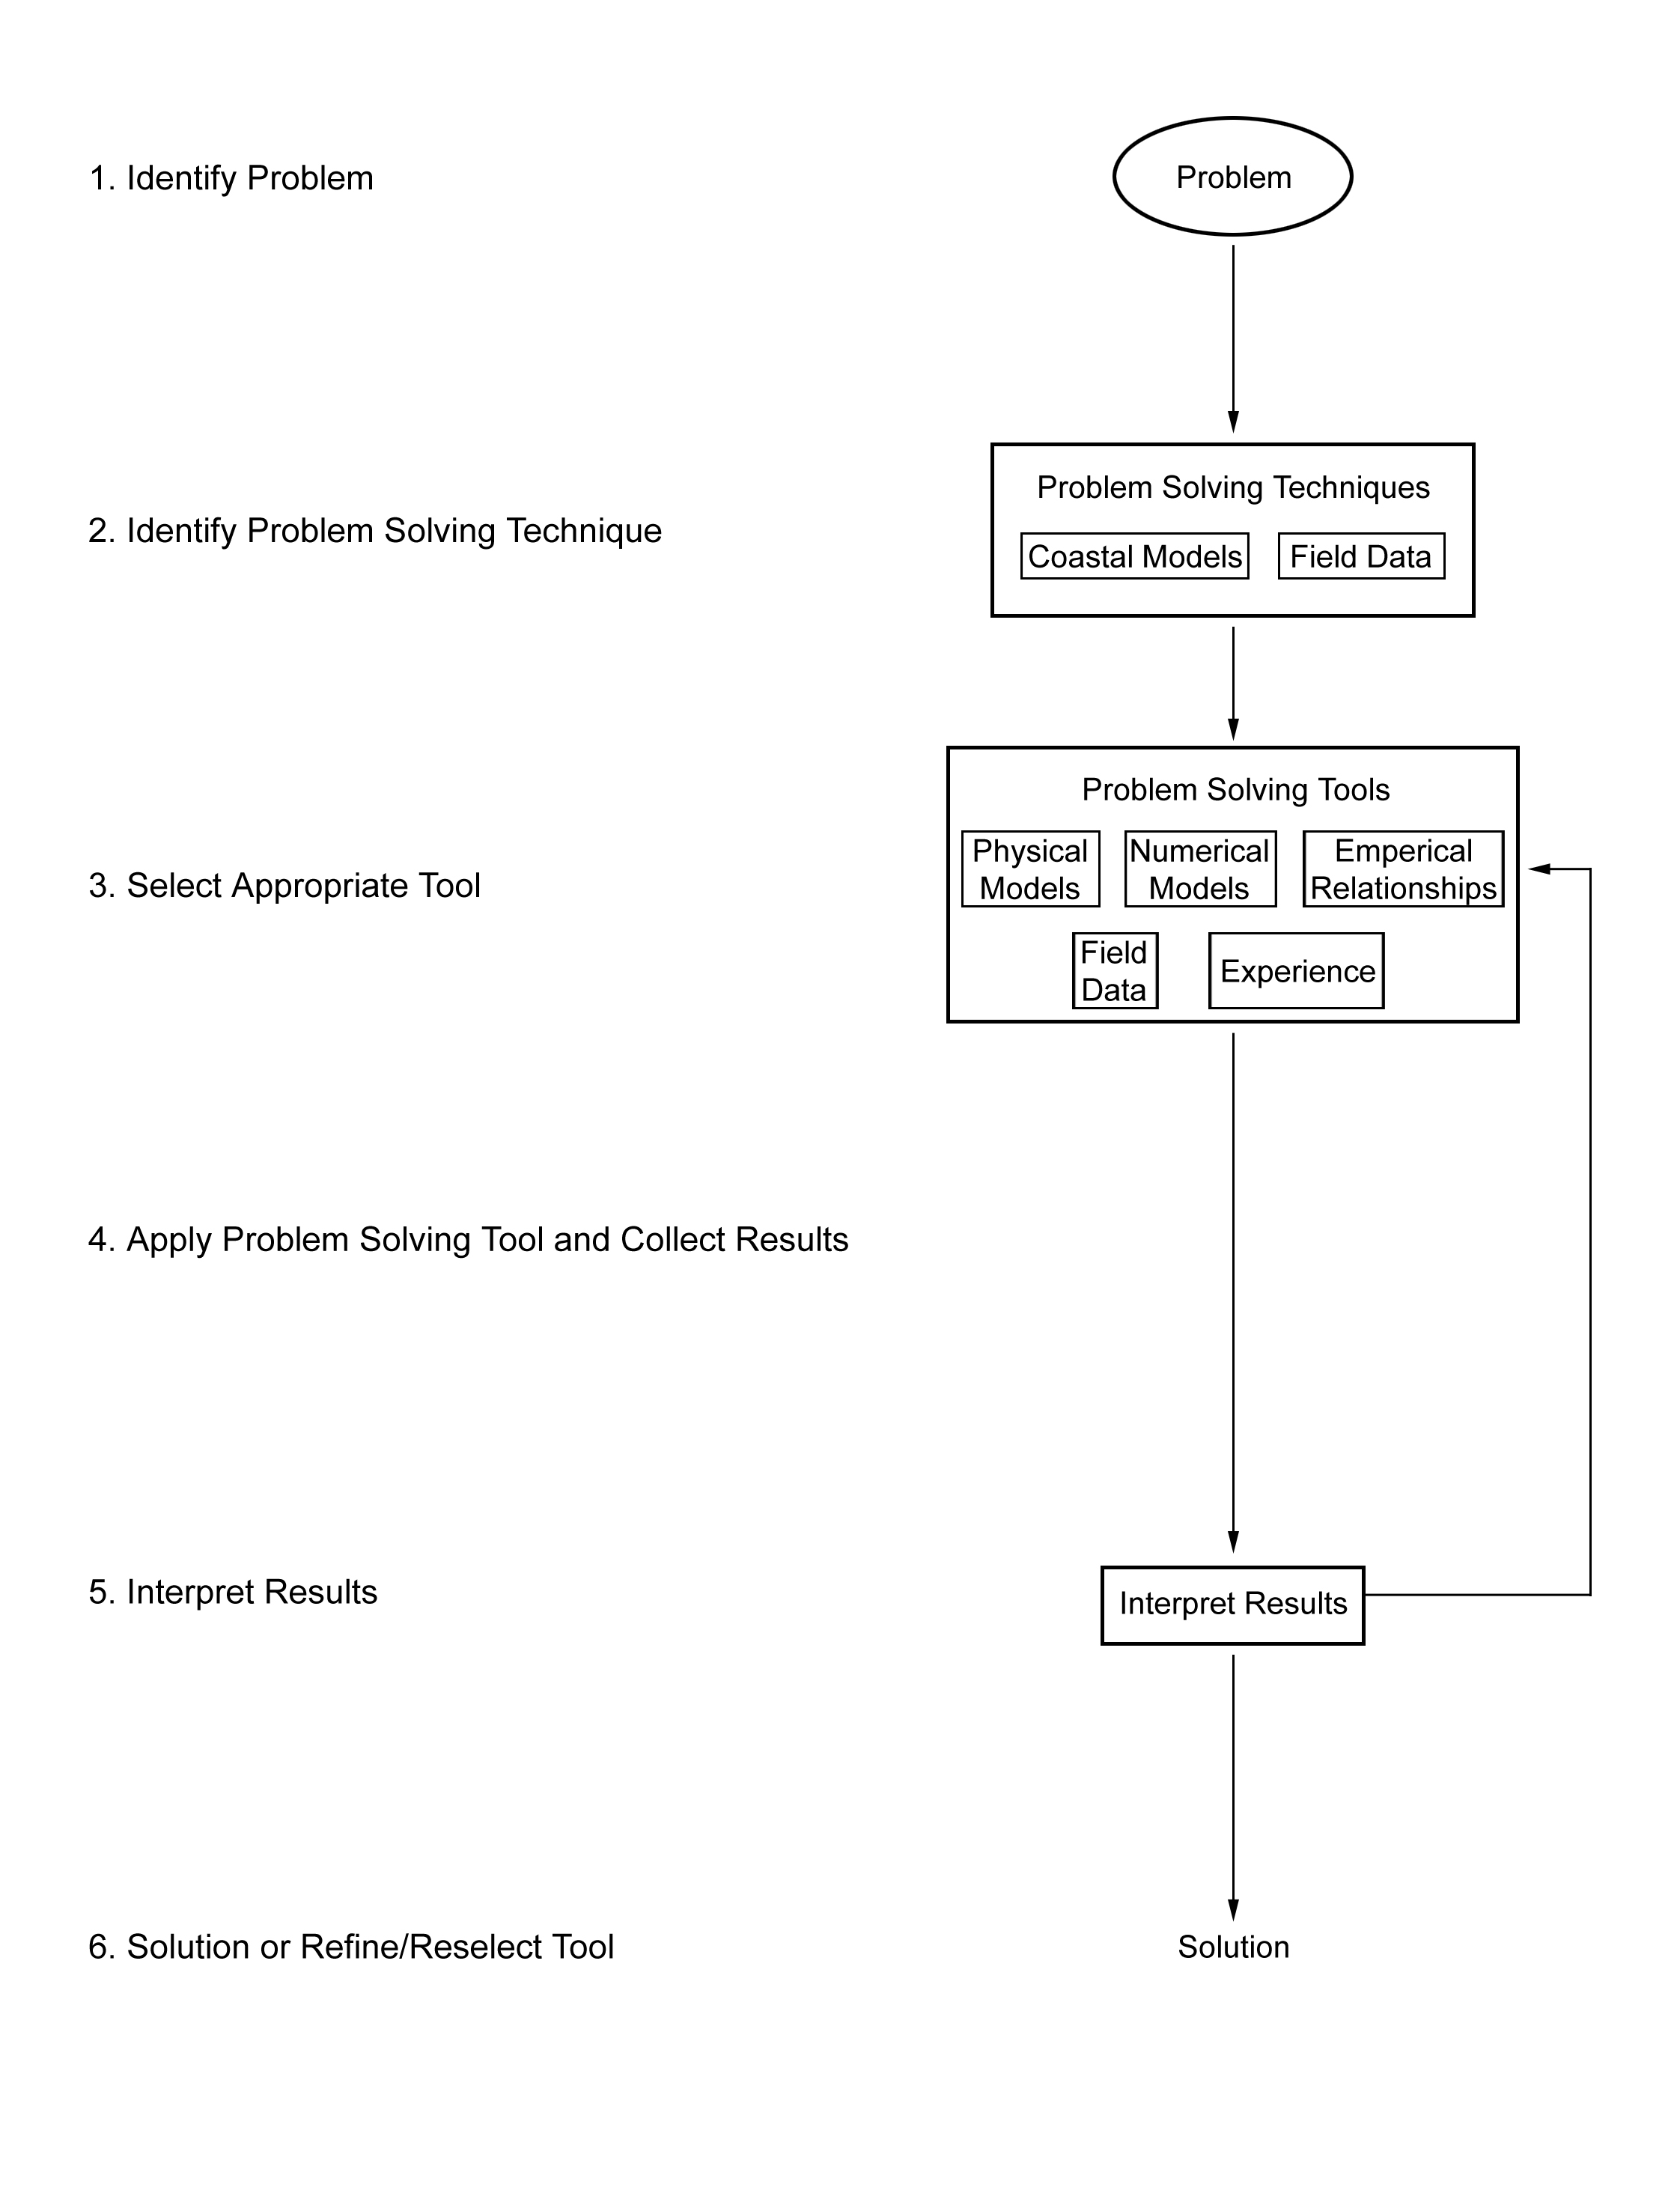

Figure 1. Coastal Engineering Problem Solving Process
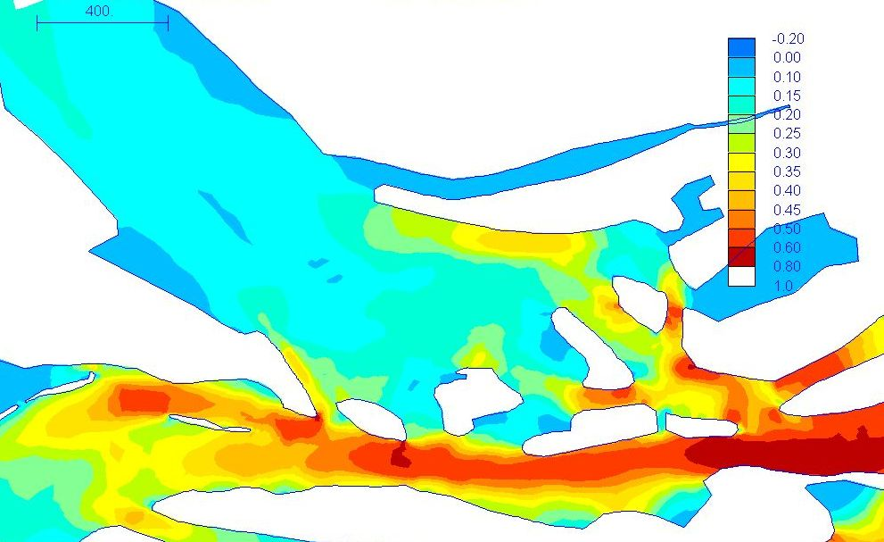
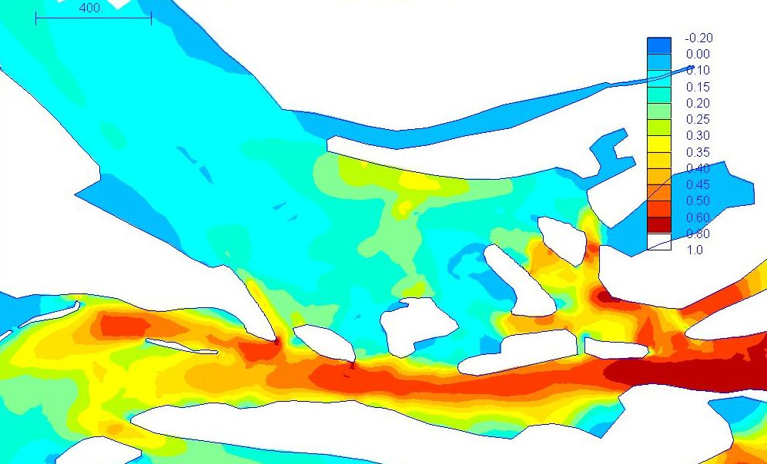

Pre-dredge site. Peak Velocity in m/s

Post-dredge. Peak Velocity in m/s
Figure 2. Predicted Pre and Post Dredge Maximum Velocities, Wallis Lake Estuary

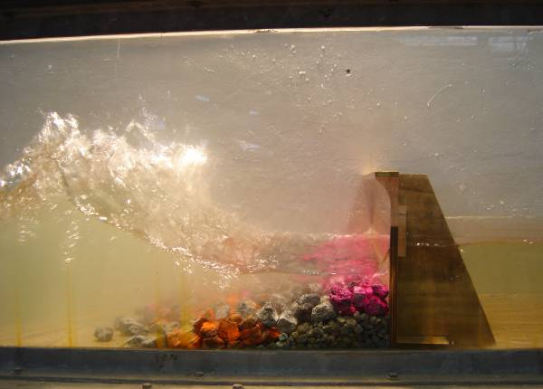
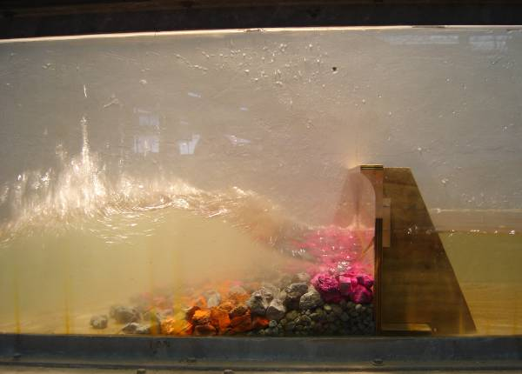
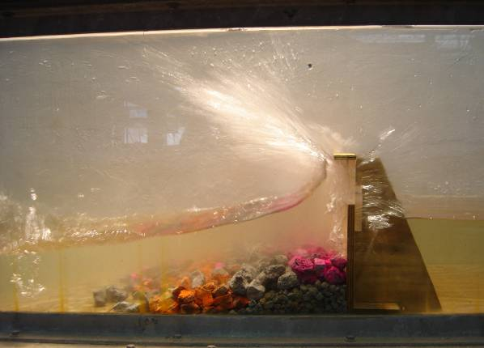

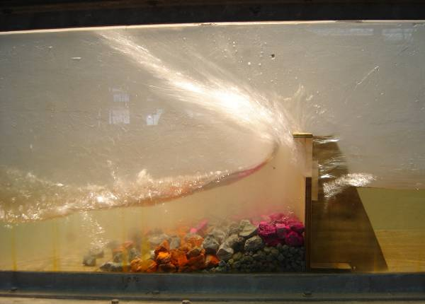

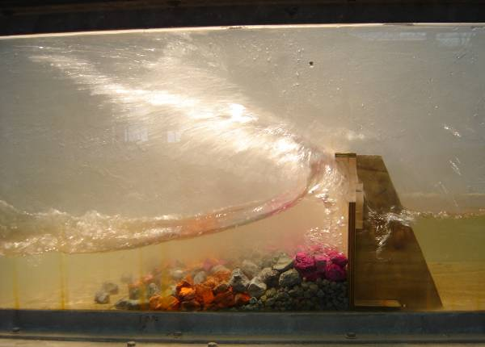

Figure 3. Physical model used in the assessment of seawall toe protection rubble

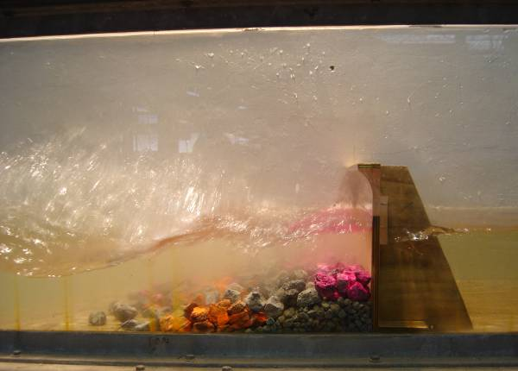

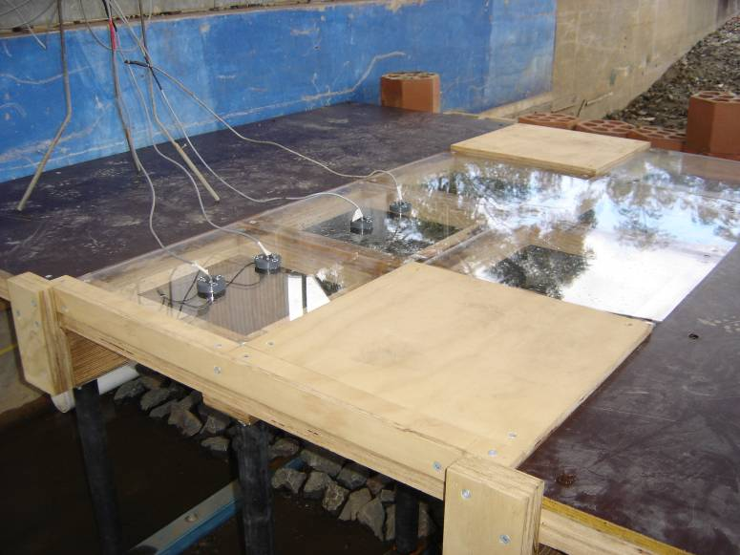

Figure 4. Physical model used in the assessment of proposed wharf design, Koniambo, New Caledonia
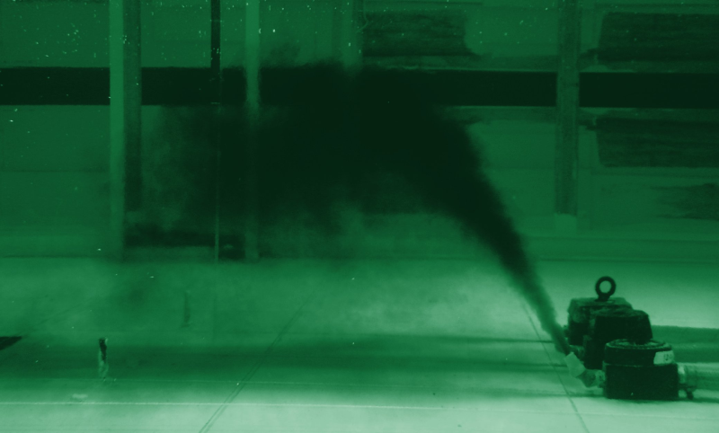

Figure 5. Physical model used for brine diffuser design

