RECENT ADVANCES IN THE TECHNOLOGY AND MONITORING OF WATER

Bronson McPherson ¹, David van Senden ², Sarah Hesse ³

1 Floodplain Engineer, Manly Hydraulics Laboratory
2 Principal Engineer, Manly Hydraulics Laboratory
3 Scientific Officer, Manly Hydraulics Laboratory

ABSTRACT

Recent advances in instrumentation and analytical tools used in the water industry have provided enhanced capabilities for interactive data management systems to support decision makers. These advances help provide assistance in planning for the sustainable use of the environment.

Real time application of analytic tools to real time hydrographic data is the next important step in bridging the gap between environmental data collection and the management of environmental systems. With aquatic disciplines data collection forms an essential component of problem solving and planning, project design, operations, early warning systems, and predictive models.

Algal bloom monitoring, nano-technology, river entrance management tools, and enhanced Internet facilities are just some of the innovative technologies and techniques that will help to bridge the gap between science and planning. This paper briefly overviews some recent advances and presents case studies outlining how MHL has used these advances to provide an interactive data management system to end-users.

These tools take information from multiple disciplines and technologies perform analyses to present meaningful interpreted parameters for use by decision makers. The tools available today and in the future, along with improved communication technologies, will help to enhance the communication between hydrographers, industry, the community, and environmental managers.

INTRODUCTION

Effective management of aquatic ecosystems requires a sound understanding of ecosystem processes and the indicators that reflect the system condition at any time. In general these complex processes are not easily monitored by a single variable but rather require a combination of different measurements and their subsequent analysis to derive a meaningful management tool. In raw form, measured data has a limited value to environmental managers who require simpler interpreted information that can be derived from the application of analytical tools.

Data may be used in a variety of ways, including storing for later use, near real-time download for compliance checking or warning and more recently for presentation and incorporation into decision support systems. Adding value to hydrographic data is an important step in bridging the gap between environmental data collection and the management of environmental systems.

Recent advances in analytical tools and more affordable monitoring systems provide a range of opportunities for the development of ‘smart’ tools that can assist managers in making timely decisions on a range of issues. Some examples of this include development of sampling triggers, assessment of flushing and water quality, alert systems for flood evacuation, and assessment of the status of intermittently closing and opening coastal lagoons (ICOL) to assist in entrance management procedures, and inputs into Australian and Global climate models.

This paper examines the real time hydrographic data collected by MHL and provides examples of innovative applications of analytical and presentation tools that provide an interpretation of environmental conditions in near real time to assist management decisions.

Data Collection and management

With aquatic disciplines data collection forms an essential component of problem solving and planning, project system designs, operations, early warning systems, and predictive models. Management decisions affecting estuaries or coastlines require a sound knowledge of the baseline and event driven conditions of indicator variables.

To improve knowledge of an aquatic system and enable better-informed management decisions, it is imperative that collected data is properly archived in an accessible manner for subsequent retrieval and use in long term assessments. MHL maintains a database of 10,000 years of data that is readily accessible. Data management is an important component of effective environmental monitoring programs that is often overlooked, and as a consequence limits the expansion of knowledge.

Enhancements in data delivery

Hydrographic data is used by people in a wide range of disciplines, often in unexpected places. For example, an entomologist may need to look at tidal data to determine the likelihood of mosquito outbreaks in wetlands in relation to public health management decisions or a policeman may require analysed tidal data to determine the fate of a body found in the water as part of a murder investigation. It is therefore important that data is collected and presented in such a way as to make it available and accessible for multifunctional use.

Data capture, analysis and delivery has been enhanced in recent years, due to developments in:

- Smart, accurate more robust and multifunctional solid state sensors
- Communication advances with telemetry, cellular phones, and satellites
- The speed and capacity of computers
- Internet and Intranet advances and usage
- The integration of data with simulation models
- Quality Assurance systems in place

The web provides the capability for clients and/or the public to examine the data and draw their own conclusions about system status (although sometimes erroneously). Models and analytical tools may be used to predict future trends or events and enhancements can be readily developed by interfacing with a variety of software packages and displaying outputs on a web page. These services are particularly relevant during storm and flood events or where the data forms a critical input to operational processes.

Converting Data to Information – ‘Value Adding’

In a publication entitled “At what Price Data?” produced by the National Committee on Coastal and Ocean Engineering of the Institution of Engineers, Australia (1993) it is noted that data is a relative measure, not absolute; but relative to a selected level of accuracy. Data is only meaningful when correctly interpreted by a competent practitioner, experienced in the specific fields of data collection and interpretation.

The “next step” in the use of collected data is its integration into decision support systems to allow a more relevant overview of the system by environmental managers. The availability and enhancement of the data has a vital role in well-informed management decisions.

This type of ‘value adding’ to data requires good understanding of system response, which is developed through a model with well-established inputs and outputs and a clear understanding of model limitations and possible errors. To get the best possible results for use by environmental managers it is important to have a good knowledge of how to apply the model and relevant presentation of simplified outputs.

The following section outlines just a few examples of MHL projects that have involved the development of analytical tools that enhance hydrographic data to assist clients with management decisions.

Lake Conjola Decision Support System

Management of coastal lagoon estuaries in NSW has increasingly incorporated the aim of reducing the level of interference with the natural opening and closing regime of estuaries. State Government policy is to allow the entrances to open and close in as near a natural pattern as possible. However, the presence of low-lying assets surrounding some of the estuaries and the fact that many coastal villages are still un-sewered introduces flooding and water quality issues that drive the pressure to manipulate the entrance conditions, usually in the form of mechanically removing the entrance constriction.

MHL was commissioned to undertake the synthesis and review of available information and develop a final decision support structure in a form that could be easily accessed and used in a practical sense to manage the estuary entrance. The Lake Conjola decision support system was developed following an Entrance Management Study, which found that closure of the lake entrance to the ocean occurs periodically (as shown in Figure 1 below) and causes deterioration of water quality and increases flood risk to local low-lying areas. The decision support system monitors the tides in the lake and alerts Council when the entrance channel has shoaled to a point that intervention is required to prevent closure.

Figure 1 Schematic of entrance shoaling at Lake Conjola
Ocean
Lake
Conjola
Entrance

The system makes use of a relationship between the tidal constituent M2 and the constriction of the entrance based on observations and records of rainfall and storm events. As the entrance begins to be constricted by sand deposition the M2 constituent in the lake is reduced. Long-term monitoring of the tidal range recorded by a water level recorder in the entrance channel therefore provides an easy means of detecting shoaling of the entrance.

Within the decision support system various trigger levels have been set which indicate the state of the system and required actions to avoid closure as shown below in Figure 2. The system provides advance warning of entrance closure so that the essential activities that must be carried out prior to dredging can be initiated in a timely manner to enable dredging to commence before closure is imminent. It is important to initiate the entrance works at the appropriate time; that is in time to finish the works before closure but not prematurely because a flood may scour the channel naturally.

The system is hosted on the internet and displays a rolling assessment of M2 tidal constituent against time (Figure 2); offshore wave height, period and direction; and rainfall. Selected Council officers are notified via email, fax or SMS when M2 reaches key trigger levels so that appropriate action can be taken.

This decision support system represents an effective measure for managing a complex estuary entrance and allows Council to manage risks to low lying properties and water quality within the lake with a high degree of confidence.

Figure 2 Graph illustrating how Council interfaces with the decision support system.
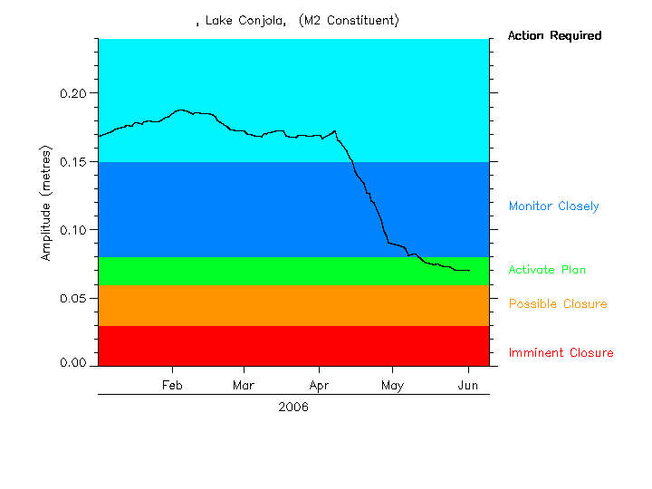

Berowra Creek Chlorophyll and Algal Monitoring

Algal concentration is an important facet of water quality due to the potential for algal blooms, particularly in nutrient-enriched waterways. Algal blooms involve high densities of naturally occurring algae, and may be toxic or non-toxic. Both toxic and non-toxic algal blooms can have a detrimental effect on water quality, due to the ingestion of toxic species by filter feeding animals such as oysters, and the deoxygenation of bottom water during the decaying process (ANZECC, 2000). This deoxygenation can affect species composition of benthic fauna, inhibition of passage of mobile aquatic species, and lead to the emission of noxious odours.

Regular summer algal blooms occur in Berowra Creek, a tributary of the Hawkesbury River estuary, affecting the local ecosystem, commercial and recreational fishing, other recreational activities, and public health. Due to the potential hazards associated with algal blooms, regular monitoring of the waterway is required. This has traditionally involved the collection of water samples that are then analysed in a laboratory, with limited capacity to forewarn the arrival of an algal bloom. The detection of algal blooms is an important issue for oyster growers, drinking water managers and natural resource managers maintaining healthy waterways. Recent advances in the use of fluorometers for the detection of chlorophyll now present a range of options for monitoring and the detection of harmful algal blooms.

MHL has developed a chlorophyll, salinity and temperature monitoring system for Hornsby Shire Council (HSC) at Berowra Creek. Single point continuous monitoring was developed using a YSI™ sonde to measure the fluorescence of the water as an estimate of chlorophyll concentration.

The single point monitoring is configured on a buoy floating in Berowra Creek with the sonde at a depth of 0.5m. The sonde is connected to a data logger inside the buoy and collects near real-time chlorophyll data. The logger is routinely downloaded by cell phone to MHL’s central computer system or can be downloaded on demand if a bloom is occurring. Interaction with the site and online data is presented to HSC via an internet web site developed and hosted by MHL an example of the information provided in this interface is shown below in Figure 3. The system can be configured to send fax, email and SMS alarms when the chlorophyll levels exceed predetermined values. The data provides early warning of high chlorophyll levels associated with algal blooms and alerts the HSC resource managers of events where action is required.

Figure 3 Graph of Council’s interface to the algal bloom alert system

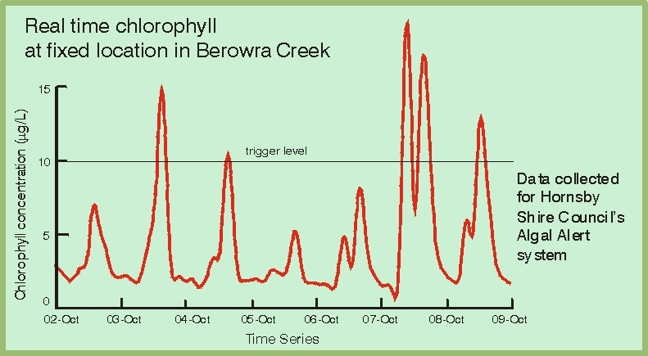

The continuous monitoring sonde was combined with the collection of field water samples in collaboration with the Department of Natural Resources (DNR) by profiling the water column using a high resolution five-band fluorometer. The field sampling was conducted to determine the effectiveness and accuracy of the YSI™ sonde as an early warning tool for potential algal blooms.
Another approach explored was high resolution vertical profiling and traversing of estuaries. This has the ability to give a ‘complete estuary’ approach to spatial and depth variations in algal levels including total chlorophyll levels attributable to blue algae, blue-green algae, diatoms, crytophyta and total algal biomass (determined by the five-band fluorometer). This type of information is a valuable tool for organisations to understand the complexities of the chlorophyll and algal behaviour in water bodies as a whole. However in the context of an algal bloom alert in a particular location it has been found that the correlation between fluorescence and chlorophyll performed well as an indicator of algal bloom occurrence in the area of interest. Thus this tool is an efficient and effective solution for water resource managers in HSC to manage algal blooms in this area even though single point monitoring does not detail the complex three dimensional chlorophyll and algal behaviour.

As a result of developing this algal bloom alert system there have been significant monetary benefits, the use of the YSI sonde fluorescence of chlorophyll as an alternative for determining actual chlorophyll via laboratory based extractive methods has been estimated to have saved over $100,000 in sampling and analytical costs over the past four years.
The benefits of the use of the algal bloom alert system as a management tool include, local oyster growers being alerted to impending bloom condition, improved understanding of algal behaviour and the development of a predictive model to forecast the likelihood of a bloom occurring over the next fortnight which has enabled Council to plan a response to bloom situations. Further side benefits include the decrease in remedial costs to oyster growers and reduced ad hoc sampling.

This algal bloom alert system represents a significant improvement in management of an active commercial and recreational estuary prone to algal blooms.

The Future - Nanotechnology

Nanotechnology comprises technological developments on the nanometer(nm) scale, or one millionth of a millimeter. This is about ten thousand times smaller than the width of a hair. Nanotechnology is any technology that exploits phenomena and structures that can only occur at the nanometer scale, which is the scale of several atoms and small molecules.

Nanotechnology refers broadly to using materials and structures with nanoscale dimensions, usually ranging from 1 to 100 nanometers (nm) (1nm is equivalent to 1/1 000 000 mm). To some extent, environmental scientists and engineers are already working with nanoscale structures. Natural weathering of minerals, such as iron oxides and silicates, and microorganisms, such as bacteria and algae, produce nanoscale colloids, which include dispersions of nanosized-particles in media with special properties that can be important in the fate, transport, transformation, and bioavailability of environmentally harmful substances (Zhang, 2003).

However, nanotechnology is not just about the size of very small things: more importantly, it is about structure and the ability to work—observe, manipulate, and build—at the atomic or molecular level (Pister, 1998). In this respect there are boundless opportunities for the use of nanotechnology in building devices which are at nanoscale.

“Smart Dust” is an emerging technology that uses tiny, wireless sensors or “motes”. Eventually these devices will be smart enough to talk with other sensors to autonomously form networks yet small enough to fit on the head of a pin. Each mote is a tiny computer with a power supply, one or more sensors, and a communication system (Zhang, 2003). Commercially available motes do not yet fit on the head of a pin; some are about the size of a deck of cards and others are as small as a stack of five cent pieces. The application of the “smart dust” technology to be deployed as a wireless sensor networks (WSN) is just one example of how the technology may be beneficial for monitoring of water.

The Center for Embedded Networked Sensing (CENS) at UCLA represents the leading body for research and development of wireless sensor networks (WSN) for environmental monitoring. Their central goal is to “create programmable, autonomous, distributed, multi-modal, multiuser observatories to address compelling science and engineering issues” (UKDTI, 2006). One of the key features of these devices is that “the user can interact with the WSN to dynamically analyse data and adjust and optimize the WSN deployment” (UKDTI, 2006). This type of device has the potential to revolutionise the way data is collected and used and extend the understanding of environmental systems to previously unexplored levels. The application of this type of technology as an environmental monitoring network would provide a previously impossible degree of spatial resolution which in turn may provide a better understanding of managing complex environmental issues.

A particular example of wireless sensor networks being employed currently is in a collaboration between Intel and the Massachusetts Institute of Technology (MIT) on water and sewer pipeline monitoring in Boston. The system monitored water pressure (for leakage detection) and water quality using pH sensors) as a stand-in for future high-spec water sensors. A variety of wireless protocols were used in the system: the gateways were attached to lamp posts and used WiFi and GPRS to link back to a lamp post connected via Bluetooth (UKDTI, 2006).

Figure 4 WSN monitoring of sewer pipes in Boston

Source: UKDTI, 2006

At this stage the vision of this technology is quite real, despite the technological leaps involved, in the future it is hoped that these types of nanosensors or “smart dust” will be very cheap and provide an alternative to current techniques and solutions to current problems. One of the big issues that such technology will present is one of data management; the exponential increase in the amount of data that will be produced as these types of sensors are adopted must also give rise to further development in filtering and mining of data for information.

The development of nanotechnology is well underway and it’s infinite number of applications from our everyday life to highly technical scientific research are becoming more apparent with every step closer. Much like the digital computer it will bring with it the possibilities of understanding our environment to a much higher degree and hence new discoveries and understandings from the smallest system to the largest. The applications of this technology will be very valuable and only limited by imagination.

Conclusion

Data collection is a vital component in the management of aquatic ecosystems. The advent of cheaper and more reliable monitoring systems and the Internet enables environmental managers to obtain more relevant information about their systems through the use of interpretive tools. The MHL case studies of Decision Support Tools presented in this paper demonstrate the value of enhancing data for environmental managers. Further work on understanding systems responses to input (measured) variables will allow the development of more client tailored tools that will benefit the management of natural resources; and in turn benefit the environment, public health and lifestyle of the people of NSW. Nanotechnology presents an exciting future for data collection and has the possibility of providing a greater understanding of environmental systems through high density data collection.

References:

United Kingdom Department of Trade and Industry (UKDTI), (2006), Global Watch Mission Report: Wireless sensor networks – a mission to the USA
Available Online: http://www.ist-runes.org/docs/brochures/DTI_Globalwatch_mission.pdf#search=%22Global%20Watch%20Mission%20Report%3A%20Wireless%20sensor%20networks%20%E2%80%93%20a%20mission%20to%20the%20USA%22 Accessed: 24-8-06

Zhang, W., Masciangioli, T. (2003) Environmental Technologies at the Nanoscale
Available Online: http://www.nano.gov/html/res/GC_ENV_PaperZhang_03-0304.pdf#search=%22Environmental%20Technologies%20at%20the%20Nanoscale%22 Accessed: 24-8-06

