COASTAL PROCESSES IN THE COFFS HARBOUR REGION

James T Carley¹, Stephen J Wyllie¹, Douglas B Lord² and Ronald J Cox¹

Corresponding author:
james.carley@unsw.edu.au
phone: 02 9949 4488
Senior Coastal Engineer

1. Water Research Laboratory, University of New South Wales
110 King Street, Manly Vale NSW 2093
2. NSW Department of Natural Resources

Introduction
Coffs Harbour is widely considered to be the safest anchorage between Port Stephens and Moreton Bay. The harbour has had a history of sand infill, and this progressive shallowing has resulted in additional wave breaking across the entrance of the outer harbour, which compromises navigability in moderate to big seas. The interception of northward littoral drift sand by the harbour has exacerbated long term erosion of beaches to the north and resulted in accretion of Boambee Beach to the south. Boambee is one of the few accreting beaches in NSW.

Current harbour
Coffs Harbour is situated on the mid-north coast of New South Wales approximately 570 kilometres north of Sydney. The harbour covers approximately 70 hectares, however, only the inner harbour of 5.8 hectares (8% of the total harbour area) can be considered an all-weather anchorage. South of Coffs Harbour, the coastline faces generally south-east and consists of long sandy embayments between rocky headlands. North of the harbour the embayments are smaller and are more easterly facing.

Prior to harbour modifications, which commenced in the late 19th and early 20th centuries (see below), Coffs Harbour’s immediate coastline consisted of a pocket beach with two offshore islands. The present configuration (Figure 1) is an artificial harbour utilising two natural islands, consisting of the following major works:

- The northern rock breakwater connecting Muttonbird Island in the north to the mainland.
- The eastern rock breakwater extending approximately 500 m seaward of Corambirra Point on South Coffs Island.
- The area between the mainland and South Coffs Island which is now reclaimed.
- An inner harbour in the north of the main harbour.
- A boat ramp basin in the south of the harbour.

History
Prior to European settlement, the Coffs Harbour area was inhabited by the Kumbaingeri (Kumbaingiri) people. About 1847, Captain John Korff in his ship Brothers took shelter from a storm in the lee of what was later named South Coffs Island and was impressed with the shelter there. Settlement by Europeans increased from the 1840s to 1880s. Korff’s name was corrupted (to Coffs) in the gazetting of the harbour, though his correctly spelt name survives in Korffs Islet south-east of the harbour.

In response to lobbying by local timber getters, the Coffs Harbour Jetty was completed in August 1892, for the transportation of goods and people to and from the harbour. At this time the two islands (Muttonbird and South Coffs) were separated from the mainland by sandy channels (Figure 2). Difficulties in berthing at the jetty during storm waves resulted in the decision to augment the natural protection of the site with breakwaters.

The northern breakwater is approximately 1,000 metres long, joining Muttonbird Island to the mainland. It was commenced in 1914 and completed in 1924. Rock for the northern breakwater construction was quarried from South Coffs Island and transported by rail across a trestle bridge (Figure 3) to the mainland and then to the northern breakwater site. The crest of this breakwater provides the only vehicle access to most of the mooring berths in the inner harbour. It has been overtopped and damaged during storm wave conditions from the east to north-east (Figure 4). Major overtopping was experienced in 1954 and 1999.

The channel between South Coffs Island and the mainland was reclaimed between 1915 and 1927, being finally closed off about 1926. This closure ended the then dominant sand pathway into the harbour from Boambee Beach.

The eastern breakwater extends approximately 400 metres seaward of South Coffs Island, with the head approximately 1.4 km offshore from Jetty Beach (Figure 1). From the head of the eastern breakwater, the harbour entrance is approximately 300 metres wide across to Muttonbird Island. The eastern breakwater was commenced in 1919 and completed in 1946. Maintenance of the eastern breakwater has been an ongoing task as the breakwater is parallel to the dominant waves and typically in mid tide water depths of 6 to 8 metres. It has experienced numerous incidents of damage due to large and/or long period storm waves.

Development of the inner northern boat harbour and wharf facilities commenced in 1971. Upgrading of these facilities and the provision of additional piled moorings for pleasure craft was completed in 1984. The present marina supports 164 floating pens and 52 piled moorings. During the winter months and following sailing races, the inner harbour facilities are completely utilised, requiring vessels to anchor in the outer harbour.

A boat ramp basin was excavated from the reclaimed area on the southern side of the harbour in 1978. The ramp has experienced sand infill and wave problems since its construction and ongoing sand removal has been undertaken.

Since the construction of the inner harbour and boat ramp, there has been a number of dredging and sand extraction campaigns to maintain adequate water depth for the fishing and recreational fleets.

A summary of the history of development is shown in Figure 5.

Waves

Offshore Waves
The deepwater ocean wave climate has been monitored with a non-directional waverider buoy since 1976, with the deployment approximately 12 km due east of the harbour in 75 to 80 metres of water. Long term wave records exist for more than seven locations on the NSW coast dating back as far as 1971 (plus locations in southern Queensland). The data includes measured directional information for Byron Bay, Sydney and Batemans Bay. Where directional measurements are not available it is hindcast from weather maps or visual observation. Missed events at one location (due to maintenance or failure) are generally recorded at other locations. Generally the buoys measure wave height and wave period every hour for a period of 18 minutes. The long term data has been valuable in identifying wave events that have caused damage to the seaward breakwaters and processes that can occur in the harbour. Table 1 presents the probability of exceedance which is the basis of the design wave selection.

Table 1: Offshore Significant Wave Heights for Selected Sites

 | ARI (years) and H_{S} (m)
Site | 1 | 2 | 5 | 10 | 20 | 50 | 100
Brisbane (1 hr) QLD EPA 22 years data | 5.0 | 5.5 | 6.1 | 6.6 | 7.1 | 7.8 | 8.2
Byron Bay (1 hr) MHL 20 years data | 5.1 | 5.5 | 6.1 | 6.4 | 6.9 | 7.5 | 7.8
Coffs Harbour (1 hr) MHL 21 years data | 5.0 | 5.6 | 6.3 | 6.8 | 7.2 | 7.8 | 8.3
Sydney (1 hr) MHL 8 years data | 5.5 |  | 6.8 | 7.3 | 7.8 | 8.5 | 9.0
Sydney (duration not given) Willoughby (1995) MSB 21 years data |  | 5.9 | 6.7 | 7.2 | 7.8 | 8.0 | 8.3
Values adopted | 5.0 |  |  |  |  | 7.8 | 10.0

Waves inside Coffs Harbour

Ocean Waves entering Coffs Harbour
Deepwater waves reaching the harbour entrance are modified through refraction and by wave breaking during large wave conditions. Numerous offshore shoals complicate this process. From the harbour entrance to inside the harbour, waves are modified by further breaking (during large wave conditions), refraction, diffraction and reflection.

In the 1970s the then Harbour Master had observed the wave climate in the harbour historically during major storm events. The February 1954 storm was observed by the Harbour Master to cause major overtopping of the northern and eastern breakwaters and severe wave breaking within the harbour. Waves overtopped the northern breakwater along its full length.

During calmer periods, offshore waves refract towards the entrance and the prevailing southeast waves penetrate the entrance and refract towards the southwest, reflect off Muttonbird Island and travel along the northern shore.

The definition of the harbour climate during storm periods was first undertaken in 1966 with the construction and testing of a physical scale model (Stone, 1966). The model was constructed to the 1961 bathymetry and tested waves 18 feet (approximately 5.5 m) in height at 10 second period. The results showed that wave climate was substantially reduced to a transmitted wave of only 50% of that at the entrance (0.5 coefficient) midway into the harbour, with transmission coefficients of approximately 0.58 at the end of the jetty and 0.25 to 0.32 just north of the jetty. It should be noted that these coefficients were relative to waves just outside the harbour entrance, as the model did not extend to deep water and should be multiplied by 0.6 to relate them to deep water (see below) so that they become 0.35 at the end of the jetty and 0.15 to 0.19 just north of the jetty (see Figure 6).

As stated above, the offshore waverider buoy has been deployed since 1976 and the wave and tide recorder at the end of the jetty from 1986 to 1994 and beyond. Walker and Carley (1995) found a transmission coefficient between the offshore waverider buoy and the Zwartz pole data measured at the end of the jetty of 0.27 (Figure 7) which was fairly independent of offshore wave direction, and compares well with the results from Stone (1966).

In 1986 a major data collection program was undertaken by the PWD to define the waves and currents in the harbour with the deployment of bottom mounted current meters at nine sites shown in Figure 8. Over the period of these deployments the wave climate was relatively mild to moderate. The wave transmission coefficients at the nine sites were similar to those found in the 1966 model. The data was not analysed for long waves (seiching), but is still available to do so. The other key finding from this study is that there is a reduction in wave height from offshore to the harbour entrance (Figure 8), which (for unbroken waves) was found to be independent of wave height, dependent on wave period and slightly dependent on the offshore wave direction. The adopted transfer function of significant wave height from offshore to the harbour entrance in PWD (1987) where offshore significant waves were less than 4 m was:

Hs Harbour Entrance = 0.6 Hs Offshore

With this information, the wave height coefficient for the analysed Zwartz pole wave data for the end of the jetty presented in Walker and Carley (1995) of 0.27 approximates that found by Stone (1966) of 0.6*0.58 = 0.35.

From data collected within the harbour presented in PWD (1987), a wave height profile was established which compares well (Figure 8) with the results of the 1966 physical model (Stone, 1966).

The offshore wave direction was visually recorded by fishermen from 1976 to 1979 and was found in PWD (1987) to correlate well with the offshore wave direction hindcast from synoptic charts. The predominant offshore wave direction is east to south east. Although swell waves approach the harbour from a wide range of directions, the range narrows to essentially east as the waves pass through the harbour entrance. The principal wave direction climate within the harbour was found to be effectively uni-directional, regardless of the offshore wave direction and agrees with wave crest plots from aerial photography taken in August 1964.

WRL has undertaken brief modelling using the surf zone model of Dally, Dean and Dalrymple (1985) using a simple one line approach (ignoring diffraction and refraction) as shown in Figure 9. It can be seen that for very large wave heights, including a theoretical 20 m offshore wave (twice the 100 year ARI significant wave), dissipation through breaking becomes the dominant process and that wave heights near the inner harbour are limited to 3 to 4 m.

The overall wave processes in the harbour under different wave conditions are:

- Waves have been observed to break at the entrance when the offshore significant wave (Hs) exceeds 4 metres.
- Wave overtopping can occur along the eastern breakwater when waves are large and wave periods are long. Wave overtopping causes a confused wave climate on the lee side.
- The northern breakwater is occasionally overtopped (anecdotally approximately once per year), as it requires storm waves with long periods from the east to north-east sector combined with high spring tides and positive tidal anomalies for overtopping to occur.
- Inside the harbour, wave heights are higher to the south of the leads under most prevailing conditions.
- Wave reflection occurs from the south shore of Muttonbird Island whereby reflected waves travel south to south-west to the eastern breakwater.
- Waves travel shore normal along the northern shore.

Wind Waves generated within Coffs Harbour

Typical local wind wave fetches within the harbour are of the order of 1,000 m. Using the design wind data presented in Table 2 and the wave hindcasting techniques of SPM (1984) and CEM (2003), extreme local wind wave conditions (outside the inner harbour) have been estimated as shown in Table 2. It can be seen that the height and period of these is far smaller than that of open ocean waves penetrating into the outer harbour.

Table 2: Design Local Wind Waves (1000 m fetch within harbour)

ARI (years) | Design Wind velocity |  |  |  | Design Wind Waves
 | 3 s gust |  | 10 min average
 | m/s | knots | m/s | knots | Hs (m) | Tp (s)
1 | 29 | 56 | 20 | 39 | 0.5 | 1.9
50 | 41 | 80 | 29 | 56 | 0.7 | 2.2
100 | 43 | 84 | 30 | 58 | 0.8 | 2.2

Tides and Water Levels
Water levels consist of (predictable) tides which are forced by the sun, moon and planets (astronomical tides), and a tidal anomaly. Tidal anomalies result from factors such as wind setup or setdown, barometric effects, seasonal changes and coastally trapped waves. The largest positive anomalies are associated with major storms and are driven by barometric and coastal wind setups. Water levels within the surf zone are also subject to wave setup and wave runup.

Tides along the NSW coast are semi diurnal (two high and two low tides a day) and are similar in range and phase along the entire open coast. Tides have been measured continuously in Coffs Harbour since 1974 at the Coffs Harbour Jetty and in the inner harbour. This is a relatively short record compared to the long term tides records at Fort Denison, Sydney Harbour which are available digitally from 1914.

Extreme storm surges at Coffs Harbour can be driven by intense ex tropical cyclones that develop in the Coral Sea and travel as far south as Port Macquarie. Such an event occurred in June 1974 when Cyclone Zoe tracked down to Wooli then offshore. This event generated a surge (positive tidal anomaly) of 0.4 m in the harbour (PWD, 1987). In Sydney the May 1974 storm generated a 0.4 m surge (positive tidal anomaly) at Fort Denison. Long term tide records collected at Fort Denison from 1914 to date show that the frequency of tidal anomalies is reasonably symmetrically distributed from a low of –0.5 m to a high of +0.4 m. Investigations published in Wyllie et al (1995) and MHL (1992) showed that this distribution could be adopted for the mid to north coast of NSW. The water levels that are important for navigation and the design of breakwaters and marinas are the extreme high and extreme low. Although the predicted tides correlate between Coffs Harbour and Sydney Harbour, the Coffs Harbour tide records are relatively short (1974 to date) compared with Sydney records and the frequency and magnitude of the extreme tidal anomalies may not by represented in the shorter record.

Published tidal planes for Coffs Harbour are shown in Table 3. Also shown in Table 3 are suggested 100 year ARI design water levels for preliminary design purposes. A value of 1.5 m AHD is generally accepted for Sydney (AWACS, 1990; MHL, 1992), however, due to the closer proximity of Coffs Harbour to tropical cyclones, this value has been increased slightly to 1.7 m AHD as a preliminary value. More detailed analysis of existing data and/or joint probability analyses would be needed for detailed design.

Table 3: Design Water Levels

 | Published Astronomical Tidal Planes |  |  |  |  |  | 100 year ARI water levels |  | 50 year ARI | 1 year ARI
Datum | HAT | MHWS | MHWN | MSL | MLWN | MLWS | High | Low | High | High
CHPD | 2.1 | 1.6 | 1.2 | 0.9 | 0.6 | 0.2 | 2.6 | -0.3 | 2.4 | 2.2
AHD | 1.2 | 0.7 | 0.3 | 0.0 | -0.3 | -0.7 | 1.7 | -1.2 | 1.5 | 1.3
Notes:
CHPD: Coffs Harbour Port Datum
AHD: Australian Height Datum (approximately mean sea level)
HAT: Highest Astronomical Tide
MHWS: Mean High Water Springs
MHWN: Mean High Water Neaps
MSL: Mean Sea Level
MLWN: Mean Low Water Neaps
MLWS: Mean Low Water Springs
Source: RAN Hydrographic Service (1999)

As waves break across the entrance to Coffs Harbour during storm conditions, some wave setup may also occur inside the harbour. Under extreme conditions, wave breaking occurs well offshore of the harbour entrance with waves reforming, refracting and diffracting inside the harbour, so the magnitude of wave setup would not be as high as that of an open coast beach. Careful analysis of water level data would be needed to exclude the effects of wave setup from harbour water levels. Wave setup would indeed affect water levels along Jetty Beach under large wave conditions. Jetty Beach, the existing breakwaters and any proposed new structures are/would be subject to wave runup.

Sediment Transport

Littoral drift at Boambee and harbour Infill
Before the interception of the longshore littoral sediment drift by the harbour in the early 20th century, the estimated net longshore littoral drift was 75,000 m³ per annum northward (Lord 1984), most of which passed between Muttonbird Island and Jetty Beach and was transported northward to Park Beach and beyond.

Bathymetric surveys of Coffs Harbour have been undertaken periodically since 1890 on the following dates: 1890, 1946, 1951, 1961, 1970, 1979, 1985, 1999, 2003. Analysis of these surveys shows that the harbour breakwaters and causeway to South Coffs Island have intercepted the longshore littoral sand drift, resulting in accretion along the northern end of Boambee Beach, with some sand bypassing South Coffs Island and being transported into the harbour.

By comparing successive bathymetric surveys, maps of the difference in bed levels between surveys can be produced and these are called isopach maps. These maps determined the rates of accretion and infilling into the harbour. In essence, the average littoral drift (longshore sand transport) at Boambee is 75,000 m³ per year northward and the average sand infilling rate for the harbour estimated by Lord (1984) was 25,000 m³ per year. The Lord (1984) investigations reported that sand was being transported into the harbour by waves (not tidal currents) and that there was no evidence of sand bypassing Muttonbird Island. The harbour wave climate and associated bed currents distributed these sands into two sand transport paths. The first is along the eastern breakwater then along the southern foreshore onto Jetty beach. The second pathway is along the south-eastern breakwater to the entrance of the inner harbour. There is some evidence that a sediment path exists east along the south-western breakwater to the entrance of the inner harbour.

Investigations by AWACS (Walker and Carley, 1995) of the boat ramp sediment infilling issue and possible remedial works, determined that the average annual longshore transport in this area (along the southern shore of the harbour) was approximately 4,000 to 5,000 m³/year, with 1,800 m³/year transported on to Jetty Beach.

The water depths at the entrance of the inner harbours have caused navigational problems for larger draft vessels. Recent dredging campaigns in 1999 and 2004 indicate an infilling rate at the entrance of the northern inner harbour of approximately 6,000 m³/year. This value is of comparable magnitude to that estimated for the southern shore of the harbour by AWACS (Walker and Carley, 1995). Licensed sand extraction is also undertaken on Boambee Beach, with the beach still accreting at up to 5 m per year.

The overall sand transport paths and accretion areas based on all the investigations and works is shown conceptually in Figure 10. The growth and transport of the shoal along the harbour from 1890 to 2003 (latest bathymetric survey) is shown in Figure 11 where it can be seen that the shoal is moving landward and reducing water depths. Further landward along the leads, the plan position of the 1979 8 metre contour shallowed to become the 5.5 metre contour in 2003, indicating accretion of 2.5 metres in 24 years.

Investigations undertaken in the Coffs Harbour Port Shoal Management Plan (SMP, Rangger, 2004) and PBP (2001) using the 1999 bathymetric survey suggest that the sand infilling rate has increased in recent years to 50,000 m³/year. Further analysis using the 2003 bathymetric survey and others since 1979, would determine whether this postulated increase in the infilling rate is realistic.

The understanding of the sand transport processes is important both for the management of the existing harbour, and planning and budgeting for any future development and maintenance program. Coffs Harbour has a sand infilling issue that is ongoing, assuming that sand bypassing does not occur around Muttonbird Island. In essence, the shoal along the leads is accreting and progressively decreasing water depths. Sand is transported along the southern and northern boundaries of the outer harbour at a rate of 4,000 to 6,000 m³/year. Both sand transport paths have to be dredged to maintain navigability for the inner harbour and boat ramp.

The future sand transport process may be similar although with possibly higher rates of infill. The entrance shoal is likely to experience changes in the wave breaking processes – more intense breaking and with more frequency and depths along the leads are likely to decrease.

Sand loss from beaches to the north
An estimate of annual sand loss from the beaches north of Coffs Harbour is shown in Table 4. It is based on two preliminary studies, namely Ranger (2004) for South Park Beach and PWD (1995) for other locations. From observations of artificial littoral barriers on other coasts (such as the Tweed River at the Gold Coast) it is reasonable to observe downdrift erosion effects over the order of 10 km. From Table 4 it can be seen that these downdrift erosion effects as far north as Green Bluff (the limit of available studies, with no data available for Korora and Moonee) amount to an estimated sand loss of 73,000 m³/year, which is very close to the estimated littoral drift transport at Boambee of 75,000 m³/year being trapped by the harbour structures.

Table 4: Sand Budget for Northern Beaches

Beach | Distance north of northern breakwater (m) | Compartment length (m) | Recession rate (PWD, 1995, m/yr) | Years of analysis | Annual sand loss (m³/year) **
Moonee | 10300 | 4500 | Not done | - | ?
Mid Sapphire (Green Bluff-White Bluff) | 7900 | 2000 | 0.3 | 1943 - 1988 | 12000
Campbells | 5700 | 2100 | 0.3 | 1942 - 1988 | 12600
Hills | 4900 | 900 | 0.0 | 1943 - 1989 | 0
Korora | 4300 | 600 | Not done | -
Charlesworth | 3800 | 300 | 0.0 | 1942 - 1986 | 0
Macauleys (Diggers) | 2800 | 800 | 0.3 | 1942 - 1986 | 4800
Park | 700 | 1600 | 0.5 | 1942 - 1993 | 16000
South Park | 0 | 700 | *2.0 |  | 28000
Total |  |  |  |  | 73400
* Not presented in PWD (1995). 2 m/year indicated in SMP (2004) .
**Based on an active profile height of 20 m, which could range from 15 to 30 m subject
to detailed analysis

Wave overtopping
The northern breakwater has a history of damage and overtopping (Figure 4). Anecdotal reports indicate that the northern breakwater is overtopped about once per year. The existing inner harbour relies on the northern breakwater for protection, as does the potential development site west of the existing fishing co-op. The road on the crest provides pedestrian access to Muttonbird Island and vehicle access to many of the marina berths. The sand bed levels along the seaward toe of the northern breakwater are generally lowering, allowing higher wave penetration. However, there are reefs at some locations at or near the seaward face of the northern breakwater, such as level with the fishing co-op.

Development of the area west of the fishing co-operative potentially can be inundated by waves during storms from the north-east combined with high ocean levels. Tropical cyclones that track into the Coffs Harbour offshore region could potentially cause major overtopping in the area as experienced in 1952.

Conclusions
Due to the regional significance and long history of Coffs Harbour, numerous studies have been undertaken. These have included hydrographic surveys, field data collection, physical models, photogrammetry and desktop analyses.

Coffs Harbour is an artificial harbour designed and constructed at a time when coastal processes were less well understood than the present day. The harbour presents a barrier on a littoral drift coast. This has resulted in accretion of Boambee Beach to the south and erosion of beaches to the north. The measured erosion of beaches to the north can be balanced against the littoral drift along Boambee Beach and sand entering the harbour. Continued sand infilling of the harbour will affect navigation. The increase in sand elevation in the harbour is outpacing even the high range sea level rise scenario for 2100. That is, on current rates, the harbour will continue to get shallower even with sea level rise.

References
63 references relating to Coffs Harbour are listed in Carley et al (2005). Only those directly cited in this paper are listed below.

AWACS (Haradasa, D, Wyllie, S.J. and Couriel, E.D. 1991), “Design Guidelines for Water Level and Wave Climate at Pittwater”, Australian Water and Coastal Studies, Report 89/23, Sydney, Australia.

Carley, J T, Wyllie, S J and Cox, R J, (2005) “Specialist Coastal Engineering Advice for Harbourside Project – Coffs Harbour”, WRL Technical Report No 2005/21, Water Research Laboratory, University of New South Wales.

CEM (2003), EM 1110 Coastal Engineering Manual, US Army Corps of Engineers.

Lord, D.B. (1984), “An Assessment of Harbour Infilling Resulting from Longshore Sediment Transport at Coffs Harbour”, Master of Engineering Science Thesis, University of New South Wales.

MHL (1992), “Mid New South Wales Coastal Region Tide-Storm Surge Analysis”, MHL Report No. 621, Manly Hydraulics Laboratory, NSW Public Works Department.

PBP (2001), “Coffs Harbour Shoal Management Study - Discussion Paper: Coastal Processes”, Patterson Britton Partners Pty Ltd

PWD (1987), “Coffs Harbour Sediment Dynamics Study”, Public Works Department NSW, Nov 1987.

PWD (1995), “Coffs Harbour City Coastal Assessment Report”, Public Works Department NSW, March 1995.

Rangger, H. (2004), “Coffs Harbour Port Shoal Management Program (SMP), Department of Lands, Grafton.

Shore Protection Manual (SPM, 1984), US Army Coastal Engineering Research Center, Vicksburg, Mississippi, USA.

Stone, P.B. (1966), “Coffs Harbour Model Investigation”, PWD Harbours and Rivers Branch Report No 180, Public Works Department NSW.

Walker, J.W. and Carley J.T. (1998), “Coffs Harbour Boat Ramp Siltation Investigations”, AWACS Report 95/18, August 1998.

Wyllie, S.J. (2003), “Coffs Harbour Eastern Breakwater Wood vs the State of NSW”. Water WRL Technical Report No 2003/31, Water Research Laboratory, University of New South Wales.

Wyllie S.J., Gorham D.J. and Davidson P.J. (1995), “Understanding Tidal Anomalies Along the NSW Coast”, Proceedings of the Australasian Conference on Coastal and Ocean Engineering, Townsville, 1993, The Institution of Engineers Australia.

Figures
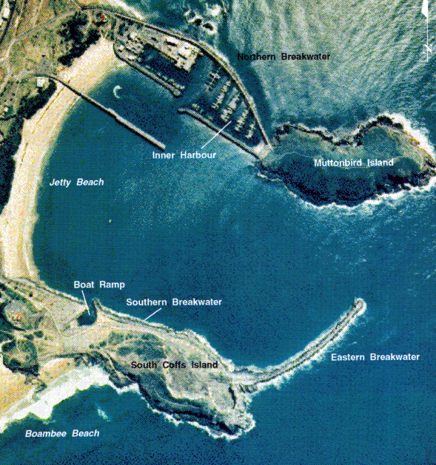

Figure 1: Current harbour layout (Walker and Carley, 1995)

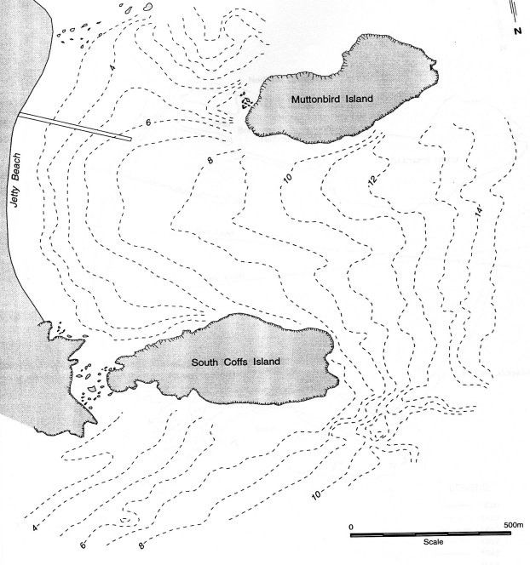
Figure 2: Layout 1890 (Lord, 1984)

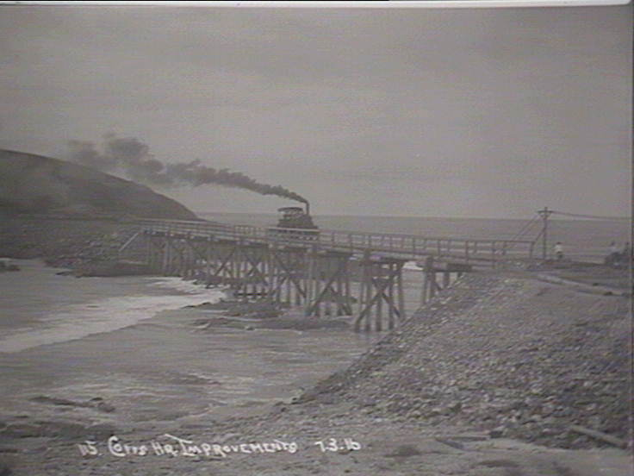

Figure 3: Transport of rock to mainland from South Coffs Island (State Library NSW)

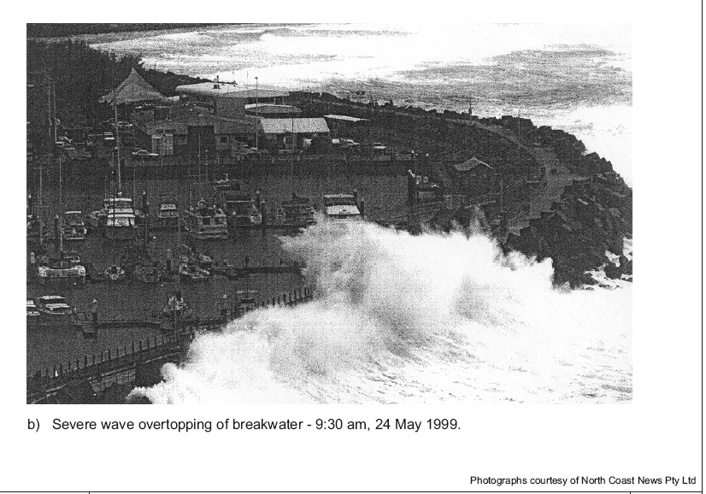
Figure 4: Wave overtopping of northern breakwater (North Coast News)

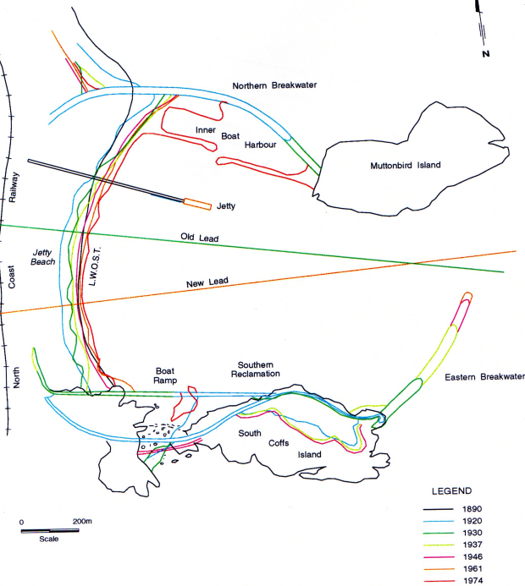

Figure 5: History of harbour development (Lord, 1984; Walker and Carley, 1995)

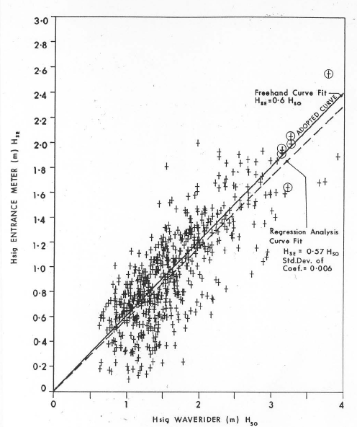
Figure 6: Wave conditions at entrance (PWD, 1987)

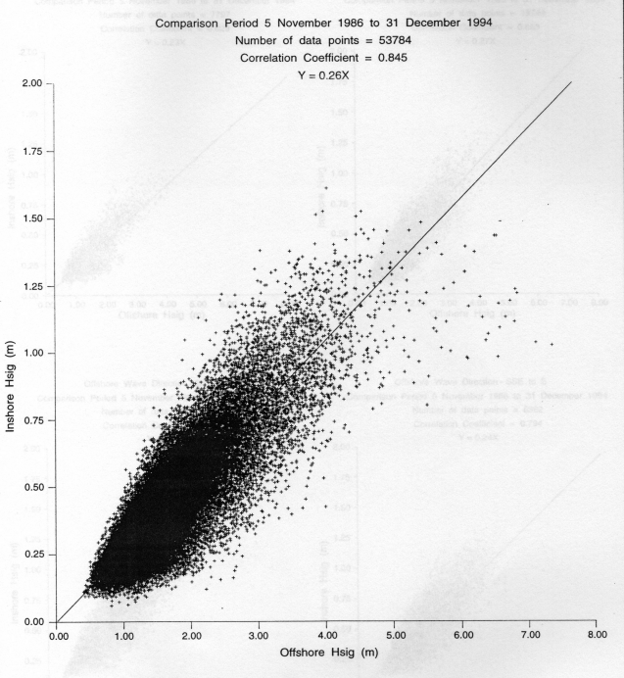

Figure 7: Zwartz pole wave data near jetty (Walker and Carley, 1995)

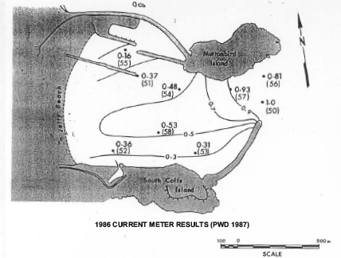

Figure 8: Current meter locations (PWD, 1987)

Figure 9: Wave height decay due to breaking (Carley et al, 2005)

Figure 10: Sand transport pathways (Carley et al, 2005)

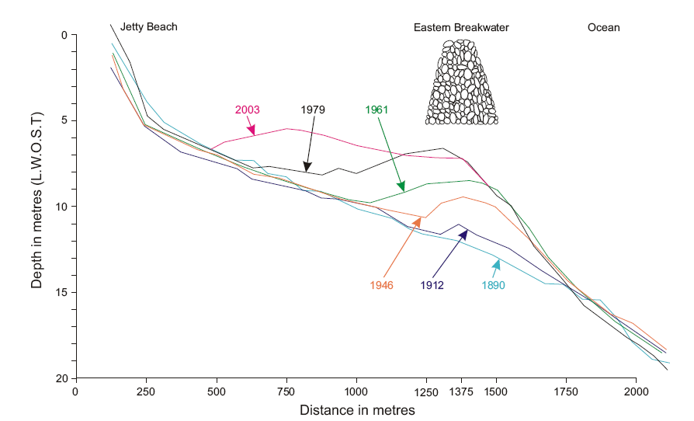

Figure 11: Section of growth in harbour shoal (Carley et al, 2005)

