CZM APPLICATIONS OF ARGUS COASTAL IMAGING IN EASTERN AUSTRALIA

Ian L. Turner and Douglas J. Anderson

Water Research Laboratory
School of Civil and Environmental Engineering, University of New South Wales
King Street, Manly Vale, Sydney NSW 2093, Australia
ian.turner@unsw.edu.au ph.02-99494488 (ext. 229)

Abstract
The last five years has seen the rapid advancement of new image analysis methods specifically targeted to support and enhance coastal management practice. In parallel to these developments, greater attention has been given to the use of the internet to build more manager-oriented information delivery systems. This paper draws upon experience from eastern Australia using a network of Argus coastal imaging sites, to illustrate and discuss the suite of image derived CZM ‘products’ that is now available to the coastal manager. Both qualitative and quantitative information is routinely delivered via the internet, ranging from hourly images of the monitoring site to weekly summaries of shoreline variability and longer-term beach width trends. All monitoring program results and data summaries are accessed via a world-wide-web interface, providing ‘real-time’ delivery direct to the managers’ desktop computer.

Introduction

Coastal researchers are increasingly turning to remote sensing methods to observe and quantify beach and nearshore change, across spatial-scales ranging from centimetres to kilometres and time-scales ranging from seconds to years. In particular, since the early 1990’s nearshore research originating from Oregon State University’s Coastal Imaging Laboratory has focused on the development of the low-cost Argus coastal imaging system (Holman et al., 1993; Aarninkhof and Holman, 1999). Supported by a growing number of international user groups, increasingly sophisticated image-based analysis techniques are being developed to observe and quantify a broad range of nearshore hydrodynamic and morphological processes.

The deployment of a network of automated, video-based monitoring stations was originally conceived of primarily as a research tool. More recently, the application of coastal imaging technology to a growing range of coastal zone management (CZM) applications has been recognised (Turner et al., 2004; Wijnberg et al., 2005; Turner et al., 2006). The temporal and spatial coverage provided by video-based coastal imaging systems are proving to be of particular value to coastal management applications along engineered coastlines.

The last five years has seen the rapid development of new image analysis tools specifically targeted to support and enhance coastal management practice. In parallel to these developments, greater attention has been given to the use of this technology to build more manager-oriented information delivery systems. Rather than the traditional reliance upon paper-based reporting (that is limited by definition to the description of retrospective coastal behaviour), the objective of this research has been to provide coastal managers with a range of tools and regularly-updated information that summarise and quantify the present coastal conditions, within the context of past observations.

In Australia, a nation whose population and industry are very much clustered around the coastline, the rapid growth of CZM projects supported by coastal imaging-based monitoring systems is in large part due to the relatively early acceptance by state and local governments of these new capabilities (Turner et al., 2006). To date, coastal imaging is being utlised at four Australian sites by local government authorities in Queensland and New South Wales, and at a further four sites through joint cooperation between the Queensland and New South Wales State governments (Figure 1). These eight sites compliment around 40 other Argus sites presently operating in Europe and the USA. This paper provides a description of the various components that together comprise the web-based and real-time beach management system currently deployed in Australia. This is followed by illustration and discussion of the core information and analyses that together comprise the suite of image-derived CZM ‘products’ that is now available to the coastal manager.

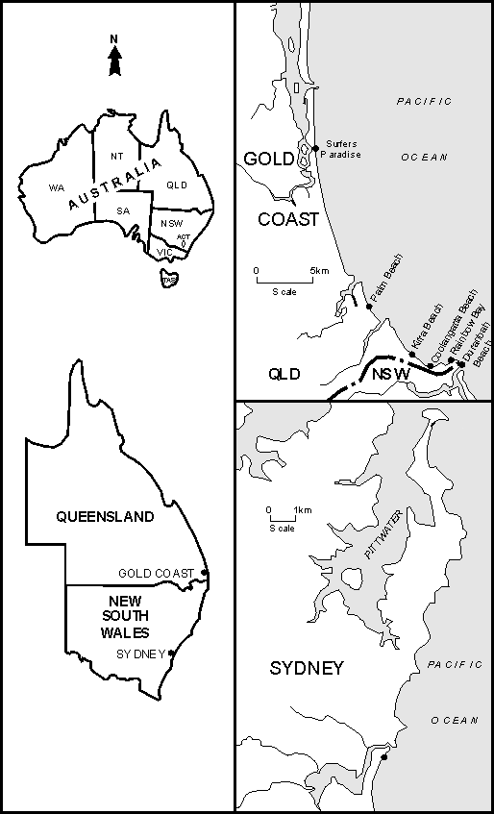

Figure 1: There are currently eight coastal imaging stations located along the south-east coast of Australia where ‘real-time’ beach monitoring and management functions are being routinely performed. CZM applications include the monitoring of beach protection works (Surfers Paradise and Palm Beach), operational management of a river entrance sand bypassing system (Duranbah, Rainbow, Coolangatta and Kirra Beaches), estuary entrance management (Narrabeen Lagoon) and monitoring of a coastal erosion ‘hot spot’ (Narrabeen Beach). (adapted from Turner et al., 2006).

Operation of Beach Management System

The beach management system described herein consists of a data acquisition system, a data archiving and assimilation system, an image pre-processing and shoreline detection system, a data development and summation system, and a web interface. Together, these systems collect, analyse and summarise a variety of core 'coastal state indicators' (Van Koningsveld et al., 2005). To the end-user coastal manager, the data acquisition, archiving, assimilation, image pre-processing, shoreline detection and data development tasks are transparent. A world-wide-web browser interface provides access to all monitoring program information and analyses in 'real-time' from any web-enabled PC. The degree of public access to this information is determined on a project-by-project basis at the discretion of coastal managers, with a secure login provided to the full suite of results, where required.

Data Acquisition, Archiving and Assimilation Systems

The acquisition of image data utilises the Argus coastal imaging system. From the coastal managers’ perspective, ‘coastal imaging' simply refers to the automated collection, analysis and storage of pictures, that are subsequently processed and analysed to observe and quantify coastline variability and change. At the core of this approach is the ability to extract quantitative data from a time-series of high quality digital images. In contrast, conventional 'surfcams' are more limited to applications where a series of pictures of the coastline is sufficient, and no quantitative information is required.

A schematic of a typical Argus station is shown in Figure 2. The key component is one or more cameras pointed obliquely along the coastline. The camera(s) are connected to a small image processing computer, which controls the automated capture of images, the initial pre-processing of images, and the transfer of images via the internet from the remote site to the laboratory.

Figure 2: Schematic of a typical five-camera ARGUS (version II) coastal imaging system of the type presently in use at all the Australian sites described herein.

The three basic image types of hourly snap-shot (snap), time-exposure (timex) and variance pictures underpin the great majority of present CZM applications. Snap images provide simple documentation of the general characteristics of the management site, but are not so useful for obtaining quantitative information. Timex images, created by the 'averaging' of 600 individual snap-shot images collected at the rate of one picture every second for a period of 10 minutes, are much more useful. Time exposures of the shorebreak and nearshore wave field provide a quantitative 'map' of the underlying beach morphology, by averaging out the natural variations of breaking waves to reveal smooth areas of white, which has been shown to provide an excellent indicator of the shoreline and nearshore bars (Lippman and Holman, 1990; Van Enckevort et al., 2004). The variance image displays the corresponding variance of light intensity during the same 10 minute time period, and can be useful to define a ‘waterline’ feature where the ambient sand colour closely matches the colour of wave foam at the shore.

At the laboratory, all images are automatically assimilated into a readily accessed and searchable database, along with concurrent wave and tide data obtained from third-party sources. This host workstation also serves as a world-wide-web server. Images are available to view and download via the web within minutes of their capture.

Image Pre-Processing and Shoreline Detection Systems

Once the hourly oblique images (snap, timex and variance) are archived in the database, merge-rectification software combines multiple camera views from a single site, to produce and archive panoramic and plan-view images of the beach (Figure 3). Fundamental to the use of image data to CZM applications is the ability to interconvert between image coordinates (i.e., individual pixels) and real-world ground coordinates. For any particular object located by its three-dimensional (3-D) ground coordinates, the associated two-dimensional (2-D) image location can be found uniquely using one of several transformation algorithms. The opposite process, the determination of the 3-D ground location of a 2-D image feature, is undetermined in a mathematical sense, and further information is needed. A common photogrammetric solution is to use stereo techniques, requiring multiple cameras focussed on the same point of interest from two or more different locations.

Conveniently, one camera station only is required per site for the special case of coastal imaging. At the open coast waves can be assumed to propagate across a horizontal plane, the elevation determined by a local tide gauge. The geometry of open coast images is therefore naturally constrained. Following the careful calibration of the individual camera/lens systems prior to installation and the one-off surveying of a limited number of ground control points within the image field of view, a unique set of mathematical equations (Holland et al, 1997) are used along with the concurrent tide measurements to convert between image coordinates and real-world position within the coastal study area.

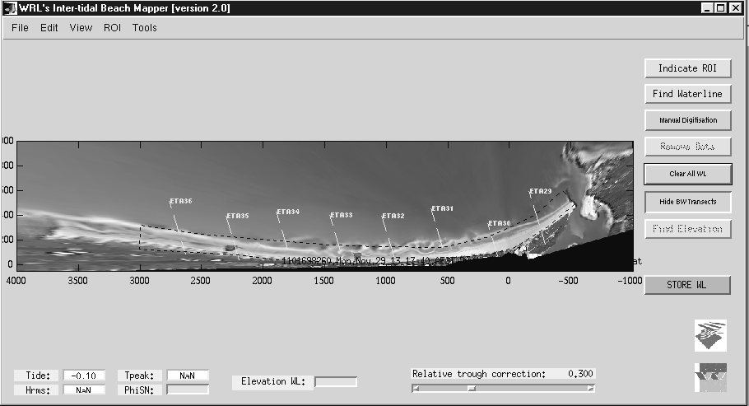
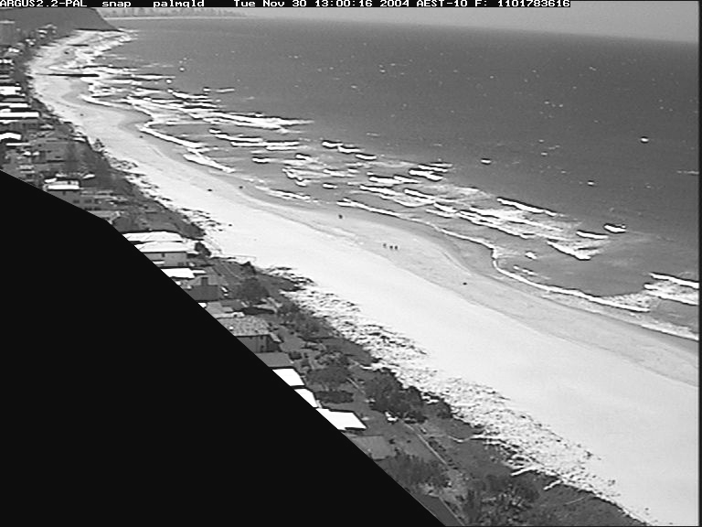
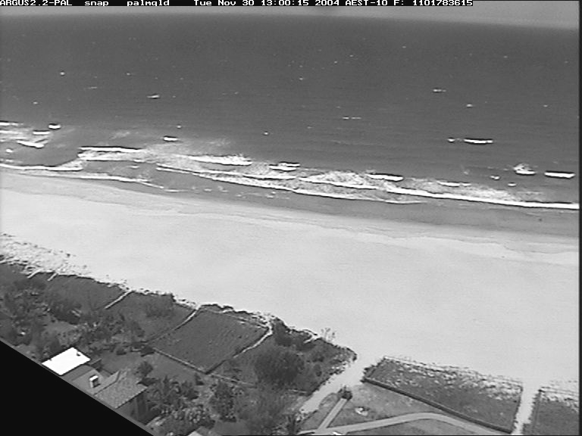
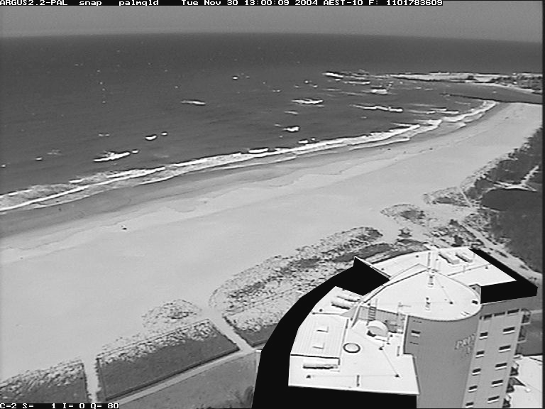
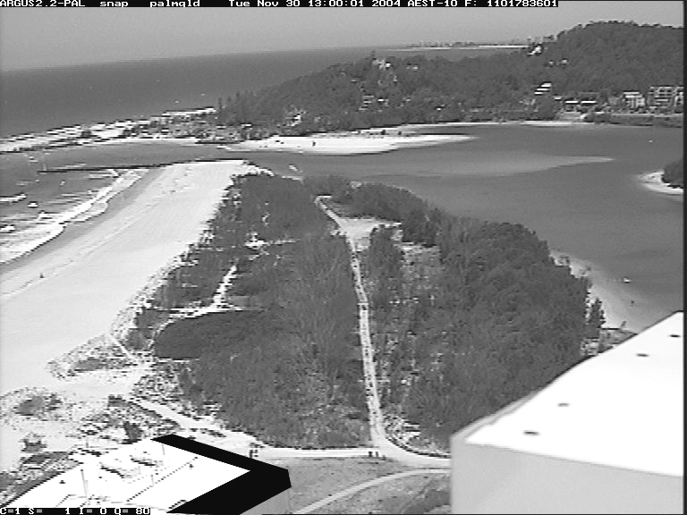
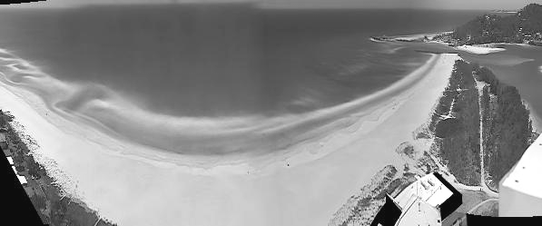
All the above pre-processing of images is fully automated. On a weekly basis, an operator maps the position of the waterline using sophisticated image analysis techniques (manually, or in an automated batch mode) and stores this information in a database. The range of methods that have been developed to identify and map the shoreline from time-series maps, aerial photography and digital images were recently reviewed in Boak and Turner (2005). There are several specific techniques available to map the changing configuration of the foreshore using Argus images, and to convert this to a weekly shoreline position (Plant et al., in press). In Australia, the Pixel Intensity Clustering or ‘PIC” method (Aarninkhof et al., 2003) has been adopted at all monitoring sites, due to its ability to objectively identify waterline features under a wide range of conditions. Briefly, the technique delineates a waterline feature from 10-minute time exposure images, on the basis of distinctive image intensity characteristics in pixels, sampled across the sub-aqueous and sub-aerial beach. Raw image intensities in Red-Green-Blue (RGB) colour-space are converted to Hue-Saturation-Value (HSV) colour space, to separate colour (Hue, Saturation) and gray scale (Value) information. The HSV intensities are filtered to remove outliers and scaled between 0 and 1, to improve the contrast between two clusters of ‘dry’ and ‘wet’ pixels. Iterative low-passing filtering of the spiky histogram of scaled intensity data yields a smooth histogram with two well-pronounced peaks, which in turn defines a discriminator to enable the mapping of the 10-minue time-averaged waterline. The computer interface that is used within the laboratory to map successive waterline features is shown in Figure 3. Concurrent tide and wave information (used to calculate setup and runup) is integrated with this waterline analysis, to model the corresponding elevation of the mapped waterline. In this manner, a growing archive of three-dimensional shoreline features is obtained.

Figure 3: Merging of images obtained by multiple cameras is used to obtain a panoramic view of the entire coastal embayment (upper image). Rectification of this merged image to real-world coordinates permits the resulting plan-view image to be processed using sophisticated image analysis techniques to determine the instantaneous shoreline position alongshore (lower image). The lower image also shows the user interface to the software tool that is used in the laboratory to map weekly shorelines. The monitoring site illustrated is the 3.5km Palm Beach embayment in QLD, that was nourished during 2005 – 2006 by the nearshore placement of 350,000 cubic metres of sand.

Data Development and Summation System

The processes described above generate approximately half a gigabyte of data per monitoring site each month. Key data includes:
- hourly snap, timex, and variance images,
- merged and rectified plan-view images (at low-tide, mid-tide, and high-tide), and
- a database of weekly shoreline positions.

In its raw form, this large and growing volume of information is of limited practical use to coastal managers. The objective of the critical data development and summation component of the beach monitoring system is to summarise this available information into a variety of succinct CZM ‘products’ that can be used directly by managers for both retrospective impact assessment and ‘real-time’ operational decision-making.

Working with coastal managers across a range of monitoring sites, automated post-processing software has been developed to summarise the image-derived information. The objective of the data development and summation system is to produce practical CZM information of the type and format that is both accessible and immediately applicable to the coastal managers’ site-specific needs. The range of data summary ‘products’ made routinely available by this system are detailed in the following section.

World Wide Web Interface

The beach monitoring system is accessed by coastal managers via an easy to use web site. This intuitive interface provides a 'real-time' portal to all the current and historical raw and analysed data. By this on-line approach to data delivery, project managers have direct access to all the qualitative and quantitative monitoring program results via their own desktop computer.

On-Line Access to ‘Real-Time’ CZM Monitoring Information

Until around 2003 coastal imaging systems installed at coastal management sites in Australia, Europe and the USA typically provided 'real-time' access only to the raw image information via the world-wide-web. Quantitative information on beach conditions was developed manually and subsequently provided to project managers via paper-based reporting. The research and development that has resulted in the advent of the on-line beach analysis system described herein represents a significant step forward for coastal monitoring, engineering and management. The range of information that is currently available via the web site for all the Australia sites (www.wrl.unsw.edu.au/coastalimaging) are described below.

Hourly images (including zoom tool)

Every hour the web-site is updated with the latest snap-shot, time-exposure and variance images. These images can be viewed to provide an immediate first-pass (qualitative) assessment of beach conditions, and a ‘zoom tool’ function enables more detailed examination of a particular region or feature of interest.

Image archive

All hourly images are archived within a database structure that facilitates searching and viewing of images via a standard web browser interface as shown in Figure 4. Coastal Managers have complete access to this archive, enabling the qualitative comparison of trends and changes in beach conditions.

Plan-view images

Every day the beach monitoring system identifies the times of low-tide, high-tide and mid-tide. Once the hourly images are indexed in the image archive, the system generates plan-view images of the beaches that are then available for viewing and download. These rectified images facilitate more rigorous qualitative assessment of the present beach and nearshore conditions. Again, small-scale features may be magnified and investigated with the on-line zoom tool function.

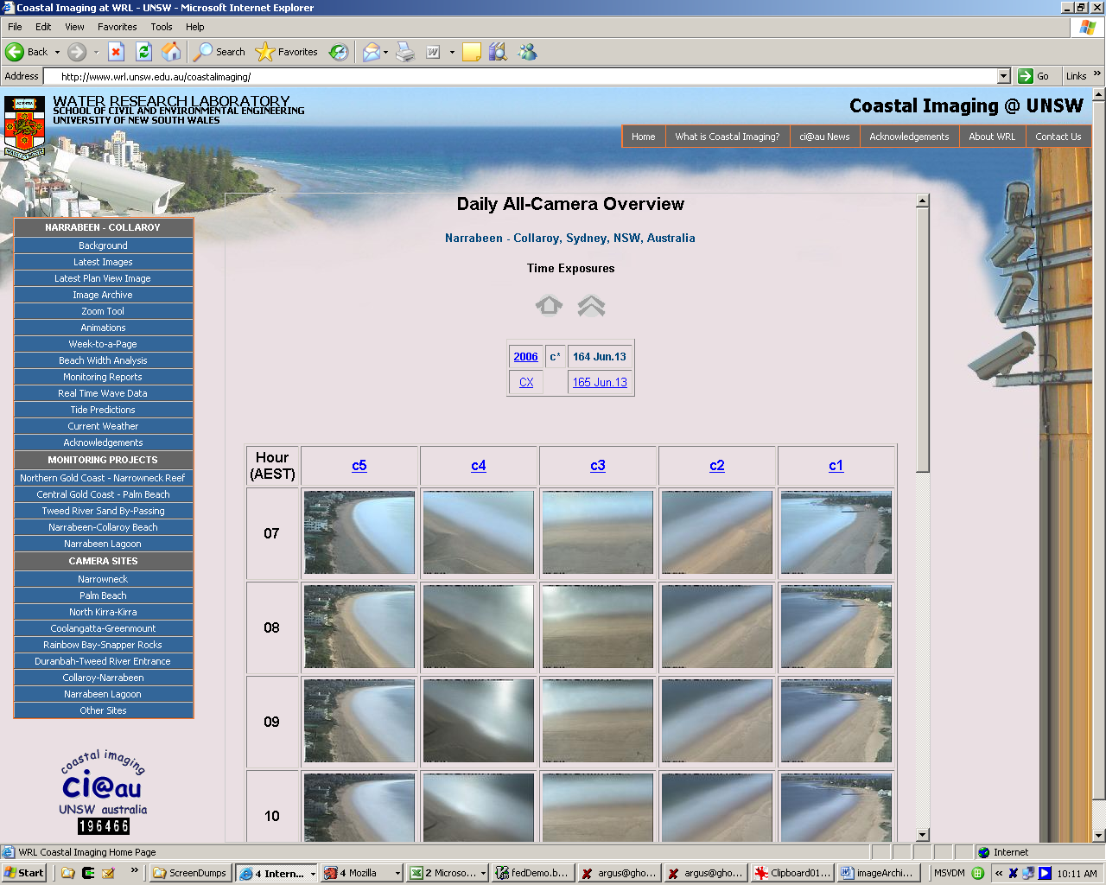

Figure 4: The on-line image archive enables quick and convenient access to the full archive of all hourly images. The monitoring site illustrated is Narrabeen Beach in NSW, the site of a coastal erosion ‘hot spot’

‘Week-to-a-page’

Each week (typically at midnight every Sunday) the beach monitoring system automatically compiles daily mid-tide plan-view images for the preceding week in to a compact ‘week-to-a-page’ figure, as illustrated in Figure 5. The purpose of this one-page weekly summary is to provide the coastal manager a means of quickly and efficiently interpreting the daily changes in beach morphology and nearshore conditions, without continual recourse to the hourly images. An archive of previous ‘week-to-a-page’ image data summaries can also be easily viewed (and downloaded as required) for the purpose of longer-term qualitative assessment. This, and all other summary data products downloadable from the project web site, is preformatted to a standard page size, to facilitate the ready inclusion of this information within any external reporting that may be required.

‘Beach-width-analysis’

Each week the mid-tide plan-view images are processed (manually, or in an automated batch mode) to map the present shoreline position along a pre-defined region or regions of interest. This information is then automatically analysed along with previous shoreline data to generate a single ‘beach-width-analysis’ figure (Figure 6), summarising: The shoreline alignment for that week, superimposed on a current plan-view image of the beach; Shoreline variability and trends, by comparing the current shoreline position to previous shorelines (last week, last month, last year) and an optional reference shoreline, often corresponding to a target beachfront alignment or threshold shoreline position; and beach width variability and trends throughout the total monitoring history, at pre-defined cross-shore control lines selected on a project-by-project basis, to meet the specific requirements of the local coastal managers.

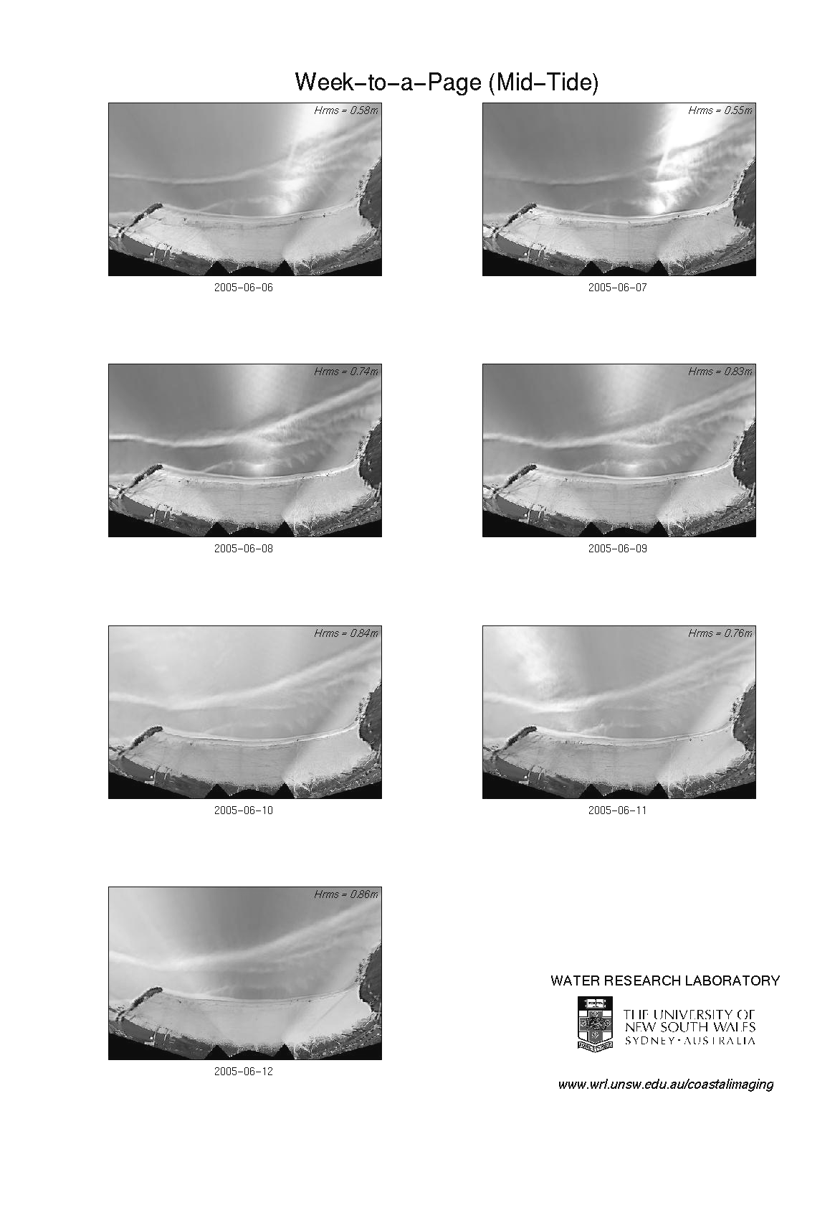

Figure 5: ‘Week-to-a-page’ data summary – provides the coastal manager a means of quickly and efficiently interpreting the daily changes in beach morphology and nearshore conditions. The site illustrated is Coolangatta Beach in QLD, one of the down-drift beaches impacted by the operation of a permanent sand bypassing system at the nearby entrance to the Tweed River.

In addition to these data being made available each week via a single ‘beach-width-analysis’ summary figure, the raw weekly shoreline and time-series beach width datasets are also archived and accessible via the project web site. Via a secure login that is provided to the coastal managers and other authorised stakeholders, these data are updated each week ready for download as ascii spreadsheet files.

Beach change animations

The creation of a time-lapse video of daily mid-tide images provides a particularly intuitive tool to identify dominant and more subtle longer-term beach trends. The beach management system provides access to beach change animations in two forms. At the end of each month, an animation is automatically created from the daily mid-tide plan-view images for that month, and linked to the web site for immediate viewing and/or download. In addition, an on-line animation tool is available to coastal managers via a secure login area of the web site, that enables animation parameters such as start and end dates, tidal stage, image type and frame-rate, to be customised. Once selected, the central host computer undertakes the necessary processing to create the required animation, and the user is then automatically emailed an acknowledgement and link to the newly-created animation. The creation of custom animations is computer processor intensive, necessitating the restriction of this functionality to a more limited number of authorised users.

‘Special’ images

The final CZM ‘product’ that is routinely and automatically created by the beach management system is special images created on a project-by-project basis, to address location-specific requirements. A present example of this type of image is a close-up (higher resolution but limited field of view) in the region of an historic shipwreck in the intertidal zone at one of the monitoring sites, that is episodically exposed and covered by the onshore-offshore movement of sand. Other examples include images of the beach in the immediate vicinity of a temporary sand outlet point for sandy by-passing operations, and at another site the area surrounding a beach outlet of a major storm drain is captured.

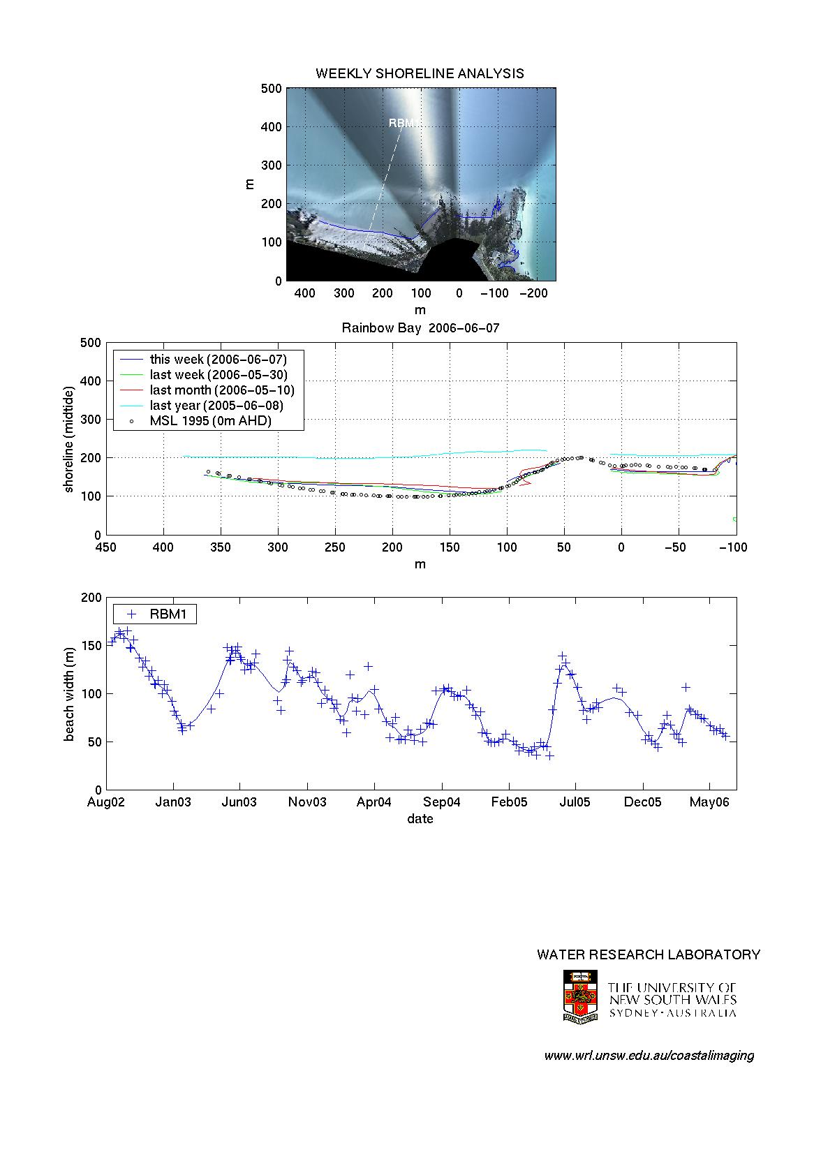

Figure 6: ‘Beach-width-analysis’ data summary – provides quantitative analysis of present and past shoreline movement and trends. The upper panel shows the present shoreline alignment, superimposed on a current plan-view image of the beach. The middle panel contrasts the present shoreline to previous shorelines, while the lower panel shows time-series of beach width at one or more selected cross-shore transects. The site illustrated is Rainbow Beach in QLD, located immediately adjacent to the main sand outlet from the Tweed River entrance sand bypassing system.

Discussion

In addition to the online delivery of image-derived data as describe and illustrated in the preceeding section, other data products are available via the beach management system, though currently not provided on-line. A relatively recent addition to the CZM products now being used across all the Australian sites is the completion of regular (monthly) ‘virtual surveys’. In short, further processing of waterline information enables a three-dimensional surface to be extracted from the two-dimensional images. Briefly, the waterline is mapped every hour through a spring tide cycle. The elevation corresponding to the detected waterlines is calculated on the basis of concurrent tide and wave information, which is incorporated in a model that combines the effects of wave setup and swash, at both incident and infragravity frequencies (Aarninkhof et al., 2003). As illustrated in Figure 7, if this process is repeated at all points alongshore throughout a complete tide cycle, a three-dimensional bathymetry of the beachface (extending from spring high to low tide) is obtained. Difference calculations between two bathymetry maps spanning any time interval of interest reveal the spatial distribution of net changes in beachface elevation, and even quantitative estimates of sand volume changes alongshore (Figure 7). This and other image-based analysis techniques are presently the focus of ongoing research.

Figure 7: Estimate of net change in beachface elevation and sand volume, derived from the extraction of 3-D ‘virtual’ survey information from 2-D images. The site illustrated is Palm Beach in QLD, where the impacts of recent sand nourishment to the southern region of the beach was observed and quantified.

(Van Koningsveld et al., 2003) identified the gap between knowledge-developers and knowledge-users in the fields of coastal research and coastal zone management, and further extended this work (Van Koningsveld et al., 2005) to suggest an improved ‘frame of reference’ for matching science with coastal management needs. The development of the beach management system described herein goes some way toward narrowing this traditional research-management divide. Key to the success of this system is that the range of resulting CZM ‘products’ were developed in an iterative manner by researchers in close collaboration with managers, across a diverse range of sites in Australia. These sites in 2006 include construction and post-construction monitoring at the location of an artificial (surfing) reef, several large-scale beach nourishment works, and the operation of a permanent sand-bypassing system (described in further detail in Turner et al (2006).

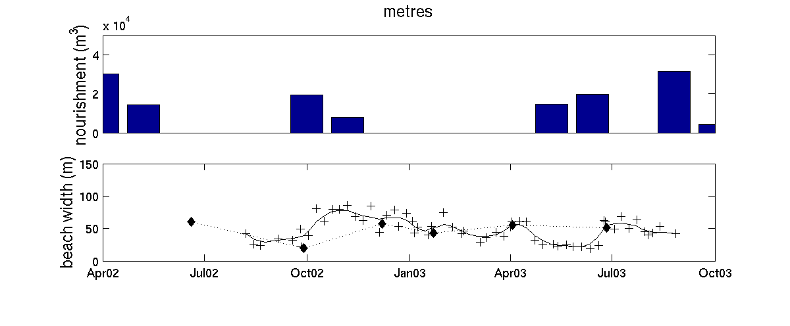
From growing experience and end-user feedback, the key capability of the beach management system is the ability to provide continuous and regularly-updated shoreline monitoring, as is succinctly illustrated in Figure 8. The upper panel shows the monthly sand delivery to this site over a 12 month period by a river entrance bypassing plant located close by, and the lower panel shows the surveyed beach response to this nourishment, based upon conventional (total station) and image-derived techniques. The imaging system first became operational at this site in August 2002 (Turner et al., 2006). The existence of quarterly survey data (for the first twelve months of the beach management system’s operation) is relatively frequent for this type of project. However, the information that is lost when compared to the weekly image-derived surveys is readily apparent. The rate of beach recovery in response to nourishment was much more rapid than the quarterly surveys suggested. Similarly, erosion-recovery cycles were entirely missed by the quarterly survey effort. For operational applications, the dependence upon imaging methods removes the risk to managers that key behaviour within the coastal system may be missed. Not every image need be the subject of routine detailed analyses. However, the coastal manager can be confident that all 'events' will be recorded and available as required (Turner et al., 2004).
Figure 8: Comparison of the results of quarterly conventional surveys (dots) and weekly image-derived beach width analysis (crosses), resulting from beach nourishment. Note that the rate of beach recovery is greatly underestimated when based upon the less frequent conventional surveys, and erosion-recovery cycles were entirely missed by the conventional survey effort. The site illustrated is Duranbah Beach in NSW, adjacent to the northern training wall of the Tweed River, and the site of temporary sandy pumping from the Tweed River entrance sand bypassing system. (Adapted from Turner et al., 2006).

Finally, while the emphasis in this paper has been to describe the role of the beach management system as it relates to coastal manager requirements, it is noted here that the project web site also provides a valuable opportunity to promote this information to a much wider range of stakeholders. By linking the monitoring web site to other locations on the world-wide-web that contain background or related information, the opportunity is provided for much wider dissemination of CZM objectives, methods and outcomes. While the Australian beach management web sites presently do not fully exploit this capability, current interest runs at more than 50,000 hits by the general public and other interested parties each year. In addition to the advantages of on-line delivery to the coastal manager, there is clearly considerable potential to greatly enhance the wider communication of project-specific CZM objectives and strategies via this same approach.

Conclusions

The application of image-based analysis techniques to specifically address CZM requirements is in its relative infancy. Based upon the experiences of the last five years, continued rapid advances can be anticipated. Increasingly sophisticated image analysis tools will become available, that in turn will assist coastal managers to identify and quantify coastal variability and trends. The true value of the internet to deliver this information direct to the managers’ desk, of the type and format that is tailored to site-specific CZM requirements, is only just beginning to be explored. Key to the continued development of this approach will be the engagement of coastal managers along with coastal researchers in the iterative design and implementation of imaging-based monitoring programs.

Acknowledgements
ILT is indebted to Stefan Aarninkhof (late of WL Delft Hydraulics), for his collaboration and support of the growth of the Australian Argus network. The authors are indebted to Professor Rob Holman of the Coastal Imaging Lab at Oregon State University for generously sharing the results of two decades of Argus-based research. The world-wide Argus-users group is a particularly stimulating collaboration of researchers, many of whom have contributed directly or indirectly to the work described herein. Funding to maintain the Australian network of Argus stations and to support research and development is provided by the Australian Research Council (Linkage Project LP0455157), NSW and QLD state governments (via the TRESBP team), Gold Coast City Council in QLD, and Warringah Council in NSW. This paper is to appear in an upcoming Special Issue of the journal Coastal Engineering.

References
Aarninkhof, SGJ and Holman, RA, 1999. Monitoring of the nearshore with video. Backscatter, 19(2), 8-11.
Aarninkhof, SGJ, Turner, I.L, Dronkers, TDT, Caljouw, M and Nipius, L, 2003. A video-based technique for mapping intertidal beach bathymetry. Coastal Engineering, 49(4), 275-289.
Boak, E.H. and Turner, I.L. 2005. The shoreline detection-definition problem: a review. Journal of Coastal Research, 21(4), 688-703.
Holland, KT, Holman, RA, Lippman, TC, Stanley, J and Plant, N, 1997. Practical use of video imagery in nearshore oceanographic field studies. IEEE Journal of Oceanic Engineering, Vol.22 (1), 81-92.
Holman, RA, Sallenger, AH, Lippmann TCD and Haines, JW, 1993. The application of video image processing to the study of nearshore processes. Oceanography, Vol.6(3), 78-85.
Lippmann, TC and Holman, RA, 1990. The spatial and temporal variability of sand bar morphology. Journal of Geophysical Research, 95(C7), 11,575-11590.
Plant, NG, Aarninkhof, SGJ, Turner, IL and Kingston, K, (in press). The performance of shoreline detection models applied to video imagery. Journal of Coastal Research.
Turner, IL, Aarnihkhof, SJD, Dronkers, TDT and McGrath, J, 2004. CZM applications of ARGUS Coastal Imaging at the Gold Coast, Australia. Journal of Coastal Research, 20(3), 739-752.
Turner, IL, Aarninkhof, SGJ and Holman, RA, 2006. Coastal imaging research and applications in Australia. Journal of Coastal Research (Special Issue - Australian Coastal Geomorphology 2004), 22(1), 37-48.
Van Enckevort, IMJ, Coco, G, Ruessink, BG, Suzuki, K, Turner, IL, Plant, NG and Holman, RA, 2004. Field observations of nearshore crescentic sandbars. Journal of Geophysical Research, 109, C06028,17p.
Van Koningsveld, M, Davidson, MA and Huntley, DA, 2005. Matching science with coastal management needs: the search for appropriate coastal state indicators. Journal of Coastal Research, 21(3), 399-411.
Van Koningsveld, M, Stive, MJF, Mulder, JPM, de Vriend, HJ, Ruessink, BG and Dunsbergen, DW, 2003. Usefulness and effectiveness of coastal research: a matter of perception? Journal of Coastal Research, 19(2), 441-461.
Wijnberg, KM, Aarninkhof, SGJ, van Koningsveld, M., Ruessink, BG and Stive, MJF, 2005. Video monitoring in support of coastal management. Proceedings, 29th International Conference on Coastal Engineering, ASCE, Lisbon Portugal, 3, 3136-3148.

