The reintroduction of saline water to estuarine wetlands in the Clarence Valley: the impact on water quality

Nicole White^{1,2}, Richard Faulkner^{1,2}, Janelle Wilkes¹ & Paul Frazier¹

¹ University of New England, Armidale, NSW 2351. www.une.edu.au,
² National Marine Science Centre, PO Box J321, Coffs Harbour, NSW 2450. www.nmsc.edu.au Email rfaulkner@nmsc.edu.au

Abstract

The nature of coastal wetlands in the lower Clarence River has been significantly changed since the installation of drains and floodgates from the early 1900s. In many cases this alteration reduced fish and bird habitats, exacerbated acid sulphate soils and mono-sulphidic black ooze, leading to problems with the water quality in wetlands and in the river. Management agencies are attempting to restore selected wetlands by re-establishing aspects of the tidal regime. The Little Broadwater is an estuarine wetland that has been the subject of a restoration trial since July 2003.The current work aims to evaluate and model the impact of tidal restoration and tidal gate manipulation on water quality in this wetland. Sampling commenced in November 2004 and statistical analysis of results established permanent sampling locations to achieve spatial and temporal representation of water quality. A systematic bi-monthly water sampling from surface and ground water is currently being undertaken (to February 2007) and analysed to facilitate the development of a water quality model capable of predicting water quality responses to various management scenarios. A large amount of data has been gathered to date, which shows considerable variation in water quality within the wetland, with broad patterns emerging. Relatively stagnant zones of the wetland exhibit salinity values with a mean of 9,600 ppm, and groundwater values between 15,000 to 20,000 ppm. Dilution by catchment runoff is also a factor. Results will be presented which include concentration and variation of salinity, pH, plus selected anions and cations, and responses to gate opening.

Keywords
Estuarine wetland, acid sulphate soils, tidal restoration, Clarence River

- Introduction

Coastal wetlands within the Clarence River Catchment (north coast of NSW) have been dramatically altered by the installation of drains and one-way floodgates since the early 1900s. In many cases this alteration reduced fish and bird habitats, exposed acid sulphate soils and produced mono-sulphidic black ooze, which led to reduced water quality in wetlands and the river. Management agencies and landholders are attempting to restore some of these wetlands by re-establishing aspects of the tidal regime. However, the effects of restoration are unknown and could potentially lead to further environmental problems.

The Little Broadwater is a large coastal floodplain wetland on the Clarence River (Figure 1 and 2) that has been the subject of a restoration trial since July 2003. It is thought that Little Broadwater was originally a tidal, fresh to brackish wetland with a mouth at least 200 m wide. Sometime between 1911 and 1927 the swamp was drained and a levee (200 – 250 m long) was built across the mouth to restrict tidal flow. A small (900 mm diameter) outlet pipe for discharge was installed at the western end of the levee in approximately the same location as the current drain (Wilkinson 2003). Later, a spillway with three one-way floodgates was installed further east along the levee to increase drainage from the wetland (Wilkinson 2003). The levee and spillway structures were replaced in the 1960s when Clarence River County Council raised the height of the levee, burying

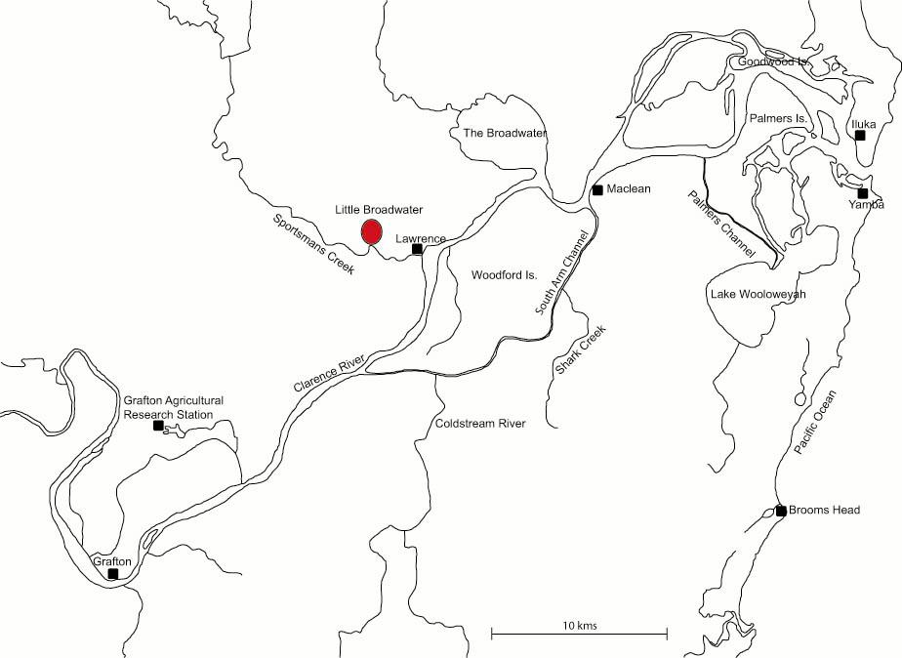
Figure 1: Location of Little Broadwater on Clarence River Floodplain, north coast of NSW.

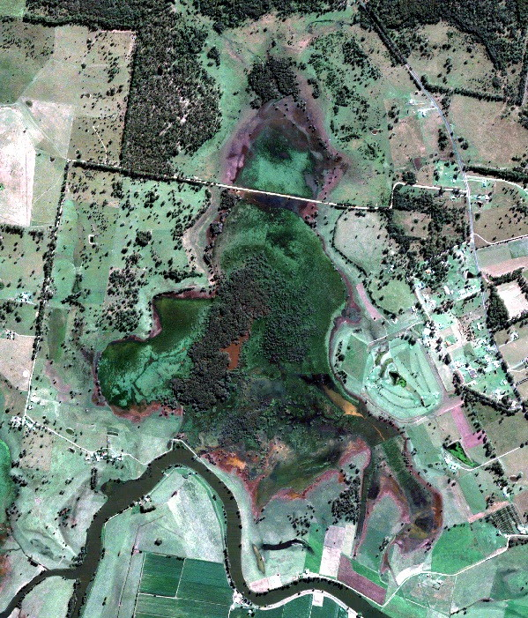
levee
drain
Figure 2: Little Broadwater, showing location of current drain and levee.
the spillway, and installed a twin-cell box culvert in the location of the small pipe (Wilkinson 2003).

Little Broadwater is an acid sulphate soil (ASS) hotspot, and drainage has led to continuous discharge of poor quality water, the appearance of large acid scalds and death of vegetation in the backswamp area. As part of the “Everlasting Swamp Acid Sulfate Soil Hot Spot Remediation Management Plan” (Wilkinson 2003), Clarence Valley Council, NSW Department of Primary Industries and landholders decided to rehabilitate Little Broadwater through limited tidal exchange. The aims were to improve discharge water quality, fish habitat, vegetation, and pasture. In March 2002 a Greenspan data logger was installed in the drain, measuring pH, electrical conductivity (EC), temperature, oxidation-reduction potential (ORP), depth, and discharge on an hourly basis. In July 2003, two 1 m by 1.2 m sized two-way tidal gates were installed in the floodgates (Figure 3). An in-drain water retention structure was also added to the culvert in the form of a weir with dropboards on the eastern side, and a fish-flap on the western side (Figure 3). These structures allow for limited tidal exchange at the discretion of the landowners and Clarence Valley Council.

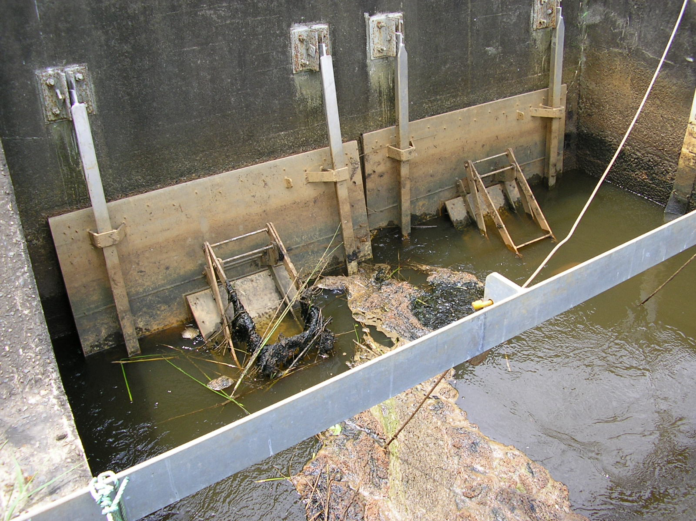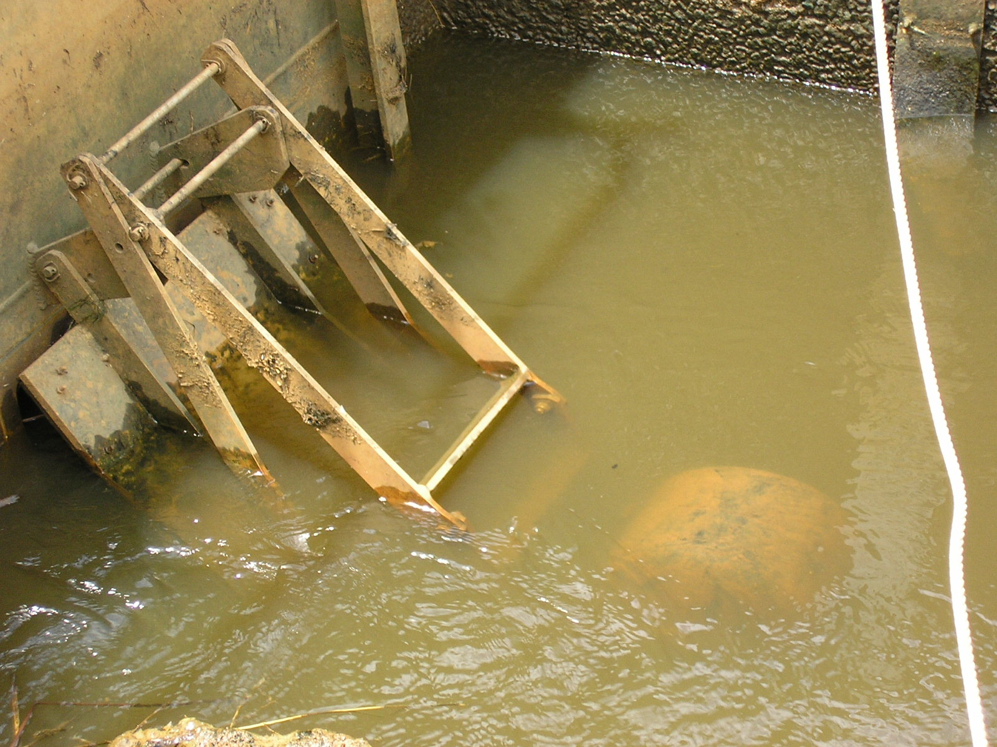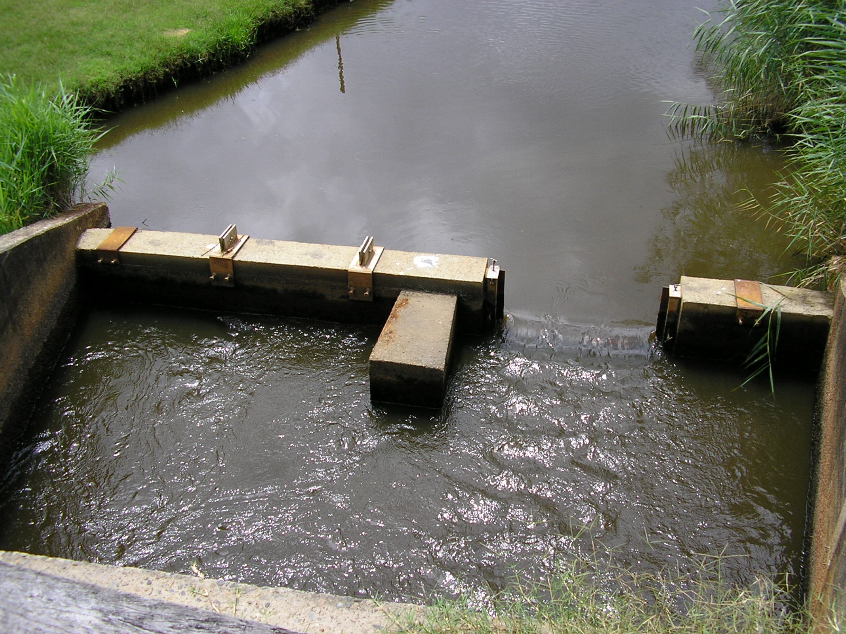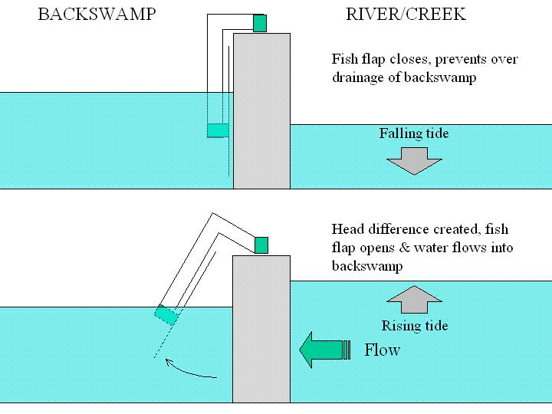
(a)
(d)
(c)
(b)
Figure 3: (a) One-way floodgates and two-way tidal gates at Little Broadwater; (b) Tidal gate and buoy; (c) Culvert on upstream side of gates, fish-flap on left and dropboard weir on right; (d) Functioning of fish-flap.

- Methods

  - Pilot Study

In November 2004 research began on water quality in the wetland, and is still continuing. The aim of the study is to evaluate and model the impact of restoring limited tidal exchange through tidal gate manipulation on water quality in Little Broadwater. A pilot study was conducted where surface water was mass-sampled in November 2004, December 2004 and February 2005 and analysed for a range of cations and anions. The primary constituents of the water were determined through principle components analysis (PCA), and then areas of differing water quality were determined with cluster plots and multi-dimensional scaling (MDS) plots. Analysis of similarity (ANOSIM) was used to determine if the areas were significantly different from each other (p < 0.05). Surface water in Little Broadwater was divided into 6 areas of significantly different water quality, as seen in Figure 4. This led to the establishment of 45 permanent surface water sampling locations, and the installation of 6 piezometer wells around the edge of the wetland (Figure 4).

  - Long-term Study

Long-term monitoring of the wetland began in April 2005, and data up to October 2006 is presented hereafter. Surface water pH, salinity, electrical conductivity, temperature, and depth were measured bi-monthly in the field at each site using a Horiba U-10, or if unavailable a TPS WP-81 handheld probe. The probes were calibrated before use with standard calibration solutions. Dissolved oxygen was measured using a Hach LDO probe.

Two surface water samples were also collected from mid-depth at each site in 125 mL acid washed polyethylene water sample bottles. The bottles and caps were rinsed three times with sample water and lowered into the water using a 1.5 m sampling pole. All air was excluded from the bottles before sealing and storing. After collection, samples were stored at 4ºC as soon as possible, and frozen within 48 hours of collection. Samples remained frozen until laboratory analysis. Soluble basic cations (Ca²⁺, Mg²⁺, Na⁺, K⁺), acidic cations (Al³⁺ and Fe²⁺) and anions (Cl⁻, SO₄²⁻) were determined bi-monthly. Water quality analysis was performed at the University of New England water laboratory in the School of Environmental Sciences and Natural Resources Management using standard methods as described below.

One sample from each site was filtered through 0.45 μm Whatman filter paper to remove particulates, and cation concentrations were determined by atomic absorption spectrometry (Varian 1979). Cl⁻ was determined by automated ferricyanide method (APHA 1992) and SO₄²⁻ by turbidimetric method (Rayment & Higginson 1992).

Continuous monitoring of the drain water in situ properties was conducted by a Greenspan Data Logger (SDL) located in the drain on the wetland (upstream) side of the dropboard weir (Figure 12). The SDL was programmed to record at one-hour intervals. A DC pump transported water samples through the flow chamber where pH, electrical conductivity (EC), dissolved oxygen (DO) and oxygen-reduction potential (ORP) were measured. Temperature, water level, velocity and flow rate sensors were located in the water body where measurements were made. The unit was solar powered, and a CDMA modem allowed data to be collected every 24 hours. Cleaning and maintenance was performed on the SDL approximately every two months by Greenspan or Clarence Valley Council Floodplain Services staff. Due to the high level of suspended solids in the water column, the DO probe did not always provide accurate measurements as the porous membrane through which oxygen permeates would clog up. The elevation of the SDL was surveyed and the water height data was corrected to elevation in m AHD.

- Results and Discussion

  - Discharge Water Quality

Long-term data from the logger in the drain shows that there is either an improvement in the pH of water discharged from the wetland during high rainfall events, or an increase in recovery time (Figure 5). At the end of February 2003 a large rainfall event (179.4 mm) led to the pH of water discharging from Little Broadwater to drop from 7 to 4, with water quality continuing to be acidic
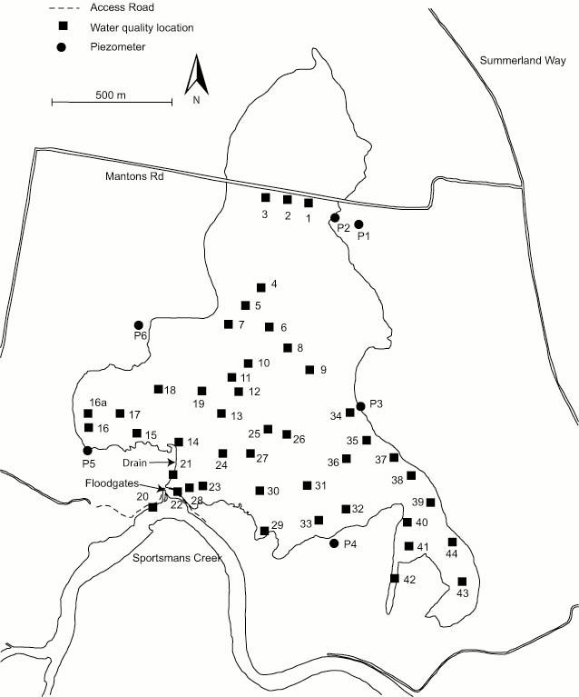
F
E
D
C
B
A
Figure 4: Surface water (1-44) and groundwater (P1-P6) monitoring sites, and areas of significantly different water quality (A-F), p < 0.05.
Figure 5: Daily mean pH of water discharged from Little Broadwater, March 2002 to January 2006.

until the end of July 2003 (5 months) when the tidal gates and dropboards were installed. In February 2004, a smaller rainfall event (66 mm) caused discharge water quality to drop from 7 to approximately 5.5, however water quality improved after two weeks. From December 2005 to the end of January 2006 discharge water quality varied between 7 and approximately 4.5. The acidity is most likely a result of oxidation of ASS in the months prior to summer rainfall beginning. This occurred because water allowed into the wetland is limited to 9,000 ppm, and over winter 2005 when salinity levels exceeded this limit, tidal exchange was restricted and parts of Little Broadwater dried out. This acid was then mobilised when the summer rainfall began. The rise and fall in pH between neutral and acidic water could be due to rainfall events being approximately a week apart, giving the system time to recover between events.

  - Wetland pH and Acidity

Surface water pH in the wetland over the monitoring period shows that on average all of the wetland except for Area A had values between 7 and 10 from Month 0 to 6 (Figure 6). Area A had an average pH of 3.5 – 5.5 from Month 0 to 4, with no surface water present in Month 6. With the start of summer rains between Month 6 and Month 8, there was a considerable drop in surface water pH throughout the swamp, except in Area A which maintained an average pH of approximately 5.5 through to Month 14. The remainder of the wetland dropped to a pH between 3 and 5 (very acidic to acidic), however Areas B and D had recovered by Month 10. Areas C, E and F remained between 2.9 and 5.7 pH until Month 18 when all areas of the wetland increased in pH. A possible explanation for the fast recovery of Areas B and D is that these locations may receive the majority of flushing, and therefore the acidic water is removed, neutralised or diluted faster than other areas in Little Broadwater. During the first two weeks of Month 17 a massive exchange event occurred via floodgate manipulation. A large amount of water was drained from the wetland, and then the swamp was filled up again with fresh water from the creek. The effect of this exchange was that surface water pH increased from an overall average of 5.4 in Month 16 to 7.7 in Month 18.

The change in acidic cation (Al³⁺ and Fe²⁺) levels in the surface water reflects the change in pH over Months 0 to 8 (Figure 7). In Area A there is a decrease in Al³⁺ and Fe²⁺ levels from Month 0 to
Figure 6: pH of surface water from Month 0 (April 2005) to Month 18 (October 2006), showing +/- 1 SE.

(a)
(c)
(b)
(d)
(e)
(f)
Figure 7: Acidic cations (Al³⁺ and Fe²⁺) from Month 0-8 (April 2005 to December 2005). (a) Area A; (b) Area B; (c) Area C; (d) Area D; (e) Area E; (f) Area F.
4, which corresponds with the increase in pH. Al³⁺ and Fe²⁺ levels then remain fairly constant to Month 8. In Areas C, E and F there is a dramatic increase in acidic cation levels, especially Fe²⁺, when the pH of surface water dropped between Months 6 and 8. These results suggest that oxidation of ASS occurred in these three areas of the wetland. In Areas B and D, however, there is not a large increase in Al³⁺ or Fe²⁺ levels with the decrease in pH. There are three possible scenarios to explain this. Firstly, there may not have been oxidation of ASS in these areas and the slight increase in levels is from mixing with surrounding waters (most likely explanation for Area D as this is only the creek, main drain and side drain which did not dry out). Secondly, oxidation may have occurred in Area B, however as mentioned earlier, preferential flushing of this area neutralised, diluted or removed the acidic cations. The third possibility is that there is a smaller area of ASS in these sections of the wetland in comparison to the other areas, and therefore less Al³⁺ and Fe²⁺ were mobilised when re-flooded.

  - Wetland Salinity

Salinity of the water in the drain has a distinct temporal trend (Figure 8), with salinity increasing over the dry winter, and decreasing once the summer rainfall begins, which may be as late in the season as February. Spatial patterns of salinity over the study period show that the southeastern corner of Little Broadwater consistently has the highest salinity (Figure 9), suggesting that this area receives little or no flushing or dilution from either tidal exchange or rainfall. The northern section of the wetland (Area A) is located at the top of the catchment and is flushed regularly during rainfall events, and as a result has the lowest salinity. Temporal change in salinity can also be seen in Figure 9. Salinity increased between Months 0 and 2, but then dropped by Month 4 due to a large, unseasonal rainfall event at the end of Month 2 and start of Month 3. Salinity levels had increased again by Month 6, and then continued to decrease to Month 12, with the average salinity over the wetland between 0 – 2,000 ppm. From Figure 9 it can also be seen that Little Broadwater was saltier from Months 0 to 6 (April to October 2005), than from Months 12 to 18 (April to October 2006). This is a result of an unseasonably wet winter in 2006.

The predominant salt in the surface water is Cl⁻, with concentrations generally averaging 4,000 mgL⁻¹ or less (Figure 10). However, in Month 6 when the highest salinity levels were recorded in the surface water, Cl⁻ concentrations in areas C and F averaged 13,000 and 11,000 mgL⁻¹ respectively. Cl⁻ concentrations have a moderate to strong correlation with the basic cations of Ca²⁺, K⁺, Mg²⁺ and Na⁺. These basic cations also have a strong correlation to each other, as seen in Figure 11. The concentrations are similar to seawater in that Na⁺ is the dominant cation, Mg²⁺ is the next dominant, and Ca²⁺ and K⁺ have the lowest concentrations in relatively equal proportions. These results suggest that the concentrations of basic cations is not related to the dissolution of estuarine clays during oxidation events, but instead have been brought into the wetland by tidal exchange. This is supported by the fact that the temporal and spatial patterns of basic cations are similar to salinity patterns in the wetland.

- Conclusion

Initial results show that there is considerable variation in water quality within the wetland. Anecdotal evidence suggests that the western and central parts of Little Broadwater receive tidal flushing via the drain, with the remainder of the wetland relying on flushing and dilution by catchment runoff. Management of tidal exchange at present is based on only allowing water into the swamp when it is less than 9,000 ppm salinity to maintain vegetation health and prevent excessive salinisation of soils. However, to prevent oxidation and acidification of soils and degradation of water quality, it may be necessary to allow water exceeding this guideline into the wetland during dry periods.

Figure 8: Daily mean salinity of water discharged from Little Broadwater, March 2002 to January 2006.

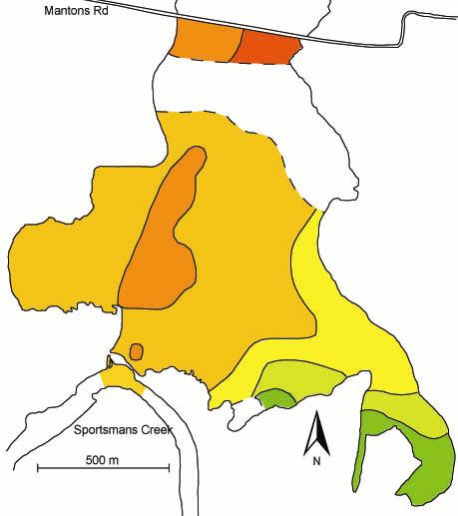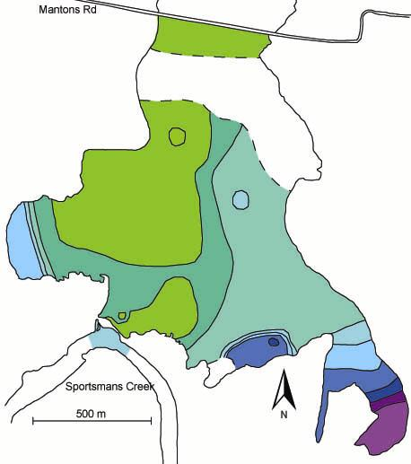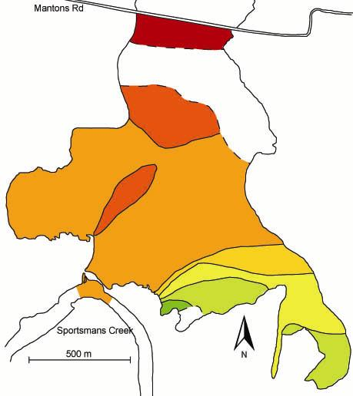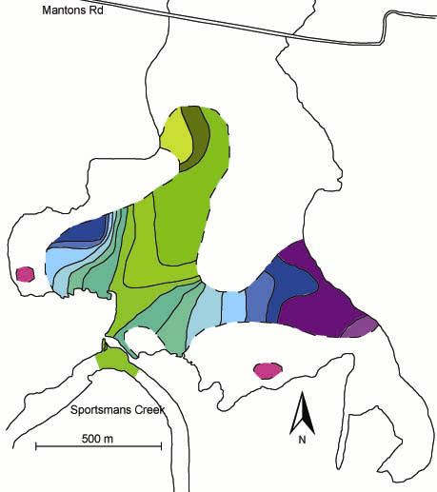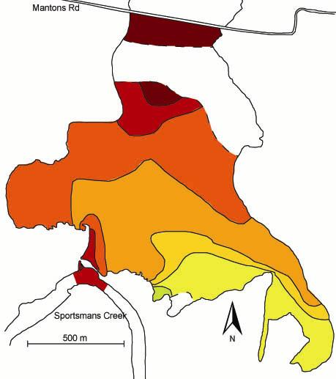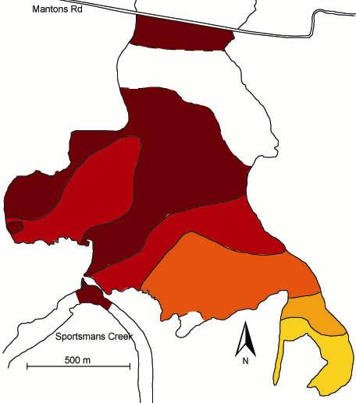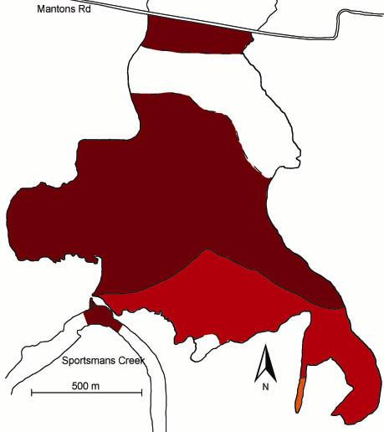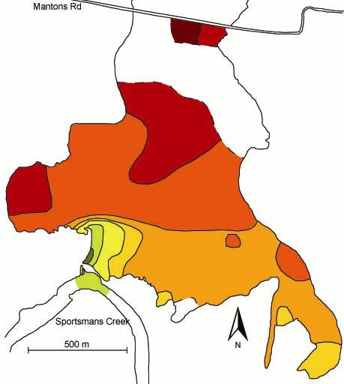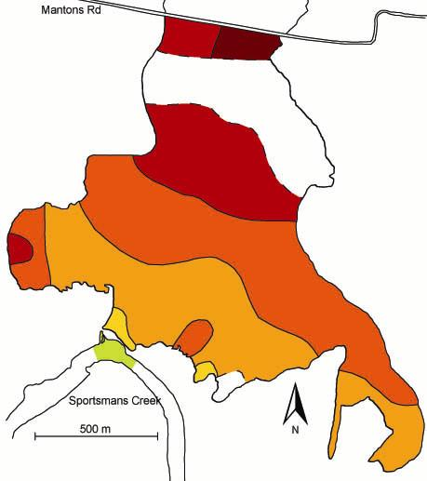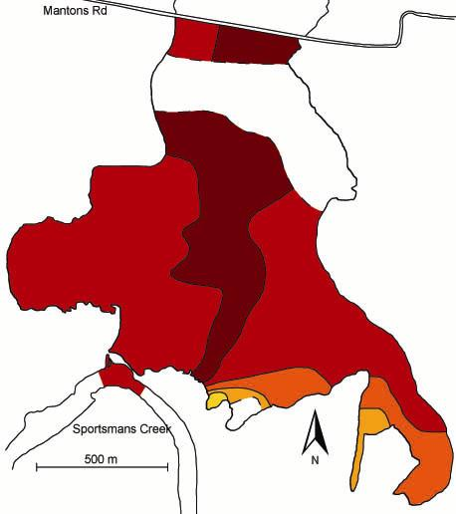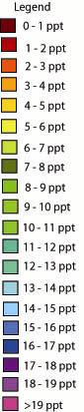
(a)
(j)
(i)
(h)
(g)
(f)
(e)
(d)
(c)
(b)
Figure 9: Salinity maps of Little Broadwater, Months 0 - 18. Legend range from 0 ppt to >19 ppt. (a) April 2005; (b) June 2005; (c) August 2005; (d) October 2005; (e) December 2005; (f) February 2006; (g) April 2006; (h) June 2006; (i) August 2006; (j) October 2006.

Figure 10: Median concentration of Cl⁻ in surface water, Months 0-8 (April 2005 to December 2005).

(a)
(c)
(b)
(d)
(e)
(f)
Figure 11: Basic cations (Ca²⁺, K⁺, Mg²⁺, Na⁺) from Month 0-8 (April 2005 to December 2005). (a) Area A; (b) Area B; (c) Area C; (d) Area D; (e) Area E; (f) Area F.
Further work on circulation patterns is anticipated to be completed over the summer of 2006/2007. Bi-monthly monitoring of surface and groundwater will be continuing until February 2007. Analysis of groundwater data is still being carried out, along with analysis of sulphates, total nitrogen and total phosphorous.

- Acknowledgements

This study was funded by NSW DPI (Fisheries), and assistance provided by Clarence Valley Council Floodplain Services, University of New England, National Marine Science Centre, and local landholders.

- References

APHA. 1992, Standard Methods for the Examination of Water and Waste Water, American Public Health Association, American Water Works Association, Water Pollution Control Federation, Washington.

Rayment, G.E. & Higginson, F.R. 1992, Australian Laboratory Handbook of Soil and Water Chemical Methods, Inkata Press, Melbourne.

Varian. 1979, Analytical Methods for Flame Spectroscopy Publication, Varian.

Wilkinson, G. 2003, Everlasting Swamp Acid Sulfate Soil Hot Spot Remediation Management Plan: Final Report: Clarence River County Council.

