Catalina Reservoir

Catalina Golf Country Club has a 27 hole golf course on 64 hectares of relict sand plain. Currently, 18.3 hectares are watered with peak daily use estimated to be 1.6ML over the summer.

The scheme commenced in the mid 1980’s, so it provides a good insight into the operational issues associated with this type of re-use. Treated effluent is stored in a 30ML reservoir and provides an average detention time (at peak irrigation times) of 19 days. The 11,000m² reservoir is located within the heart of the golf course and is part of the scenic amenity to both the golf course and adjoining residential area.

Photo 2 The reservoir

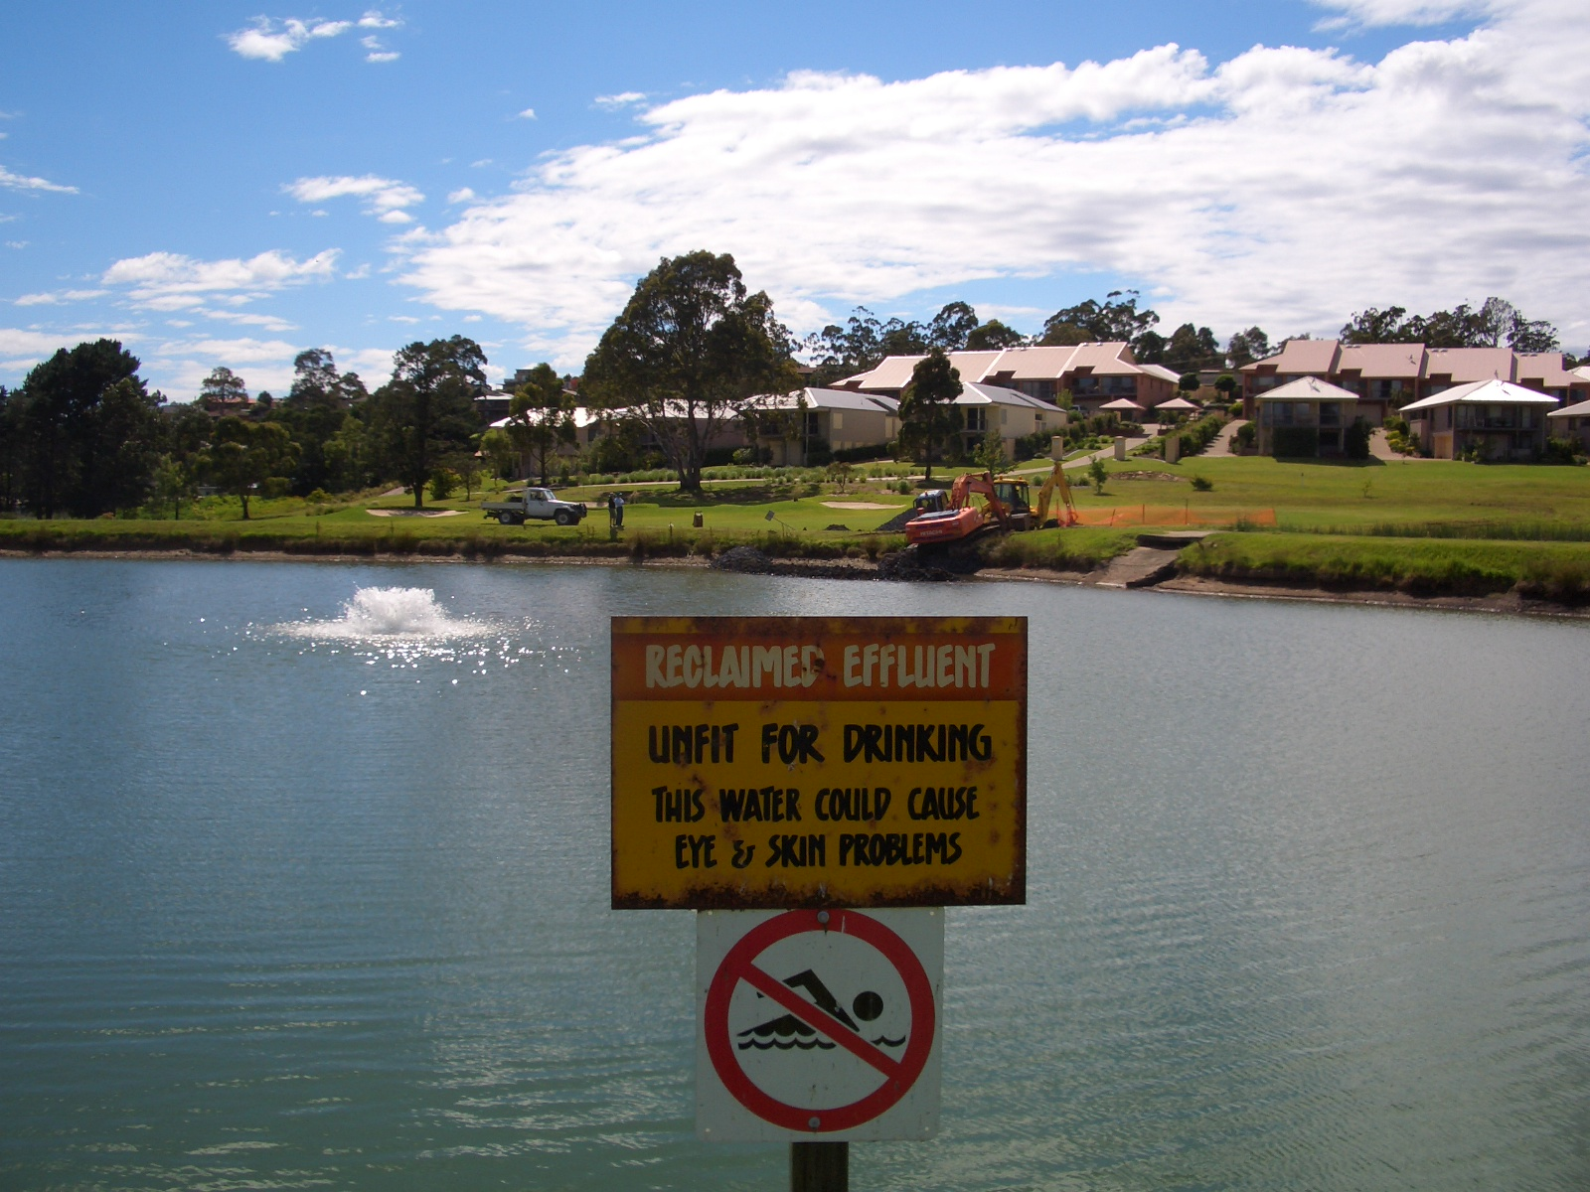

The reservoir also receives stormwater runoff from the adjoining residential area, so water level can fluctuate by 1m or more. This fluctuation may also account for the absence of any wetland species around the margins.

Photo 3 Algal bloom in reservoir

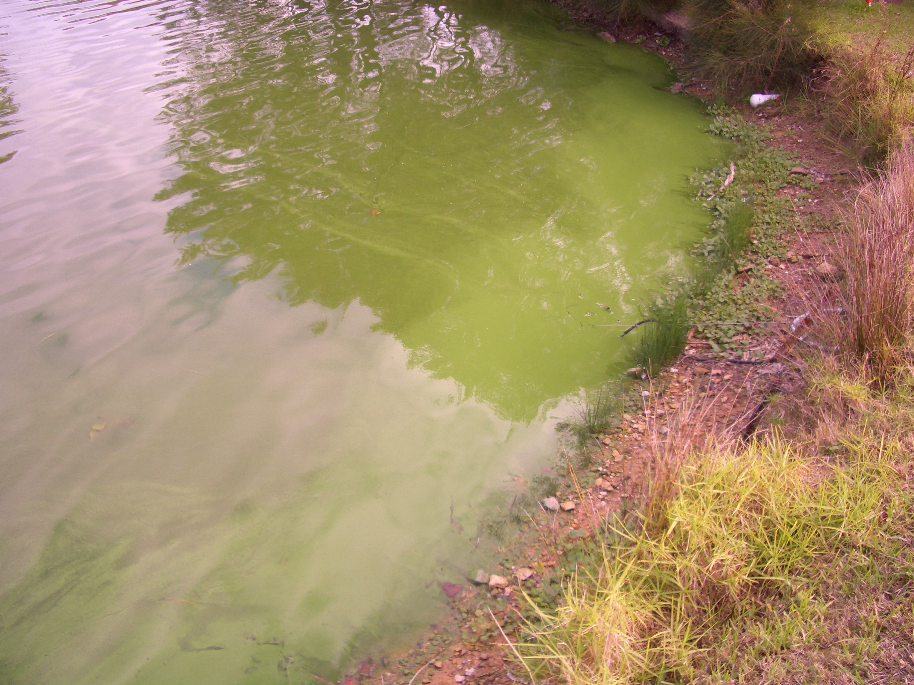

In 2003, prior to the current project, the reservoir was fitted with aeration and mixing pumps. The result has seen a change in algae types, with conditions now favoring blue green algae. As further blooms occurred over the summer after the aeration and mixing equipment was installed, an alternative method was sought to address the problem.

In 2004, Council commissioned Ecowise Environmental to undertake an algal management plan as the blocking of irrigation spray heads and pumps following summer algal blooms worsened. Data collected by the club and analysed by Ecowise provides the best estimate of baseline nutrient levels prior to the PRB or rafted reedbeds being installed for this study.

Total Nitrogen levels in the dam over the period September 2002 to August 2004 averaged 2.18mg/L. The peak value recorded in April 2003 was 4.1mg/L.

Total Phosphorus levels in the dam waters over the same period averaged 6.21 mg/L. The peak vale recorded in August 2004 was 8.2mg/L.

Considering the trigger value for TP is 0.035mg/L and TN is 1mg/L, it was apparent that significant reductions were required to reach this target and minimize the incidence of further algae.

Ecowise recommended the use of a Phoslock to bind sediments, but with an initial cost of $115,000, followed by on-going treatments that would cost a further $200,000 per annum, this was beyond the resources of the club, who would have preferred to have the input level of P from STP reduced.

As part of the current works, a permeable reactive barrier was installed in December 2005 with the aim of reducing TP by around 50%. The breakwall was constructed using 150 tonnes (100 cubic metres) of material sourced from steel works at Port Kembla. The slag provides a relatively cheap supply of lime (calcium) that is slowly released into the water when submerged. The calcium bonds with the phosphorus, and the new compound is not available for algae.

Photo 4 Breakwall under construction

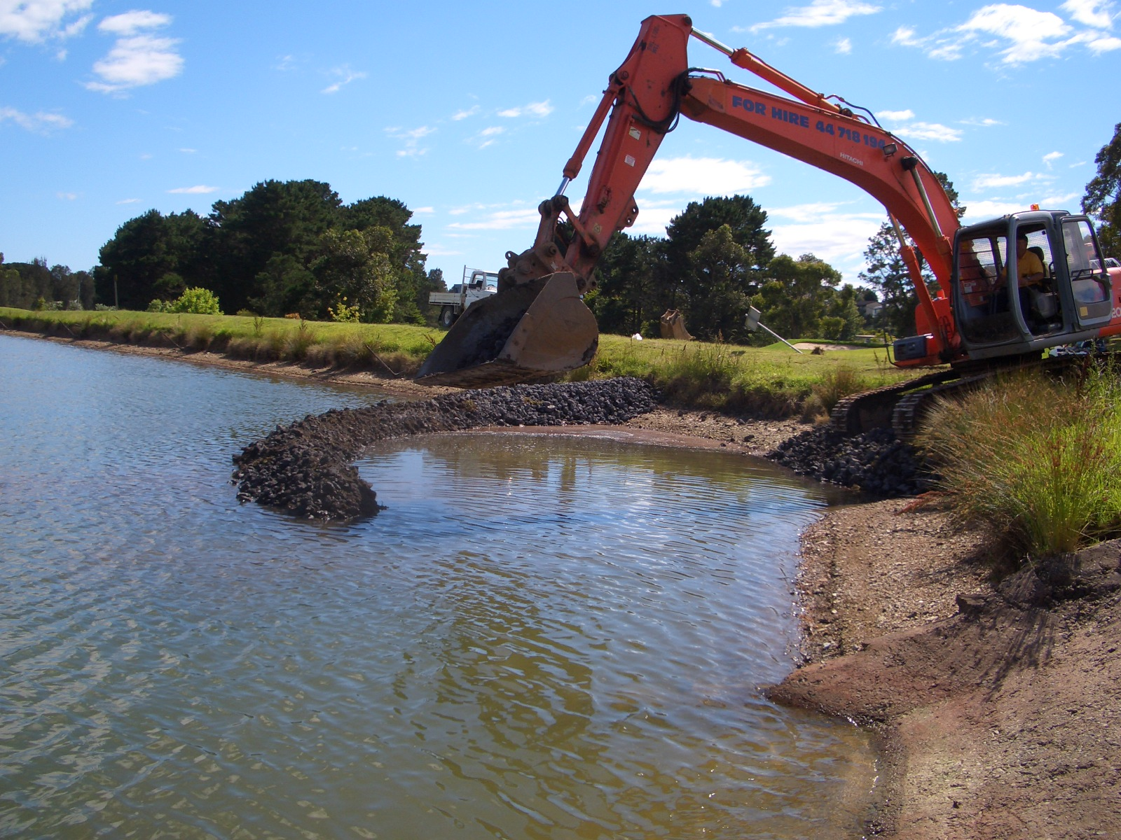

The inner core of the breakwall was constructed using 80-200mm rock, which was capped with 20-80mm rock. All incoming effluent is forced to pass through a loose wall of rock, measuring 7m wide at the base, and 3m wide at top water level, with a length of 22m.

