Figure 1 Cross-section of PRB

Photo 5 Incoming effluent

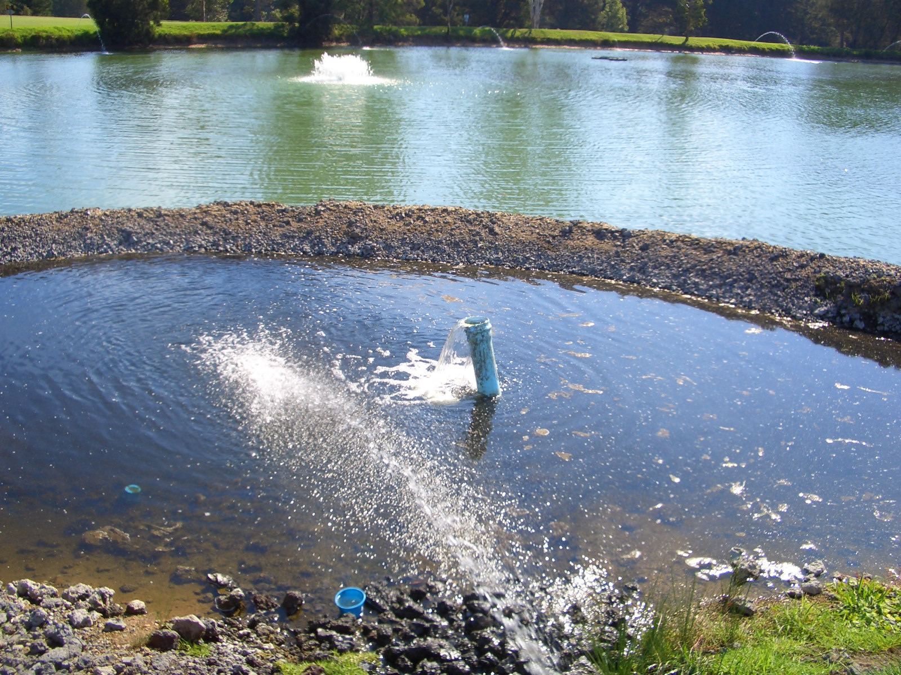

The water quality was monitored over the six months (8 samples) following the installation of the PRB. The effluent was monitored at three locations shown in Figure 2 and results are presented in Table 2.

Figure 2 Sampling points within reservoir

Table 2 Water quality results 6 months after installation of PRB

In terms of the sample points that tracked the effluent entering the reservoir, the results show a reduction in incoming TP from 10mg/L to 3.7mg/L. This new background level is significantly lower (68%) than the 6.2mg/L reported by Ecowise, Environmental between September 2002 and August 2004 (Spurway & Associates, 2005).

According to staff from Catalina Country Club, the reservoir has always had a high pH (8.5 to 9, increasing over summer). This is likely to be the due to the algae (respiration of alga elevates pH). For this reservoir, there is no substantial back ground data on pH, so any increase can not be directly linked back to the PRB. However, given the size of the water body in relation to the size of the PRB, any increase is unlikely to be significant. Furthermore, as pH is linked to the amount of algae in the reservoir, any increase caused by the PRB should be off-set by the reduction in algae.

Even though a significant reduction in TP was achieved and algal blooms were not significant in summer 05/06, it was still apparent that further algal blooms could occur while the TP and TN remained at current levels. The next step was to install the rafted reedbeds to offer a more integrated solution, rather than focusing on a target that can not be achieved without significant cost using products such as Phoslock or augmentation of the STP.

As a starting point, a 50m² raft was installed in autumn 2006. Unfortunately, this raft was severely attacked by birds over the winter of 2006. This was likely due to the lack of bird habit surrounding the reservoir. In November 2006, 6 x 50m² rafts were installed with netting to protect from birds

Photo 4 Two of six 50m² rafts installed November 2006

