THE USE OF SEDIMENT BIOGEOCHEMICAL INDICATORS IN ESTUARINE ECOSYSTEM HEALTH ASSESSMENTS: A CASE STUDY OF THE IMPACT OF THE WEST BALLINA RECLAIMED WATER FACILITY ON THE LOWER RICHMOND RIVER ESTUARY

Bradley Eyre
Centre for Coastal Biogeochemistry,
Southern Cross University
PO Box 157 Lismore, NSW 2480, Australia
www.scu.edu.au/schools/esm/ccb

ABSTRACT
To be able to effectively manage both eutrophication, and oligotrophication, of coastal systems environmental managers need criteria, to assess the current health of their ecosystems and, to define critical (sustainable) nutrient loads. Eyre and Ferguson (In press) recently developed a trophic scheme for defining critical (sustainable) carbon loading rates and possible thresholds for shallow coastal ecosystems based on the relationship between denitrification efficiency and carbon loading for 22 Australian coastal ecosystems, including coastal embayments, river-dominated estuaries, and ICOLLS. The purpose of this paper is to demonstrate the application of the Eyre and Ferguson (In press) denitrification efficiency and carbon loading trophic scheme for assessing the impact of current discharges from the West Ballina Reclaimed Water Facility (RWF) on the ecosystem health of the lower Richmond River Estuary. Nutrient and chlorophyll-a concentrations in North Creek Canal were highly elevated adjacent to the outfall, which would typically be used to indicate (i.e. comparison to guidelines etc.) the RWF was having a large impact on the health of the ecosystem. In contrast, according to the Eyre and Ferguson (In press) trophic scheme the sediment biogeochemical processes in North Creek Canal were only slightly impacted. This low impact reflects the rapid flushing of the system with little of the water column production deposited and decomposed in the sediments, and is also consistent with the water column dissolved oxygen concentrations which were similar to the Richmond River Estuary, the sediment carbon data that show only small increases adjacent to the outfall, and the macrofauna data that show no detectable impact. This case study has demonstrated that sediment biogeochemical process measurements should be included in ecological health assessments of estuarine ecosystems.

INTRODUCTION

Numerous indicators have been proposed for assessing the health of estuarine ecosystems (e.g. Ward et al., 1998; DIPNR, 2003; Scheltinga, 2004). The key components of estuarine health are the structure (populations, assemblages) and function (energy and material flow) of the system (Rapport et al., 1999). As such, the rates of ecosystem processes should be an appropriate indicator for assessing the health of estuarine ecosystems. In shallow coastal systems pelagic and benthic compartments are tightly coupled and much of the carbon production and metabolism occurs in the sediments. As such, sediments and benthic communities are probably the most sensitive part of the coastal ecosystem to stress, making them ideally suited as an indicator of change, and for defining management criteria such as critical (sustainable) carbon loading rates. Dark CO₂ effluxes (respiration) and denitrification efficiencies (DE) are the two most useful sediment biogeochemical parameters for assessing the current health of benthic systems. The dark CO₂ efflux is a measure of the amount of organic matter being decomposed in the sediments and is therefore a link to carbon production (algae) in the water column. Most importantly when organic matter is decomposed in the sediments it consumes oxygen, which can lead to hypoxia and anoxia in the overlying water column. The denitrification efficiency (DE) is the percentage of total inorganic nitrogen released from the sediments as di-nitrogen gas (N₂) ((N₂-N/(DIN+N₂-N)) x 100%) (Eyre and Ferguson, In press). Its important to maintain a high DE because nitrogen that is converted to N₂ via denitrification is permanently lost from the system, whereas nitrogen that effluxes from the sediments as dissolved inorganic nitrogen (DIN; mostly NH₄⁺) can stimulate more production in the water column. The stimulation of more water column production can in-turn lead to greater organic matter deposition and decomposition and oxygen consumption. These bottom-up changes have flow-on effects, which alter the structure of higher trophic levels such as fish and macrofauna communities (Kemp et al., 2005). Eyre and Ferguson (In press) recently developed a trophic scheme for defining critical (sustainable) carbon loading rates and possible thresholds for shallow coastal ecosystems based on the relationship between denitrification efficiency and carbon loading for 22 Australian coastal ecosystems, including coastal embayments, river-dominated estuaries, and ICOLLS. The purpose of this paper is to demonstrate the application of the Eyre and Ferguson (In press) denitrification efficiency and carbon loading trophic scheme for assessing the impact of current discharges from the West Ballina Reclaimed Water Facility (RWF) of the ecosystem health of the lower Richmond River Estuary.

METHODS

The West Ballina RWF currently discharges about 3.36 ML/ d of effluent into North Creek Canal that runs between the lower Richmond River and North Creek (Figure 1). Although the RWF is nearly 40 years old median dissolved nutrient concentrations in the effluent are reasonably low (TN=6.44 mg/L; TP=1.63 mg/ L; NH₄ = 0.81 mg/ L; NO₃ = 2.21 mg/L), but the chlorophyll-a concentrations in the effluent are quite high (260 mg/L). The assessment of the impact of current releases from the West Ballina RWF on the ecosystem health of the lower Richmond River Estuary included (1) a review of nutrient and chlorophyll-a data for the period 2001 to 2006, and dissolved oxygen data for the period 1999 to 2001 (2) sampling of sediment contamination (3) sampling of benthic respiration, productivity, nutrient fluxes and denitrification (4) sampling of macrofauna, (5) tracing of the effluent plume with stable isotopes and (6) mapping of the aerial distribution of seagrass and benthic microalgae. This paper will focus on the water quality and benthic respiration, nitrogen fluxes and denitrification components of the assessment. Details of the other parts of the assessment can be found in Eyre et al., (2007). Nutrient, chlorophyll-a and dissolved oxygen data were collected monthly adjacent to the RWF outfall, 50 m upstream and 50 m downstream and at two sites in the Richmond River and at two sites in North Creek (Figure 1). Triplicate cores for the sediment biogeochemical measurements were collected in December 2006 at five sites in North Creek Canal (adjacent to the RWF outfall, half way to the confluence, and at the confluence, of the Richmond River and North Creek), at one site in the industrial estate canal off North Creek Canal, and at one site in the Richmond River (Figure 1). Details of the sediment biogeochemical methods can be found in Eyre and Ferguson (2005).

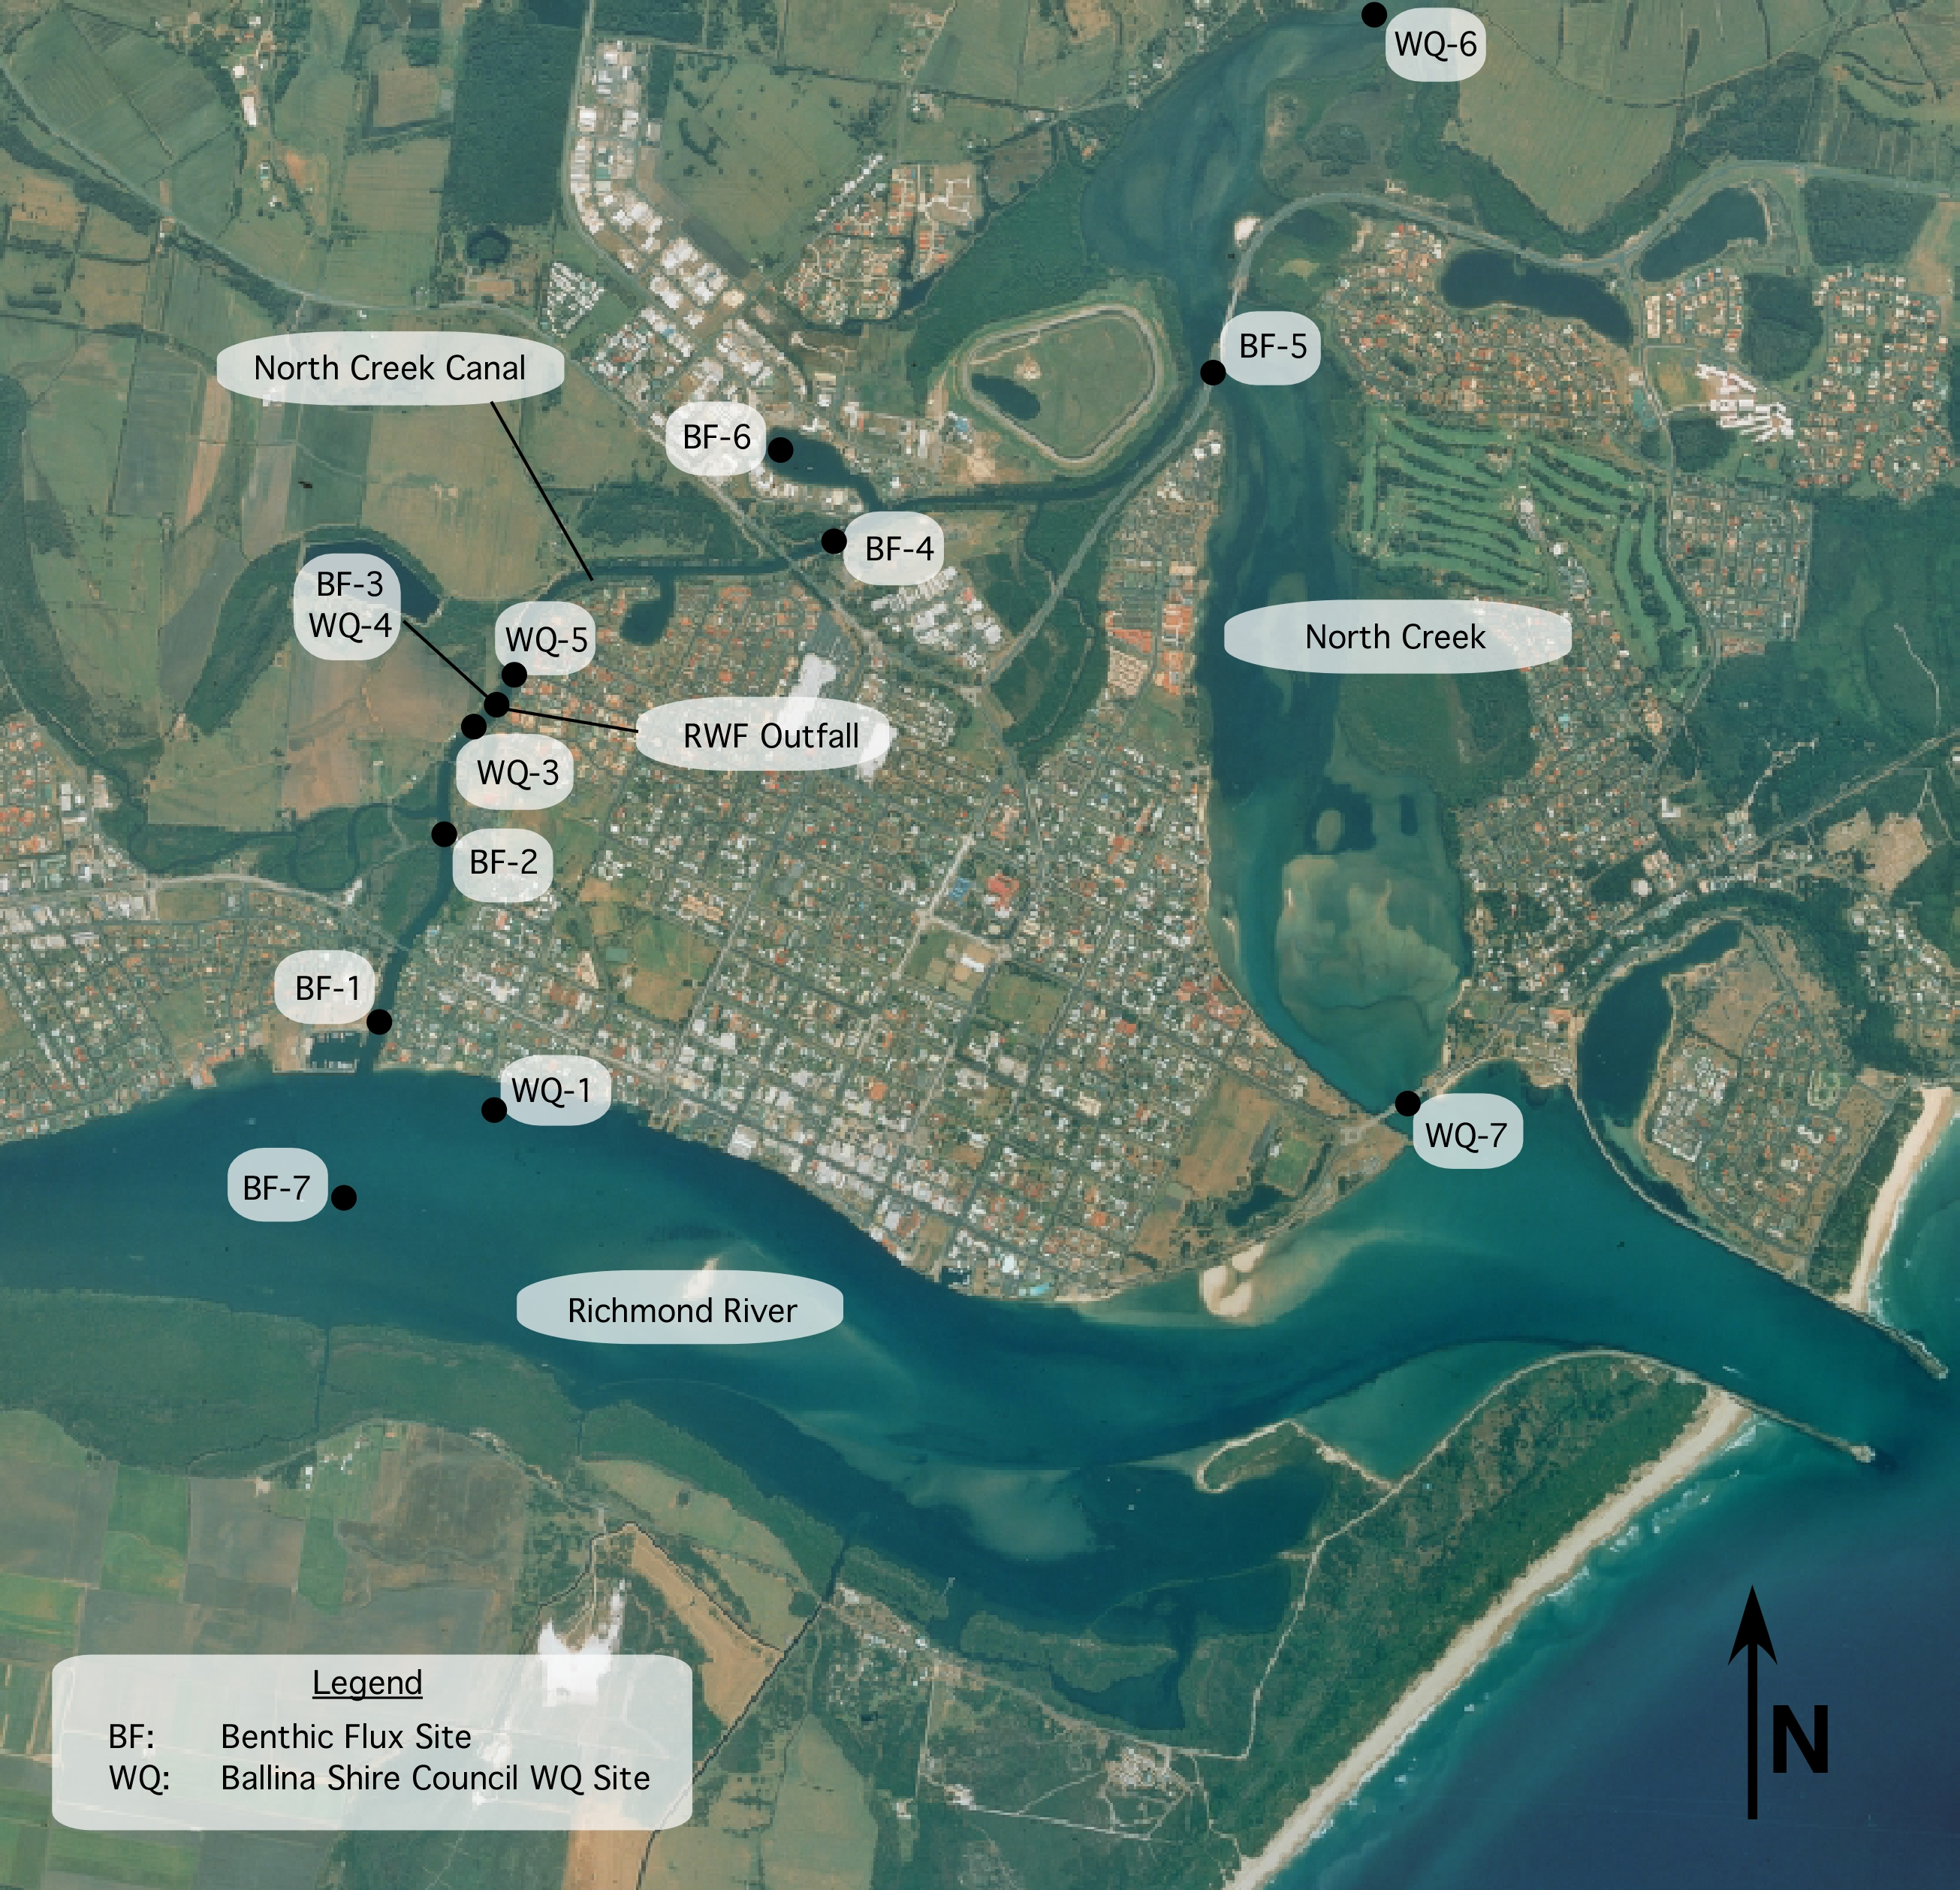

Figure 1. Location of the West Ballina Reclaimed Water Facility outfall and the water quality and sediment biogeochemistry sample sites.
RESULTS AND DISCUSSION

Water Quality

Nutrient concentrations in North Creek Canal were highly elevated with Total Nitrogen, Total Phosphorus, NO_{x}⁻ and NH₄⁺ concentrations up to 7.10, 1.55, 4.42 and 2.21 mg L⁻¹ respectively measured at the RWF outfall (Figure 2). TN, TP, NO_{x}⁻ and NH₄⁺ concentrations all decreased downstream (towards Richmond River) and upstream (towards North Creek) from the outfall, but concentrations in North Creek Canal still remained elevated above concentrations in the Richmond River and North Creek. Mean and 90 percentile NO_{x}⁻, NH₄⁺ and TP concentrations were higher upstream than downstream suggesting that effluent may be transported more in that direction. This is consistent with the higher ∂¹⁵N values in seagrass and mangrove samples upstream than downstream (Eyre et al., 2007).

Elevated chlorophyll-a concentrations (algal biomass) up to 274 µg L⁻¹ were measured at the outfall (Figure 2), but it is unknown how much of the algal biomass was produced in-situ due to elevated nutrient concentrations and how much was discharged from the RWF. Modelling suggests that only a small proportion of the chlorophyll-a is produced in-situ (Eyre et al., 2007). Elevated chlorophyll-a concentrations (from either source) increases light attenuation in the water column and reduces the light reaching the sediments, which can result in a loss of benthic production. Chlorophyll-a concentrations decreased rapidly downstream (towards Richmond River) and upstream (towards North Creek) from the outfall, but concentrations in North Creek Canal still remained elevated above concentrations in the Richmond River and North Creek. The 90 percentile chlorophyll-a concentrations were slightly higher upstream compared to downstream reflecting the higher upstream nutrient concentrations.

Sediment Biogeochemistry

The dark CO₂ effluxes and denitrification efficiencies (DE) from the 7 sample sites are summarised in Table 1 and the CO₂ efflux ranges and median DE for shallow coastal systems of different trophic status are given in Table 2 for comparison. The carbon decomposition rate at BF-3 (RWF outfall) was only slightly higher than the upper limit that is considered optimum for unvegetated sediments in a healthy coastal system. In contrast, the DE was well below the median for Oligotrophic coastal systems and approached the median DE for Mesotrophic coastal systems. Upstream (site BF-4) and downstream (site BF-2) of the RWF outfall the dark carbon decomposition rates fell within the optimum range, but the DE was elevated at site BF-2 and depressed at site BF-4. CO₂ effluxes at sites BF-1 and BF-5 were elevated due to high seagrass respiration rates. Overall the sediment biogeochemical processes in North Creek Canal were only slightly impacted, despite high algal biomass in the water column (i.e. high chlorophyll-a concentrations; Figure 2). As such, much of the water column production is probably flushed out of the system and not deposited and decomposed in the sediments. This is consistent with the rapid system flushing (0.4 day), the water column dissolved oxygen concentrations which were similar to the Richmond River Estuary, the sediment carbon data that show only small increases adjacent to the outfall, and the macrofauna data that show no detectable impact from the RWF effluent (Eyre et al., 2007).

In contrast to the main North Creek Canal channel, the very low DE in the industrial canal indicates that sediment biogeochemical processes were highly impacted. Consistent with the low DE were high alkalinity and phosphorus fluxes indicating anoxic conditions and high rates of sulphate reduction (Eyre et al., 2007). The cores had a strong smell of hydrogen sulfide and visually there was no macrofauna in the cores (no macrofauna were sampled at this site). The industrial canal is poorly flushed and much of the organic matter produced in the water column would be deposited in the sediments. Ebb tide discharge of RWF effluent would be particularly beneficial, as it would stop the upstream transport of nutrients and organic matter (algal biomass) into the canal estate, which would decrease in-situ phytoplankton production, and the associated deposition of organic matter to the sediments. Stormwater runoff may also contribute to the increased algal production the canal estate.

Table 1. Dark CO₂ effluxes and denitrification efficiencies for the 7 sample sites.
Site | Dark CO₂ Efflux (µmol m⁻² h⁻¹) | Denitrification Efficiency (%)
BF-1 (downstream seagrass) | 3202 | 42
BF-2 (downstream) | 824 | 85
BF-3 (outfall) | 1346 | 47
BF-4 (upstream) | 776 | 25
BF-6 (industrial canal) | 1157 | 5
BF-5 (upstream seagrass) | 2322 | 10
BF-7 (Richmond River) | 475 | 52

Table 2. Dark CO₂ effluxes and denitrification efficiencies for unvegetated sediments in shallow coastal systems of different trophic status (Eyre and Ferguson, In press).
System Type | Dark CO₂ Efflux (µmol m⁻² h⁻¹) | Median Denitrification Efficiency (%)
Optimum | 500 - 1000 | 75
Oligotrophic | <2000 | 68
Mesotrophic | 2000 - 4000 | 40
Eutrophic | 4000 - 6000 | 18
Hypertrophic | >6000 | 8

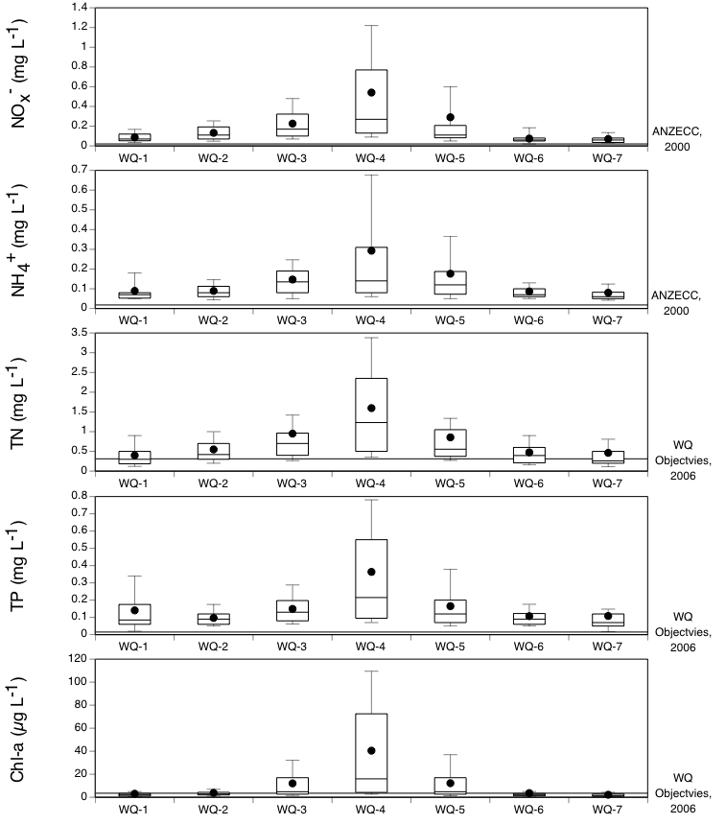

Figure 2. Box plots of monthly water quality data for sites in North Creek, North Creek Canal and the Lower Richmond River Estuary for the period 2001 to 2006.
REFERENCES

DIPNR. 2003. Use of Indicators for assessing estuary health. A guide.

Eyre, B. D. and Ferguson, A. J. P. 2005. Benthic metabolism and nitrogen cycling in a sub-tropical east Australian estuary (Brunswick) - temporal variability and controlling factors. Limnology and Oceanography 50, 81-96.

Eyre, B. D. and Ferguson, A. J. P. In press. Denitrification Efficiency for Defining Critical Loads of Carbon in Shallow Coastal Ecosystems. Hydrobiologia.

Eyre, B. D., Reichelt-Brushett, A. and Bucher, D. 2007. Ecological health assessment of the impact of releases to the lower Richmond River Estuary from the current and proposed augmented West Ballina Reclaimed Water Facility. Report for Department of Commerce. Centre for Coastal Biogeochemistry. 74p.

Kemp, W. M., W. R. Boynton, J. E. Adolf, D. F. Boesch, W. C. Boicourt, G. Brush, J. C. Cornwell, T. R. Fisher, P. M. Glibert, J. D. Hagy, L. M. Harding, E. D. Houde, D. G. Kimmel, W. D. Miller, R. I. E. Newell, M. R. Roman, E. M. Smith & J. C Stevenson. 2005. Eutrophication of Chesapeake Bay: historical trends and ecological interactions. Marine Ecology Progress Series 303: 1-29.

Rapport, D. J., Bohm, G., Buckingham, D., Cairns Jr., J., Costanza, R., Karr, J. A., de Kruijf, H. A. M., Levins, R., McMichael, A. J., Nielsen, N. O., and Whitford, W. G. 1999. Ecosystem health: the concept, the ISEH, and the important tasks ahead. Ecosystem Health 5, 82-90.

Scheltinga, D. M., Counihan, R., Moss, A., Cox, M. and Bennett, J. 2004. Estuarine, Coastal and Marine Indicators for regional NRM Monitoring. CRC for Coastal Zone, Estuary and Waterway Management.

Ward, T., Butler, E. and Hill, B. 1998. Environmental indicators for state of the environment reporting- estuaries, and the sea. Australia: State of the Environment (Environmental Indicator Reports, Department Environment, Camberra.

