The significance of anthropogenic and natural impacts on Subaerial delta morphology: Mullet/Hooka Creek, Lake Illawarra, New South Wales

Abstract

The recent morphological evolution of the Mullet/Hooka Creek delta, Lake Illawarra, NSW, has been assessed in respect to anthropogenic and natural factors. The assessment is based on the analysis of the 1916 historical parish map along with aerial photographs from 1948 to 2006. These images were digitised, georeferenced and analysed in a geographical information system (GIS) framework. Between 1916 and 1955 the morphological changes of the delta were pronounced and can be attributed to the construction of the military tank trap by the Australian Army in the early 1940’s. Some of the apparent expansion of the deltas area can be attributed to the use of different sources of data when assessing the 1916-1948 period. Between 1955 and 1975 the deltas subaerial footprint decreased in response to several large food events enhanced by the bypassing of Mullet Creek’s lower reach. Post 1975 the delta entered a general growth phase in response to increased urban development within the catchment. However, scouring and bar erosion associated with the February 1984 flood event slowed the rate of subaerial expansion of the delta up until the 1990’s. The construction of four offline wetlands in the early 1990’s has further limited the amount of sediment supplied to the system. The research demonstrates that the observed changes can be related to both natural processes and anthropogenic modifications to the catchment and thus providing important information for developing future catchment management plans.

Introduction

Both the long term and recent evolution of fluvio-deltaic systems is often difficult to establish due to the reworking of dateable material by delta progradation (Hopley and Jones 2006). The high gas content associated with many deltaic deposits limits the effectiveness of geophysical techniques such as seismic and radar. In dynamic rapidly prograding deltas, such as Mullet/Hooka Creek, sedimentation rates are highly variable with prodelta sedimentation rates ranging from 2-16 mm/yr (Chenhall et al. 1995; Payne et al. 1997; Jones and Chenhall 1991; Sloss et al. 2004). Furthermore, the establishment of deltaic sedimentation rates is resource intensive, time consuming and expensive often making it unfeasible to establish recent progradation rates. An alternative method, based on the use of historical maps and aerial photographs, allows rapid assessment of morphological changes to fluvio-deltaic systems. Morphological changes observed in historical maps and aerial photographs, when assessed in respect to land use patterns and flood events, can be of significant benefit when assessing anthropogenic and natural impacts on delta morphology. Furthermore this information can assist with the development of holistic estuary management plans.

Land managers, such as local councils, are using GIS techniques to monitor and map environmental change over various spatial and temporal scales. Calzadilla et al. (2002) illustrated that GIS technology and remotely sensed imagery can be used successfully in modern sedimentary environments. As modern deltas are dynamic geologically young features, changing at various rates from days to years, the use of GIS and photogrammetric techniques provides a timely and cost effective analysis of morphological change (Yeh and Li 1997; Yang et al. 1999; Weng 2001). Furthermore, the use of historical maps has extended this GIS capability to assess the longer term morphological evolution of deltas in response to natural processes and anthropogenic impacts, for example, the evolution of the Po River delta since 1590 (Correggiari et al. 2005). Historical maps have also be used to assess the evolution of the Godavari (Rao et al. 2005) and Danube (Giosan et al. 2005) deltas as they prograde into the Bay of Bengal and Black sea respectively. Closer at hand, the evolution of Macquarie Rivulet delta into Lake Illawarra has been successfully documented using similar techniques (Hopley et al. 2007).

The recent (1916-2006) morphological evolution of Mullet/Hooka Creek delta is established with the analysis of historical maps and aerial photographs within a GIS framework enabling the accurate area calculation of the deltas subaerial portions.

Regional Setting

The Mullet/Hooka Creek delta is prograding into the northwestern portion of Lake Illawarra, approximately 90 km south of Sydney (Fig. 1). The western margin between the lake and the escarpments foothills is characterised by interbedded sedimentary and volcanic strata of the Broughton Formation (Carr 1982; Bowman 1974). These units are, in turn, overlain by the Illawarra Coal Measures, Narrabeen Group and the Hawkesbury Sandstone (Bowman 1974) where Mullet Creek’s headwaters originate. Hazelton (1993) identified four soil landscape groupings within the Mullet/Hooka Creek delta catchment. The moderate to extreme erosional ratings of the soils suggests that significant amounts of sediment can be introduced to the deltaic environment by erosion events such as large scale flooding or land clearing.

The Mullet/Hooka Creek catchment has a total area of 86.4 km² and is the second largest catchment for the lakes (WBM 2003, 2006). The main tributaries contributing sediment to the delta front include Dapto Creek, Gibson Creek, Hooka Creek, Mullet Creek, Reed Creek and Robins Creek. Mean average maximum daily temperatures during the warmer months of December to March reach in excess of 25ºC, with the lowest mean average maximum daily temperature ~17ºC occurring in July (Bureau of Meteorology 2005). The proximity of the escarpment to the ocean has resulted in the development of a pronounced orographic effect. The majority of the rainfall occurs between January and April, with a maximum in March, yielding approximately 1500 mm to 1600 mm per year (Bureau of Meteorology 2005). The predominant wind directions affecting Lake Illawarra are illustrated in Figure 2. In the warmer months northeasterly, southwesterly and southerly winds are typical, with westerly and southwesterly winds occurring during the cooler months. Wind velocities range up to 45-55 km/hr (WBM 2003) but may be higher during storms.

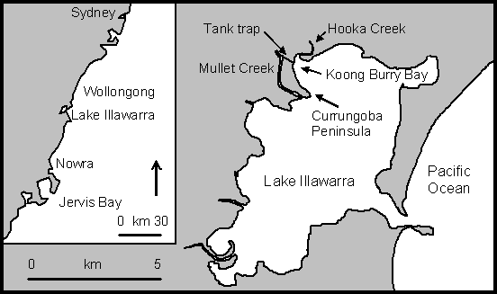
Figure 1: Location map of Lake Illawarra and the Macquarie Rivulet delta.

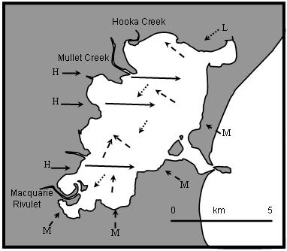
Figure 2: Predominant wind directions affecting Lake Illawarra during summer (dotted), winter (solid) and all year round (dashed). The resulting travel paths of the developed wind-waves are indicated within the lake (after Hopley et al. 2006).

Flood events have significant impacts on the morphological evolution of coastal environments such as deltas. Between 1919 and 2003 twenty-eight major or severe floods, with lake heights greater than 1.5 m AHD, and three moderate flood (>1.2 m AHD) events occurred in the Lake Illawarra catchment (Lawson and Treloar 2005, Wollongong City Council 2006). The identified major flood events occurred in 1919, 1930, 1943, January 1950, April 1950, May 1955, February 1959, October 1959, March 1961, November 1961, June 1964, November 1966, April 1969, November 1969, March 1974, April 1974, March 1975, February 1977, March 1977, March 1978, February 1984, August 1986, April 1988, February 1990, July 1990, June 1991, February 1992, August 1996 and April 2003. The minor/moderate flood events occurred in August 1987, August 1998 and August 1990.

Lake levels are dependent on fluvial inputs, precipitation, evaporation, tides and entrance conditions. Typical water levels in the lake in the absence of fluvial inflows is between +0.2 to +0.25 m Australian height datum. Tidal fluctuations have minimal impacts on the lakes water level, with tidal ranges between + 0 m and + 0.07 m, proximal to the Lakes entrance, depending on entrance conditions and a tidal penetration restricted to approximately 2km west of Bevans Island (WBM 2006). Tidal movement does not significantly affect the remainder of the Lake.Table 1 shows the entrance condition, percentage of time that this condition has occurred and the associated tidal ranges. It is believed that water level variations would have minimal effect on the calculated areas since tidal ranges are limited and the analysed aerial photographs were not taken during flood events.

Table 1: Lake entrance conditions, percentage of time condition has occurred and the associated tidal influence on lake levels (after WBM 2006).
Entrance condition | Percent of historical time entrance condition occurred | Tidal influence
Closed | 10% | 0.00m
Very heavily shoaled | 20% | 0.01 m
Heavily shoaled | 50% | 0.02 m
Moderately shoaled | 15% | 0.04 m
Scoured/Fully open | 5% | 0.07 m

Lake Illawarra was inhabited by aborigines of the Wadi Wadi language group who are believed to have had minimal environmental impact on the area. In the early 1800s the first Europeans came to the area in search of cedar trees. In 1816 Lake Illawarra’s foreshore and surrounding land was surveyed and subdivided. Initially, the area was used for agricultural purposes such as the cultivation of wheat, oats and potatoes (Lake Illawarra Authority 2007). Dairy farming and associated pasture improvement replaced much of the crop based farming by the late 1800s. Many of the large land grants were further divided for residential development in the 1920s. Analysis of the aerial photographs suggests that urban development within the catchment commenced in the 1960s. Analysis of census data suggests that the average annual number of dwellings constructed up until 2001 increased significantly, with much of the growth occurring in the last 10-20 years (Fig.3).

Since European settlement, Mullet Creek and its tributaries have undergone at least three phases of significant anthropogenic modifications due to engineering works. In the early 1900s a small dam was constructed approximately 5.5 km upstream of the Creek’s mouth (Young 1976). In 1941 the Australian Army Engineering Corp excavated a channel from the sharp bend in Mullet Creek to Koong Burry Bay. The final large scale engineering works consisted of the construction of four offline wetlands (Rob 1, 2 and 3; Reed 1), in the early 1990’s.

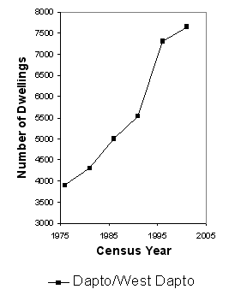
Figure 3: The number of dwellings constructed between 1976 and 2001 in the Dapto/West Dapto area, NSW, based on Australian census data.

Data Collection and Digitising of Images

Historical parish maps and aerial photographs with complete spatial coverage of the Mullet/Hooka Creek delta were used to assess the recent morphological evolution of the delta (Table 2). The use of a single map/aerial photograph per time period minimises processing errors associated with the merging of multiple images. Experimentation revealed that maps/aerial photographs with a scale of 1:25,000 or larger were the most effective when georeferencing and delineating the deltas boundaries. However, it was possible to georeference images at scales as small as 1:40,000. The selected maps and aerial photographs were scanned at a resolution of 600 dpi (following Hughes et al. 2006) and saved as tiff files.

Table 2: The maps and aerial photographs used to assess the recent morphological changes of the Macquarie Rivulet delta and the associated georeferencing and area data. Note: GCP = ground control point and RMS = root mean square.
Year | Type | County | Parish | Photo | No of GCPs | RMS error (m) | Total delta area (ha) | Rate of Increase (%)
1916 | Map | Camden | Kembla |  | 262 | 5.89184 | 289.5142 | 0
1948 | Photo |  |  | NSW 201, run 3 photo 9 | 133 | 5.80308 | 291.2661 | 0.61
1955 | Photo |  |  | NSW 595, run 4 photo 50 | 159 | 5.86219 | 292.9231 | 0.57
1963 | Photo |  |  | NSW 1139, run 6 photo 5012 | 72 | 5.02868 | 289.1528 | -1.29
1975 | Photo |  |  | NSW 2299, run 8 photo 4 | 75 | 4.86992 | 288.7435 | -0.14
1982 | Photo |  |  | NSW 2997, run 23b photo 157 | 101 | 4.96747 | 289.2111 | 0.16
1984 | Photo |  |  | NSW 3367, run 3 photo 17 | 79 | 6.43251 | 288.8725 | -0.12
1990 | Photo |  |  | NSW 3753, run 23 photo 104 | 83 | 4.36383 | 288.9653 | 0.03
2002 | Photo |  |  | NSW 4600, run 13 photo 7 | 211 | 3.76874 | 289.2080 | 0.08
2006 | Photo |  |  | NSW 4956, run 14 photo 151 | 97 | 5.76534 | 289.5688 | 0.12

Georeferencing and Image Processing

The digitised images were spatially rectified using ArcGIS version 9.2 georeferencing tools and image to image techniques (Calzadilla et al. 2002; Hopley et al. 2006). It was found that the RMS errors obtained using simple georeferencing techniques were comparable to those obtained when using more complex aerotriangulation and orthorectification techniques. The similarity in the results can be attributed to the limited topographic variations within the study areas. Furthermore, Hughes et al. 2006 noted that the application of aerotriangulation and orthorectification techniques are limited by the limited number of ground control points (GCPs) which can be consistently identified in all images. A combination of hard (bridges and roads) and soft (trees and sections of stable channel) GCPs were used in the georeferencing process as recommended by Hughes et al. (2006).

Georeferencing of the 2002 Mullet/Hooka Creek image was completed using GCPs derived from the Illawarra roads and Illawarra wetlands vector data sets (AMG 66 AGD 56 created by the School of Earth and Environmental Sciences, University of Wollongong, in 1993). The georeferenced 2002 image was then used to reference the 1990 image. The number of GCPs required to accurately georeference the aerial photographs and maps ranged between 72 and 262 with RMS errors between 3.77 m and 6.43 m (Table 2). The Mullet Creek images georeferenced for this study required significantly more GCPs than the 20 to 51 used by Hopley et al. (2006) for the Macquarie Rivulet delta. The increased number of GCPs is directly linked to the increased coverage of the Mullet/Hooka Creek study area relative to the size of the image. The RMS errors achieved fall within the accepted range (25-40 m) given the scale of the maps and aerial photographs.

Polygons/shape files were on-screen digitised within ArcGIS version 9.2 was used to delineate the deltas boundaries. These polygons/shape files were produced at a scale of no more than 1:2,500. To ensure consistency between each of the time periods the polygon/shape file from the previous map/aerial photograph was copied, renamed and modified to reflect the morphological changes at the active portions of the delta. The spatial extent of the polygons/shape files was calculated using the X tools extension. The calculated areas were used to establish the growth and percentage increase of the delta between 1916 and 2002 (Fig.4).

Mullet Creeks Recent Subaerial Morphological Evolution 1916-2002

Between 1916 and 1948 the GIS analysis indicated that the delta increased in size by 1.75 ha or 0.61% (Fig.4; Table 2). This increase in subaerially exposed land is concentrated in the Koong Burry Bay area (Fig.5a) and can be attributed to two main factors. The most significant factor was the construction of the tank trap in 1941 by the Australian Army. The tank trap connected Mullet Creek to Koong Burry Bay via a 660 m long channel with an average width of 15 m in 1948. It was not possible to ascertain the original depth of the trap, however the authors believe for it to effectively limit tanks crossing the trap it would have been a minimum of 2 m deep. Based on this depth assumption, a minimum of 19800 m³ of sediment would have been excavated to produce the trap. It is likely that some of the increase in the delta’s area can be attributed to the disposal of the excavated material proximal to the site. Potential areas where the spoil may have been dumped are along the east-southeastern shore line of Currungoba Peninsula, the southeastern and western bank at the entrance to Hooka Creek and the small elongate island off the eastern bank of Hooka Creek (Figs 1 and 5a). However, it is not possible to determine this as the authors were unable to obtain any spatial data or documents pertaining to construction of the trap. Furthermore, the subsequent increase in hydraulic gradient and water velocity, due to the construction of the tank trap, would have more efficiently transported the entrained sediment into the lake via the trap than via the lower reach of Mullet Creek.

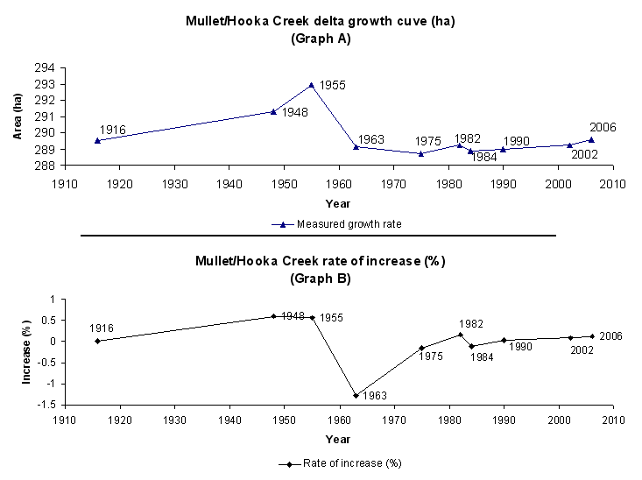
Figure 4: Graphs illustrating (a) growth of the Mullet/Hooka Creek delta area and (b) rate of increase in percent between 1916 and 2002.

The other factor that can be attributed to the observed increase in area and morphological differences is that the 1916 polygon/shape file is based on a georeferenced parish map whereas the 1948 polygon/shape file is based on a georeferenced aerial photograph. It is not possible to calculate the extent of the apparent artificial growth of the delta due to the differing data types. This discrepancy was also observed by Hopley et al. (2006) when they assessed the recent morphological evolution of the Macquarie Rivulet delta.

Over the 32 years between 1916 and 1948 two channel mouth bars developed in Koong Burry Bay (Fig.5a). The crescent or lunette shape of the larger mouth bar is often associated with inertia-dominated systems where the outflowing water and the receiving basins water is able to mix adequately in both horizontal and vertical space (Suter 1994; Reading and Collinson 1996). However, Koong Burry Bay is very shallow for approximately 1 km into the lake, which is not conducive to the development of inertia-dominated channel mouths. It is more likely that the lunette shape is the result of reworking by southeasterly wind-waves which occur throughout the year.

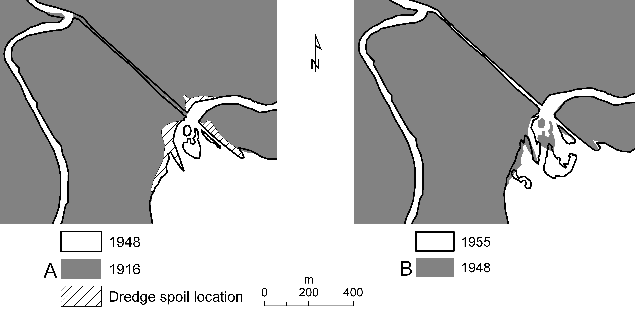
Figure 5: The extensive morphological differences in the Mullet/Hooka Creek delta between (a) 1916-1948 and (b) 1948-1955 are illustrated. The cross hatching in Fig a indicates the probable location of the dredge spoil.

Assessing the impact of the dam’s construction in the early 1900s on the delta’s growth was not possible due to poor temporal coverage of the spatial data. However, the authors believe that the construction of the dam would have had significantly limited the amount of sediment transported to the delta’s mouth. In particular, the coarser grained sediments transported via saltation and bed load processes would have been trapped by the dam, where as the finer grained sediment transported in suspension would have overtopped the wall. The fine grained nature of the sediment entering the lake would have been deposited until the velocity of the entering water plume decreased to a point that facilitated the flocculation of the suspended sediment.

From 1948 to 1955 the delta increased in area by 1.66 ha or 0.57% (Fig.4; Table 2).The majority of the increase is associated with the subaerial expansion of the large levee extending from the southeastern mouth of the tank trap in a south-southeasterly direction (Fig.5b). In addition to the growth of this levee a secondary smaller bar has developed to the south of the levee. The large mouth bar evident in the 1948 image has been reworked towards the southeast and has increased in size significantly (Fig.5b). The small southeast to northwest orientated levee-like bar has also increased in size over the seven years. The overall birdsfoot morphology of the bars within Koong Burry Bay are characteristic of a friction-dominated channel mouth which is commonly associated with fluvial dominated systems entering relatively shallow water (Suter 1994; Reading and Collinson 1996). The emergence of the large levee, the reworking and increase in size of the mouth bars evident in 1948 and the development of other bars suggests that additional sediment was introduced to the system. This additional sedimentation can be attributed to the construction of the tank trap that enabled sediment to bypass the lower reach of Mullet Creek.

Between 1955 and 1963 the delta’s morphology was significantly modified (Fig.6a). During this time the delta decreased in area by 3.77 ha or 1.29% (Fig.4; Table 2). The absence of the large levee evident in the 1955 image accounts for much of the decrease in area (Fig.6a). The rapid formation of the levee resulted in it being relatively unconsolidated and highly susceptible to reworking by flood events and wind waves. During this eight year period five significant flood events occurred. The impact of these flood events on Koong Burry Bay would have been enhanced by the presence of the tank trap. Prior to the construction of the trap, floodwaters would flowed around a very tight bend in Mullet Creek and continuing for another 2.7 km to the lake. The construction of the trap bypassed this directional change, reduced the sinuosity and decreased the length of the flow path resulting in the floodwaters entering the lake at higher velocities and with increased erosion potential. Other observed morphological changes in the Koong Burry Bay/Hooka Creek area included the reworking and slight extension of the bar orientated parallel to the tank trap and the erosion of the small spit near the mouth of Hooka Creek. A levee-like extension of the southern bank of Mullet Creek at the upstream entrance to the tank trap developed (Fig.6a). This levee would have further limited the amount of sediment transported down the main channel of Mullet Creek.

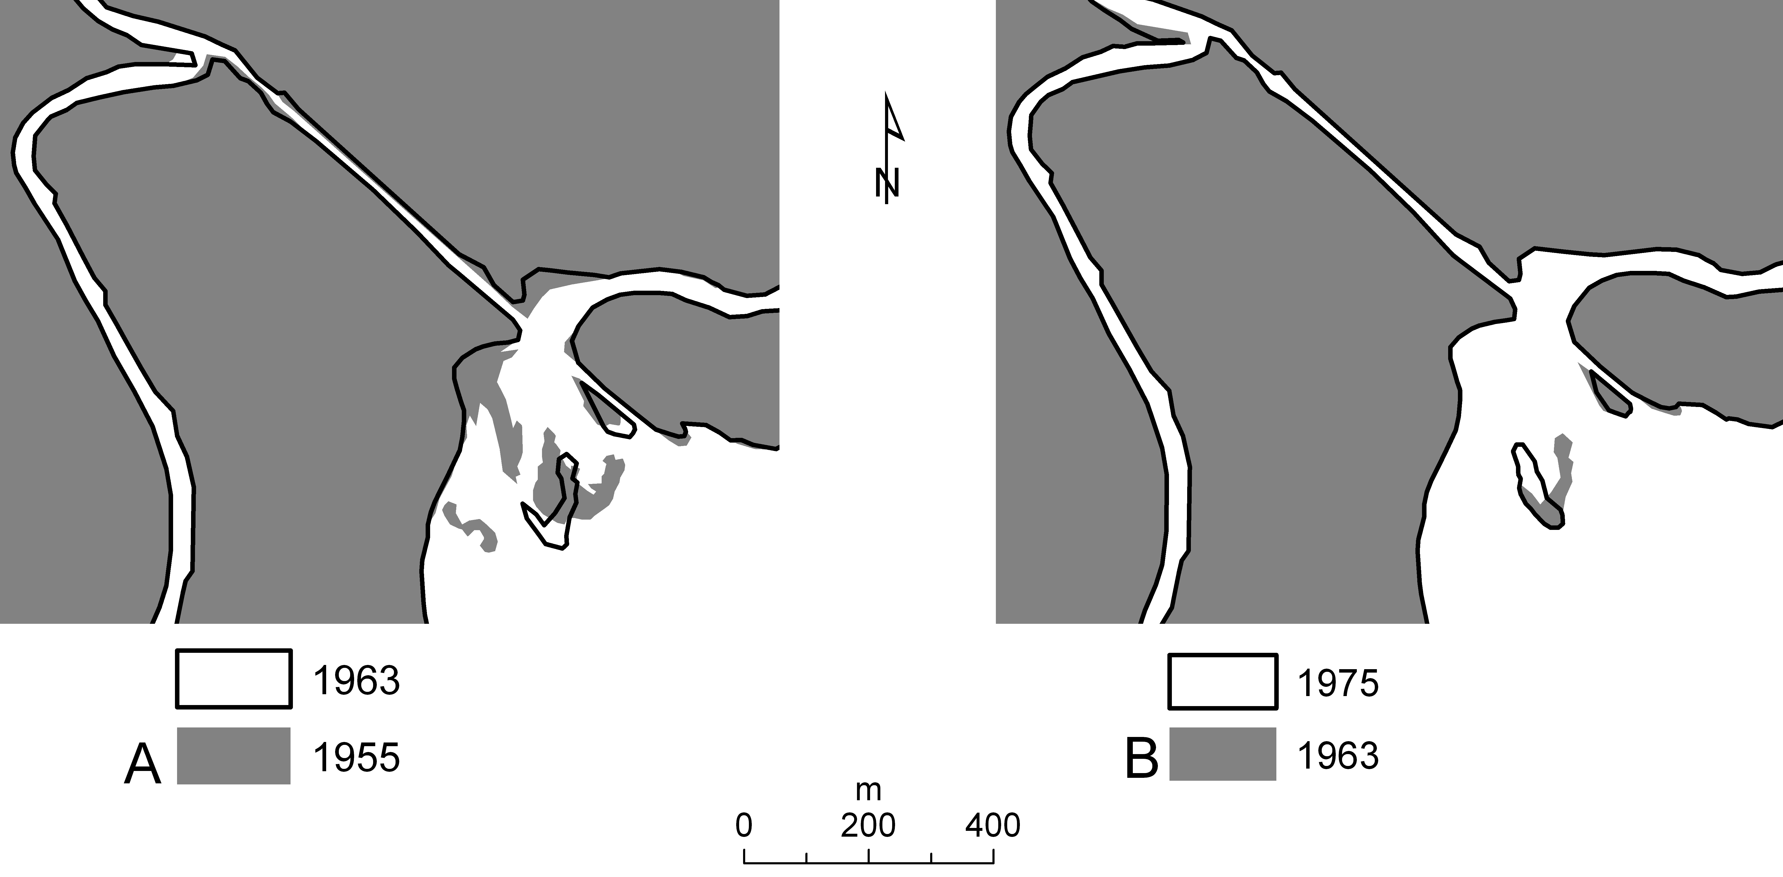
Figure 6: The morphological differences in the Mullet/Hooka Creek delta between (a) 1955-1963 and (b) 1963-1975 are illustrated.

Between 1963 and 1975 a further seven flood events occurred which reduced the size of the delta by a further 0.41 ha or 0.14% (Figs4 and 6b; Table 2). Morphologically, the levee in Mullet Creek at he entrance to the tank trap decreased in size significantly. It is probable that the tank trap was not large enough to carry full flood flows thus forcing excess floodwaters down the lower Mullet Creek channel and eroding the levee. The other significant morphological change was the reworking of the tank trap’s main mouth bar towards the southwest (Fig.6b).

Post 1975 the Mullet/Hooka Creek delta moved into a constructive phase with the delta increasing in size for each of the assessed periods, with the exception of the 1982-1984 period. Between 1975 and 1982 the Mullet/Hooka Creek delta increased in sized from 288.74 ha to 289.21 ha an increase of 0.16% (Fig.4; Table 2). The observed increase is associated with the increased size of the large mouth bar in Koong Burry Bay (Fig.7a). Over the 7 years the bar increased in length by 30 m and in width by 25 m at its widest point. The orientation of the northwestern part of the bar is likely the result of waters discharging from Hooka Creek. Furthermore, a small bar has developed proximal to the easterly edge of the large bar. It is probable that this constructive phase of the delta is related to increased urbanisation in the Dapto/West Dapto area (Fig.3).

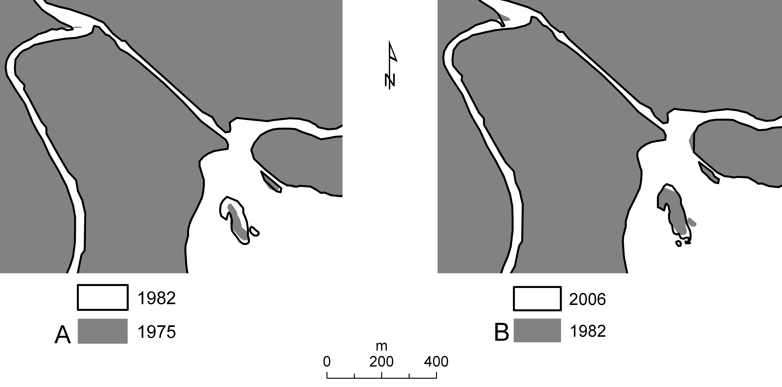
Figure 7: The morphological differences in the Mullet/Hooka Creek delta between (a) 1975-1982 and (b) 1982-2006 are illustrated.

Between 1984 and 2006 minimal morphological changes were observed (Fig.7b). However, between 1982 and 1984 the delta decreased in size by 0.34 ha or 0.12% (Fig.4; Table 2). This decrease in the delta’s area can be directly attributed to the extreme 1984 flood event which was concentrated in the Mullet Creek catchment. The intense rainfall and subsequent flooding caused significant channel erosion, particularly in the steeper-gradient upper to mid reaches of the catchment (Nanson and Hean 1985). Much of the eroded sediment was deposited upstream of the rail and freeway embankments and on the floodplains of Mullet Creeks. The reduced sinuosity and increased hydraulic gradient of the tank trap would not have dissipated the floodwaters, effectively resulting in the floodwaters entering the lake with relatively high erosive power. Morphologically, the floods reworked the small bar proximal to the easterly edge of the large bar, eroded the western bank of Hooka Creek and altered the sharp bend in Mullet at the tank traps upstream end.

Between 1984 and 1990 urban development within the catchment increased and would have contributed additional sediment to the delta (Fig.3). However, the GIS analysis indicates that the morphology and size of the Mullet/Hooka Creek delta remained relatively stable with an area increase of 0.09 ha or 0.03% (Fig. 4,; Table 2). The limited change to the deltas morphology is likely to be an artefact of the 1984 flood event. The flood would have scoured into the channels base creating a sediment sink that required infilling prior to sediment delivery to the delta front resuming. The inhibited growth of a delta due to the creation of a sediment sink has also been documented by Hopley (2004).

From 1990 to 2002 the Mullet/Hooka Creek delta increased its subaerial footprint by 0.24 ha or 0.08% (Fig.4; Table 2). The growth of the delta was concentrated in the Koong Burry Bay area at the mouth of the tank trap. The large bar orientated parallel to the Currungoba Peninsula remained stable between 1984 and 1990 but increased in size slightly between 1990 and 2002 with its overall length increasing from approximately 186 m to 220 m. During this period approximately 2150 dwellings were constructed (Fig.3) in the Mullet Creek catchment, in particular the West Dapto area. The construction of so many dwellings is likely to have generated significant amounts of free sediment that could be transported to the delta. However, the restricted growth of the delta suggests that the four offline wetlands (Rob 1, 2 and 3; Reed 1), constructed in the early 1990’s with a combined capacity of ~123,000 m³ (Sinclair Knight and Partners 1992), were absorbing the majority of the freely available sediment associated with the rapid West Dapto urbanisation.

Over the 4 years between 2002 and 2006 the deltas subaerially area increased by 0.36 ha or 0.12% (Fig.4; Table 2). This observed increase in area, given the continued urban expansion of the West Dapto area (Fig.3), is minimal. The minimal subaerial expansion of the delta, given the development further demonstrates the effectiveness of the offline wetlands as sediment traps. The major morphological changes through this period consisted of the development of two small bars at the south-eastern end of the large bar (Fig. 7b). These bars may be the result of sediment transported to the delta mouth during the 2003 flood event.

Conclusions

Over the 85 years assessed in this study, the Mullet/Hooka Creek delta has undergone significant morphological change. These changes can be attributed to a combination of anthropogenic and natural factors. The study has illustrated that the construction of the tank trap by the Australian Army in the 1940’s has been one of the primary factors that shaped the recent evolution of the delta. The construction of the trap bypassed the lower 2.7 km of Mullet Creek increasing the amount of sediment delivered to Koong Burry Bay. This additional sediment contributed to the formation of new levees and bars. Post 1955 several large flood events eroded much of the sediment deposited since the construction of the tank trap as the lack of sinuosity and the shortened channel length would have enhanced the erosive power of the floods entering the lake. The rate of urban development within the catchment increased from the mid to late 1970’s with its most rapid rise occurring between the 1991 and 1996 census years. This increased development is likely to have contributed additional sediment to the system resulting in the deltas subaerial footprint increasing. However, the 1984 flood event reworked some of the subaerially exposed land and reduced the size of the delta. The presence of the tank trap would have again intensified the erosive power of the water entering the lake during the flood event. Scouring of Mullet Creek’s bed, due to the 1984 flood, produced a sediment trap effectively minimising the amount of sediment delivered to the delta front up until the early 1990’s. Once the sediment sinks were infilled, sedimentation recommenced increasing the subaerial footprint of the Mullet/Hooka Creek delta. Furthermore, the study has illustrated that the construction of offline wetlands can effectively minimise the amount of free sediment transported and deposited at the mouth of deltas in areas of urban development.

The study has demonstrated that the use of historical parish maps and aerial photographs georeferenced and analysed within a GIS framework can effectively track morphological changes to fluvio deltaic systems, with reasonable accuracy. When undertaking such an assessment it is important to consider the scales and accuracy of the historical maps as many were not regularly updated. Another issue with the technique is related to the temporal coverage of the aerial photographs as large scale flood events, such as the 1984 can occur between photographic records. However, the impact of this will be reduced as remotely sensed imagery with high temporal coverage becomes more cost effective to acquire.

Acknowledgements

This research was supported by Wollongong City Council, and the School of Earth and Environmental Sciences and the GeoQuEST Research Centre at the University of Wollongong. Furthermore, I would like to thank Dr B Chenhall and Dr B Jones for their critical review of the draft manuscript.

References

Bureau of Meteorology, 2005. Climate averages. www.bom.gov.au/climate/averages /cw-068188.
Bowman, H. N., 1974. Geology of the Wollongong, Kiama and Robertson 1:50 000 Sheets 9029-II 9028-I&IV. Geological Survey of New South Wales, Sydney.
Calzadilla P. A., Damen, M. C. J., Geneletti, D., and Hobma, T.W., 2002. Monitoring a recent delta formation in a tropical coastal wetland using remote sensing and GIS. Case study: Guapo River Delta, Laguna De Tacarigua, Venezuela. Environment, Development and Sustainability, 4, 201-219.
Carr, P.F., 1982. A reappraisal of the stratigraphy of the upper Shoalhaven Group and lower Illawarra Coal Measures, southern Sydney Basin, New south Wales. Proceedings of the Linnean Society of New South Wales, 106, 287-297.
Chenhall, B. E., Yassini, I, Depers, A. M., Caitcheon, G., Jones, B. G., Batley, G. E., and Ohmsen, G. S., 1995. Anthropogenic marker evidence for accelerated sedimentation in Lake Illawarra, New South Wales, Australia. Environmental Geology 26, 124-135.
Correggiari, A., Catteneo, A., and Trincardi, F., 2005. Depositional patterns in the late Holocene Po delta system. SEPM (Society for Sedimentary Geology) Special Publication 83, 365-392.
Giosan, L., Donnelly, J. P., Vespremeanu, E., Bhattacharya, J. P., Olariu, C., and Buonaiuto, F. S., 2005. River delta morphodynamics: examples from the Danube delta. SEPM (Society for Sedimentary Geology) Special Publication 83, 393-411.
Jones, B. G. and Chenhall, B. E., 2001. Lagoonal and estuarine sedimentation during the past 200years. In Heijnis, H. and Harle, K. (eds), Archives of human impact of the last 200 years, pp. 42-46. Australian Institute for Nuclear Science and Engineering Workshop, Lucas Heights.
Hazelton, P. A., 1993. Kiama soil landscape series, Sheet 9028. Department of Conservation and Land Management. Sydney.
Hopley, C. A., 2004. The Holocene and beyond: Evolution of Wandandian Creek delta, St Georges Basin, New South Wales. Unpublished honors thesis, University of Wollongong.
Hopley, C. A., and Jones, B. G., 2006. Holocene stratigraphic and morphological evolution of the Wandandian Creek delta, St Georges Basin, New South Wales. Australian Journal of Earth Sciences, 53, 991-1000.
Hopley, C. A., Jones, B.J., Puotinen, M. 2006 Morphological changes, assessed within a GIS framework, in the prograding Macquarie Rivulet delta, New South Wales. Proceedings of 36th Sydney Basin Symposium.

Hopley, C.A., Jones, B.J., Puotinen, M. 2007. Assessing the recent (1834 – 2002) morphological evolution of a rapidly prograding delta within a GIS framework: Macquarie Rivulet delta, Lake Illawarra, New South Wales. Australian Journal of Earth Sciences, 54, 1047-1056.
Hughes, M. L., McDowell, P. F., and Marcus, W. A., 2006. Accuracy assessment of georectified aerial photographs: implications for measuring lateral channel movement in a GIS. Geomorphology, 74, 1-16.
Jones, B.G., and Chenhall, B.E., 1991. Lagoonal and estuarinesedimentation during the past 200 years. In: Heijnis H. & Harle K. eds. Archives of Human Impact of the Last 200 Years, pp. 42 – 46.Australian Institute for Nuclear Science and Engineering Workshop, Lucas Heights.
Lake Illawarra Authority, 2007. History of Lake Illawarra. www.lia.nse.gov.au/facts/ history.
Lawson and Trelour, 2005. Lake Illawarra floodplain risk management study and plan. Report prepared for Lake Illawarra Authority, Wollongong City Council and Shellharbour City Council by Lawson and Treloar Pty Ltd, Sydney (available through the Wollongong City Library).
Nanson, G.C., Hean, D., 1985. The west dapto flood of Febuary 1984: rainfall characteristics and channel changes. Australian Geographer 16, 4, 249-258.
Payne, M., Chenhall, B. E., Murrie M., and Jones, B. G., 1997. Spatial variation of sediment-bound zinc, lead, copper and rubidium in Lake Illawarra, a coastal lagoon in eastern Australia. Journal of Coastal Research 13, 1181-1191.
Rao, K. N., Sadakata, N., Malini, B. H., and Takayasu, K., 2005. Sedimentation processes and asymmetric development of the Godavari delta, India. SEPM (Society for Sedimentary Geology) Special Publication 83, 435-451.
Reading, H. G., and Collinson, J. D., 1996. Clastic coasts. In: Reading, H. G. (ed.), Sedimentary Environments: Processes, Facies and Stratigraphy, pp. 154-231. Blackwell Science, Cambridge.
Sinclair Knight and Partners., 1992. Water Quality Measures Stage 1 Release Area West Dapto - Final Report. Wollongong City Council, Wollongong.
Sloss, C. R., Jones, B. G., Murray-Wallace, C. V., and Chenhall, B. E., 2004. Recent sedimentation and geomorphological changes, Lake Illawarra, NSW, Australia. Wetlands (Australia) 21, 73-83.
Suter, J. R., 1994. Deltaic coasts. In: Carter, R. W. G., and Woodroffe, C. D. (eds), Coastal Evolution: Late Quaternary Shoreline Morphodynamics, pp. 87-120. Cambridge University Press, Cambridge.
WBM Oceanics Australia., 2003. Lake Illawarra Estuary Processes Study – Final Report. Lake Illawarra Authority, Wollongong.
WBM Oceanics Australia., 2006. Lake Illawarra Estuary Management Study and Strategic Plan – Final Report. Lake Illawarra Authority, Wollongong.
Weng, Q., 2002. Land use change analysis in the Zhujiang delta of China using satellite remote sensing GIS and stochastic modelling. Journal of Environmental Management 64, 273-284.
Wollongong City Council, 2006. Wollongong City Council: Environment. Online <http://www.wollongong.nsw.gov.au>.
Yang, X., Damen, M. C. J., and van Zuidam, R. A., 1999. Satellite remote sensing and GIS for the analysis of channel migration changes in the active Yellow River delta, China. JAG 1, 146-157.
Yeh, A. G., and Li, X., 1997. An integrated remote sensing and GIS approach in the monitoring and evaluation of rapid urban growth for sustained development in the Pearl River delta, China. International Planning Studies 2, 193-211.
Young, R. W., 1976. Infilling of the lake. In: Turnbull, E. S., and Young, R. W. (eds) Lake Illawarra: an environmental assessment project. p. 10-19. Wollongong City Council and University of Wollongong.

