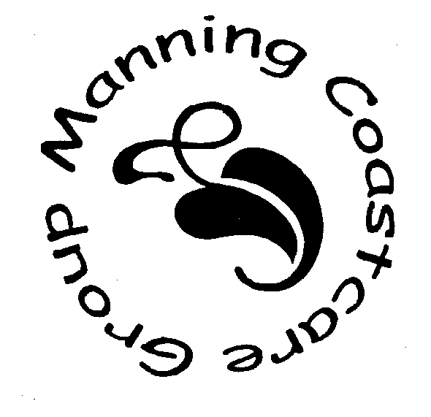

2007 NSW Coastal Conference – Yamba

MANNING COASTCARE GROUP – Case Study

Abstract prepared by Daintry Gerrand (B. App. Sc. Ecology), Jim Love ( B Nat. Res.), Warwick Dyson (B. Sc. (Honours) of Manning Coastcare Group Inc.

Manning Coastcare Group (MCCG) won the Australian Government National Coastcare Award in 2006. The Award recognised the scale of achievement and systematic approach to planning and on-ground works.

As a community organisation we have recognised the need to take a holistic approach on a regional scale and that our goal was to achieve restoration of the coastal corridor and maintenance of biodiversity as opposed to conserving a small number of specific sites. Our key members have practical common sense and tertiary training in environmental management and education and a strong desire for productive on-ground works. We have looked objectively at the history of activity and the scale of the task to be undertaken and allocated work priorities according to the funds and resources available.

In 1996 the Group started work on 8 Littoral Rainforest Sites along the Manning coastline in liaison with Greater Taree City Council. In 1998 MCCG received ‘Coastcare’ and “NSW Environmental Trusts’ funding to undertake a baseline study of environmental weeds at 51 sites along the coast - ‘Coastline Survey of Asparagaceae and other Environmental Weeds (Williams and Gerrand) and 8 Littoral Rainforest Action Plans (Williams and Gerrand).

In 2000, the Greater Taree City Council LGA Bitou Bush Control Strategy (Williams and Gerrand) was prepared. This strategy and the preceding studies and plans facilitated prioritisation of weeds, development of and further application for funds.

The Group now targets prioritised weeds over some 200 hectares of coastal corridor under funding from the Hunter Central Rivers CMA.
.
Approx $579,089 has been received in Grant funds since 1996 from a variety of National Landcare Program, Coastcare, NSW Environmental Trusts, Envirofund and the Hunter Central Rivers Catchment Management Authority.

Conservation of the biodiversity of the coastal corridor has been a central focus MCCG with activities covering some 80% of the 40 kilometre coastline. Manning Coastcare Group has also concentrated on developing skills and providing social and employment opportunities for the local community.

Specialist Contract Regenerators are used in sensitive environments such as the 'endangered ecological communities' of Littoral Rainforest and Themeda Grasslands and where spraying of Bitou Bush is required. These Contractors are locally based and have developed invaluable specialised knowledge on weed control techniques and local conditions.

The Group has developed a mechanism for harnessing community contribution on a regular basis through an 'over 50's volunteer worker' program in association with Centrelink. Over 30 locals contribute 15 hours per week every week of the year under this scheme. When this in-kind contribution is coupled with the Groups other voluntary time MCCG has contributed $3 million in labour since 1996.

Specialist Contract Regenerators are used in sensitive environments such as the 'endangered ecological communities' of Littoral Rainforest and Themeda Grasslands. These Contractors are locally based and have developed invaluable specialised knowledge on weed control techniques and local conditions.

The Group has developed a mechanism for harnessing community contribution on a regular basis through an 'over 50's volunteer worker' program in association with Centrelink. Over 30 locals contribute 15 hours per week every week of the year under this scheme. When this in-kind contribution is coupled with the Groups other voluntary time MCCG has contributed over $3, 552, 510 in-kind labours since 1996.

The Group also works closely with Greater Taree City Council Noxious Weeds Dept. and the NSW Lands Department on the application of aerial spraying along the coastal corridor to complement the more site specific works around sensitive littoral rainforest environments. Monthly meetings are conducted with alternate meetings held in the field to review works on various sites.

In times of increasing population pressures along the coastal fringe and climate change predictions the sustainability of our natural ecosystems as well as our local social networks is a very important part of 'building the resilience of our local environment'.
Manning Coastcare Group is continuing to expand its programs to integrate changes in community profiles, shifts in arrangements for the unemployed and to maintain biodiversity within the coastal corridor.

