MANAGEMENT AND MONITORING OF AN ICOLL ENTRANCE CLEARANCE

Cameron, D.W.¹, Morris, B.D.², Collier, L. ³, and Mackenzie, T.³

¹ Warringah Council, Sydney, NSW
² Water Research Laboratory, University of New South Wales, Sydney, NSW
³ Cardno Lawson Treloar Pty Ltd

Abstract

Narrabeen Lagoon is the largest coastal lagoon in the Sydney Region. It is located in the Warringah Council LGA and has a catchment area of 55km² and a surface area of 2km². It is intermittently open and closed to the ocean, thus falling into the class of estuaries known as Intermittently Closed and Open Lakes and Lagoons (ICOLL). The closure of the lagoon is usually associated with continuous infilling of the entrance area by marine sediment. In order to mitigate and manage flood risk and water quality issues due to lagoon closure, clearance operations have been undertaken every 3-5 years since the mid 1970s in accordance with the long-standing entrance management policy. The most recent clearance operation occurred in late 2006, lasted approximately 12 weeks and saw some 45,000 m³ removed and used to replenish Collaroy/Narrabeen Beach. The latest clearance operation and subsequent morphological evolution of the entrance of the lagoon is being monitored using in-situ RTK-DGPS surveys combined with state-of-the-art video techniques using images collected via an ARGUS coastal imaging system. Initial results from this monitoring indicate that the infilling is rapid and occurs mainly by means of the formation of a flood shoal within the entrance. ICOLL systems are particularly problematic to manage due to their intermittent nature. The ongoing monitoring following the clearance operation provides a unique opportunity to gain further insight into ICOLL infilling processes. This knowledge will in turn enable Warringah Council and other public authorities to better manage Narrabeen Lagoon and other systems of this type in the longer term.

Introduction

The entrance to Narrabeen Lagoon is intermittently filled with marine sediment when the amount of sand moved into the lagoon entrance by the incoming tide exceeds the amount of sand removed by the outgoing tide (MHL, 1989). The closure of the lagoon entrance for extended periods can have quite significant socio-economic and environmental impacts on the lagoon, and surrounding areas (CLT, 2007), which include:
- Increases in the frequency and severity of flooding to low lying residential/commercial areas surrounding the lagoon, as well as creeks discharging into it;
- Reductions in Lagoon water quality due to the impairment or cessation of tidal flushing from the entrance;
- Decrease in biodiversity due to reduced recruitment through the entrance (The Ecology Lab, 2003).

Since 1975, excess sand at the entrance to Narrabeen Lagoon has been cleared at relatively regular intervals in order to manage the issues associated with entrance closure. The present paper outlines the management and monitoring of the 2006 entrance clearance operation.

Intermittently Closed and Open Lakes and Lagoons or ICOLLs are barrier type estuaries that can be either open or closed to the ocean (Roy et al., 2001). These coastal lagoon systems that are irregularly open-closed are often found on micro-tidal coasts (spring tidal range < 2 m) in temperate regions of the world where the annual rainfall lacks seasonality (Gale et al., 2006). Of the one hundred and thirty major estuaries in NSW over half are classified as ICOLLs (Haines et al., 2006). They also make up the majority of estuaries in South Africa (about 70%) where they are referred to as TOCEs, Temporally Open/Closed Estuaries (Stretch and Parkinson, 2006). These type of systems are also found in the USA (Elwany et al., 1998), Brazil (Suzuki, 1998), Mexico (Lankford, 1976), and New Zealand (Kirk and Lauder, 2000).

Recent work has examined the morphological behaviour and processes of regularly open-closed systems, with a particular focus on seasonally-open inlets (e.g., Ranasinghe et al, 1998; Ranasinghe and Pattarachi, 1999). Systems that are irregularly open have received less attention; however, there is an increasing interest in ICOLLs with a growing body of work tending to concentrate on biological and ecological aspects (e.g., Everett et al. 2007; Gale et al. 2006; Pollard, 1994). There have also been a limited number of studies covering the hydrodynamics (e.g. Gordon, 1990; MHL, 1989) of the entrance to ICOLLs. As well, the general classification (i.e. Haines, 2003), current management strategies (e.g., Haines, 2004) and natural sensitivity and vulnerability (e.g. Haines et al., 2006) of these coastal lagoon systems has been assessed. However, prior to the current study there have been, to the authors’ knowledge, no detailed studies of the infilling of an ICOLL following an entrance clearance and the implications on future entrance management strategies.

The study site

The study site comprises two main areas – the entrance of Narrabeen Lagoon (see Figure 1) and Collaroy/Narrabeen Beach. Both areas are located in the Warringah Local Government Area (LGA) approximately 12 kilometres north of the entrance to Port Jackson. Narrabeen Lagoon is the largest of the four coastal lagoons in the Warringah LGA, and it is also the largest in the Greater Sydney Metropolitan Area. It has a surface area of approximately 2km² and a catchment area of 55km². The main body of the lagoon is connected to the ocean by a long narrow channel, two kilometres in length and typically 150 metres wide. The ocean entrance to the lagoon lies between Narrabeen Head and a stabilized sand dune region known as Birdwood Park (MHL, 1989).

Collaroy Beach is bounded by a minor headland with Fishermans Beach and Long Reef Headland to the south. Narrabeen Beach is bounded to the north by North Narrabeen rock pool, and Narrabeen Headland. The beach is approximately 3.6 kilometres in length from Collaroy rock pool to the entrance of Narrabeen Lagoon. Wetherill Street forms the map boundary between the beaches of Collaroy and Narrabeen (WC, 1997).
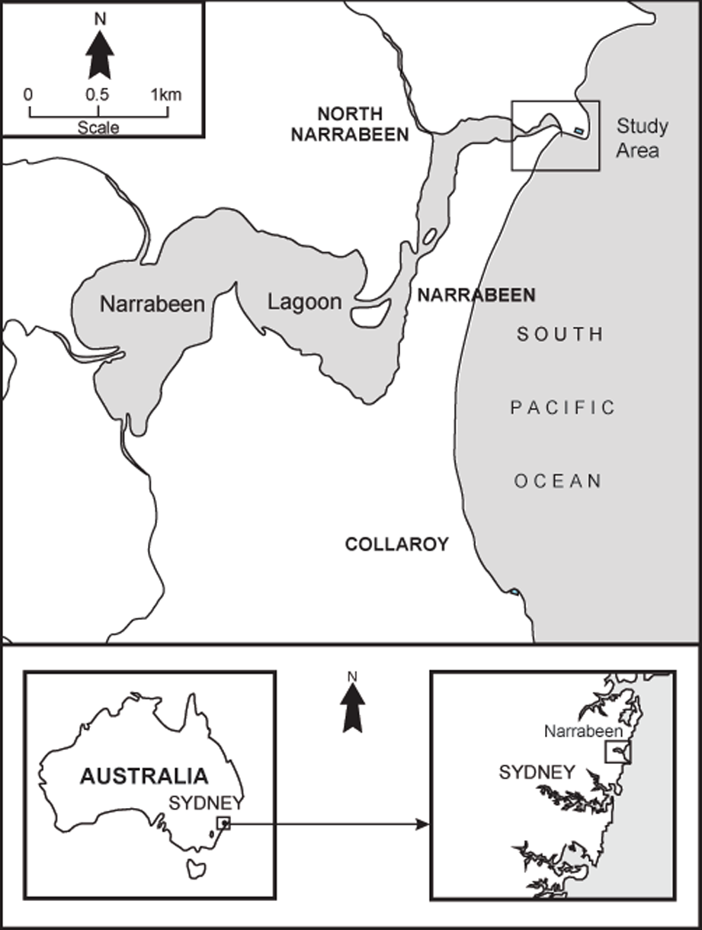
Figure 1. Maps showing location of Narrabeen Lagoon Entrance.

Why is sand cleared from the entrance of Narrabeen Lagoon?

The entrance of Narrabeen Lagoon naturally closes due to the movement of sand into the Lagoon entrance resulting from wave, current and wind processes. In general terms, the amount of sand moved into the entrance by the incoming tide exceeds the amount of sand carried out of the entrance by the outgoing tide. This causes an infilling, or choking, of the entrance of the lagoon which further reduces the capacity for the outgoing tidal currents, particularly in the absence of rainfall, to transport sediment out of the system. Over time the entrance becomes infilled to the point where it closes.

In a pristine system, with no development in its catchment or floodplain, the above-mentioned process would not be expected to be a problem because a natural entrance breakout would occur when lagoon or ocean water levels overtopped and breached the entrance berm. However, Narrabeen Lagoon is not a pristine system. The catchment of Narrabeen Lagoon has become urbanised over time, leading to a gradual deterioration of water quality in the lagoon. For example, until the 1970’s, the Lagoon received septic runoff from the surrounding development, resulting in extensive macroalgae blooms and odour problems (WBM, 2002). In its Independent Inquiry into Coastal Lakes the NSW Healthy Rivers Commission classified Narrabeen Lagoon as being in a Healthy Modified Condition (HRC, 2002).

Whilst water quality is certainly a fundamental driver in the management of the Narrabeen Lagoon entrance, flooding is the key issue. There are a significant number of flood-affected commercial, light industrial and residential properties within the Narrabeen Lagoon floodplain (SMEC, 2003). The development of the low-lying land took place before its flood prone nature was well understood (MHL, 1989). Flooding varies from water above habitable floors to the inundation of gardens and secondary buildings (SMEC, 2003). The primary flood affected areas are:
- The eastern side of the entrance channel;
- Lakeside Caravan Park and the surrounding residential area north of the lagoon entrance;
- The Mullet Creek area, from Pittwater Road to Jacksons Road;
- Narrabeen Creek floodplain including Warriewood Shopping Centre;
- The Wimbledon Avenue peninsula;
- NSW Academy of Sport; and
- The southern foreshore of the Central Basin.

In summary, a closed entrance may exacerbate flooding of low-lying land surrounding the Lagoon and can also initiate water quality problems (WBM, 2002). It is important that the entrance clearance operations are undertaken periodically because they enable the lagoon entrance to be successfully mechanically opened when water levels rise to the pre-determined level. They promote a medium term increase in the duration of open entrance conditions through improving the hydraulic efficiency of the tidal water flow through the entrance, which in turn reduces the likelihood of the entrance closing.

Narrabeen Lagoon Entrance Management Policy

The Narrabeen Lagoon Entrance Management Policy was adopted by Warringah and Pittwater Councils in 1996. The Policy describes the procedures for artificially opening and closing the Lagoon entrance, as well as periodic entrance clearance operations. The Policy, which includes the LagoonWatch monitoring program and defines responsibilities for entrance works, serves both estuary management and floodplain management purposes (WBM, 2002).

Under the Policy, before initiating an entrance clearance operation it is essential to firstly consider whether the following conditions exist:

- computer model information from Lagoon Watch and/or field observations indicate that the duration of entrance openings is decreasing to consistently less than ten (10) days over a period of six (6) months.
- the entrance area is choked (i.e. filled with beach sand) from west of the Ocean Street Bridge downstream to the natural rock weir at the entrance.

These conditions certainly existed prior to the 2006 entrance clearance operation. It is interesting to note that between 27 June 2005 and 10 September 2006 the lagoon entrance had to be mechanically opened on five (5) separate occasions.

Where is the sand placed?

Since the 1980s, all of the sand excavated as part of an entrance clearance operation has been placed on Collaroy/Narrabeen Beach, which has a long history of damage from coastal erosion (WC, 1997). During the entrance clearance operations of the 1970s, sand was used to re-build the dune in Birdwood Park, as well as rehabilitation works on other Warringah beaches.

How often are clearance operations undertaken?

The clearance of sand from the entrance of Narrabeen Lagoon is a maintenance activity that must be undertaken periodically. Historically, entrance clearance operations have been undertaken on average every three years since the mid 1970s. The chronology of entrance clearance operations is provided in Table 1 (CLT, 2006).

Table 1. Past Entrance Clearance Operations (Adapted from PBP, 2003)

Year | Sediment Removed (m³) | Location with Respect to Ocean Street Bridge | Approximate Cost ($)* | Approximate Duration
1975 | 150,000 | ? | 48,000 | 5 months
1979 | 37,500 | ? | ? | 1 month
1982/83 | 60,000 | ? | ?
1987 | 40,000 | East | 140,000 | 3 months
1990 | 30,000 | East and West | 60,000 | 4 months
1992/93 | 56,000 | East and West | 176,000 | 5 months
1995 | 27,500 | East and West | 39,000 | 4 months
1999 | 70,000 | East and West | 330,000 | 3 months
2002 | 40,000 | East and West | 600,000 | 4 months
2006 | 45,000 | East and West | 800,000 | 2 months
* Dollar estimates are likely to relate to the year in which the expenditure occurred and cannot be directly compared due to variables such as inflation, whether Council ‘outsourced’ the work (i.e. used external contractors/consultants), or undertook the work ‘in-house’.

Who pays for the entrance clearance operations?

The NSW Government provides financial assistance to Warringah Council for up to two thirds of the total cost of the project, in accordance with the 2:1 cost sharing arrangements of the NSW Floodplain Management Program. Warringah Council pay the balance and then seek re-imbursement from Pittwater Council for its share of the costs (i.e. one sixth of project costs, excluding staff time).

Monitoring of entrance

Monitoring of complex and dynamic coastal systems, such as the entrance to Narrabeen Lagoon, is logistically difficult, time-consuming and expensive. As a response to this, changes to the coastline are being monitored around Australia, and globally, using the state-of-the-art automated video systems known as ARGUS (Holman and Stanley, 2007). The stations collect colour video images every hour from multiple cameras over extensive spatial scales (i.e. kilometres) and long time scales (i.e. years). These systems are being used to build a database of frequent, long-term, spatially-extensive observations at a number of coastal sites.

There are currently 8 sites in Australia (Turner et al., 2006), including Narrabeen Lagoon Entrance, being monitored by these video systems which encompass both beach and tidal inlet environments. The data collected supports a range of coastal process studies and are also used for verification of numerical models to predict coastal dynamics and change.

Further to the installation of the ARGUS station a morphological monitoring program is being undertaken at the entrance to Narrabeen Lagoon using a state-of-the-art Real Time Kinematic Differential GPS (RTK-DGPS) system. The survey data obtained complements the continuous video data in order to quantitatively and qualitatively monitor the evolution of the lagoon entrance following the clearance operation.

The 2006 entrance clearance operation

Project Management

Due to the project’s size and complexity, a decision was made early in the planning stages of the project to commission a specialist coastal engineering company to assist Council in managing the project. Council invited quotations from suitably qualified companies and Cardno Lawson Treloar (CLT) was the successful tenderer. CLT’s role was divided into two distinct parts - the first part being the preparation of the tender documentation for the clearance and the second part being the supervision and administration of the project.

The preparation of the tender documentation for the entrance clearance involved; updating existing tender documents (i.e. from the 2002 entrance clearance), surveying the Lagoon entrance (both sediment and seagrass), determining design profiles for the excavation, and specifying nourishment locations. The supervision and administration of the project involved; coordinating the tendering process for the construction stage of the project, community consultation, obtaining necessary approvals, on-site administration and supervision including surveys and assurance of compliance with design profiles, and reporting to Council.

Pre-clearance design details

The pre-clearance bathymetry of the lagoon in the area of the works was defined from survey. In the preparation of the design for the clearance works, a number of factors were considered, including location of seagrass beds, proximity of training wall and Ocean Street Bridge, depth to the rock weir, and the maximum depths of excavation. The design of the clearance works was broken into two zones; a western (upstream of the bridge) zone and an eastern (downstream of the bridge) zone. The design removed similar quantities of sand from both the eastern and western zones (CLT, 2006). The total volume proposed to be removed was 42,900m³ (i.e. 22,700m³ from Western zone and 20,200m³ from Eastern zone).

Beach Replenishment

A survey of Collaroy/Narrabeen Beach was undertaken by the Water Research Laboratory (WRL), a part of UNSW, on both 27 June 2006 and 13 September 2006 as part of an ongoing research project. The survey was conducted using a RTK-DGPS mounted on a quad bike and driven shore-parallel along the length of the embayment. The survey information was utilised in the beach replenishment design. The design for the beach replenishment was based on the need to create a profile which endeavoured to provide some short-term stability and protection for the properties along the beach-front. The design also took into account advice provided by NSW Department of Primary Industries (Fisheries) regarding the need to minimise impacts on beach ecology (CLT, 2006).

Pre-clearance approvals

Review of Environmental Factors (REF)

In accordance with Part V of the NSW Environmental Planning & Assessment Act (1979) a REF was prepared for the 2006 entrance clearance operation (CLT, 2006). The REF identified the potential impacts associated with the clearance operation and identified a range of environmental management measures for implementation. These included an Erosion and Sediment Control Plan, a Traffic Management Plan, and a Waste Management Plan.

A Preliminary Acid Sulfate Soil Assessment (SESL, 2006) was undertaken by the Contractor. Based on this assessment it was determined that an Acid Sulfate Soil Management Plan was not required (CLT, 2007).

Permits and Licences

A number of permits and licences were required for the project, as follows:
- Department of Lands – concurrence/consent for works.
- Department of Primary Industries – permit applied for under Part 7 of the Fisheries Management Act, 1994 and issued.
- Department of Environment and Conservation – licence applied for under the Protection of the Environment Operations Act, 1997 and issued (dredging > 30,000 m³).
- Department of Natural Resources – no permit required under the Rivers and Foreshores Improvement Act, 1948 (CLT, 2007).
- Pittwater Council – provided approval to temporarily relax the 3 tonne limit of Walsh St, North Narrabeen. This improved the overall safety of the operation significantly by allowing a circuitous, uni-directional route for truck movements along Ocean St, Walsh Street, and Pittwater Rd.

Community Consultation

Community consultation was undertaken via media releases and associated newspaper articles, distribution of an information brochure, and poster displays. Additional community information included a notice distributed by Council to affected areas advising of traffic changes relating to the works. A phone number was also provided for complaints as required under the DEC licence (CLT, 2007).

Tender and Award

The Tender process was via Open Tender and was advertised in the national press. Kingston Civil Constructions was selected as the successful tenderer based upon the evaluation of both cost, and non-cost items such as program, method statement for the works, environmental protection, previous experience, and traffic control methods (CLT, 2007).

Clearance Works

Description of works

The major items of work included:
- Excavation of marine sediment from the lagoon entrance as detailed on the Drawings;
- Sieving of any excavated sediment which contained pieces of rock exceeding the size specification and disposal of this rock material off site;
- Transportation of marine sediment to Collaroy/Narrabeen Beach, placement at designated points on the beach and spreading of the sediment along the beach front;
- Mechanical opening of the Lagoon Entrance; &
- Traffic Management (CLT, 2007).

Environmental Management Plan (EMP)

An Environment Management Plan (EMP) was developed by Kingston Civil Constructions and largely followed the recommendations outlined in the REF (CLT, 2006). This plan was developed to ensure that damage was not caused to any existing structures or the natural environment. The EMP considered the need for permits/licences and control measures under relevant legislation, outlined potential environmental impacts through an Environmental Impact Planning Checklist, listed measures to be taken in case of an environmental incident (e.g. spills) and outlined Site Environmental Guidelines which list measures that were to be taken to minimise the impact of the proposed works on the surrounding environment.

Management plans incorporated into the overall Environmental Management Plan included a Soil and Water Management Plan, Noise and Vibration Management Plan, and a Waste Management Plan. A specific requirement for this project was the implementation of silt curtains around areas where clearance works were occurring, to minimise the amount of suspended sediment generated from the clearance operation, and ultimately to prevent any adverse impacts associated with suspended sediments affecting nearby seagrass beds and aquatic fauna (CLT, 2007).

Preparatory earthworks - pre-entrance clearance

Prior to the commencement of the clearance operations, the Lagoon Entrance was opened on 10 September 2006 (in accordance with the Entrance Management Policy) following rainfall over the catchments feeding Narrabeen Lagoon. Before the clearance works could commence, the Lagoon Entrance was artificially closed with sand on 29 September 2006. The primary motivation for initiating the artificial closure was to minimise turbidity and the transport of suspended sediments during clearance works and ensure that lagoon water levels were sufficient to cover the seagrass beds and ensure their survival during the entrance clearance operations. The artificial closure involved the construction of a sand “levee” to a height of 1m AHD, with sand being progressively deposited in a south-north direction. The height of the levee was sufficient to maintain water level for ecological purposes, while providing some storage capacity for any rainfall events that might occur during the entrance clearance works (CLT, 2007).

Beach replenishment works

The technical specification indicated that the replenishment works should be limited to the placement and spreading of sediment on Collaroy/Narrabeen beach in the following areas:
- Between high water mark and the fence line of properties near the ends of Mactier, Clarke, Wetherill, Stuart and Frazer Streets;
- Between high water mark and the vegetation line of the dunes adjacent to the Collaroy Beach Car Park, north of the Collaroy commercial area.

Seven locations were identified for the delivery of material for the purpose of beach replenishment. These were Mactier Street, Clarke Street, Wetherill Street, Stuart Street, Frazer Street, Collaroy Beach Car Park and Sydney Lakeside Holiday Park beach (CLT, 2007).

Operational Environmental Matters

Several environmental matters arose during the clearance operation and are outlined below.

In addition to the comprehensive management measures recommended to protect seagrass (CLT, 2006), monitoring was undertaken to detect damage to seagrass beds as a result of the clearance works. Results of this monitoring found that there was little variation in the distribution and total area of seagrass beds (The Ecology Lab, 2007).

Following the commencement of the clearance operation, concern was expressed by the NSW Department of Environment and Conservation about the impact of the entrance clearance works upon a pair of Osprey that were nesting in a Norfolk Island Pine approximately 100m south-west of the Ocean Street bridge. In response to this concern, Warringah Council commissioned Avifauna Research & Services to conduct an impact assessment of the clearance operations on the Ospreys. It was concluded that the works had no detrimental impact upon these birds or their breeding success. (Avifauna Research & Services, 2007).

The need for better delineation of areas in which nourishment material should be placed during replenishment works were highlighted by two minor matters (CLT, 2007). The first was an incident where sand was inappropriately placed on a vegetated area of public land in front of a residence on Mactier Street, which resulted in a confrontation. The second was when sand was placed in front of a stormwater outlet on the beach adjacent to Ramsay Street, briefly causing backwater flooding in the street. Residents notified Council and the blockage was promptly cleared. No damage was sustained to any property.

A minor water pollution incident occurred, which was suspected to have been caused by an oil leak from trucks entering the water. The matter was promptly dealt with by Kingston and it was later determined that the leak originated from a stormwater drain leading from a nearby light industrial area on Pittwater Road.

The final minor incident was a claim that the transport of sand along Wetherill Street and deposition on Collaroy Beach resulted in the deposition of sand, salt spray and diesel fumes on a newly rendered and painted building in Wetherill Street. After further investigation, the claim was subsequently dropped (CLT, 2007).

Post-Clearance Monitoring

In order to monitor the evolution of the Narrabeen Lagoon entrance system following the clearance operation, various types of data are being collected. These include image data, morphological survey data as well as hydrodynamic data.

Video image data are acquired via a fixed ARGUS station (Holman and Stanley, 2007) located on the roof-top of the North Narrabeen SLSC. The colour images are collected hourly from four cameras during daylight hours and the station has been collecting images since July 2005. In November 2006 a fifth camera was installed on the swimming club building on the northern side of the lagoon entrance and communicates with the station via a wireless link. This camera provides detailed image data of the lagoon entrance channel.

The oblique images collected can be rectified to real-world (xyz) co-ordinates using the methods of Holland et al. (1997) in order to undertake various qualitative analyses. More details of the analyses of these data can be found in Morris et al. (2007) and Morris and Turner (2007). Examples of merged oblique images collected from the video system immediately following the reopening after the clearance operation (7th December 2006) after two months (8th February 2007) and after seven months (12th July 2007) are shown in Figure 2(a), (b) and (c) respectively.

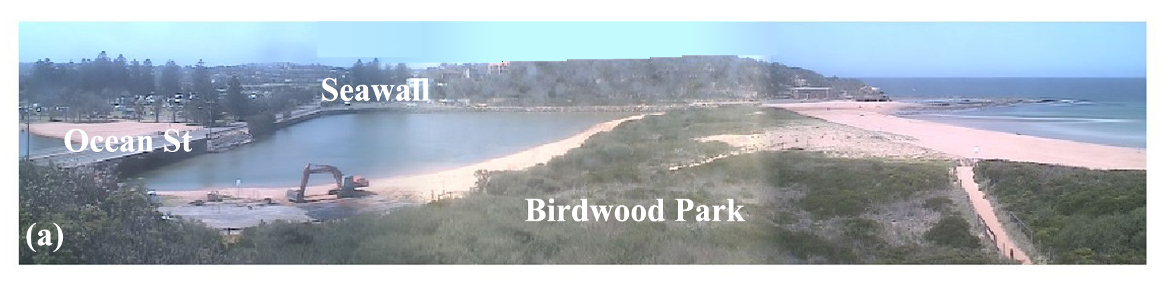
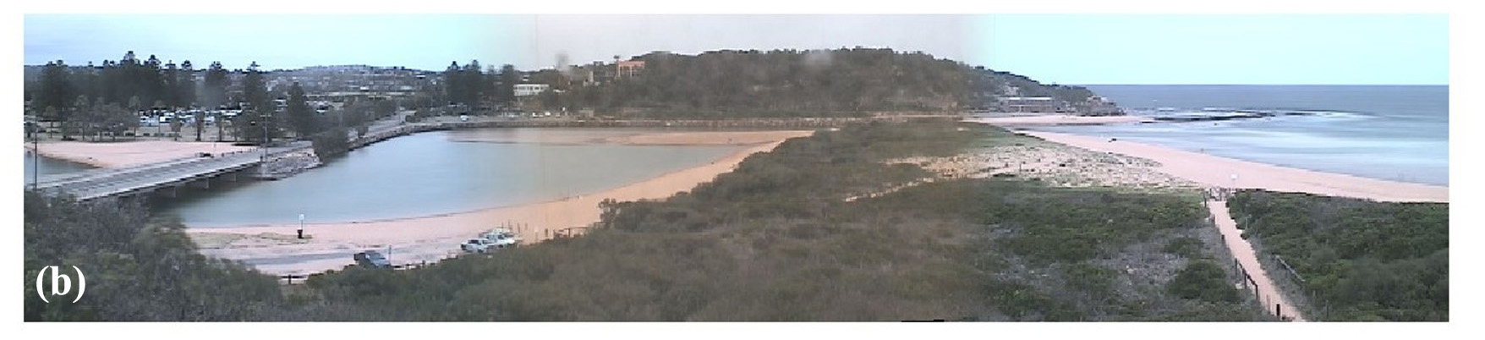
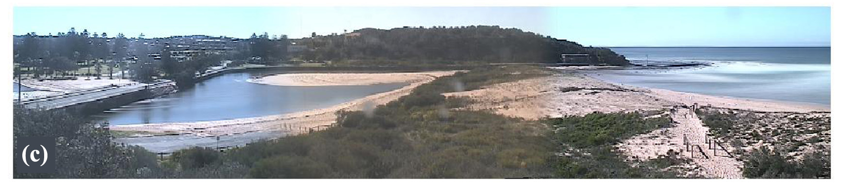
Figure 2. Merged oblique Argus images of the study site. (a) At the completion of entrance clearance, one day after re-opening of the entrance (7th December 2006). (b) Two months after reopening (8th February 2007). (b) Seven months after the re-opening of the entrance (12th July 2007).

Regular morphological surveys are ongoing since the re-opening of the lagoon following completion of the entrance clearance operation on 6th December 2006. These surveys are undertaken in two parts; the first using a Trimble RTK-DGPS mounted on a modified golf cart at low tide for the topography of the system. The second part is undertaken at slack high tide using the RTK-DGPS and a survey grade echo sounder mounted on a kayak to measure the bathymetry. The two data sets are then post-processed, checked for quality control and combined.

Using the combined survey data, easily comparable morphological maps are generated for each survey by gridding the data onto the same size and spaced grid and then blanking appropriately for areas that do not require repeat surveying, i.e. Birdwood Park dune, north of the seawall and the nearshore zone. A plot of the morphological map obtained from the survey of 2nd July 2007 is shown in Figure 3.

To evaluate the morphological evolution of the lagoon entrance each map is compared to a baseline map generated using the initial survey following the clearance operation, i.e. the survey of 7th December 2006. Volume calculations are performed on a cropped area of the map which contains only the region of the flood shoal and are based on the net change in elevation for each survey as compared to the baseline (pre-infilling) survey.

Hydrodynamic data was obtained via Manly Hydraulics Laboratory and consists of lagoon water levels and ocean wave data. A continuous Narrabeen Lagoon water level record is obtained from a permanent water level recorder adjacent to Ocean St bridge and data are referenced to MSL, see Figure 4(b). Ocean wave data is obtained from the Sydney waverider buoy and the parameters were used to calculate deepwater wave power shown in Figure 4(c).

Figure 3. Example of morphological map generated from RTK-DGPS survey data for 2nd July 2007.

Although various types of data are being acquired at Narrabeen Lagoon Entrance and the monitoring of its evolution is ongoing, the focus here is on the analysis and interpretation of the initial seven months of image and survey data with particular interest in the initial evolution the flood shoal.

As expected from anecdotal evidence from previous clearance operations the video data showed the rapid reformation and growth of the flood shoal due to sediment ingress following the reopening of the lagoon entrance, see Figure 2. Using the morphological maps generated from the survey data the evolution of the volume of the flood shoal was calculated and are shown in Figure 4(a). These results quantify the consistent increase in the volume (and area) of the flood shoal that were seen from observations in the field and the qualitative analyses of the video image data.

The flood shoal started to form within the first weeks following the entrance clearance and whilst the volume shows a consistent increase over time it is somewhat episodic with changes between surveys being as much as 2,300 m³ (1st to 14th June 2007), but more typically of the order of 420 m³. The total change in volume of the flood shoal in the initial seven months was 12,900 m³, which equates to an average ingress rate of 445 m³/week.

The water level in the lagoon entrance is tidal, however, it is super-elevated (with a mean level above zero MSL) and the range is significantly attenuated relative to the oceanic tidal fluctuations, see Figure 4(b). Further to this the lagoon water level is also affected by “pumping”, or increased elevations, due to both spring tides and/or storm waves. An example of this is seen during a swell event in the early part of June 2007 in Figure 4. This swell event coincided with a large increase in both the volume and area of the flood shoal indicating that the increased ingress of sediment to the flood delta is due to the increased lagoon water elevation and/or the increased wave energy in the nearshore.

Figure 4. Comparison of volumetric evolution with hydrodynamic forcing. (a) Cumulative volume of flood shoal. (b) Lagoon water levels. (c) Wave power.

Clearance Outcomes

Overall the 2006 Narrabeen Lagoon Clearance Operation was a success with only minor issues during the works phase. The major objectives of the operation were all fulfilled. There was improved flood mitigation and water quality in the lagoon system following clearance of the sand and restoration of tidal flushing (Wiecek and Floyd, 2007). Although not an objective of the entrance clearance operation, flow on benefits of the clearance operation included significant improvements in recreational amenity around the lagoon entrance area. For example, during the peak summer holiday period of 2006/07 the Sydney Lakeside Caravan Park (the only park of its type on the Sydney Northern Beaches) was once again filled with ‘happy campers’, unlike the previous year when the entrance was closed and there was no tidal flushing, and the water was stagnant. In the previous summer holidays (i.e. the summer of 2005/06), both Pittwater and Warringah Councils received numerous complaints from park visitors and members of the community. Visitors to this park travel from all over NSW and the economic benefits to the local economy are significant. In summary, the improved level of community satisfaction that is provided following an entrance clearance operation, and the resulting re-establishment of tidal flushing, should not be underestimated. The lagoon entrance area is highly valued by both visitors to the area and the local community and the ability to use the area for water-based recreational activities (eg. swimming) has a number of direct and in-direct benefits. One of the in-direct, and perhaps less obvious, benefits is the increased inclination of the community to care more about other areas of the lagoon system, such as the health of the catchment and the lagoon’s aquatic ecosystems.

Projects costs

The total cost for the 2006 entrance clearance operation (excluding Council staff time) was approximately $800,000 with ‘works’ costs of the order of 80% of the total fee and ‘management’ costs (design, assessment, supervision, management) of the order of 20%.

Recommendations from Post Completion Report

The Post Completion Report (CLT, 2007) contains a number of recommendations for consideration prior to the next entrance clearance operation. The recommendations are as follows:

- Commence planning for clearance operation approximately 12 months prior to the anticipated commencement of works to allow sufficient time to obtain necessary licences, permits and approvals.
- Bathymetric survey of excavation profile be mandatory by the contractor on a minimum 3 weekly basis to ensure that over-excavation does not occur.
- Bathymetric survey of the beach areas before and after the works.
- Works occurring outside of known Osprey breeding period (July to December).
- Ensuring that future contractors implement the complete requirements of the Traffic Management Plan to help avoid any traffic incidents.
- Further monitoring of avifauna and the establishment of a monitoring program for aquatic fauna.
- Incorporate recommendations as appropriate from the MHL study into alternative entrance clearance strategies (MHL, 2007) and BMT WBM’s review of coastal lagoon entrance management in the Warringah LGA (BMT WBM 2007).

The implementation of these recommendations may improve the management of future entrance clearance operations.

Concluding remarks

Entrance clearance operations were undertaken in Narrabeen Lagoon between 29 September 2006 and 6 December 2006 by Kingston Civil on behalf of Warringah and Pittwater Councils. These operations involved the removal of ~45,000 m³ of sand from the entrance of Narrabeen Lagoon, which was used for beach replenishment works along Collaroy/Narrabeen Beach, and minor replenishment of the beach area adjacent to the Sydney Lakeside Holiday Park.

The entrance clearance works were completed successfully without any major issues. A few minor issues were experienced relating to traffic, inappropriate placement of sand, a water pollution incident (caused by others) and minor damage to properties in Wetherill Street. However, the majority of these issues were resolved during the course of the works. Monitoring of seagrass (Zostera capricorni and Halophila ovalis) and a pair of Osprey (Pandion haliaetus) nesting in close proximity to the works indicated that the clearance work did not have a significant impact upon seagrass distribution or extent, or on the foraging and breeding activities of the Ospreys (CLT, 2007).

One of the main reasons why the project was a success, apart from the thorough planning during the early stages of the project, was because of the high level of knowledge, skills and experience of the project team (including staff and contractors from Warringah Council, CLT, WRL, DNR, Pittwater Council, and Kingston Civil). There was good communication among the project team and a genuine willingness to work together to get the job done. Everyone involved in the project carried out their role in a highly professional manner.

Monitoring of the entrance post completion of the clearance operation is ongoing, however results to date have provided qualitative and quantitative information on the initial infilling of the entrance via the evolution of the flood shoal volume. Future work will continue to quantify the infilling mechanisms in order to provide further insight into ICOLL processes.

It is likely that the implementation of the recommendations from the Post Completion Report (CLT, 2007), together with the findings from the ongoing monitoring being undertaken by WRL, will lead to further improvements in the management of future entrance clearance operations. This combination of science and management, feeding off each other and not occurring in isolation, will lead to ongoing improvements in the management of Narrabeen Lagoon entrance, and has applicability to other systems facing similar issues.

Acknowledgements

The ARGUS video monitoring station at Narrabeen Lagoon is supported by funding to UNSW from Warringah Council. Thanks also to North Narrabeen SLSC for permission to locate the ARGUS station at the surf club and Pittwater Council for its assistance and permission to locate the fifth camera on the swimming club. Further, the authors would like to thank Pittwater Council and staff from the NSW Department of Environment and Climate Change (Sydney Flood Group) for their cooperation and key roles in helping to ensure the clearance operation was a success. The NSW Department of Commerce Manly Hydraulics Laboratory is also acknowledged who, on behalf of the NSW Department of Environment and Climate Change, provided the lagoon water level and wave data. Bradley Morris is funded by a Faculty of Engineering UNSW Postgraduate Research Scholarship.

References

Avifauna Research & Services, 2007. Impact Assessment of Clearance Operations on Ospreys (Pandion haliaetus) at Narrabeen Lagoon. Prepared for Warringah Council.
BMT WBM, 2007. Review of coastal lagoon entrance management in the Warringah LGA. Currently being undertaken by BMT WBM on behalf of Warringah Council.
CLT, 2006. Narrabeen Lagoon Entrance Clearance Review of Environmental Factors. Prepared for Warringah Council by Cardno Lawson Treloar Pty Ltd.
CLT, 2007. Narrabeen Lagoon Entrance Clearance Operation Post Completion Report. Prepared for Warringah Council by Cardno Lawson Treloar Pty Ltd.
Gale, E., Pattiaratchi, C., Ranasinghe, R., 2006. Vertical mixing processes in Intermittently Closed and Open Lakes and Lagoons, and the dissolved oxygen response. Estuarine, Coastal and Shelf Science 69, 205-216.
Elwany, M.H.S., Flick, R.E., Aijaz, S., 1998. Opening and Closure of a Marginal California Lagoon Inlet. Estuaries 21(2), 246-254.
Everett, J.D., Baird, M.E., Suthers, I.M., 2007. Nutrient and plankton dynamics in an intermittently closed/open lagoon, Smiths Lake, south-eastern Australia: An ecological model. Estuarine, Coastal and Shelf Science, 72, 690-702.
Gordon, A.D., 1990. Coastal lagoon entrance dynamics, 22nd Int. Coastal Eng. Conf. ASCE, Delft., pp. 2880-2893.
Haines, P., 2003. The Significance of Entrance Behaviour in Coastal Lagoons, 12th NSW Coastal Conference, Port Macquarie, pp. 87-95.
Haines, P., 2004. Current Entrance Management Practices for NSW ICOLLs., Coastal Zone Asia Pacific Conference, Brisbane, pp. 294-300.
Haines, P.E., Tomlinson, R.B., Thom, B.G., 2006. Morphometric assessment of intermittently open/closed coastal lagoons in New South Wales, Australia. Estuarine, Coastal and Shelf Science 67, 321-332.
Haines P. E., 2006. Physical and chemical behaviour and management of NSW ICOLLs. PhD thesis, Griffith University 505p.
Holland, K.T., Holman, R.A., Lippman, T.C., Stanley, J. and Plant, N., 1997. Practical use of video imagery in nearshore oceanographic field studies. IEEE Journal of Oceanic Engineering, 22(1): 81-92.
Holman, R.A., Stanley, J., 2007. The history and technical capabilities of Argus. Coastal Engineering, 54, 477-491.
Healthy Rivers Commission, 2002. Independent Inquiry into Coastal Lakes – Final Report, Sydney.
Kirk, R.M., Lauder, G.A., 2000. Significant coastal lagoon systems in the South Island, New Zealand - Coastal processes and lagoon mouth closure. Science for conservation, 146, 47 pp.
Lankford, R.R., 1976. Coastal lagoons of Mexico. Their origin and classification. In: M. Wiley (Editor), Estuarine Processes. Academic Press, New York, pp. 188-215.
MHL, 1989. Narrabeen Lagoon Entrance Study. MHL552, Manly Hydraulics Laboratory, Public Works Department, N.S.W, 105pp.
MHL, 2007. Alternative management strategies for clearing Narrabeen Lagoon Entrance. Prepared for Warringah Council.
Morris, B.D., Coco, G., Bryan, K.R. and Turner, I.L., 2007. Video-derived mapping of estuarine evolution. Journal of Coastal Research, SI 50: 410-414.
Morris, B.D., Turner, I.L., 2007. Rapid infilling of an intermittently open-closed lagoon entrance following mechanical clearance, 18th Australasian Coastal and Ocean Engineering Conference, Melbourne, Australia, pp. 6.
PBP, 2003. Narrabeen Lagoon Entrance Clearance Operation Post Completion Report.
Prepared for Warringah Council by Patterson Britton & Partners Pty Ltd.
Pollard, D.A., 1994. A comparison of fish assemblages and fisheries in intermittently open and permanently open coastal lagoons on the south coast of New South Wales, south-eastern Australia. Estuaries, 17(3): 631-646.
Ranasinghe, R., Pattiaratchi, C., Masselink, G., 1998. Seasonal inlet closure: Governing processes. Journal of Coastal Research, SI(26), 32-41.
Ranasinghe, R., Pattiaratchi, C., 1999. The seasonal closure of tidal inlets: Wilson Inlet - a case study. Coastal Engineering, 37, 37-56.
Roy, P.S., Williams, R.J., Jones, A.R., Yassini, I., Gibbs, P.J., Coates, B., West, R.J., Scanes, P.R., J.P., H., Nichol, S., 2001. Structure and function of south-east Australian estuaries. Estuarine, Coastal and Shelf Science 53, 351-384.
SESL, 2006. Preliminary Acid Sulfate Soil Assessment for Narrabeen Lagoon, Narrabeen NSW. Prepared for Kingston Civil.
Suzuki, M.S., Ovalle, A.R.C., Pereira, E.A., 1998. Effects of sand bar openings on some limnological variables in a hypertrophic tropical coastal lagoon of Brazil. Hydrobiologia 368, 111-122.
SMEC, 2002. Narrabeen Lagoon Floodplain Risk Management Study & Plan. Volume 1 – Pittwater. Prepared for Pittwater Council.
SMEC, 2003. Narrabeen Lagoon Floodplain Risk Management Study & Plan. Volume 1 – Warringah. Prepared for Warringah Council.
Stretch, D., Parkinson, M., 2006. The breaching of sand barriers at perched, temporary open/closed estuaries - a model study. Coastal Engineering Journal 48(1), 13-30.
The Ecology Lab, 2003. Maintenance Clearance at the Entrance of the Narrabeen Lagoon - Effects on the Distribution of Seagrasses. Prepared for Warringah Council.
The Ecology Lab, 2007. Clearance at the Entrance of the Narrabeen Lagoon - Effects on the Distribution of Seagrasses. Prepared for Warringah Council.
Turner, I.L., Aarninkhof, S.G.J., Holman, R.A., 2006. Coastal imaging applications and research in Australia. Journal of Coastal Research, 22(1), 37-48.
Warringah Council, 1996. Management Policy for Narrabeen Lagoon Entrance. Warringah Council Policy Manual, ENV-PL 420, 6p.
Warringah Council, 1997. Collaroy/Narrabeen Coastline Management Plan. A Coastline Hazards Policy - Plan of Management. Warringah Council, 1997, Sydney.
WBM, 2002. Narrabeen Lagoon Estuary Management Plan. Prepared for Warringah and Pittwater Councils: Final Report.
Wiecek, D., Floyd, J., 2007. Does dredging in ICOLL entrances improve tidal flushing? 16th NSW Coastal Conference, Yamba, (in press).

Disclaimer - The views expressed in this paper are the authors’ and are not necessarily those of Warringah Council, the Water Research Laboratory (UNSW), or Cardno Lawson Treloar Pty Ltd.

