A regional application of an adaptive quantitative method to measuring sustainability of the SouthERN Regional Organisation of Councils in Queensland, Australia

Introduction

With growing global concerns focused on climate change, and the like, civilisation as we know it is at threat. Throughout the world the majority of modern societies are based on metropolitan centres that engineer and construct outward due to augmenting demographics. This demand exponentially stresses the need and desire for more energy, resources and space. To help alleviate this overdevelopment a framework based on sustainability-thinking offers a partial solution to a stability crisis. To date, much of the sustainability-based literature, that is, for the purpose of developing stable societies, has focused on qualitative methodologies as a premise to integrating or defining sustainability. Qualitative research focuses on reality as a social construct, placing its primacy on subject matter from an insider’s point of view (Creswell, 1994). These conditions have enabled the growth and development of qualitative sustainability research over the past few decades. However it is evident, due to current global trends, that qualitative sustainability methods alone are not suffice. The emergence of quantitative sustainability, that is, research that examines social facts from an objective reality viewed from an outsider’s point of view, means variables can be identified and relationships measured (Creswell, 1994). Quantitative sustainability research is receiving a great deal of interest from mainstream policy-makers alike. As novel research and methodological management applications continue to expand from within the discipline, it is hopeful that this research may foster further or supplementary knowledge to better assist with unsustainable practices.

One innovative quantitative sustainability concept is the index of sustainable functionality (ISF) (Imberger et al., 2005). The primary idea of the ISF derived from related sustainability concepts and indices – both qualitative and quantitative in nature. Examples include the Environmental Sustainability Index (Esty et al., 2001), the Human Development Index (UNDP, 1990), the Index for Sustainable Economic Welfare (Daly and Cobb, 1989), the Gross Happiness Indicator (Thinley, 1998), the Ecological Footprint (Rees, 1992) and the Genuine Progress Indicator (Cobb, Halstead and Rowe, 1995). The concept of the ISF has grown from either a lack of recognition or useability of these previous methods; it utilises an objective, quantitative multi-criteria methodology to examine and measure sustainability. From this standpoint, it is optimistic this sort of research will promote ideas and recognition for advancement in this field.

This ISF study examines the Southern Regional Organisation of Councils (SouthROC), located in South East Queensland (SEQ), Australia. The SouthROC is one of four local government regional collaboration groups. It has Queensland memberships from Beaudesert Shire Council (BSC), Gold Coast City Council (GCCC), Logan City Council (LCC) and Redland Shire Council (RSC) (Figure 1.). The Tweed Shire Council located in New South Wales is also formally a part of the SouthROC but is not included in this study due to its exclusion from SEQ. This study is labelled the ISF of the SouthROC and is one of four ISF studies that make up a larger project called the ISF of SEQ. It also is an expansion of the pilot study, the ISF of the Gold Coast, which was a small-scale trial project using simplified methods (Cirella, Tao and Mohammed, 2007). The SouthROC is one of the fastest growing regions in SEQ; its land use patterns include urban, suburban, rural residential and rural environments. It is experiencing massive changes due to a booming population and very strong economic growth. These settings are optimal for an ISF application.

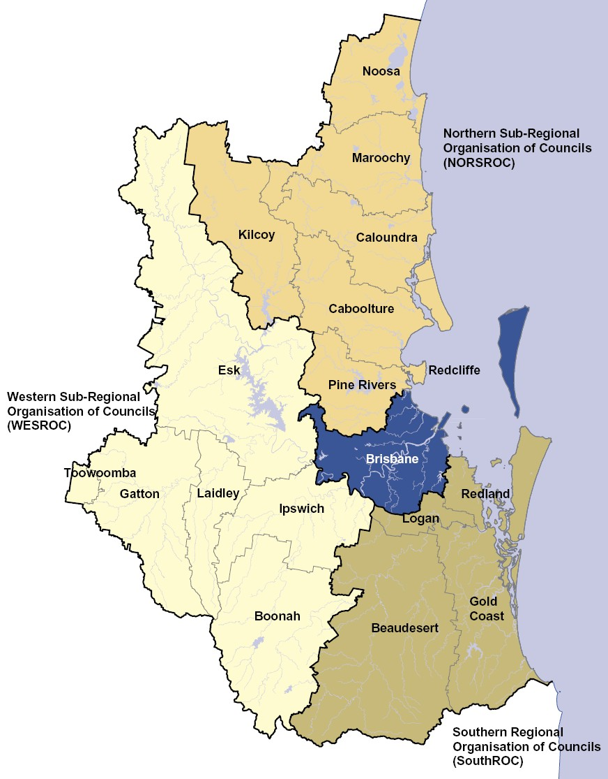

Figure 1. The SouthROC is located in the south eastern corner of SEQ. The Queensland memberships for the SouthROC include four local government councils: BSC, GCCC, LSC and RSC (Queensland Government, 2005).

Methods

The methodology used to measure sustainability is effectively the manner in which sustainability is defined in this study. The definition of sustainability is formulated via the utilisation of the ISF. The ISF is founded on the principle that functions of complex systems are preserved, and their functionalities remain invariable. While this functionality does not change, the system’s variability can fluctuate. The following definition of sustainability is based on this notion.

An action by one system on another system, within a particular domain or across adjacent domains is adaptively sustainable provided the rate of change of functions, measured by normalised independent indicators, brought about by action, is slower that the rate at which the recipient system can respond without loss of function (Imberger et al., 2005).

This definition is action driven in that “actions are defined as the dependencies between systems” (Imberger et al., 2005). An action is thus the amount of variation that influences the functionality of systems. The method used for the ISF of the SouthROC measures sustainability on this premise and is put together using an engineering scope and matrix-based approach. This is quantitative in that it institutes an approach of measuring sustainability via adaptive means which incorporates complex interactions recorded over time to establish traceable records of sustainability trends. The process of contributing and/or being able to adapt to these trends is fundamentally the ability to act, or begin to act, sustainability-friendly (Cirella, Tao and Mohammed, 2007). The methodology of the ISF of the SouthROC is comprised of two parts structure and computation.

Structure of the ISF of the SouthROC

The method in which the structure of the ISF of the SouthROC is put together is via five defined steps. The process is linear and it identifies the manner in which the ISF of the SouthROC is created (Figure 2.).

Step 1. Identify the domain and sub-domains
The domain is the region being measured for sustainability. SEQ is the domain; this study is one fourth of a larger project labelled the ISF of SEQ. The SouthROC is a sub-domain, that is, a spatial resolution within the domain of SEQ. This study is thus abridged to measure only the ISF of SouthROC.

Step 2. Identify the systems and perspectives
The four systems of this project are defined as the natural system, social system, individual system and economic system. They are the main mechanisms of the domain. The perspectives are viewpoints which are identified as environmental, social and economic. Together the systems and perspectives make up the matrix-based approach to the ISF framework.

Step 3. Identify the functions and indicators
Functions are the activities that a system should be performing for a particular perspective, while indicators are the datasets that record the changes in sustainability over time. In this study there are 24 functions and 60 indicators. The scale of the study is 25 years measured in 5 year blocks from 1980 to 2005.

Step 4. Normalise the datasets
The datasets are normalised by setting the indicator values between zero and one so that they can be compared and aggregated.

Step 5. Weightings and aggregation
The weightings are the subjective values weighted via a nine person expert panel. The relationships of the weightings for functions-to-perspectives and indicators-to-functions results in percentage values that are incorporated into the index calculations. The summation of each year recorded provides the profile results for the ISF of the SouthROC.

Figure 2. The five step process of the structure of the ISF of the SouthROC (Cirella, 2006).

First, to formulate the definition of the ISF the definition of various terms variables must be assigned. The region in which the study is to take place is labelled the domain (D), while sub-domains (D_{i}) may exist and are a spatial resolution within the domain. This project identifies the domain as SEQ (D). The domain of SEQ includes four sub-domains: the Northern Sub-Regional Organisation of Councils (NORSROC) (D₁), the Western Sub-Regional Organisation of Councils (WESROC) (D₂), the SouthROC (D₃) and Brisbane City Council (Brisbane) (D₄). The scope of this paper will only cover the sub-domain of the SouthROC (D₃) (Figure 3.). The formation of the SouthROC is subdivided into four regional councils: BSC, GCCC, LSC and RSC.

The ISF of SEQ
Domain  (D) | D – South East Queensland
Sub-domains  (D_{i}) | D₁ – NORSROC | D₂ – WESROC | D₃ – SouthROC | D₄ – Brisbane
Systems  (S_{ij}) | S₁₁ – NORSROC-  Natural  S₁₂ – NORSROC-  Social  S₁₃ – NORSROC-  Individual  S₁₄ – NORSROC-  Economic | S₂₁ – WESROC -  Natural  S₂₂ – WESROC -  Social  S₂₃ – WESROC -  Individual  S₂₄ – WESROC -  Economic | S₃₁ – SouthROC -  Natural  S₃₂ – SouthROC -  Social  S₃₃ – SouthROC -  Individual  S₃₄ – SouthROC -  Economic | S₄₁ – Brisbane -  Natural  S₄₂ – Brisbane -  Social  S₄₃ – Brisbane -  Individual  S₄₄ – Brisbane -  Economic

Figure 3. The application of the ISF of SEQ – domain, sub-domains and systems breakdown (Cirella, 2006).

Second, it is necessary to identify the matrix-based approach. This approach is defined by labelling systems (S_{ij}) and perspectives (N^{k}_{ij}) on opposite sides of a matrix. The systems of the ISF of the SouthROC are mechanisms of the domain which, collectively, correspond to all aspects of its sustainability. There are four systems for the SouthROC labelled natural (S₃₁), social (S₃₂), individual (S₃₃) and economic (S₃₄). The numerical values for each of the systems has been added to better identify with the project’s scope (Figure 3 also illustrates this point by labelling the systems’ variables). The perspectives are intra or interdomainal viewpoints (Brown, 2006) that use a cross-reference pattern against the related systems. The perspectives are commonly influenced by the domain (Imberger et al., 2005) and skeleton the viewpoint of the function selected for measurement. This study has three perspectives: social, environmental and economic (Figure 4).

 |  |  | System (S_{ij})
 |  | Natural |  | Social | Individual | Economic
Perspective (N^{k}_{ij}) | Social | Function(s) of the Natural System as determined by the social perspective |  | Function(s) of the Social System as determined by the social perspective | Function(s) of the Individual System as determined by the social perspective | Function(s) of the Economic System as determined by the social perspective
Perspective (N^{k}_{ij}) | Environmental | Function(s) of the Natural System as determined by the environmental perspective |  | Function(s) of the Social System as determined by the environmental perspective | Function(s) of the Individual System as determined by the environmental perspective | Function(s) of the Economic System as determined by the environmental perspective
Perspective (N^{k}_{ij}) | Economic | Function(s) of the Natural System as determined by the economic perspective |  | Function(s) of the Social System as determined by the economic perspective | Function(s) of the Individual System as determined by the economic perspective | Function(s) of the Economic System as determined by the economic perspective

Figure 4. The matrix-based approach of the ISF of the SouthROC (Imberger et al., 2005, Cirella, 2006).

Third, the next step in defining the ISF is that systems must have the aptitude to safeguard certain functions (F^{k}_{ijl}), that being, functions are the activities that a specific system should being carrying out for a particular perspective (Imberger et al., 2005). Using a system-perspective approach functions utilise specific indicators that are tested against its relating function. The ISF definition of an indicator is a tool in which data can be analysed and simplified for changes in sustainability. Hence, indicators are to be clearly associated with the function they are testing against, be scientifically valid and available over time and for comparison to thresholds (Brown, 2006). For the ISF of the SouthROC the functions totalled 24 while the indicators totalled 60; both functions and indicators are founded from sources such as government reports, interviews, technical papers and literature alike (see Appendix 1 for the list of functions and indicators used). The ISF of the SouthROC is measured in 5 year blocks from 1980 to 2005; thus, the time period of the study measures the sustainability for the region over a 25 year span.

Fourth, the normalisation of data is needed to establish a universal standard of measurement between the different scales and units of each indicator. Normalised indicators (I^{k}_{ijlm}) are defined with upper and lower functional bounds which are assigned to a value between zero and one. The definition of the upper and lower assigned values equals zero when it is at its worst state and/or situation and one when it is at its best state and/or situation. Thus, when the system operates at full dysfunctionality it is regarded as being at the lowermost level or equal to zero, whereas when the system is at one it is calculated to be at the uppermost level of functionality hence is fully functional. Linear interpolation is used to link these two bounds (Brown, 2006; Cirella, 2006).

Fifth, this step is the last step to the structure of the ISF of the SouthROC; it examines the weightings (W^{k}_{ijlm}) and the aggregation of the data. This process is the preparation of data before formulation of the ISF values. The weightings of the data are determined by the use of a nine person expert panel (see Appendix 2 for the expert panel results). Each expert panel member is given two questionnaires; the first questionnaire ranks each function against its associated perspective and the second ranks each indicator against it associated function. Indicators with sub-indicators were not included in the second questionnaire; they are equally weighted within their associated indicator. The two questionnaires thus rank each function-to-perspective and indicator-to-function relationship. The aggregate of the weightings from the expert panel attempts to limit the bias and/or subjectivity of the functions and indicators used. Using the first questionnaire results from the expert panel, the aggregation is done by assigning each perspective a value of 100 percent and dividing that percentage between each of its relating functions. The same process is done with the indicator-to-function questionnaire results by assigning each function a value of 100 percent and dividing that percentage between each of its relating indicators. Aggregation is thus the percentile weightings on the normalised indicator datasets and then on the weighted normalised indicator datasets. This results in a weighted sum of indicators which then allows for the calculation of the normalisation of functions. Once functions have been normalised the structure of the SouthROC is complete and the results can be used to calculate the ISF values.

Computation of the ISF of the SouthROC

The formation of the sub-domain for the ISF of the SouthROC is divided into four council regions: BSC, GCCC, LSC and RSC. Essentially four independent ISF values are created, added up and divided by four to create the ISF of the SouthROC. The computation of the ISF of the SouthROC uses formulae that originate from Imberger et al. (2005).

The subsequent three formulae use the following defined variables.

i = sub-domain
j = system
k = perspective
l = function
m = index or weighting

The formulation of the weightings measure equation (equation 1) calculates the relative importance of each function (F^{k}_{ijl}). Indicators are pre-weighted using simple mathematical aggregation as described in step five of the structure of the ISF of the SouthROC.

$W_{\text{ijlm}}^{k}=\frac{1}{F_{\text{ijl}}^{k}}\sum_{m=1}^{m=F_{\text{ijl}}^{k}}{}W_{\text{ijlm}}^{k}$ (1)

The computation process must also meet the following requirements of the net normalised indicator value, which is the control equation, placing all values equal to and/or between zero and one (equation 2). Noting that any value below zero will be equal zero and any value above one will be equal one.

$λ(I_{\text{ijlm}}^{k})=\left\{\right.\left\{\begin{matrix}0 & \text{for} & I_{\text{ijlm}}^{k}<0 \\ I_{\text{ijlm}}^{k} & \text{for} & 0≤I_{\text{ijlm}}^{k}≤1 \\ 1 & \text{for} & I_{\text{ijlm}}^{k}>1\end{matrix}\right.$ (2)

The summation of each product of the indicators (λ(I^{k}_{ijlm})) and weightings (W^{k}_{ijlm}) gives a resulting value by the use of the following ISF equation (equation 3). The sub-domain value of i = 3 represents the third sub-domain of the larger project of the ISF of SEQ. The following equation is used on each of the four regional councils – BSC, GCCC, LSC and RSC – each one giving a resulting ISF value. These values are added together and divided by four to create the ISF values of the SouthROC. The presented results make this clear.

$\text{ISF}=\sum_{i=3}^{F}{}\sum_{j=1}^{F_{i}}{}\sum_{k=1}^{F_{\text{ij}}}{}\sum_{l=1}^{F_{\text{ij}}^{k}}{}W_{\text{ijlm}}^{k}λ(I_{\text{ijlm}}^{k})$ (3)

Also, the methods for this study should point out that the advantage of separating the function from the normalised indicator is that the weightings reflect the changing priorities people and/or communities often associate with a defined set of functions. Whilst with normalised indicators, measurement of the absolute functionality of the system is more domain-related (Imberger et al., 2005). For this study the ISF of the SouthROC integrates existing concepts of the triple bottom line and the concept of capital theory. The perspectives – environmental, social and economic – are solely based on the triple bottom line approach, while the concept of capital theory analyses linkages among the theories of production, growth, value and distribution. It should also be noted that the sum of individual perspectives by definition are equal to social ones therefore the individual is not a perspective (Cirella, 2006, Imberger et al., 2005).

Results

The results for the ISF of the SouthROC are divided into four regional councils. The ISF results for each council as well as for the whole of the SouthROC are presented from the years 1980 to 2005 (Table 1).

Year | BSC  (Beaudesert) |  | GCCC  (Gold Coast) |  |  | LSC  (Logan) |  |  | RSC  (Redland) |  |  | SouthROC
Before
1980 | 0.54 |  |  | 0.56 |  |  | 0.55 |  |  | 0.52 |  |  | 0.54
1985 | 0.54 |  |  | 0.57 |  |  | 0.56 |  |  | 0.57 |  |  | 0.56
1990 | 0.56 |  |  | 0.57 |  |  | 0.56 |  |  | 0.59 |  |  | 0.57
1995 | 0.57 |  |  | 0.58 |  |  | 0.59 |  |  | 0.60 |  |  | 0.58
2000 | 0.60 |  |  | 0.59 |  |  | 0.61 |  |  | 0.62 |  |  | 0.60
2005 | 0.64 |  |  | 0.64 |  |  | 0.65 |  |  | 0.65 |  |  | 0.65
After

Table 1: The ISF results for BSC, GCCC, LSC, RSC and SouthROC.

The results over the 25 year period can further be detailed when examining each of the four regional councils. The BSC increased 10% from 54% to 64% functionality (Figure 5). Details of the BSC indicate a strong growth in workforce and council objectives that focus on tackling some of its resource shortages. The GCCC increased 8% from 56% to 64% functionality (Figure 6). Its growth is extremely rapid and it scored well in many economic and environmentally related aspects, mostly relating to a number of council projects and programs recently introduced. The LSC increased 10% from 55% to 65% functionality (Figure 7). This council also has introduced numerous programs, including workforce related initiatives that show positive trends toward sustainability. Finally, the RSC increased the most at 13% from 52% to 65% functionality (Figure 8). The RSC has boosted its environmental awareness while still maintaining a growing infrastructure and population influx. It too is steadily on a positive pathway to sustainability.

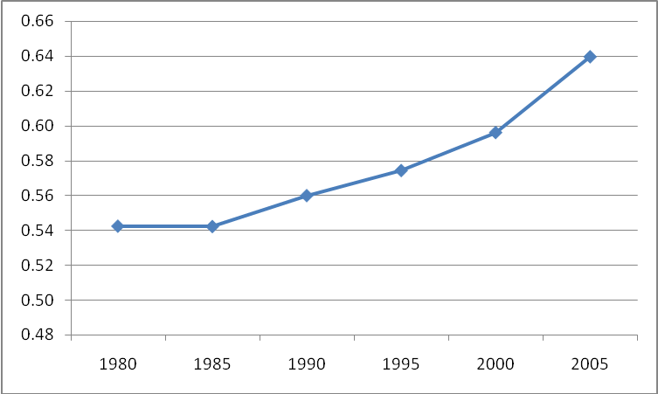

Figure 5. The ISF results of BSC. Figure 6. The ISF results for GCCC.

Figure 7. The ISF results of LSC. Figure 8. The ISF results for RSC.

The findings from the four regional councils’ results combine to construct the ISF of the SouthROC. The results show an increase of 11% from 54% to 65% functionality. As a whole the SouthROC region scored an intermediate level of functionality in 2005. Some initial concerns are overdevelopment and some lack of social awareness but the trend for the most part is moving in a positive direction of functionality.

Discussion

The SouthROC can further be analysed by comparing the ISF values with the genuine progress indicator (GPI), gross regional product (GRP) and the population growth rate (Figure 9). From 1980 to 1990 all three indices project similar levels of linear stability. However, over the remaining 15 years from 1990 to 2005 the findings are significantly different. The GPI shows a minor increasing trend. The GRP increases 19%, indicating a huge augmentation in economic expenditure. The ISF has a linear trend that is similar to the GPI but is calculated and represents a more quantitative measure of the consequences of expenditure rather than the actually expenditure itself (Imberger et al., 2005). These results suggest that when comparing the ISF, GPI and GRP the inefficiencies of using an economic-based index, like the GRP for measuring the wellbeing or sustainability of a region, falls short by its over exaggerated results. For the entire measured period the population growth rate steadily increased at a minor exponential rate meaning an increase of energy, resources and land use demands region-wide. The contribution of the ISF of the SouthROC as an appraisal for the region is at the forefront of index-based sustainability and can inform local governments and/or communities of the current trends of sustainability-friendly actions. The trend of the ISF can be developed and be used for future reference and tracking.

Conclusion

Quantitative sustainability can contribute to the societal problems of continuing to develop unsustainably. The ISF centres on the key idea of being a useful management tool to help prevent such actions. It also can help and/or support with decision making and resource allocation. Current research is continuing on the development of the entire ISF of SEQ, which should also assist with the discovery of sustainability on a larger scale within the region. In a global context this effort is urging the need and will to better improve our societies and cooperatively use linkages to design sustainability tools alike.

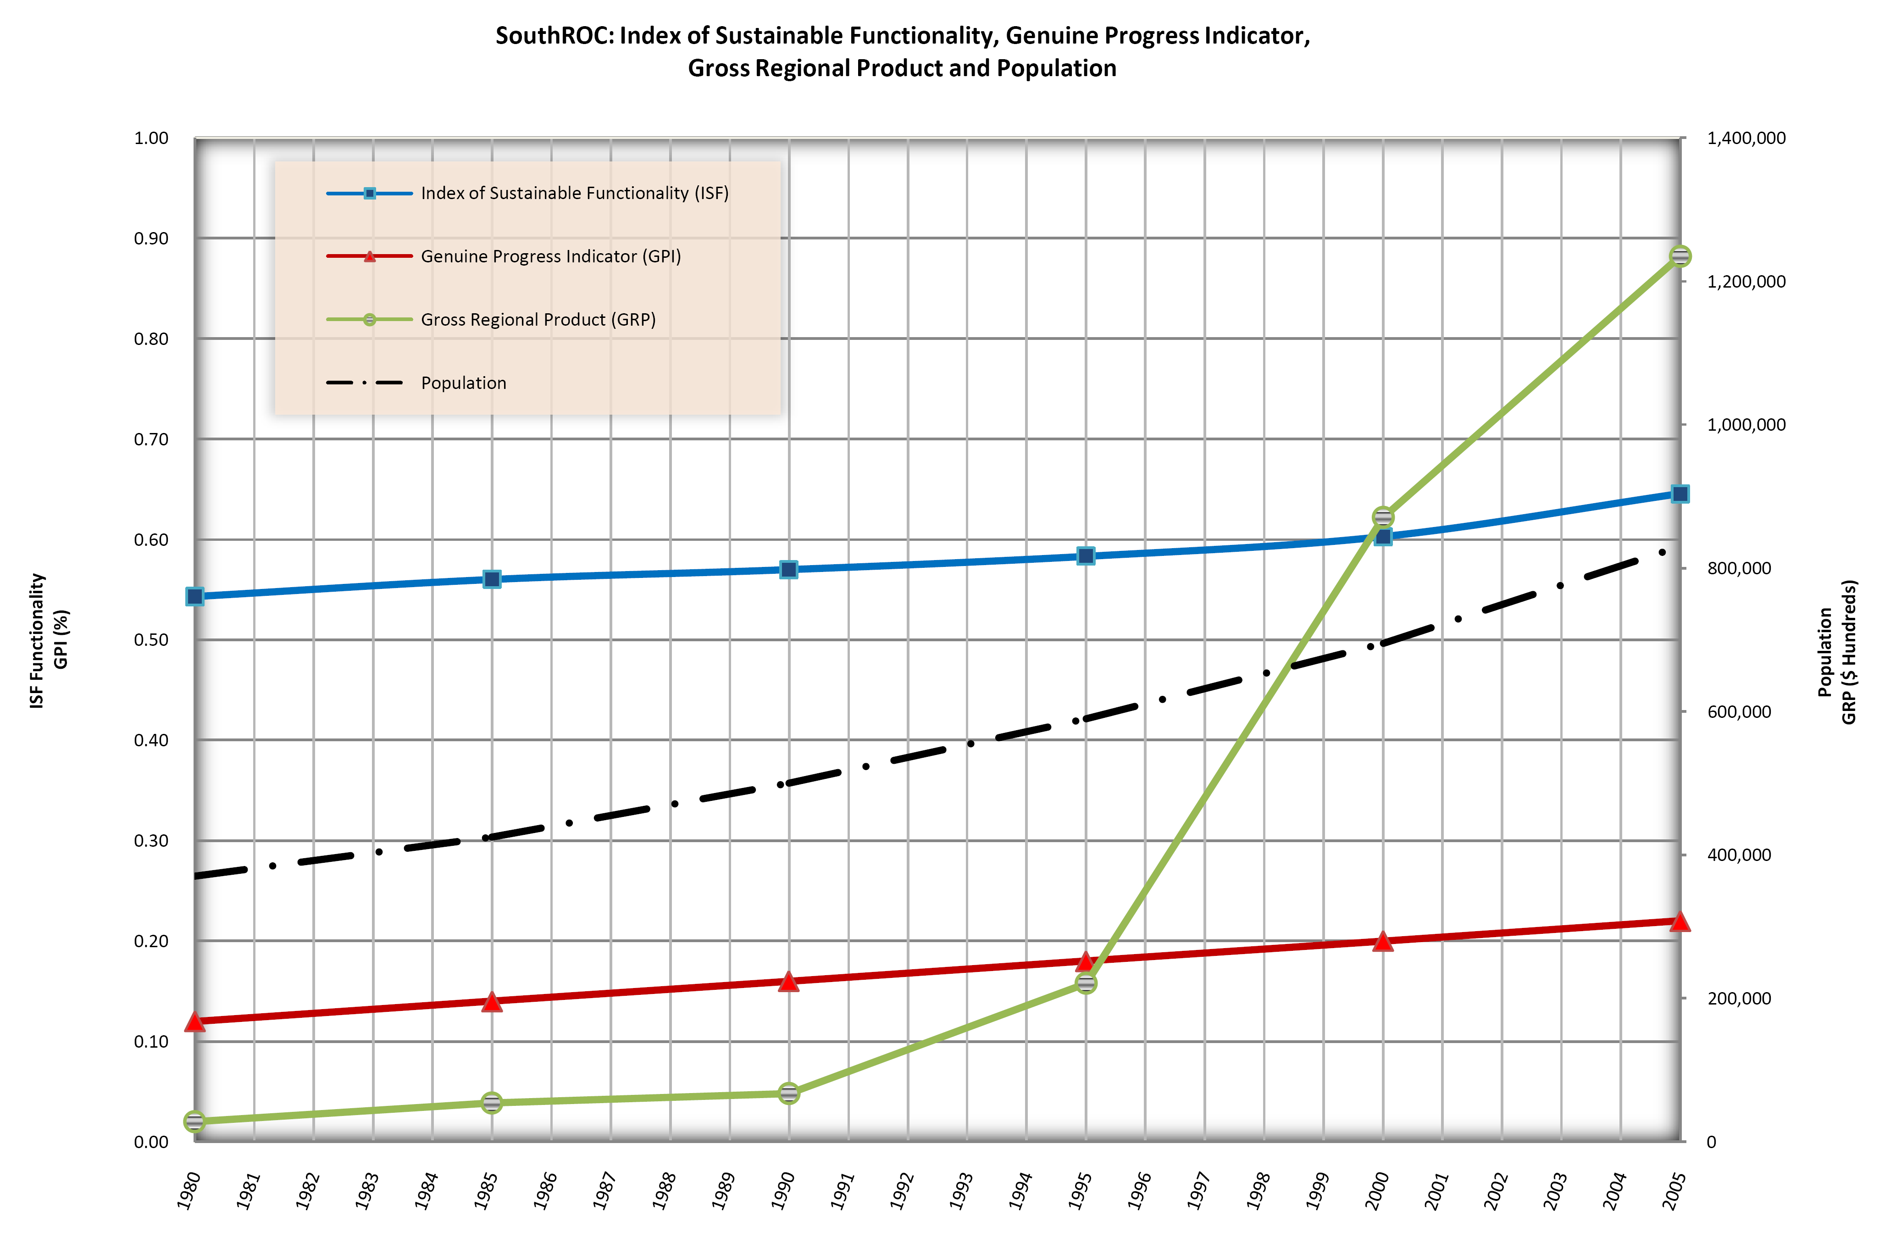

Figure 9. SouthROC: ISF, GPI, GRP and population (Australian Bureau of Statistics, 2004).

Acknowledgements

This work is undertaken with support from the Griffith School of Engineering and Centre for Infrastructure Engineering and Management. Recognition goes to Professor Jörg Imberger, Centre for Water Research, University of Western Australia; Mr. Chris Scraggs, GCCC; and Dr. Bill Weeks, Queensland Main Roads. From Griffith University: Ms. Cymone Perry, Griffith School of Engineering; Mr. Ryan Dunn, School of Environmental and Applied Sciences; Professor Pat Dale, Australian School of Environmental Studies; and Ms. Nita Van Der Watt, Griffith Law School.

References

Australian Bureau of Statistics. 2004. Regional Statistics, Queensland. http://www.abs.gov.au/.

Brown, A., 2006. The index of sustainable functionality (ISF): A prospective tool for assessing the sustainability of the impact of the World Bank projects. Perth, Australia: Centre for Water Research, Dissertation.

Cirella, G.T. 2006. The Index of Sustainable Functionality of South East Queensland: An Adaptive Quantitative Method to Measure Sustainability. Gold Coast, Australia: Griffith School of Engineering, Griffith University, Technical Report.

Cirella, G.T., Tao, L. and Mohamed, S. 2007. An application of an adaptive quantitative method to measure the sustainability of the Gold Coast, Australia. Journal of Coastal Research SI 50 (Proceedings of the 9th International Coastal Symposium).

Cobb, C., Halstead, T. and Rowe, J. 1995. If the GDP Is Up, Why Is America Down? Atlantic Monthly 59-78, October 1995.

Creswell, J.W. 1994. Research design: Qualitative & quantitative approaches. Thousand Oaks, CA: Sage Publications.

Daly, H. and Cobb, J. 1989. For the Common Good. Boston: Beacon Press.

Esty, D.C., et al. 2001. 2001 Environmental Sustainability Index: An Initiative of the Global Leaders of Tomorrow Environment Taskforce, World Economic Forum. New Haven: Yale Center for Environmental Law and Policy.

Imberger, J.; Mamouni, E.D.; Anderson, J.; Ng, M.; Nicol, S. and Veale, A., 2005. The index of sustainable functionality: a new adaptive, multi-criteria method to measure sustainability and its application to Western Australia. Ecosystems In Press.

Thinley, L.J.Y. 1998. Values and Development: Gross National Happiness. Thimpbu, Bhutan: Centre for Bhutan Studies.

Queensland Government. 2005. South East Queensland Regional Plan 2005-2006. Office of Urban Management. Department of Local Government, Planning, Sport and Recreation: The State of Queensland Publication.

Rees, W. 1992. Ecological footprints and appropriated carrying capacity: What urban economics leaves out. Environment and Urbanisation 4(2), October 1992.

UNDP. 1990. Human Development Report 1990: Concept and Measurement of Human Development. http://hdr.undp.org/
Appendix 1

The following appendix is a list of the four systems used with each related perspective. Within each perspective its related functions (1 to 24) and indicators (1 to 60) are illustrated. Note that indicators 1, 3, 9 and 14 are divided into sub-indicators labelled with Roman numerals.

The Natural System

From an Environmental Perspective

Function 1. To maintain imperative ecosystem processes
Indicator
- Water quality distributed to the general population within the region
  - Normalised pH balance
  - Normalised dissolved oxygen (O2) levels
  - Normalised phosphorus concentration (P) levels
  - Normalised nitrogen concentration (N) levels
  - Normalised FC (E. coli) levels

Function 2. To maintain related linkages between diversity of plant and animal species in an environment
Indicator
- Percentage completion of the Regional Nature Conservation Strategy for South East Queensland 2003-2008
  - Habitat destruction via settlement, infrastructure, mining, crops and pasture

Function 3. To uphold climate change initiatives
Indicators
- Renewable energy consumption and/or usage within the region
  - Wind energy usage
  - Solar power energy usage
  - Biomass energy usage
  - Wave or tidal energy usage
- Carpooling within the region
- Percentage of public transport used in the region
- Percentage of commercial businesses that include climate change initiatives as part of their corporate plan
- Percentage of local government initiatives implemented that promote Queensland’s State Government initiatives on climate change

From a Social Perspective

Function 4. To provide aesthetic and recreational use of nature for the community
Indicator
- Area of protected land area as a percentage of total land area

Function 5. An environment beneficial to human health
Indicator
- Normalised air quality levels
- Normalised ozone (O₃) levels
- Normalised nitrogen dioxide (NO₂) levels
- Normalised particulate matter levels
- Number of air quality complaints per capita
Ecol
From an Economic Perspective

Function 6. The provision of natural aesthetics for economic benefit
Indicators
- Price of a property with waterfront or beachfront view as a percentage of the price of a similar property without a view
- Percentage change in price of a property with a waterfront or beachfront view, compared to percentage change in price of a similar property without a view
- Percentage change in price of a property next to a green space compared to percentage change in price of a similar property further from green space

Function 7. To provide renewable and non-renewable resources
Indicators
- Renewable resource – annual water consumption trends
- Non-renewable resource – total fossil fuels value against Gross Regional Product
  - Coal consumption

The Social System

From an Environmental Perspective

Function 8. To conserve the natural environment responsibly through government policy, legislation and services and through public awareness and involvement in environmentally-friendly initiatives
Indicators
- Percentage of solid waste recycled
- Percentage of council expenditure allocated to ‘green spaces’
- Percentage of council expenditure allocated to sustainable development
- Percentage of wastewater reused

From a Social Perspective

Function 9. To provide all individuals in society with equitable opportunities and outcomes – via the provision of basic services
Indicators
- Weekly income by gender
- Number of deaths per year due to heart disease
- Percentage of annual government expenditure allocated to health
- The number of violent and property crimes per 1000 residents
- Percentage annual government expenditure allocated to law, order and public safety

Function 10. To promote and encourage a diverse, interrelated and participative society
Indicators
- Equity of political representation
- Proportion of indigenous residents, residents born overseas and Australian born residents from outside the region, compared with the whole of the region
- Percentage of residents with a high school education
- Percentage of annual government expenditure allocated to education and welfare
- Percentage government expenditure allocated to recreation and culture
Community System
From an Economic Perspective

Function 11. To support business and industry through appropriate, innovative and effective implementation of policy and management strategies by the local government
Indicators
- Percentage of annual council expenditure allocated to economic development
- Average business satisfaction rating

Function 12. To provide a stable social society
Indicators
- The number of crimes reported per capita
- Funding to local tertiary universities and TAFE within the region from state and federal governments
- The number of people who own or who have purchased (via mortgage) a home in which they are residing

The Individual System

From an Environmental Perspective

Function 13. To minimise the consumption of finite resources
Indicators
- The number of cars per individual
- Residential energy consumption per capita

Function 14. To minimise waste output
Indicators
- Household waste to landfill
- Proportion of households that participate in kerbside recycling

From a Social Perspective

Function 15. To contribute to the continued safeguarding of population maintenance
Indicators
- Population distribution via population growth
- Population distribution via total fertility rate

Function 16. To contribute to the continued function of the social system through participation
Indicator
- Fraction of total number of participants that are held within the workforce

Function 17. To contribute to the continued function of the social system through compliance
Indicators
- The cumulative impact of criminal offences, weighted by the severity of the offences
- Fraction of police force of total population versus the cumulative crime rate

From an Economic Perspective

Function 18. To provide human capital in the form of knowledge and labour for production
Indicators
- The proportion of working aged population with only a school qualification
- Participation rate of population in secondary and tertiary education

Function 19. To consume available goods and services
Indicators
- Total of goods and services as a proportion of average weekly household disposable income
- Remainder of income after servicing of debt and investments as a proportion of average household disposable income

The Economic System

From an Environmental Perspective

Function 20. To minimise adverse impacts of industry on the environment
Indicators
- Total energy use by industry per gross regional product
- Total energy use by industry that is from renewable sources
- Industrial solid waste to landfill per gross regional product
- Fraction of total solid waste by industry that is recycled

From a Social Perspective

Function 21. To ensure affordability and provision of basic needs
Indicators
- Fraction of working population whose income is over the minimum wage
- Percentage change in cost of housing versus percentage change in gross disposable income

Function 22. To create diversity and opportunity
Indicators
- Gender equality as a deviation from 50% across all industries
- Occupied job types as fraction of total number of possible job types in the economic system

From an Economic Perspective

Function 23. To provide accurate measures for all forms of capital which are traded in the local economic system
Indicators
- Measuring stability in the economic system
- Measuring economic growth
- Measuring equity accessibility of markets

Function 24. To contribute to stability and progression towards growth in the region
Indicators
- Growth rate in region
- The stochastic diversity of the regional industry diversity compared to Queensland’s industry diversity
- Growth rate of people employed in the region’s industries
Appendix 2

The following two tables outline the results from the nine person expert panel. The relationships between functions-to-perspectives and indicators-to-functions are independently ranked using a scale of High – Medium-High – Medium – Medium-Low – Low. For each table the results are averaged, weighted, stacked and summed.

Expert Panel: Functions-to-Perspectives (24 Functions)
S_{ij} - N^{k}_{ij} | F^{k} | High | Medium- | Medium | Medium- | Low | Averaged Function | Weighted Function | F^{k} Weighted Stack |  | 12 Summed Stack
 |  |  | High |  | Low |  |  |  | (% of S_{ij} - N^{k}_{ij} |  | Control (100%
 |  | (H) | (MH) | (M) | (ML) | (L) | (H-MH-M-ML-L) | (Zero-to-One) | per F^{k}) |  | S_{ij} - N^{k}_{ij} Check)
Nat. - | 1 | 5 | 2 | 1 | 1 |  | 4.22 | 0.84 | 35 |  | 100
Env. | 2 | 4 | 2 | 2 | 1 |  | 4.00 | 0.80 | 34
 | 3 | 1 | 5 | 2 | 1 |  | 3.67 | 0.73 | 31
Nat. - | 4 | 3 | 5 | 1 |  |  | 4.22 | 0.84 | 51 |  | 100
Soc. | 5 | 4 | 2 | 3 |  |  | 4.11 | 0.82 | 49
Nat. - | 6 | 1 | 4 |  | 4 |  | 3.22 | 0.64 | 49 |  | 100
Econ. | 7 | 3 | 1 | 2 | 2 | 1 | 3.33 | 0.67 | 51
Soc. - Env. | 8 | 3 | 4 | 1 | 1 |  | 4.00 | 0.80 | 100 |  | 100
Soc. - | 9 | 2 | 3 | 2 | 1 | 1 | 3.44 | 0.69 | 48 |  | 100
Soc. | 10 | 3 | 2 | 3 | 1 |  | 3.78 | 0.76 | 52
Soc. - | 11 | 2 | 3 | 4 |  |  | 3.78 | 0.76 | 48 |  | 100
Econ. | 12 | 3 | 5 | 1 |  |  | 4.22 | 0.84 | 52
Ind. - | 13 | 6 | 1 | 1 | 1 |  | 4.33 | 0.87 | 52 |  | 100
Env. | 14 | 4 | 3 | 1 |  | 1 | 4.00 | 0.80 | 48
Ind. - | 15 | 1 | 3 | 4 | 1 |  | 3.44 | 0.69 | 33 |  | 100
Soc. | 16 | 2 | 4 | 3 |  |  | 3.89 | 0.78 | 36
 | 17 | 1 | 2 | 4 | 1 | 1 | 3.11 | 0.62 | 31
Ind. - | 18 |  | 7 | 1 | 1 |  | 3.67 | 0.73 | 51 |  | 100
Econ. | 19 | 2 | 2 | 3 | 2 |  | 3.44 | 0.69 | 49
Econ.- Env. | 20 | 5 | 1 | 1 | 2 |  | 4.00 | 0.80 | 100 |  | 100
Econ. - | 21 | 3 | 3 | 3 |  |  | 4.00 | 0.80 | 51 |  | 100
Soc. | 22 | 2 | 5 | 1 | 1 |  | 3.89 | 0.78 | 49
Econ. - | 23 | 2 | 3 | 3 | 1 |  | 3.67 | 0.73 | 50 |  | 100
Econ. | 24 | 2 | 3 | 3 | 1 |  | 3.67 | 0.73 | 50

Expert Panel: Indicators-to-Functions (60 Indicators)
F^{k} | I_{l} | High | Medium- | Medium | Medium- | Low | Averaged Indicator | Weighted Indicator |  |  | I_{l} Weighted Stack | 24 Summed Stack
 |  |  | High |  | Low |  |  |  |  |  |  | Control
 |  | (H) | (MH) | (M) | (ML) | (L) | (H-MH-M-ML-L) | (Zero-to-One) | (% of I_{l} per F^{k}) |  |  | (100% F^{k} Check)
1 | 1 | 4 | 4 |  | 1 |  | 4.22 | 0.84 | 100 |  |  | 100
2 | 2 | 3 | 1 | 4 | 1 |  | 3.67 | 0.73 | 100 |  |  | 100
3 | 3 | 7 |  |  |  | 2 | 4.11 | 0.82 | 22 |  |  | 100
 | 4 | 1 | 3 | 2 | 2 | 1 | 3.11 | 0.62 | 18
 | 5 | 3 | 4 |  | 2 |  | 3.89 | 0.78 | 21
 | 6 | 2 | 3 |  | 4 |  | 3.33 | 0.67 | 19
 | 7 | 3 | 3 | 1 | 1 | 1 | 3.67 | 0.73 | 20
4 | 8 | 2 | 4 | 2 | 1 |  | 3.78 | 0.76 | 100 |  |  | 100
5 | 9 | 4 | 3 | 2 |  |  | 4.22 | 0.84 | 100 |  |  | 100
6 | 10 | 2 | 2 | 3 |  | 2 | 3.22 | 0.64 | 32 |  |  | 100
 | 11 | 2 | 3 | 2 |  | 2 | 3.33 | 0.67 | 34
 | 12 | 2 | 3 | 2 |  | 2 | 3.33 | 0.67 | 34
7 | 13 | 5 | 4 |  |  |  | 4.56 | 0.91 | 53 |  |  | 100
 | 14 | 5 | 1 | 2 | 1 |  | 4.11 | 0.82 | 47
8 | 15 | 6 | 2 |  | 1 |  | 4.44 | 0.89 | 28 |  |  | 100
 | 16 | 2 | 3 | 2 | 2 |  | 3.56 | 0.71 | 23
 | 17 | 5 | 1 | 2 |  | 1 | 4.00 | 0.80 | 25
 | 18 | 4 | 3 |  |  | 2 | 3.78 | 0.76 | 24
9 | 19 |  | 1 | 6 | 2 |  | 2.89 | 0.58 | 19 |  |  | 100
 | 20 | 1 | 3 | 3 |  | 2 | 3.11 | 0.62 | 19
 | 21 | 2 | 2 | 3 | 1 | 1 | 3.33 | 0.67 | 20
 | 22 | 2 | 2 | 3 | 2 |  | 3.44 | 0.69 | 21
 | 23 |  | 6 | 2 | 1 |  | 3.56 | 0.71 | 21
10 | 24 | 1 | 6 | 2 |  |  | 3.89 | 0.78 | 21 |  |  | 100
 | 25 | 2 | 1 | 4 | 2 |  | 3.33 | 0.67 | 19
 | 26 | 2 | 4 | 1 | 1 | 1 | 3.56 | 0.71 | 20
 | 27 | 1 | 5 | 1 | 1 | 1 | 3.44 | 0.69 | 20
 | 28 | 2 | 2 | 4 | 1 |  | 3.56 | 0.71 | 20
11 | 29 | 2 | 2 | 3 | 2 |  | 3.44 | 0.69 | 52 |  |  | 100
 | 30 |  | 2 | 6 | 1 |  | 3.11 | 0.62 | 48
12 | 31 | 3 | 4 | 2 |  |  | 4.11 | 0.82 | 37 |  |  | 100
 | 32 | 2 | 3 |  | 2 | 2 | 3.11 | 0.62 | 30
 | 33 | 1 | 4 | 2 | 2 |  | 3.44 | 0.69 | 33
13 | 34 | 6 | 1 | 2 |  |  | 4.44 | 0.89 | 48 |  |  | 100
 | 35 | 6 | 3 |  |  |  | 4.67 | 0.93 | 52
14 | 36 | 5 | 3 | 1 |  |  | 4.44 | 0.89 | 54 |  |  | 100
 | 37 | 3 | 1 | 3 | 2 |  | 3.56 | 0.71 | 46
15 | 38 | 3 | 3 | 2 | 1 |  | 3.89 | 0.78 | 53 |  |  | 100
 | 39 | 1 | 2 | 5 | 1 |  | 3.33 | 0.67 | 47
16 | 40 | 1 | 4 | 3 | 1 |  | 3.56 | 0.71 | 36 |  |  | 100
17 | 41 | 2 | 6 | 1 |  |  | 4.11 | 0.82 | 53 |  |  | 100
 | 42 | 2 | 3 | 2 | 1 | 1 | 3.44 | 0.69 | 47
18 | 43 | 2 | 1 | 3 |  | 3 | 2.89 | 0.58 | 44 |  |  | 100
 | 44 | 2 | 5 | 2 |  |  | 4.00 | 0.80 | 56
19 | 45 | 3 | 2 | 3 | 1 |  | 3.78 | 0.76 | 52 |  |  | 100
 | 46 | 2 | 1 | 5 |  | 1 | 3.33 | 0.67 | 48
20 | 47 | 5 | 1 | 3 |  |  | 4.22 | 0.84 | 26 |  |  | 100
 | 48 | 8 |  |  |  | 1 | 4.56 | 0.91 | 28
 | 49 | 3 | 2 | 2 | 2 |  | 3.67 | 0.73 | 22
 | 50 | 5 | 1 | 1 |  | 2 | 3.78 | 0.76 | 24
21 | 51 | 1 | 5 | 2 |  | 1 | 3.56 | 0.71 | 48 |  |  | 100
 | 52 | 2 | 5 | 2 |  |  | 4.00 | 0.80 | 52
22 | 53 | 1 | 2 | 1 | 4 | 1 | 2.78 | 0.56 | 47 |  |  | 100
 | 54 | 2 | 1 | 5 | 1 |  | 3.44 | 0.69 | 53
23 | 55 | 3 | 2 | 4 |  |  | 3.89 | 0.78 | 32 |  |  | 100
 | 56 | 3 | 5 | 1 |  |  | 4.22 | 0.84 | 35
 | 57 | 2 | 5 | 2 |  |  | 4.00 | 0.80 | 33
24 | 58 | 3 | 4 |  | 2 |  | 3.89 | 0.78 | 36 |  |  | 100
 | 59 |  | 6 | 1 | 2 |  | 3.44 | 0.69 | 32
 | 60 |  | 4 | 5 |  |  | 3.44 | 0.69 | 32

