INVESTIGATION AND PROSECUTION OF UNAUTHORISED VEGETATION CLEARING

Abstract

Urban development is placing considerable pressure on natural areas, in particular the vegetation of the Illawarra escarpment. Incidences of illegal vegetation clearing on private land are also increasing in the Wollongong Local Government Area (LGA) over the past two years. A Management Plan prepared by Council for the escarpment outlines key areas to be protected though the use of conservation zonings. These zonings will be incorporated into a revised Local Environmental Plan (LEP) for the escarpment.

Illegal clearing of vegetation and development of land is most likely occurring in an attempt to pre-empt decisions of Council in relation to new LEP zonings. These illegal activities are detected mainly as a result of complaints by residents or observation of sites adjacent to roadways. In many cases detection is often some time after the clearing event has occurred. Council’s response to illegal clearing has included issuing orders under the Environmental Planning and Assessment Act 1979 (EP&A Act) and notices under the Protection of the Environment Operations Act 1997 (POEO Act), Civil court proceedings and criminal action in the NSW Land and Environment Court with varying levels of success and at considerable expense to Council. Frustration at the process of detection, investigation and prosecution of land clearing events, and the rehabilitation of illegally cleared vegetation, has forced a re-evaluation of our approach. Proactive measures include the comparison of aerial photographs (2001 to 2006) to detect changes in vegetation cover which can then be investigated in the field, thus detecting illegal land clearing that may not have been directly witnessed.

Introduction

Wollongong is Australia’s ninth largest city. It is located 80 kilometres south of Sydney on a narrow coastal strip bordered by the Royal National Park to the north, Lake Illawarra to the south, the Illawarra escarpment and sandstone plateaux to the west and the Tasman Sea to the east. The local government area (LGA) supports a population of almost 200,000 and covers approximately 70,000 hectares of land of which more than half is bushland.

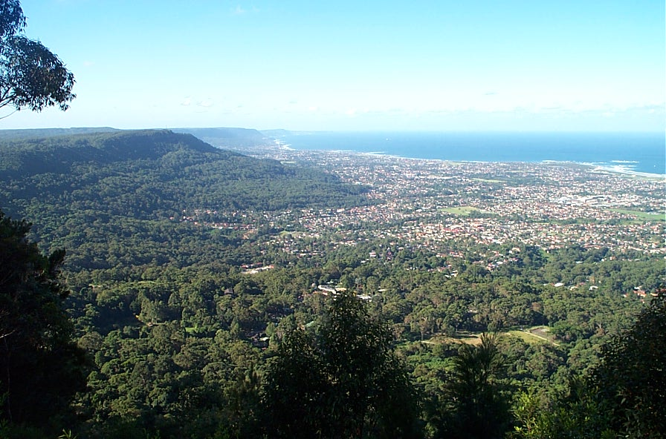

Figure 1 Illawarra escarpment and coastal plain, looking north from Mount Keira

The Illawarra escarpment has major conservation significance and is regarded as a great natural icon of the Illawarra region. It is also a highly valued setting for residential development. Increasing urban development pressure triggered a Commission of Inquiry in 1999 into the long-term land use and planning of the Illawarra escarpment. In conclusion, the Commissioner contended that development must not be allowed to dominate the escarpment.

The preparation of an Illawarra Escarpment Strategic Management Plan (IESMP) was one of a number of recommendations handed down by the Commissioner. This plan was completed in 2005 and drew on a number of previously completed studies to guide long term planning of the escarpment. These studies included:

- Riparian and floodplain management;
- Draft Native Vegetation Management Plan;
- A Land Stability Study;
- A Bioregional Assessment, Parts 1-3;
- A review of the Illawarra Regional Environmental Plan No.1;
- European and indigenous heritage;
- Update of landslip maps;
- Bushfire Asset Protection Zone Risk Management Study;
- Social study.

The studies combined to highlight areas of both key significance and development constraint, which formed the basis for revised land use zonings proposed in the IESMP. The Minister for Planning approved the IESMP subject to a number of amendments. Council then endorsed the revised IESMP in March 2006. One of the principles of the IESMP relevant to this discussion is that no further clearing of escarpment lands would be supported, as defined from baseline 2001 aerial photos (IESMP 2005). The Illawarra Escarpment Landuse Review Strategy (HLA 2007) took the IESMP one step further toward a detailed review at the property scale of landuse zonings, guided by principles of the IESMP. This strategy was adopted by Council in August 2007 and forms the basis for changes made through the current LEP review.

The delays throughout the planning process and the current revision of the Wollongong LEP has led to some uncertainty amongst landowners about how these changes would affect their future development opportunities. This is possibly a major factor that has led to the increased incidence of land clearing witnessed over the past two years since the finalisation of the IESMP.

Incidences of clearing

Since 2005, incidences of illegal clearing in the Wollongong LGA have increased. Clearing is defined in this paper as those instances where more than five trees are affected, where no consent has been issued from Council, the Rural Fire Service or any other approval body. In the years 2005 to present, approximately 13 clearing complaints were received. These complaints affected a total cleared area of approximately 13 hectares of land. This figure only represents the areas of known clearing activities from complaints, and total clearing is probably much larger. The affected areas ranged in size from 10 trees to 4 hectares. Some of these sites included large areas of understorey clearing. Most of these incidents are reported from complaints by residents, or are the result of a Council officer observing the works in the process of undertaking other activities. Many appear to be clearing activities that aim to remove constraints to development.

Compliance response

The recent increase in the occurrence of illegal land clearing complaints has initiated the need for Council to develop a consistent and effective response to these issues. In dealing with these issues, the Environment and Health Division has to date relied heavily on external legal advice. This response process is currently under review, and will include a revision of the responsibilities of Divisions within Council.

The primary objective of our recent compliance action has been to gain environmental restoration of the affected site. As a secondary outcome, a penalty for breach of legislation is sought, to act as both a financial penalty and as a deterrent to those in the community who may also consider undertaking illegal land clearing.

Table 1 outlines a summary of response tools that Wollongong Council has used in its compliance response for clearing of over five trees.

Table 1 Summary of clearing response tools

Response | Type of incident | Problems | Benefits
Order 121B  and/or 121P, under the EP&A Act 1979. | Clearing without consent. | Can be appealed.  Appeals result in increased legal costs. | Little or no legal fees if not appealed.
Civil proceedings in the Land & Environment Court. | Clearing without consent  Conservation value sites | Large legal costs.  Lengthy process - may delay site outcomes | Breaches of orders are easier to respond to if it was a court order.
Criminal proceedings in the Land & Environment Court. | Clearing without consent  For major land clearing events where a high level of evidence is gathered. | Very large legal costs. | Larger fines obtainable.  Restoration for tree clearing can also enforced simultaneously to the fine.
Clean-up and Prevention notices under the Protection of the Environment Operations Act 1997. | Appropriate where vegetation removal has or is likely to result in a pollution incident, usually sedimentation of waters. Can be used to address immediate impacts, but generally needs to be followed up with other response such as an order or court action. | These are generally not able to be used for the restoration of vegetation. | Cannot be appealed.
Proceedings in the local court for development without consent. | Not yet trialled in Wollongong for this scale of clearing, but  is used for Tree Management Order breaches. | Locally dependent on magistrate. | Evidence is by way of witness stand, so reduced legal fees for affidavit preparation.  Court enforced orders have more strength.

Of the 13 complaints received since 2005, ten of these have been responded to with compliance action with requirements for restoration works. Restoration has usually been enforced by Wollongong City Council through an order issued under the EP&A Act. Once an order has been issued, ongoing compliance monitoring is required which requires a substantial amount of officer time. An order typically requires the engagement of a qualified bush regenerator to prepare a vegetation management plan and a maintenance program for five years. The requirements may vary depending on the sensitivity and conservation significance of the site and the extent of the impact. This can often amount to quite a significant cost to the offender, which may exceed the cost of a fine that is likely to be issued in any court proceedings.

Over the past two years, four incidents of illegal vegetation clearing have resulted in lengthy actions in the Land and Environment Court. Two of these proceedings have been initiated by Council, one criminal prosecution, and one as a result of failure to comply with the order issued under the EP&A Act. A further two matters were initiated by the alleged offenders through appealing orders issued by Council under the EP&A Act. Where action is undertaken in the Land and Environment Court, the site often deteriorates over the lengthy time required for the court process. Further, in the instance where an Order is appealed, the legal process defines that Council’s costs are not recoverable.

Lessons learnt

Our increased response to land clearing incidences has enhanced our skill set in this area. From this we have learnt that several factors are important in contributing to a successful outcome. These include:

- Quick response. Being prepared to undertake timely investigations with appropriate equipment and expertise to collect evidence as soon as possible on learning of the incident. Evidence is likely to change if an offender is aware of an impending investigation.

- GPS survey of affected areas. Surveying the entire boundary of the clearing in the first inspection ensures proceedings against the correct land owner/s. Land boundaries are not always fenced, or fenced accurately. The survey can reveal multiple owners might be involved. This data is also more useful for overlay in GIS with other data such as vegetation mapping, threatened species, and cadastral information, and is critical as a basis for compliance action.

- Photos. Photos are an obvious tool in the collection of evidence, although several techniques exist to maximise their efficiency. Timing and dating of photos is more credible in the court and may provide a useful reference also to the observations in the field. Photographing features with some reference to scale is important, for example placing a pen or measuring device on a tree stump. Close up photos of detail of vegetation cleared may assist to determine species cleared, including species of conservation significance.

- Prompt recording of observations / conversations. The writing up of field investigations should be conducted as soon as possible on the same day. Records of conversations with stakeholders need to be clearly recorded in ‘they said / I said format’. Observations of physical evidence should be clearly defined, with opinions of those observations demarcated.

- Ensuring proper legal authority to enter. The legislation in which officers are operating under will specify conditions of entry, for example whether a written notice is required to be issued prior to entry. Improper entry can result in evidence being unusable in court.

- Communication with other Government agencies. Where the incident falls within the jurisdiction of other legislation, for example the Native Vegetation Act 2003 or the Threatened Species Conservation Act 1995, the incident will need to be referred to the relevant agency. Coming to agreement on the best response will help present a unified position, and means the offender is less able to play one organisation off against the other.

- Combine resources with other agencies. There are many cases where joint action may be appropriate depending on the implications under different legislation. Different agencies have access to different resources, such as aerial photos, ecological data, prior compliance history and so on. Sharing of these resources is likely to increase the evidence base and therefore strengthen the case.

- Adherence to proper statistical method. Larger affected areas may be difficult to plot all evidence, and may require a different approach such as random sampling using quadrat methods. In doing this, adherence to proper random selection of sites, and appropriate scientific sampling strategies will be important in the quality of the evidence.

- Continuation of staff personnel responding to an event. To maximise the success of the response and to decrease the level of frustration with the offender, it is important to maintain the same staff for the duration of the project where possible.

- Notice writing. The use of appropriate notices and orders and the correct wording of these is critical to ensure the legal validity of a notice. This reduces the chances of an order being appealed and won on a technical basis.

- Threatened/or rare species. Land clearing often results in complete clearing and removal of the understorey due to use of machinery. Surveys after the event usually reveal an absence of regionally rare or threatened species. Any compliance response on sites where records of such species existed should allow for adequate time and conditions for the return of a fauna species or resprouting or germination from soil seed bank for plant species.

- Keeping good records of all contact with stakeholders. Any matter may eventually progress to the court due to an appeal or the investigating officer’s own initiation. Keeping records of all conversations throughout an investigation will serve well as evidence in the court, and for the investigating officer’s own monitoring purposes.

- Timely monitoring. Where restoration works are required, regular site inspections are best timed with due dates for key activities. A lack of monitoring of restoration works may result in complacency of the land owner resulting in a poor restoration outcome.

Revising our approach

The recent increase in clearing has forced Council to review our approach. Inconsistencies in responses to land clearing incidences can be a weak point in court proceedings, and also send a poor message to the community.

Currently, Council is largely reactive in its response to illegal land clearing. The resourcing requirements for Council to become more proactive in its response are currently under review. A first step toward a proactive approach has been to systematically assess natural areas for other potential instances of illegal clearing. This project is outlined below.

Aerial photo analysis

One step toward progressing a more proactive response has been to carry out an aerial photo comparison exercise to identify areas of potential illegal clearing.

A GIS exercise was carried out whereby aerial photos of 2001 and 2006 (scale 1:4000) were visually assessed for differences in vegetation cover. Sydney Catchment Authority lands to the west of the escarpment were excluded from this analysis. Areas showing marked canopy or understorey reduction were defined in GIS by the delineation of polygons around the affected areas. This allowed for the analysis below in Table 2.

Table 2 Summary of Analysis Results

VEGETATION STATUS | Total hectares
New clearing | 132.2
No Change – Cleared | 19,753.1
No Change – Vegetated | 14,785.3
Re vegetated | 18.7
Grand Total of area assessed | 34,689.3

A total of 132 hectares was found to have been cleared between the March 2001 and January 2006 aerial photos. A further analysis was run to derive a course estimate on the number of hectares cleared that did not have development consent. To do this a query was generated to identify all parcels that had received development approval between this same period. It was assumed that clearing within lots with approved DA’s was consented, although a further detailed analysis is required to review this accurately. From this analysis we estimated that only 10% (13 hectares) of the clearing within this period had DA approval. It should be noted however that Rural Fire Service approval for hazard reduction may have been given for some of this clearing; however this analysis was not attempted. Figure 2 shows an example of one of the clearing comparisons between 2001 and 2006 aerial photos. The photo on the right shows areas that have been defined as being cleared sine 2001.

Figure 2 Aerial photo analysis example.

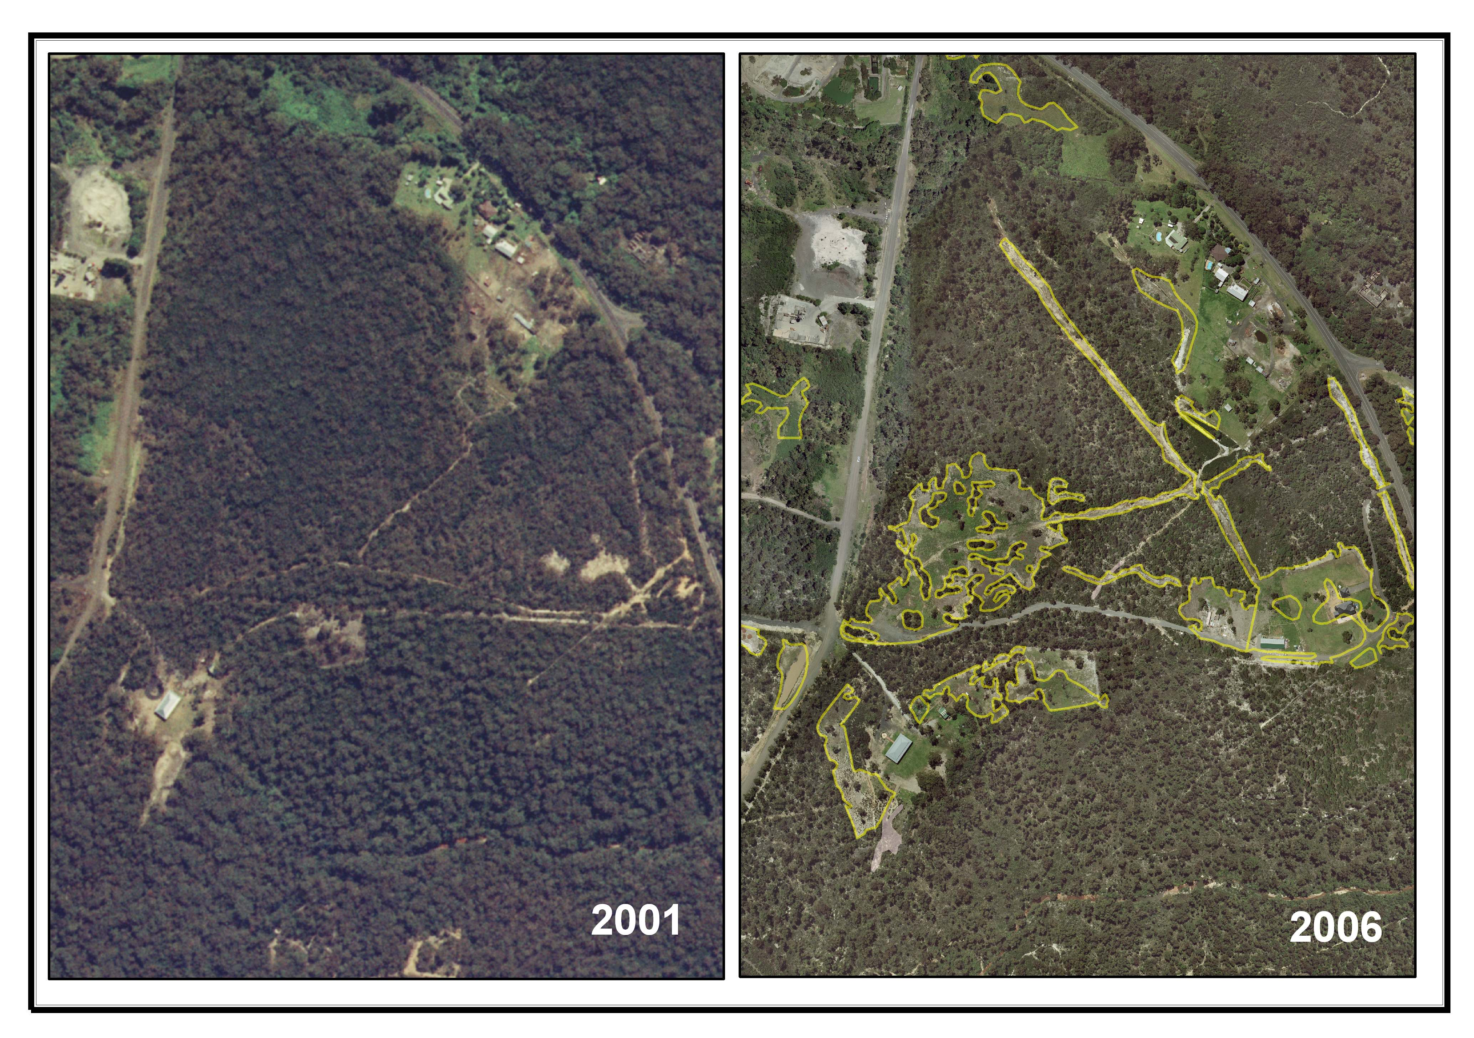

Following this process, it is the intention to follow up these sites with some investigation and potential compliance action where sufficient evidence is obtainable. The analysis also showed that most of our clearing is occurring in the northern portion of Wollongong LGA. This knowledge informs us of the benefit of targeting education efforts to this area.

Review of compliance resources

An internal review of the allocation of resources to compliance is being undertaken. It was found that legal fees for land clearing amounted to a sum of $104,000 for the year 2005-06. As such, a significant incentive is to become more cost effective and consistent in our compliance response. The review of our internal processes is also being enhanced by consultation with other councils.

The first step in this review was to conduct internal workshops with Wollongong City Council officers from three council divisions, and legal representatives in an effort to consolidate understanding of our current compliance response methods. It was unanimous that some consolidation of skills in compliance is required to maximise the efficiency of our response.

Operationally, the compliance response has been spread across different sections of Council, depending on the scale, and whether or not there is an active DA. This has involved response from Councils Development Assessment and Compliance Division, the Tree Preservation Office, Environment Protection Unit and Rangers Services Units. Delineation between these responsibilities is sometimes variable, and skills within these teams also vary. This current spread of resources results in reduced levels of customer services, inconsistencies and inefficient use of resources. Wollongong City Council aims to better integrate the skills and resources to provide clarity regarding the roles and responsibilities.

The next step will be to formalise a policy and procedure for responding to and resolving illegal land clearing matters. Following the adoption of such a policy by senior management it is anticipated that compliance responses will be undertaken in accordance with this policy. This should minimise both cost and risk to Council.

Skills needed

Identification of skills has been undertaken to clarify the needs of a centralised compliance unit. The skills required to respond appropriately to incidents of illegal vegetation clearing vary depending on the complexity of the case. The general skills required include:
- Evidence gathering, there are two distinct parts to this:
  - determining the facts, e.g. what occurred, when it occurred and who was responsible;
  - determining the physical impacts on flora/fauna and the environment;
- The interpretation and application of planning instruments (to determine if illegal development has occurred) including the POEO Act, EPA Act and LG Act;
- The application and correct wording of Notices and Orders issued under the EPA Act, and in some instances also the POEO Act;
- The review of rehabilitation plans and the monitoring of works; and
- Experience in the Land and Environment (or Local) Court.

Education

Education is imperative and two major focus areas need to be addressed. The roll out of policy changes such as pending LEP amendments need to be done in tandem with education about the background for the changes made and the implications of changes for landholders. This may reduce some uncertainty and therefore reduce panic clearing.

There is much overlapping legislation relating to the protection of native vegetation and parallel confusion over existing use rights. Joint efforts need to be made between agencies to outline this legislation, so that clear guidance is provided on the protection of native vegetation and the process that landowners need to go through for applications for clearing.

Further efforts could also be made to facilitate the prompt reporting of clearing. Further education and/or media campaigns should be directed in an effort to reduce the incidence of land clearing.

Summary

In summary, it is expected that a more consistent and consolidated approach to environmental compliance will lead to improved performance and better environmental outcomes for Wollongong.

Wollongong City Council is undertaking significant compliance action to deal with illegal land clearing within its local government area, including legal action in the NSW Land and Environment Court. This compliance is coupled with the development of a proactive response to deal with the increased land clearing within its Local Government Area. This proactive response is focussed on internal process improvement, developing external relationships with other agencies, improved customer service, education and media promotion, land use planning and projects to identify land clearing target areas.

Significant progress has been made towards addressing illegal land clearing and it is anticipated with the implementation of a more consistent, and consolidated approach this will improve into the future to preserve the valuable natural resource assets of the Wollongong LGA.

References

HLA-Envirosciences Pty Limited (2007) Illawarra Escarpment Land Use Review Strategy. Report prepared for Wollongong City Council

Wollongong City Council (2005) Illawarra Escarpment Strategic Management Plan.

Contacts
Jedda Lemmon
Natural Resource Officer
Wollongong City Council
Ph: 4227-7687
jlemmon@wollongong.nsw.gov.au

Martin Parmenter
Environment Protection Manager
Wollongong City Council
Ph: 4227-7330
mparmenter@wollongong.nsw.gov.au

Acknowledgements

The author wishes to acknowledge Martin Parmenter, Julie Peterson and Gaby Kirwood (Wollongong City Council) for their contributions to the text of this paper and their project management of this process.

The views expressed in this document should not be relied upon as legal advice.

