LIVING ON THE EDGE – INVESTIGATING LANDSLIDE RISK IN A COASTAL COMMUNITY

J. Spencer
Clarence Valley Council

W. Timms, J. Carley
UNSW Water Research Laboratory

L. Speechley, B. Walker
Jeffrey & Katauskas Pty Ltd

Introduction and background

The coastline is constantly being reshaped by the forces of nature. As it is also a desirable zone for habitation, an important component of any coastline management plan includes assessing landslide risk and implementation of appropriate management strategies.

A project to review landslide risk on the slope above Main Beach, Yamba Hill was initiated by Clarence Valley Council with funding from the Natural Disaster Mitigation Program. This paper provides preliminary findings of the project including verification of a conceptual model of subsurface processes and groundwater levels that may trigger slope instability.

The project was designed specifically to include community consultation (eg. meetings, newsletters and a website) in parallel with technical investigations. Meetings with the community and individual residents were held prior to investigations. Information flow is actively maintained through newsletters and a website, with opportunities for community feedback.

Yamba Hill is a coastal dune approximately 30 m high that overlies weathered sandstone and a cliff approximately 6-8 m high above Main Beach. The slopes above the cliff line are 18-35° and vegetated by scrub and bushes. Residential lots and the Pacific Hotel are located on a flatter bench area which rises from Marine Parade behind the Surf Life Saving Club.

Landslide risk zones (LRZs) were ranked as a function of consequence multiplied by probability. Higher landslide risk is associated with developed coastal areas due to the consequences of potential landslips to people and property. This current study builds upon an earlier assessment for the Yamba Coastline Management Study (MHL, 2003) which included a geotechnical assessment (J&K, 2000). Evidence of slope instability in this area is evident during site walkovers, including fractured pathways and downwards creep of retaining walls. The site has a history of slope instability, with known landslides used to derive the probability of instability.

The Water Research Laboratory (WRL) team worked in association with Jeffery and Katauskas (J&K) Pty Ltd and Groundwater Data Collection Services (GDCS) on the Yamba Hill project.

A B

Fig 1 Location map of A) Yamba Hill study area B) Monitoring transects, piezometers and inclinometer installations.

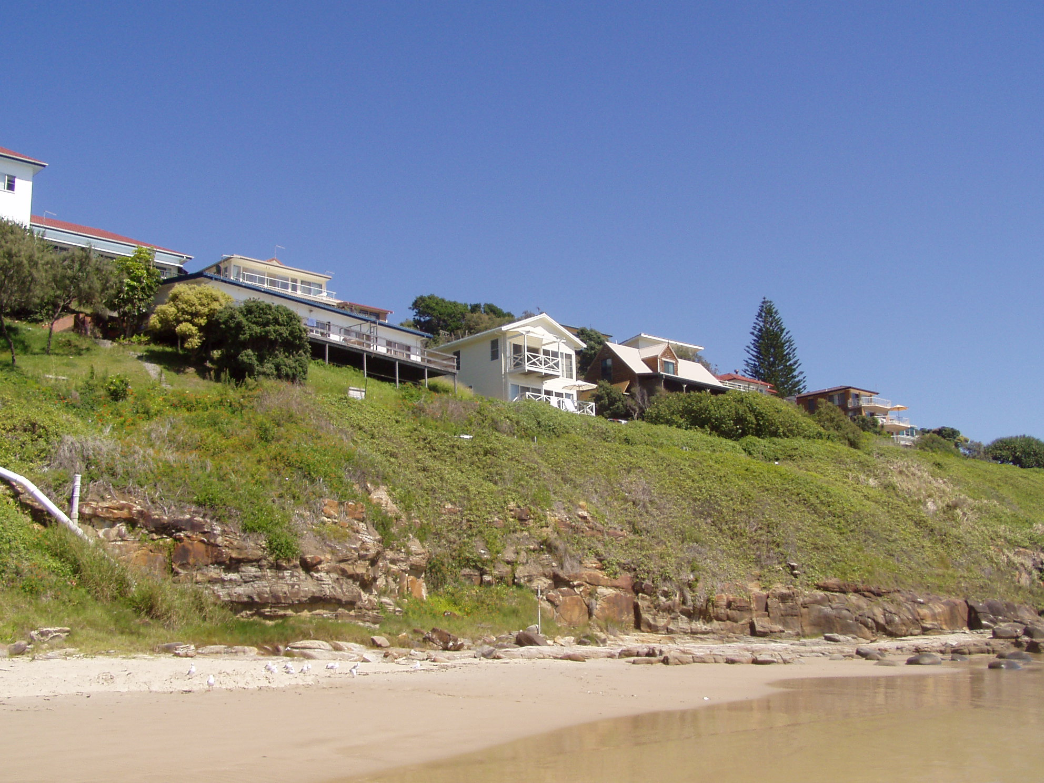

Fig 2 View of the study area on Yamba Hill pictured from Yamba Beach

Community consultation

Community involvement in the project has been invited since the inception using a range of communications. This critical aspect of the project is continuing, with the current emphasis on sharing the findings of the slope stability assessment completed after 2 years of monitoring and seeking feedback from residents and stakeholders. To date, the project has included two community meetings held at the Yamba Surf Club, development of a website (www.wrl.unsw.edu.au/yamba), three information newsletters, regular letter updates from CVC to residents and stakeholders, and a phone contact number for information.

Site investigations and monitoring methods

Site investigations were designed to target high risk areas identified during previous studies. Small landslips have historically occurred in dune sands underlain by weathered clay and sandstone above Main Beach. Three monitoring transects were established on a high dune slope perpendicular to the beach (8 monitoring sites). Monitoring sites were located at the top of slope, mid-slope and at the toe of the sandy slope on a low sandstone cliff behind the beach (Table 1 and Figures 1 and 2).

Table 1
Summary of Monitoring Installations
Type | Site | Location |  | RL Surface | Depth
Type |  | mE | mN | mAHD | mBGL
Piezometer | 1A | 535239.34 | 6743756.73 | 29.47 | 11.58
Piezometer | 1B | 535257.60 | 6743754.70 | 21.37 | 3.73
Piezometer | 1C | 535279.74 | 6743753.97 | 11.96 | 3.95
Piezometer | 2A | 535229.52 | 6743849.19 | 33.13 | 9.20
Piezometer | 2C | 535284.18 | 6743843.10 | 14.62 | 1.39
Piezometer | 3A | 535238.17 | 6743883.30 | 30.21 | 5.31
Piezometer | 3B | 535264.08 | 6743882.30 | 23.87 | 3.80
Piezometer | 3C | 535283.81 | 6743865.97 | 15.62 | 1.95
Inclinometer | 1A | 535240.19 | 6743756.10 | 29.41 | 19.05
Inclinometer | 1C | 535279.59 | 6743755.19 | 12.14 | 5.75
Inclinometer | 2A | 535230.52 | 6743850.19 | 33.18 | 13.85
Inclinometer | 2C | 535284.17 | 6743842.06 | 14.67 | 5.80
Inclinometer | 3A | 535239.28 | 6743883.50 | 30.24 | 11.30
Inclinometer | 3C | 535283.56 | 6743867.00 | 15.78 | 4.25
* All piezometers were 50 mm diameter PVC with machine slotted screened from 0.75 m above base.

Drilling, rock coring and testing of sediments were undertaken to determine the geotechnical and physical properties of subsurface materials. Inclinometer casings were installed to enable monitoring of ground movement at approximately 3 monthly intervals. Groundwater levels are monitored at 30 minute intervals with automatic loggers installed in piezometers with short screen intakes at the sand-clay interface. Monitoring between 26th May 2005 and 25th May 2007 captured a 1 in 10 year storm event in June, 2005. Monitoring will continue to observe response to at least three 1 in 10 year storm events.

Monitoring Results

Groundwater response to a major rainfall event

The only significant rainfall event that occurred during the monitoring period was the 385 mm that fell over several days around 30th June, 2005 (250.4 mm maximum daily rainfall). This event was a 1 in 10 Average Return Interval (ARI) event for a 2 hour duration, and 1 in 94 ARI event for an 18 hour duration.

The lower piezometers across the study area (ie. sites B and C) showed greater response to this June, 2005 event than the upper piezometers (Table 2, Figure 3). Sites 1A to 3A showed 0.6 to 0.95 m rise in level over a period of approximately 3 to 7 days. Sites 1B, 1C, 2C, 3B and 3C displayed rises of 1.12 to 1.74 metres over a period of between 12 and 24 hours. However, it is noted that the initial rise rate of piezometer 3A was fast but delayed. The lower piezometers all began to respond to the event before the upper piezometers.

This data reflects the fact that there is a limited catchment area upslope of the study area. As a result, piezometers located at near the base of the slope are characterised by a larger response to rainfall infiltration over a larger, upslope area.

Fig 3 Groundwater levels for Transect 1 (May 2005- May 2007)

Inclinometer monitoring of slope movement

Inclinometer monitoring was carried out during the period of 29 April 2005 (initial baseline setup reading) to 8th March 2007. All inclinometers with the exception of Location 2C indicated little or no significant movement. However, Location 2C showed 5 mm of movement with the plane of movement at a depth of about 3 m. Sandy clays exist at 3 m depth in Borehole 2C, therefore the movement is occurring within the sandy clays.

The mode of movement was consistent with the stability results for Transect 2, which showed that the lowest factor of safety occurs for slip circles at the toe of the slope when higher groundwater levels exist during rainfall periods. The movement in inclinometer 2C tends to suggest a slow moving (Creep) type movement occurring at the toe of the slope.

Table 2
Groundwater Level Response to Rainfall Event 29th June – 7th July 05
Location | Statistics
Location | Magnitude of Rise | Lag* | Maximum Rate of Rise
 | m | hours | mm/hr
1A | 0.75 | 176.50 | 21
1B | 1.12 | 12.00 | 222
1C | 1.74 | 17.00 | 58
2A | 0.63 | 116.25 | 18
2C | 1.17 | 22.75 | 117
3A | 0.95 | 75.50 | 219
3B | 1.31 | 9.50 | 265
3C | 1.19 | 34.25 | 122
* Lag time for each piezometer is the difference between time of first response and time at which peak levels were recorded.

Updated Assessment for Yamba Hill

Hydrogeological conceptual model

The observed behaviour of groundwater levels in response to rainfall during the monitoring period was consistent with the initial conceptual hydrogeological model (J&K, 2000). Detailed analysis of borehole stratigraphy and groundwater monitoring data was used to verify and refine the conceptual model. Groundwater parameters of relevance to slope stability assessment are summarised in Table 3, comparing the initial model with observations from the site. Observed saturated thickness, depth to groundwater, groundwater level rise, lag times and drainage times were all within the range of values allowed for by the initial hydrogeological model.

In summary, observed conditions were consistent with the simplified hydrogeological model, and observed groundwater level response (0.75 to 1.74 m) to rainfall events was within the range (1 to 2 m) that was predicted. The hydrogeological model that was adopted is therefore considered to be conservative and appropriate for the Yamba Hill site.

However, the hydrogeological model was improved by accounting for a lower rather than higher lateral hydraulic gradient after rainfall events (Figure 4). This result suggests that the toe of the slope becomes saturated during rainfall events. The hydrographs near the toe of slope had two distinctive recovery rates – early rapid decline (ie. 77 mm/day) then slower decline (ie. 6 mm/day) while the average drainage rate was close to the 19 mm/day in the initial conceptual model. The two stage drainage curves were attributed to local drainage immediately after the rain period, followed by a slower groundwater level decline due to additional infiltration from further up the slope arriving at the toe of the slope.

Table 3
Summary of conceptual groundwater models

Parameter | Initial model  (J&K 2000) | Revised model  (June 2005 event)
Groundwater level rise (m) | 1 to 2 | 0.75 to 1.74
Saturated zone above silty clay or bedrock (m) | 0.5 to 1 m | 0.3 to 3.5
Depth of sand at crest of slope (m) | 3 | 3.8 to 16.4
Depth of sand at toe of slope (m) | 1 to 2 | 3.8 to 4.2
Depth to clay (m) | 9 to 10 | 1.7 to 16.4
Thickness of clay (m) | 2 to 4 | 0.2 to 3.3
Vertical flow to crest of slope – time lag between rainfall and groundwater level rise (days) | 3 | 3 to 7.4
Vertical flow to toe of slope – Time lag between rainfall and groundwater level rise (days) | 0.7 days | 0.7 to 1.4
Lateral flow - time lag between rainfall and groundwater level rise (days) | 8 to 40 ^ | 11 to 67  (Piezo 1C)
Time to drain after event (days) | 10 to 80 days  (av. 19 mm/day) | 96 days  (Piezo 1C)
Average rise in groundwater levels for 100 mm event (mm) | 375 mm#  (300 to 400 mm) | 286 mm
^ assuming K lateral is 2 to 10 times vertical K
# assumes 75% average permeable area and 0.2 effective porosity

Lateral groundwater flow rates for Transect 1 were calculated to be 0.18 m³/day similar to the 0.2 m³/day projected by the initial groundwater model (Figure 4). These flow rates assumed a saturated hydraulic conductivity value of 10⁻⁵ m/s or 36 mm/hr (Douglas Partners, 1996). These values are considered to be realistic for silty sand, and are unlikely to be improved by site specific testing.

Limited drainage rates mean that groundwater levels below the crest of the dune remain high for 2 to 3 months after a major rainfall event. Therefore, antecedent rainfall will be the most critical element in producing groundwater levels which may cause instability of the slope.

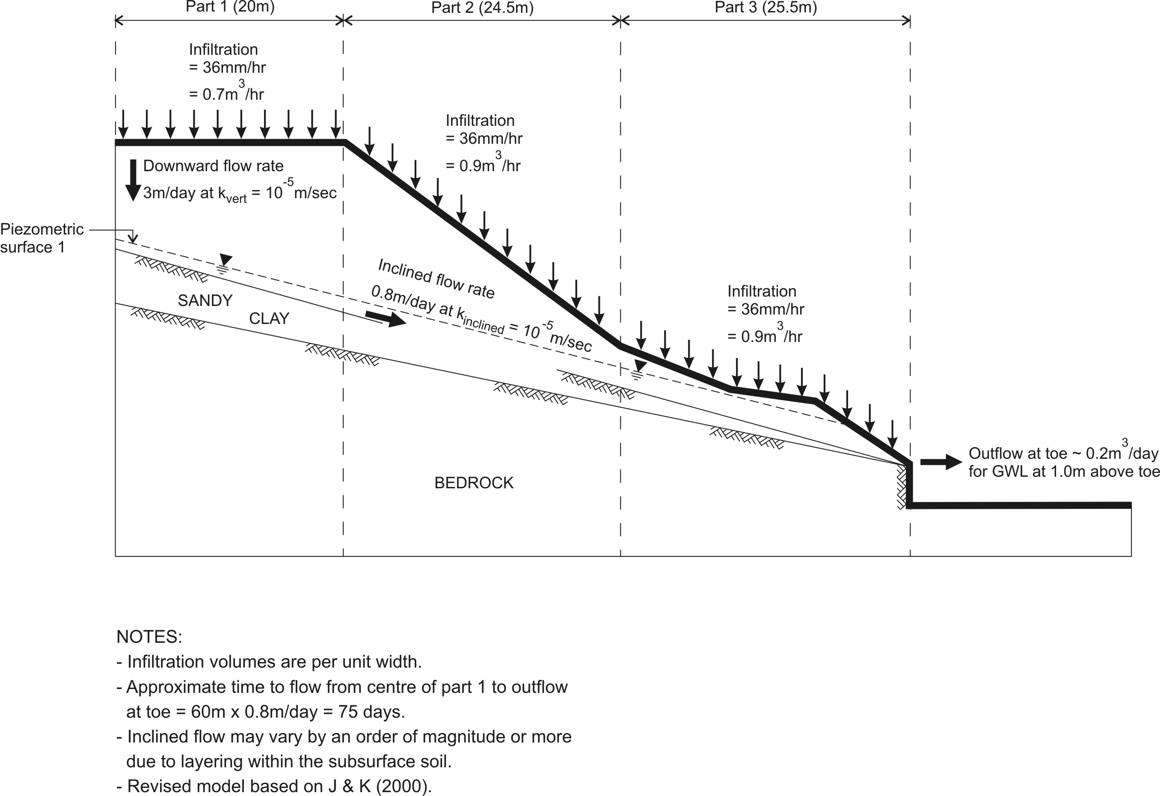

Fig 4 Revised hydrogeological conceptual model (modified from J&K, 2000).

Geotechnical stability analysis

The slope stability analysis considered surface conditions, sub-surface conditions, including suitable material properties (eg. effective cohesion, effective friction angle), together with groundwater level response to rainfall. A computer program SLOPE/W was used to analyse slope stability by considering circular failures through the sandy silt overlying bedrock. Although circular failure is not always the case, it is considered to be a reasonable approximation for many failures.

Overall the stability analysis of three subsurface models (Transects 1, 2 and 3) showed the slopes have low factors of safety (FOS) particularly for higher groundwater levels and the slope close to the Pacific Hotel. Calculated FOS values ranged from 1.0 to 1.6 for varying locations, types of failures and groundwater level conditions. These FOS values were generally less than the usually accepted values of at least 1.5 for reasonable design case and as low as 1.25 that may be tolerated for transient short term conditions.

Coastal processes and hazards

Consideration of coastal processes indicates that hazards are increasing over time at Yamba Beach due to a combination of storm erosion, shoreline recession and long term weathering and erosion of the rock cliffs. Both storm erosion and future recession will erode sand from the toe of the slopes fronting Yamba Beach, however, much of the beach (particularly the northern end) is fronted by rock cliffs/shelves which would limit short term erosion.

The rock cliffs and ledges would resist short term beach erosion, however when exposed, they are likely to suffer from long term weathering and erosion. Detailed studies would need to be undertaken for Yamba Beach, but studies at other sandstone coastlines in NSW indicated mean erosion rates between 1 and 5 mm/year. These reported mean rates need to be interpreted with regard to the episodic nature of cliff collapse events – that is, many years elapse between major events.

Landslide Risk Analysis

The risk analysis included rainfall analysis and probability assessment, in accordance with the AGS (2000) Risk Management Guidelines. The earliest known landslide occurred in May, 1938 with several recorded events since then (J&K 2000), although we are not aware of any landslides during the monitoring period for this project.

The probability of a landslide occurring was determined to be as follows:

- For earthslides and scour at the toe of the slope – 1 in 10 years to 1 in 125 years. However, considering that a landslide occurs only 50% of the time a ‘trigger’ level is reached, the probability equates to 5x10⁻² to 4x10⁻³.

- For earthslides encompassing the steeper hillslide slopes – 1 in 10 years to 1 in 100 years. For a 50% trigger, this probability equates to 5x10⁻² to 5x10⁻³.

Risk was then determined as a function of probability and consequence. Risk estimates were determined in relation to the suggested criteria in AGS (2000), with 10⁻⁴ tolerable risk and 10⁻⁵ as acceptable risk for loss of life of person most at risk. It will be up to the owners to decide whether these values are appropriate and the conclusions regarding the risk estimates reasonable.

The highest risk values identified were associated with Landslide Risk Zone 1a (LRZ1a, Figure 5). This zone was characterised by steepest slopes, a history of movement and expected high occupancy rate. In this zone the results of the risk assessments were:

- For slow to very slow movement 5x10⁻⁵ (tolerable)
- For rapid to very rapid movement 10⁻³ (unacceptable)

For LRZ1b which includes residential dwellings to the north of the Pacific Hotel the risk assessments were:

- For slow to very slow movement 10⁻⁵ (acceptable, just)
- For rapid to very rapid movement 4x10⁻⁴ (unacceptable)

The data obtained from investigations and monitoring during this project do not allow any adjustment to the LRZs.

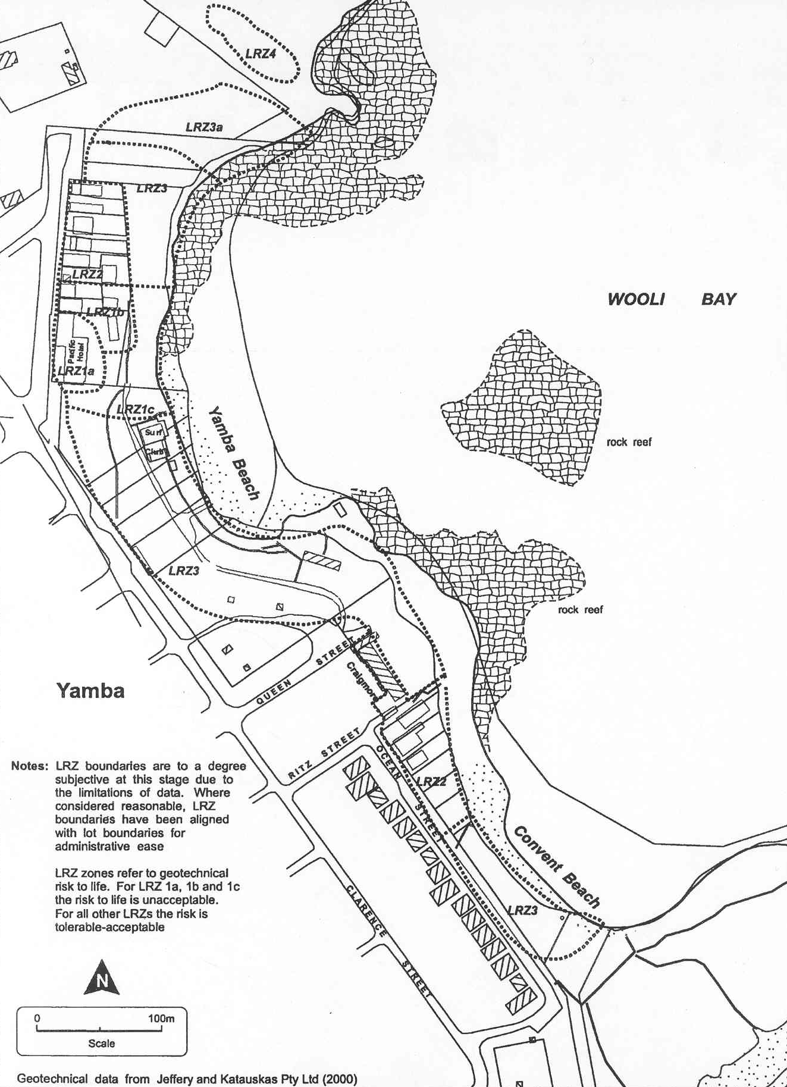

Fig 5 Landslide risk zones (After J&K 2000 and MHL 2003).

Summary and recommendations

In summary, investigations and monitoring at Yamba Hill to date have confirmed previous estimates of groundwater level response to major rainfall events and slope stability assessments. The hydrogeological conditions and recharge response that was observed was within the range expected for a sand dune sediments overlying a weathered sandstone slope, however it is noted that only a single 1 in 10 year ARI event occurred during the 2 year monitoring period.

All inclinometers with the exception of Location 2C indicated little or no significant movement of the hill slope. However, Location 2C showed 5 mm of movement with the plane of movement at a depth of about 3 m. The movement in inclinometer 2C tends to suggest a slow moving (Creep) type movement occurring at the toe of the slope.

On the basis of the revised slope stability risk assessment, it is considered that emergency levels and the subsequent management implications that were put into place in October 2000 should remain in place until more permanent stabilisation measures are adopted.

Two warning levels were set up as an interim measure: an Orange level which was based on a 1 in 3 year rainfall and a Red level which was based on a 1 in 10 year rainfall, taking into account antecedent rainfall over periods of 1 to 90 days. Various slope treatment/stabilisaton options should be investigated in more detail with a view to implementation as soon as possible.

Groundwater monitoring should also continue, and inclinometer measurements extended to an annual basis unless significant rainfall events occur and/or movements of the slope are observed, in which case the inclinometers should be read as soon as possible.

References

AGS (2000). Landslide Risk Management Concepts and Guidelines. Australian Geomechanics Society Sub-Committee on Landslide Risk Management.

CVC (2004). Yamba Coastline Management Plan – Implementation Strategy. Issued 16 March, 2004. Clarence Valley Council

Jeffrey and Katauskas Pty Ltd (2000). Report to Manly Hydraulics Laboratory NSW Department of Public Works and Services on Geotechnical Assessment for Yamba Coastline Management Study.

Jeffrey and Katauskas Pty Ltd (2007). Report to UNSW Water Research Laboratory on Updated Geotechnical Assessment for Pilot Hill, Yamba, Draft September, 2007.

MHL (2003). Yamba Coastline Management Study - Stage 4 - Draft Coastline Management Plan. Report MHL1142, June 2003.

WRL (2007). Yamba Hill Groundwater Level Monitoring Assessment to Mid-2007. UNSW Water Research Laboratory 2007-32 report to Clarence Valley Council, Draft, September, 2007.

WRL (2005). Yamba Hill Groundwater Level Monitoring Interim Report. UNSW Water Research Laboratory Technical Report 2005-34 report to Clarence Valley Council.

