HYDROLOGY AND WATER QUALITY OF A RESTORED WETLAND ON THE CLARENCE RIVER FLOODPLAIN

White N. S. ^{1,2}, Faulkner R ^{1,2}, Frazier P ¹, Wilkes J ¹
¹ University of New England, Armidale, NSW
² National Marine Science Centre, Coffs Harbour, NSW

Abstract

Many coastal floodplain wetlands in northern NSW have been drained and fitted with one-way floodgates. These wetlands are often underlain by acid sulphate soils (ASS) that can release acidic by-products into the groundwater and surface water if oxidised. The Little Broadwater, on the Clarence River, is typical of these altered wetlands. An ongoing restoration trial focussing on increased tidal exchange, initiated in June 2003, provided the opportunity to study the rehabilitation process currently taking place in the wetland. The study aimed to examine the effect of restoration on wetland hydrology (quantity and quality). Discharge water quality, especially in reference to pH, has significantly improved since tidal restoration. Monitoring has identified that the central portion of the wetland is flushed regularly. However, the northern and southeastern sections of the wetland receive little or no tidal exchange. Principal components analysis has shown that temporal and spatial variation in water quality is due to salinity. Temporal variation in salinity is primarily dependent upon rainfall, whereas spatial variation is due to circulation patterns and pre-existing conditions. Variation in pH is not a function of rainfall alone, but is also determined by prior water levels and circulation patterns. ASS by-products are present in the groundwater along the eastern edge of the Little Broadwater, with an average pH of 4 and extremely high concentrations of dissolved Al³⁺ and Fe²⁺ recorded. The results of this study will be used to develop a water quality predictive tool for future management of the Little Broadwater.

Introduction

Flood mitigation works have been carried out on the Clarence River floodplain since the early 20th century. Works included levees, drains, and one-way floodgates. As a result, many of the floodplain wetlands were drained and restricted from tidal exchange to increase the grazing potential of the floodplain. However, the draining of wetlands has had a number of detrimental effects, including the degradation of water quality, changes in vegetation communities, and loss of breeding and feeding grounds for birds and fish.

The exposure of acid sulphate soils (ASS) by draining coastal floodplain wetlands is one of the primary contributors to poor water quality. These soils developed during the Holocene-age after the last sea level rise, and are now commonly found in coastal floodplains, coastal wetlands, and estuarine embayments where there is a shallow watertable (Sammut, White & Melville 1996). ASS are stable under anoxic conditions, however, draining the wetlands oxidises the soils which then produce sulphuric acid along with iron and aluminium. During flood events severe acidification of drains and rivers can occur, and toxic levels of aluminium and iron are often recorded too.

Little Broadwater is a wetland on the Clarence River floodplain that is typical of these modified coastal wetlands with ASS. It was originally a tidal estuary with a mouth at least 200m wide. Tidal exchange was restricted sometime between 1911 and 1927, when the Little Broadwater Drainage Trust constructed the Little Broadwater levee. A small (900 mm diameter) pipe for discharge was installed at the western end of the levee in approximately the same location as the current drain. Later, a three-cell spillway with three one-way floodgates was installed further east along the levee to increase drainage. The levee and spillway structure were replaced in the 1960s when Clarence River County Council (now Clarence Valley Council) raised the height of the levee and installed a twin cell box culvert in the location of the small pipe (burying the spillway). The culvert has two one-way floodgates and a drain with a length of 200 m and width of 5 m. The Little Broadwater levee crest is now approximately 1.22 m AHD (Wilkinson 2003).

Due to tidal restrictions and drainage of the wetland, acidic water commonly discharged from Little Broadwater after high rainfall, and acid scalds were often seen on the ground surface. In 2001 the area was targeted by the Department of Land and Water Conservation (now Department of Natural Resources) for the Acid Sulphate Soils Hotspots Remediation Program. Restoration works began at Little Broadwater with the installation of two two-way tidal gates in June 2003. These were placed on the existing one-way floodgates. The culvert also had an in-drain water retention structure added, in the form of a weir with dropboards and a reverse fish-flap. These structures, however, only allow for limited tidal exchange to occur, at the discretion of the landowners and Clarence Valley Council (CVC).

Together CVC, landholders, NSW Department of Primary Industries (NSW DPI), and WetlandCare Australia set general aims for the rehabilitation project. These were to improve discharge water quality, vegetation cover and health, fish access, water bird habitat, and grazing potential. Presented here are the preliminary results from a two-year monitoring program of surface water and groundwater quality at Little Broadwater. The results of this study will be used to develop a water quality predictive tool for future management of the Little Broadwater.

Background

Study Area

Little Broadwater is a large coastal floodplain wetland on the Lower Clarence Floodplain, 3.2 km upstream of the junction of Sportsmans Creek and the Clarence River (Figure 1). The wetland covers an area of approximately 235 ha, with a local catchment of approximately 670 ha (Smith 1999 cited in Wilkinson 2003: 8). The main land use within the Little Broadwater catchment is cattle grazing with areas of timber and scrub. The wetland itself is used for grazing by four private landowners. There is also crown reserve (approximately 4 ha) in the eastern area of Little Broadwater, and approximately 33 ha of crown land in the central area of the wetland. The topography of the wetland is relatively flat, with an average land elevation of –0.1 m AHD. The soils at Little Broadwater are characterised by their strong acidity, salinity, sodicity and potential for high aluminium (Morand 2001). The sulphuric layer is at an average depth of –0.4 m AHD (Wilkinson 2003). The climate is sub-tropical, with summer dominant rainfall, hot summers and cold winters.

Little Broadwater is an important wetland as it is used by a number of birds listed as threatened species in NSW as feeding and breeding grounds. They include the endangered black-necked stork (Ephippiorhynchus asiaticus), and the vulnerable brolga (Grus rubicundus), osprey (Pandion haliaetus), and comb-crested jacana (Irediparra gallinacea). Commercially important species such as bream (Acanthopagrus australia), mullet (Mugil cephalus), freshwater eel (Anguilla spp.) and prawns (Metapenaeus macleayi) have also been seen in Little Broadwater. The predominant vegetation communities include softrush (Eleocharis equisentina), swamp oak (Casuarina glauca), phragmites (Phragmites australis), river club rush (Schoenoplectus litoralis) and water couch (Paspalum distichum).

Methodology

The monitoring program was designed to investigate the seasonal and spatial variation of surface water and groundwater quality, and the relationships between tidal gate and weir manipulations, surface water and groundwater elevations. From March 2002 to February 2007 discharge water quality was monitored continuously with a Greenspan Submersible Data Logger (SDL). Hourly measurements of pH, electrical conductivity (EC), dissolved oxygen (DO), oxygen-reduction potential (ORP), temperature, water level and flow velocity were recorded by the SDL.

Monitoring of surface water and groundwater quality within the wetland was conducted bi-monthly from April 2005 to February 2007. A pilot study from November 2004 to February 2005 led to the establishment of 45 surface water monitoring sites, including one in Sportsmans Creek (Figure 2). Five piezometer wells were installed on the edge of the wetland (based on maximum water level in non-flood periods), and one at the toe of a hill in the north of the wetland (Figure 2). In situ measurements of pH, salinity, EC, temperature, DO (not for groundwater) and depth were recorded.

Two water samples were collected from each surface water and groundwater site at the same time as the in situ measurements. Samples were collected in 125 mL acid washed polyethylene water sample bottles. The bottles and caps were rinsed three times with sample water. All air was excluded from the bottles before sealing and storing. After collection, samples were stored at 4ºC as soon as possible, and frozen within 48 hours of collection. Samples remained frozen until laboratory analysis.

Of the two samples, one was filtered through 0.45 μm Whatman filter paper and the other remained unfiltered. The filtered sample was analysed for basic cations (Ca²⁺, Mg²⁺, Na⁺, K⁺), acidic cations (Al³⁺, Fe²⁺ and Mn²⁺) and anions (Cl⁻, SO₄²⁻). Cations were measured using standard procedures for atomic absorption spectrometry (Varian-Techtron 1979). Cl⁻ was measured using the automated colour method, and SO₄²⁻ by the turbidimetric method (Rayment & Higginson 1992). The filtered sample was used to determine total nitrogen (TN) and total phosphorous (TP) concentrations (Hosomi & Sudo 1986).

Acid Discharge Events

The quality of water discharged from Little Broadwater has improved since tidal exchange was re-established in mid-2003. This is especially evident by the decreased duration, severity and occurrence of acid events both before and after tidal exchange, and also in comparison to another unmanaged drain (Figure 3). The Reedy Creek monitoring station was located upstream of Little Broadwater, on the southern side of Sportsmans Creek, and drains the Everlasting Swamp. It can be clearly seen in Figure 3 that at the end of February 2003 (prior to tidal exchange) a large rainfall event (179 mm in 24 hours) resulted in acidic water being discharged from both wetlands. Acidic water continued to discharge from Little Broadwater until mid-July, and from Reedy Creek until mid-August. Tidal exchange was re-established at Little Broadwater in mid-June, and may have contributed to the quicker improvement in discharge pH. Subsequently, there were a number of acid events recorded at Reedy Creek in response to rainfall, but at Little Broadwater either no acidic water was discharged or the severity of the event was much less. Other acid discharge from Little Broadwater (December 2005 to February 2006, and December 2006 to January 2007) had faster recovery times than acidic discharge prior to tidal exchange.

Spatial and Temporal Patterns of Surface Water Quality

Salinity

Surface water salinity was quite variable throughout the monitoring period, ranging from 0.1 ppt in April 2006 (Sites 2 and 3) to 35.3 ppt in October 2005 (Site 16). On average April 2006 and February 2007 were the freshest months (medians of 0.6 and 1.2 ppt, respectively), whilst June and October 2005 were the most saline (medians of 11.4 and 11.3 ppt, respectively), as indicated in Figure 4. When comparing between years 2005 was the most saline, with a median salinity of 4 ppt compared to 1.5 ppt for 2006. Sites 1 and 2 were the freshest areas over the monitoring period (median 0.7 ppt), and Sites 29 and 43 had the highest average salinity (median 4.3 ppt).

Temporal variation in salinity at Little Broadwater is strongly influenced by rainfall, and to a lesser extent tidal gate management (exchange). Figures 4 and 5 show that during 2005 there was an increase in salinity between April and June followed by a sudden decrease by August. This pattern is likely due to the large rainfall event at the end of June (183 mm over 5 days). Surface water salinity increased again between August and October 2005, and then decreased again by December. Surface water at Little Broadwater continued to decrease in salinity through to April 2006, and then a slight increase in salinity over winter occurred again. However, continuing rainfall and runoff in the upper Sportsmans Creek catchment meant that saline intrusion from the Clarence River, and therefore into the wetland, was limited. The result of this was continuing freshwater exchange at Little Broadwater, maintaining the surface water salinity at lower levels than the previous year.

Spatial variation of salinity is also important to understand, as it can be used as a conservative tracer to infer circulation patterns in wetland systems. In Little Broadwater it is clear that the northern area of the wetland is the freshest and the southeastern portion is generally the saltiest (Figure 5). The only months that differed from this pattern were June and August 2006, when the saltiest area was directly around the drain. This is due to tidal exchange with Sportsmans Creek, and shows that during high water levels in the wetland tidal exchange is limited to the immediate area around the drain. From these maps it can be inferred that the northern part of Little Broadwater receives very little or no tidal exchange, and relies on flushing from direct rainfall or runoff from the northern part of Little Broadwater catchment. Water entering the system through the drains may flow to the southeastern area of the wetland, but does not appear to flush back out. Salinity is concentrated here by evaporation, and is only diluted or flushed by direct rainfall and limited surface runoff from the catchment.

In October 2005 the majority of the wetland dried out (Figure 5), due to a number of factors. Firstly, during 2005 landholders, NSW DPI and CVC allowed tidal exchange to occur at Little Broadwater until salinity levels in Sportsmans Creek reached around 9 ppt. Once the salinity in the creek exceeded this level, then the tidal gates and weir would be manipulated to prevent the creek water from entering the wetland. This occurred in September 2005, however, by that stage salinity in some areas of the wetland were around 20 ppt. By October the lack of tidal exchange and rainfall, along with increased evaporation, had resulted in a large proportion of Little Broadwater drying out and many isolated pools of surface water appearing. Some of these pools were very saline – the pool in the west was 35.3 ppt, and the pool in the southeast was 29.1 ppt. However the pool in the central area of the wetland only ranged in salinity between 7 and 10 ppt. This is the deepest area in the wetland, and is also shaded by the swamp oak forest. Due to these two factors, there may be less evaporation or concentration of salts in comparison to other areas in the wetland. Little Broadwater remained this way until late October/early November 2005 when the summer rainfall began.

Acidity

Surface water pH was also quite variable throughout the monitoring period, ranging from less than 3 to greater than 10 (Figure 6). The sites with a pH consistently below 6 were Sites 1 – 3, 29, 31 – 33, and 39 – 44. Surface water at Little Broadwater had a median of 6.8 pH over the monitoring period. From April to October 2005 surface water pH was predominantly greater than 7, with some sites regularly recording below 6 pH (Figures 6 and7). Then in December 2005 there was a severe decrease in pH, with the average below 6 until August 2006. In December 2006 and February 2007 there were again a couple of areas where the pH remained below 6.

The severe acidification of surface water in December 2005 was due to Little Broadwater drying out in October 2005 which oxidised ASS, and then high rainfall. This provided a unique opportunity to see how the acidified system would improve with flushing by tidal exchange. The pH maps shown in Figure 7 support the flushing regime inferred from the salinity maps – the central area of the wetland receives the majority of tidal exchange, and other areas rely on rainfall for dilution. The acidic areas in the north and southeast did not become neutral or alkaline until October 2006, after another large rainfall event in August/September (Figure 3).

There is considerable spatial variation in surface water pH at Little Broadwater. Between April and August 2005 the most acidic areas were in the north and in the south-southeast at Site 29 (Figure 7). In October 2005 when the wetland was very dry, some isolated areas of surface water became quite alkaline, with values of greater than 10 pH recorded. The north, west and southeast areas of the wetland remained acidic from December 2005 to August 2006, however, in October 2006 they become quite alkaline. By December 2006, however, the southeast corner was acidic again, and remained so to the end of the monitoring in February 2007.

Oxidation of ASS can also result in toxic concentrations of Al³⁺ and Fe²⁺ being released into the water. Concentrations of soluble Al³⁺ and Fe²⁺ were much higher during acidic conditions (Figure 8). The very high concentrations of Fe²⁺ (> 5 mgL⁻¹) are from sites in the southeast during December 2005 in very acidic conditions. The high concentrations of soluble Al³⁺ at low pH were also recorded in the same area during December 2005. However, there were also high concentration of soluble Al³⁺ recorded when the surface water pH was between 7 and 10. These concentrations were in the northern central area, and the eastern side extending down to the southeast in April 2005, and to a lesser extent October 2005. It is not immediately obvious why the concentrations of soluble Al³⁺ were high during these non-acidic times.

Spatial and Temporal Patterns of Groundwater Quality

Groundwater salinity immediately adjacent to Little Broadwater ranged between 3.9 ppt (April 2005, P2) to 20.4 ppt (June 2006, P6), with a median of 15.7 ppt. Away from the edge of the wetland, groundwater salinity ranged between 0.8 ppt (February 2007) and 5.1 ppt (October 2005), and a median of 1.8 ppt. The freshest groundwater sites were P1 and P2 (Figure 9), located in the north of the wetland. The higher salinity of P2 compared to P1 suggests that the sediments next to the wetland are saline, however, this does not appear to be leaching into the surface water as it was quite fresh over the same period. The only exception was in April and June 2005 when surface water and groundwater salinity in this area was almost identical. It is noted by (Morand 2002) that salt precipitates were observed on the sediment surface in the northern area of Little Broadwater.

To verify the presence or absence of ASS, and their oxidation, the Cl⁻:SO₄²⁻ of water is used in conjunction with soil and water indicators (Stone, Ahern & Blunden 1998). These include the field pH of water (surface and groundwater) and soils, presence of shell, jarosite or iron oxide mottling in the soil profile, iron stains on the surface, and scalded low lying land (Stone, Ahern & Blunden 1998). Ratios of less than 2 indicate the presence of sulphidic material, 2 – 5 the presences if sulphidic material is uncertain, and 5 – 9 there is either no sulphidic material or it has not been oxidised at any time (Stone, Ahern & Blunden 1998).

ASS have already been identified at Little Broadwater (Morand 2002), so only water characteristics of ASS were measured during the monitoring program. Groundwater pH along the eastern edge of Little Broadwater (P2 and P3) was acidic (< 5 pH) throughout the monitoring period (Figure 9). Groundwater at other locations around the wetland ranged between a pH of 6 and 9. The Cl⁻:SO₄²⁻ at P2 was predominantly less than 2 (with the exception of October 2006 and February 2007 when the Cl⁻:SO₄²⁻ was 2.9). P3, P4 and P6 also had a Cl⁻:SO₄²⁻ less than 2 during February and April 2006, and August 2006 (P4 only). The concentrations of soluble Al³⁺ and Fe²⁺ at P2 and P3 were extremely high, with concentrations of up to 235 mgL⁻¹ recorded. These indicators along with acid scalds on the surface, confirm that sulphidic material is present in the north and east adjacent to the wetland. Other groundwater sites have indicators such as scalded areas and iron stains. The higher Cl⁻:SO₄²⁻ at these other sites may be due to the high salinity of the groundwater acting as a buffering agent. P3 has a high salinity too, but low pH, which suggests that the buffering capacity of the groundwater has been exceeded.

Summary

Since the restoration of Little Broadwater began in 2003, the duration and severity of acid discharge events has been reduced. Surface water quality within the wetland was not always the most desirable, although poor water quality within Little Broadwater did not always result in poor discharge water quality. The majority of the monitoring period was under fresh conditions due to regular rainfall from November 2005 to February 2007. The most saline sampling periods were June and October 2005, although in October nearly half of the wetland was dry due to zero tidal exchange and little or no rainfall. As a result ASS were oxidised, and when the summer rainfall began in November 2005, the entire wetland became acidic. Large areas of the wetland remained acidic until after August 2006.

Using salinity as a conservative tracer, and mapping it along with pH, a general idea of circulation and flushing regimes within Little Broadwater can be inferred. The northern section of the wetland is fresh and acidic, receiving little or no tidal exchange. Flushing of this area is only by direct rainfall or surface water runoff from the upper catchment. The southeast corner of Little Broadwater is predominantly the most saline area within the wetland, and has variable acidity. Inflowing water through the gates appears to be transported to this area, but does not flow back out, resulting in a concentration of salts which is exacerbated by evaporation. Flushing of this area is predominantly by direct rainfall and limited surface water runoff from the catchment. The central and western section of the wetland receives the majority of tidal exchange, resulting in variable salinity and primarily neutral water.

Leaching of ASS by-products is still occurring adjacent to the wetland in the north and on the eastern edge, including acidic groundwater and extremely high concentrations of soluble Al³⁺ and Fe²⁺. Little Broadwater has been identified as a priority area for management of ASS, and soil analysis at the wetland by Morand (2002) has determined that these soils are the primary type. It was unclear at the groundwater sites on the western and southeastern edge of the wetland as to whether oxidation of ASS had occurred or not.

The restoration works at Little Broadwater have improved the quality of water discharged from the wetland, and although water quality within the wetland was variable over the monitoring period, small fish were often observed throughout the wetland. To reduce the risk of high salinity levels in the southeast area of Little Broadwater, CVC, NSW DPI and landholders revised the salinity limit for tidal exchange to 2 ppt in 2006. The predominance of vegetation with low salt tolerance also contributed to the decision to reduce the salinity limit for tidal exchange. The risk with this low limit is that during time when salinity in Sportsmans Creek is high, tidal exchange will be drastically reduced or prevented, and the wetland may dry out again as it did in Spring 2005. It is necessary to maintain surface water cover in the wetland to prevent the oxidation of ASS and another severe acid event such as that which occurred in December 2005. Future management strategies need to be flexible to allow for changing climatic conditions and prevent further acid events from occurring, but also maintain vegetation cover for both grazing and habitat.

Acknowledgements

Thank you to the landholders of Little Broadwater and to NSW DPI for funding the project. Many thanks also to everyone who helped in the field and laboratory, including technical staff at the University of New England, staff at Clarence Valley Council Floodplain Services, and all the volunteers.

References

Helsel, D.R. & Hirsch, R.M. 2002, Chapter A3: Statistical Methods in Water Resources, U.S. Geological Survey. Retrieved 30 August 2007 from
http://water.usgs.gov/pubs/twri/twri4a3/

Hosomi, M. & Sudo, R. 1986, 'Simultaneous determination of total nitrogen and total phosphorus in freshwater samples using persulfate digestion', International Journal of Environmental Studies, vol. 27, no. 3, pp. 267 - 275.

Morand, D.T. 2001, Soil Landscapes of the Woodburn 1:100 000 Sheet, Department of Land and Water Conservation, Alstonville, NSW.

Morand, D.T. 2002, Everlasting Swamp "Hotspot" Study - Soils Report: Department Land and Water Conservation, Alstonville, NSW.

Rayment, G.E. & Higginson, F.R. 1992, Australian Laboratory Handbook of Soil and Water Chemical Methods, Inkata Press, Melbourne.

Sammut, J., White, I. & Melville, M.D. 1996, 'Acidification of an estuarine tributary in eastern Australia due to drainage of acid sulfate soils', Marine and Freshwater Research, vol. 47, pp. 669-684.

Stone, Y., Ahern, C.R. & Blunden, B. 1998, Acid Sulfate Soils Assessment Guidelines, Acid Sulfate Soil Management Advisory Committee, Wollongbar, NSW, Australia.

Varian-Techtron 1979, Analytical Methods for Flame Spectroscopy. Varian-Techtron, Publication No. 85-100009-00, Springvale, Australia.

Wilkinson, G. 2003, Everlasting Swamp Acid Sulfate Soil Hot Spot Remediation Management Plan: Final Report: Clarence River County Council.

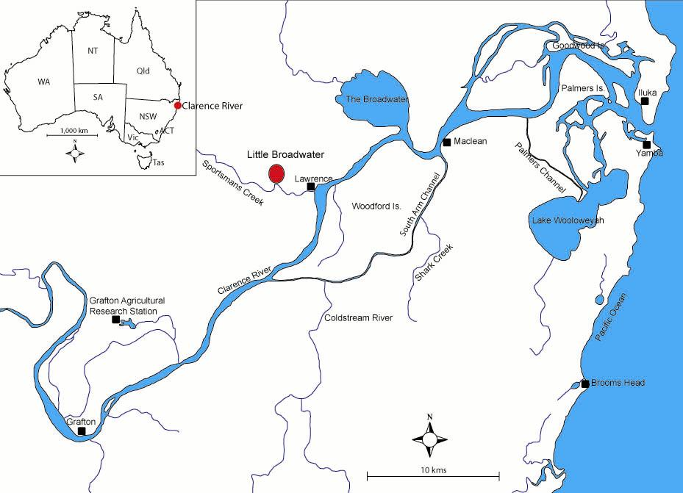
Figure 1: Clarence River Floodplain and the location of Little Broadwater.

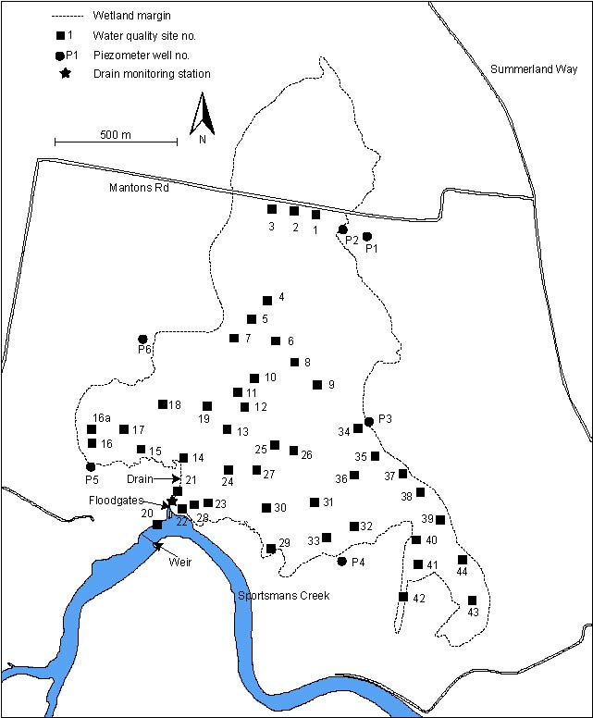
Figure 2: Little Broadwater, with monitoring sites indicated, and also the location of the drain and floodgates.

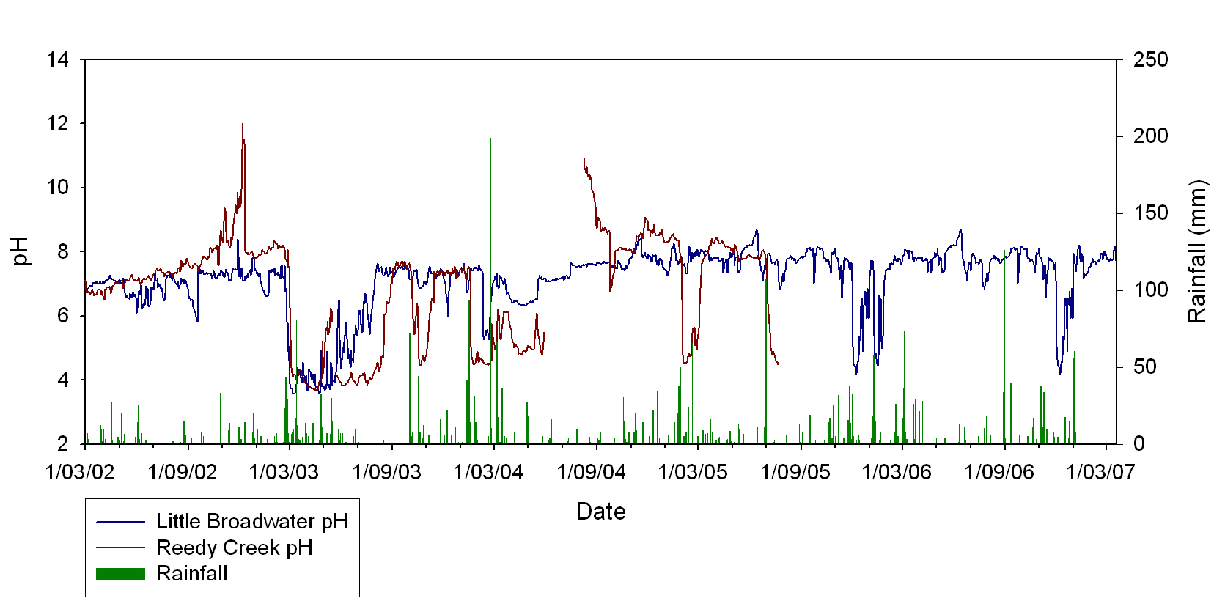
Figure 3: Daily mean pH of drain water from Little Broadwater and Reedy Creek (an unmanaged drain further upstream), March 2002 to March 2007. Daily rainfall is also shown. The duration of acid events at Little Broadwater has greatly decreased since tidal exchange was re-established in June 2003.

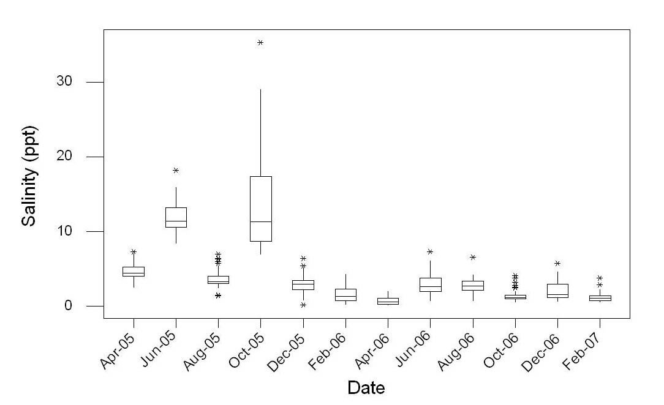
Figure 4: Boxplots of surface water salinity at Little Broadwater. The middle line in the box is the median (50th percentile), the ends of the box the 25th and 75th percentile, the whiskers extend to within one step of the box, and an asterisk represents an outside value (Helsel & Hirsch 2002). The saline outside values are sites located in the southeast area of the wetland. There is a clear difference in salinity between 2005 and 2006, which is related to rainfall.

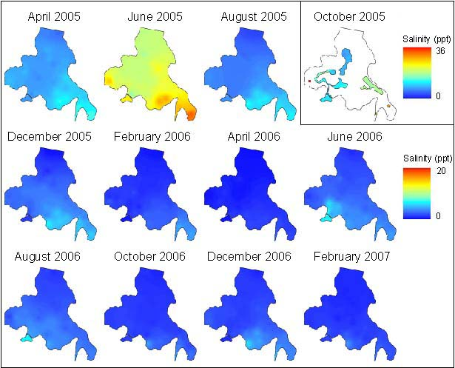
Figure 5: Surface water salinity maps of Little Broadwater. Dark blue indicates freshwater, yellow and red represents more saline water. *Note October 2005 uses the same colour ramp but at a different scale. This is due to the very saline conditions during this month.

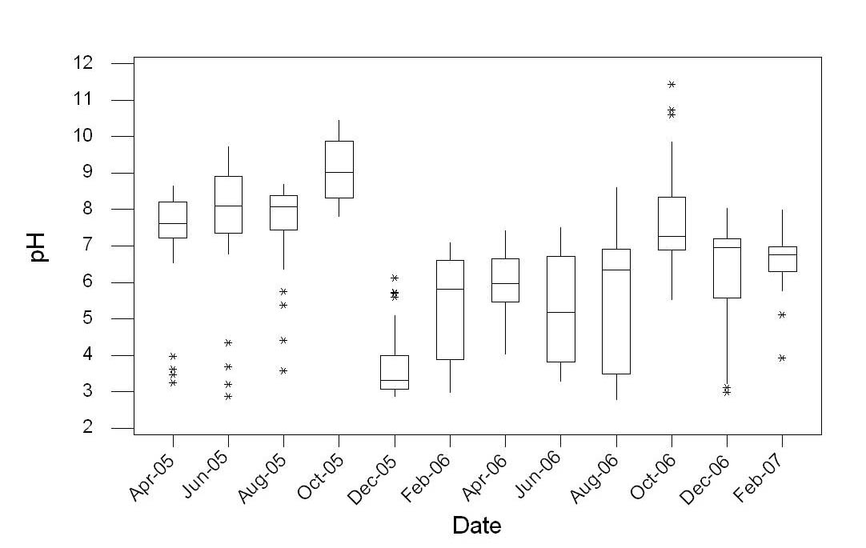
Figure 6: Boxplots of surface water pH within Little Broadwater, April 2005 to February 2007. The middle line in the box is the median (50th percentile), the ends of the box the 25th and 75th percentile, the whiskers extend to within one step of the box, and an asterisk represents an outside value (Helsel & Hirsch 2002). Surface water pH prior to December 2005 was neutral, but then the average pH was less than 6 up to August 2006. The acidic outside values are the north and southeast areas of the wetland.

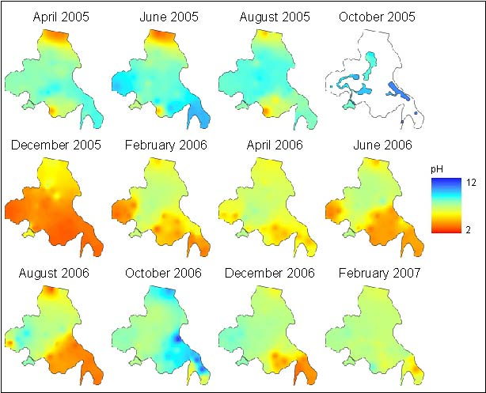
Figure 7: pH maps of Little Broadwater, April 2005 to February 2007. The severe acid event in December 2005 was due to the wetland drying out in October 2005. The predominant acid areas are in the north, and the south-southeast areas. Tidal exchange in the central area of the wetland is clearly seen from February to December 2006.

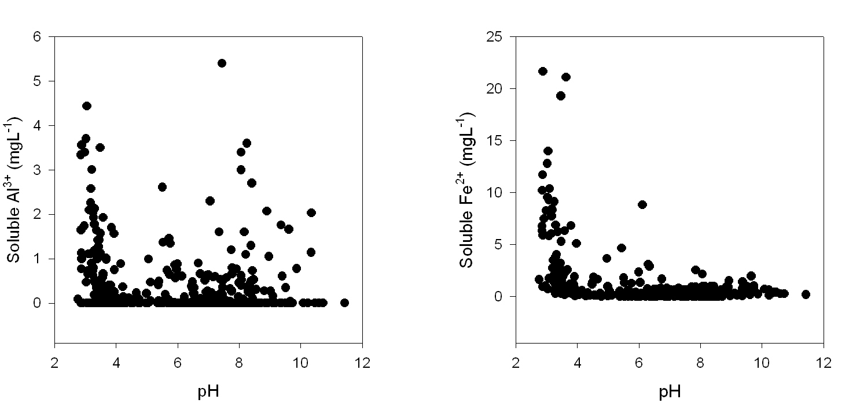
Figure 8: Scatter plots of soluble Al³⁺ and Fe²⁺ vs. pH for surface water in Little Broadwater, April 2005 to February 2007. High concentrations of soluble Al³⁺ and Fe²⁺ occur during acidic conditions when ASS have been oxidised.

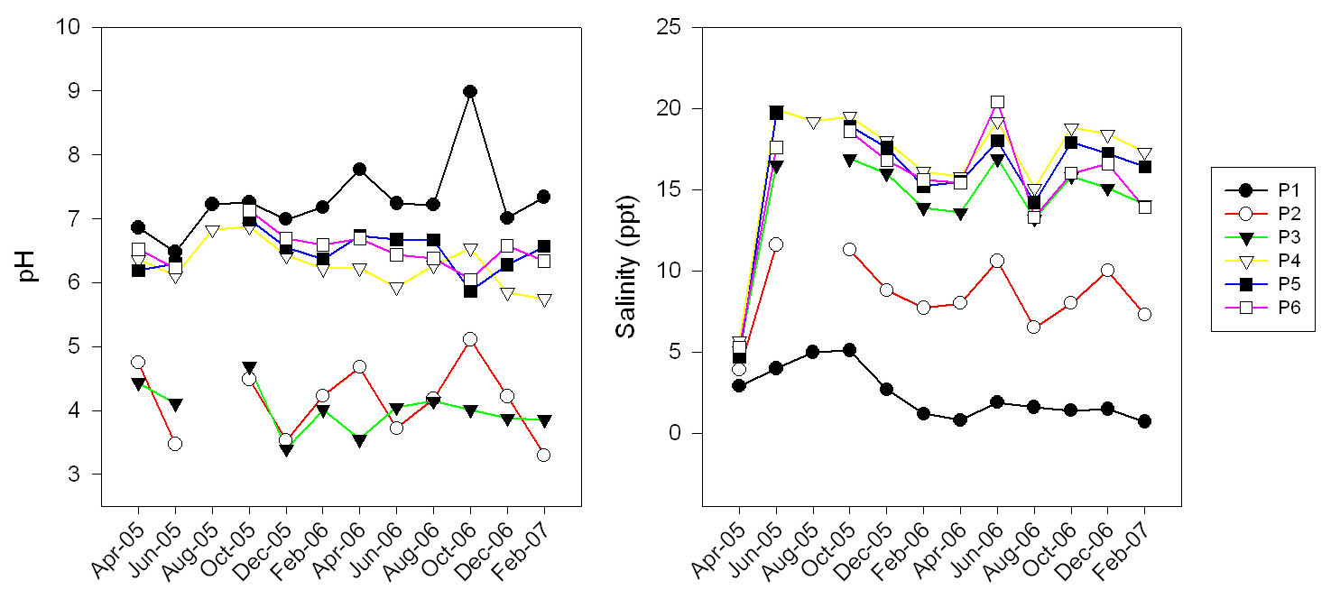
Figure 9: pH and salinity of groundwater around Little Broadwater. Groundwater at P2 and P3 is acidic (< 6 pH). Groundwater salinity is lowest at P1, which is also the furthest from the edge of the wetland.

