Monitoring beach usage on NSW beaches: Is it beneficial?

Peta Williams¹, Gervase Tuxworth² and Chris Lane²
¹ Griffith Centre for Coastal Management (GCCM) Gold Coast Campus, Griffith University QLD 4222
² CoastalWatch Suite 3, 66 Appel Street Surfers Paradise QLD 4217

Abstract
People primarily use beaches for fun and recreation. Monitoring beach usage is important for providing data to help predict future beach needs. CoastalCOMS, an automated observation system for coastal monitoring, can measure the extent of beach usage by counting how many people are on the beach at any one time.

Another important aspect of beach usage monitoring is to determine what people are using the beach for. For example, are they walking on the beach, sunbathing, or entering the water? The information obtained about how people are using the New South Wales beaches will provide data to coastal councils and coastal management authorities to help future beach planning and management. It will also be useful for surf lifesaving organisations and local lifeguards.

The technique used to automatically count the number of people on the beach is a simple approach to counting objects. The algorithm converts the image to greyscale and performs a technique known as ‘thresholding’ on the video. This converts dark colours to black and light colours to white, creating a black and white image. This also has the effect of making foreground objects white and background objects black. The rest of the algorithm simply counts the number of detected foreground objects in each frame of the video and averages the number of people out over the length of the video. While this technique is not practical in complex environments, on a beach environment there are very few incorrect classifications as there are few objects aside from people on the beach.

This paper will look at the CoastalCOMS system its uses and benefits, and how it can be used by local councils, coastal management groups, and surf lifesavers to help improve the management of New South Wales beaches.

Introduction
The Coastal Conditions Monitoring System (CoastalCOMS) is an automated observation system for coastal monitoring. The system is comprised of a shore-mounted video camera network and sophisticated image processing routines for analysis and display of coastal environment information.

CoastalCOMS provides comprehensive real-time and predictive information about beach and surf conditions. The real-time data includes offshore wave height, nearshore wave height, wind direction and strength, surf quality, beach state, beach usage and shoreline position. Combined with data from other sources, such as tide predictions and expert observations, the collected data is stored and used to train predictive algorithms for short term forecasting of nearshore wave height and surf quality, beach state changes, and beach user risk.

CoastalCOMS offers seven modules of information relating to beach conditions. These are vision, wave height, beach state, beach risk, surf quality, beach usage, and shoreline position. The information provided in each module is often related to, and dependant upon, the information in the other modules. Each module may consist of display elements derived directly from video, raw data from climatic and other physical processes, and processed information (including predictive information) derived from this raw data.

This paper will review CoastalCOMS, its uses and benefits, and how it can be used by local councils, coastal management groups, and surf lifesavers to help improve the management of our NSW beaches in regards to beach usage.

Beaches are used primarily for recreation and fun. Monitoring beach usage is important for providing data to help predict future beach needs. The CoastalCOMS can measure the extent of beach usage by counting the number of people using the beach at any given time. Figure 1 shows an image captured from a CoastalCOMS camera.

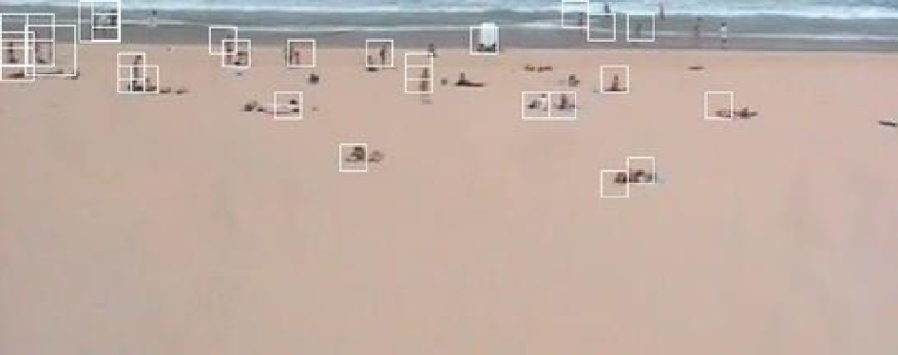
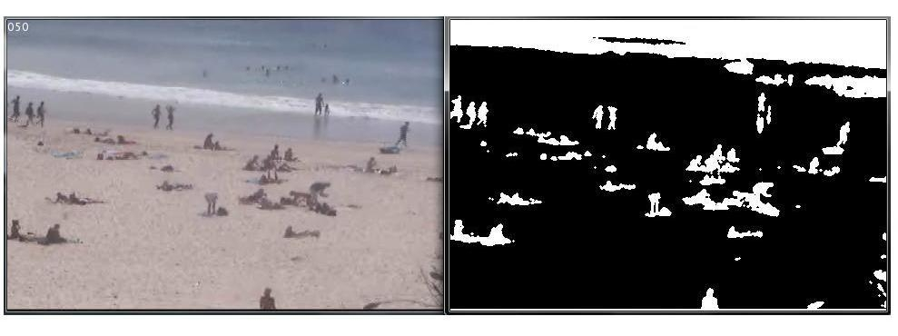
Figure 1. Image showing areas (rectangles and shadows) that have been classified as a “person object”. (Source: CoastalWatch, 2007)

Information gained from CoastalCOMS is important for use in future beach planning and beach safety management. This shows the importance of beach monitoring and being able to ascertain what people are doing on the beach, for example: Is the person walking on the beach, sunbathing or entering the surf?

Methodology
The technique used to automatically count the number of people on the beach is a simple approach to counting objects. An algorithm converts the image to greyscale and performs a technique, known as ‘thresholding’, on the video. This converts dark colours to black and light colours to white, thus creating a black and white image. This also has the effect of making foreground objects white and background objects black. The rest of the algorithm counts the number of detected foreground objects in each frame of the video and averages the number of people out over the length of the video.

While this technique is not practical in complex environments, on a beach environment there are very few incorrect classifications as there are few objects aside from people on the beach. The misclassified objects are insignificant compared to the number of people on the beach. Accuracy rates of up to 90% have been achieved by manipulating camera direction and zoom. By breaking the beach up into 3 or more sections (figure 2), an accurate count on both wide beaches and beaches where the camera is a significant distance from the target can be obtained.

There are some limitations to the system. These include the inability of the technique to work in adverse weather conditions and poor lighting. Generally speaking, 9am – 4pm will provide sufficient lighting conditions for an accurate count. Outside these times, accuracy rates can drop significantly, and additional parameters are required to obtain reasonably accurate results.

Figure 2. Breaking the beach up into 3 sections for counting the number of people. (Source: CoastalWatch, 2007)

Benefits
With CoastalCOMS providing comprehensive real-time and predictive information about beach and surf conditions, the system has many benefits not only to local councils and surf life saving but also to the local community. This includes beach health, beach safety, and better local planning and management techniques.

Data collected from two NSW beaches – Cronulla and Maroubra – over two months in July and August 2007 (figure 3) using the CoastalCOMS software, shows that Maroubra, not surprisingly, was more popular and used more extensively throughout these two months than Cronulla Beach. But results also show the popularity of both beaches during the winter months not only on weekends but also unexpectedly during the week.

This data is but a snapshot and an example of the potential information and results that can be gathered from using the CoastalCOMS software. Further analysis of long-term data would provide specific information in regards to demand on specific days.

Results gained from CoastalCOMS can help to prioritise management and planning strategies to target certain beach areas along the NSW Coast. In the case of Cronulla and Maroubra, results may indicate that beach patrols are just as important during the week as they are on the weekends. With big events scheduled at both locations throughout the surf calendar it reinforces that facilities and amenities in the area, such as parking spaces and open parklands and bbq facilities, have to be properly managed to meet the increasing demand. This demand can be clearly established and analysed using the CoastalCOMS software.
Figure 3. Cronulla vs. Maroubra: Beach usage numbers

With the growth of NSW’s general population along with the number of tourists rising each year, the amount of people visiting the beaches is increasing. This is resulting in more beaches being used, more of the time by an increasing number people, many of whom are unfamiliar with beaches and their associated risks. Many beaches along the coast have no surf life saving clubs or patrols. There is now, more than ever, a greater need to maintain public safety on beaches. The CoastalCOMS technology could provide an analysis of swimmers using the beach during patrolled hours and assess the need for lifeguards outside normal hours, after 5pm or before 9am, on certain beaches along the NSW coast. It can also help determine information on each beaches general characteristics, suitability for swimming and other recreational activities, beach health and access, and the need for certain lifeguards resources. It is an important tool for beach safety and future planning issues for the coast.

The CoastalCOMS data allows local councils and surf life saving clubs to access information on the number of people using a particular beach and what they are using the beach for as well as the potential hazards of that beach. As stated above, this aids lifeguards as they can access information on the number of people currently on their beach and the general activities they are undertaking. The lifeguards can then better assess any associated risks as well as the current beach conditions. Beaches can then be better managed with a proper distribution of lifeguards and other resources and facilities.

This technology could be used in conjunction with the beach hazard rating system (Short, 2000), which refers to the scaling of a beach according to the physical hazards (1-safest, 10-least safe) associated with its beach type together with any local physical hazards. For example Maroubra’s safety rating is 7, whereas Cronulla’s safety rating is 3 (SLS NSW, 2007). This data would aid local NSW lifeguards as they will be able to access vital information on the numbers of people currently on each particular beach and exactly what it is they are using it for. They can then better assess any associated risks and the current beach conditions in regards to the beach usage data and better plan for any potential dangers, which may arise. Consequently, the beaches are better managed with proper distribution of lifeguards and other resources. With the popularity of these two beaches, this technology will be of particular importance during the summer seasons when the number of people using these beaches is at its peak.

The system can also benefit local councils in their local area planning and coastal management strategies, with the system being able to determine the number of people using the area and what they are using the area for. This will help local councils plan for parking, infrastructure and other amenities, which may be required in the area. This can either be used to increase parking and amenities in an area of high demand, in order to help combat problems caused by high usage, or increase parking and amenities in an area of low demand and improve public transport to reduce the parking pressure. For example there is very limited parking at Maroubra Beach and with people numbers reaching 276 during the winter months can the local area cope with the increased numbers during the summer months or has this beach already reached its capacity because of the limited parking and facilities in the area. The CoastalCOMS program would help Maroubra’s local council determine its carrying capacity and aid in future local area planning to accommodate the increasing numbers of people using its beach.

In terms of coastal management, it can look at current coastal management techniques used by local councils, such as beach nourishment and dune revegetation, and determine whether they are of any benefit to the area and the people using that area. It can also determine whether that management technique is actually needed elsewhere instead. For example, local councils can focus funding on beaches that are directly impacted on by an increased number of people using them, ensuring that the beaches can meet the expectation of the tourist and local community. It is a local council’s responsibility to ensure the provision of a healthy beach system, otherwise it could impact on the local community’s lifestyle and the tourism dollar.

All of these benefits can help manage current local council spending and ensure that funding is being distributed within areas with the highest needs. Better management and planning of a particular area will have a positive effect on local businesses and the local economy. Improved use of local council funding can then be used to address community concerns regarding beach amenity and safety.

Conclusion
CoastalCOMS addresses a need for readily accessible real-time and predictive information on beach usage and surf conditions. It is easily installed and provides coverage over wide areas of coastline while conveniently displaying the information at a single location.

Effective coastal management recognises the need to manage and plan for the long-term impacts of natural and human activities to protect coastal resources for future generations. Coastal management authorities require adequate and timely access to information on the health of the beach system in order to effectively manage the distribution of resources and to address community concerns regarding beach amenity and safety. A system, which combines the wide array of ever-changing environmental parameters in one graphical display, enables efficient communication of information to stakeholders and the public.

The benefits of CoastalCOMS, as demonstrated in the case of the two Sydney beaches, are varied and can be applied to any beach area along the NSW coast or Australian coast. The information provided by CoastalCOMS is especially useful for coastal councils and their lifeguards, coastal management authorities and surf life saving organisations.

Acknowledgments
A special thanks to Prof. Rodger Tomlinson and Sally Kirkpatrick of the Griffith Centre for Coastal Management.

References
CoastalWatch (2006) www.coastalwatch.com, cited April 2007

Gold Coast City Council (2007) www.goldcoast.qld.gov.au, cited April 2007

Short, A., (2000) Beaches of the Queensland Coast: Cooktown to Coolangatta, University of Sydney Printing Services, University of Sydney

Surf Life Saving NSW (2007) www.surflifesaving.com.au/surflife_CMS/BeachSafety, cited September 2007

