TWO CENTURIES OF COASTLINE CHANGE ON THE NORTH COAST OF NEW SOUTH WALES

Dr Peter Helman
Senior Research Fellow
Griffith Centre for Coastal Management
Griffith University, Gold Coast, Southport, Qld

Abstract
Extensive research on past records on the New South Wales and south east Queensland coast has revealed changes that have been related to sea level trends and multi-decadal phases of Interdecadal Pacific Oscillation (IPO). Indicators suggest that before European settlement of Australia sea level trend was stable or slightly falling. Sea level commenced a slowly rising trend from the 1820’s. The rise is detected in early tide gauge observations in Tasmania during the early 1840’s, as well as tide gauge observations at Sydney (from 1886) and Auckland (from 1899). The rising trend is attributed to: gradual warming that followed the global sea level fall after the Tambora eruption (1815), a long negative IPO phase (from the 1850’s to 1890’s) and global warming during the 1900’s. Observations at Sydney indicate sea level rise of around 100mm/100 years, well below the global average of 180mm/100 years. The relatively small rise on the east coast has resulted in erosion of barrier dunes, deposition in estuaries, and washover of barriers and spits. The timing of coastal events is generally related to the oscillation of the IPO. During positive phases of IPO the east coast experiences recurring droughts, low storminess, sea level below the long term trend and inshore accretion. During negative IPO phases the east coast experiences wet periods, major floods, sea level above long term trend and coastline erosion. Coastline changes at specific sites illustrate the impact of sea level rise, due to climate change and climatic variability, largely influenced by IPO phase.

Introduction
Coastal management decisions are commonly based on analysis from 50 years of aerial photography or even shorter periods of measured data, for example from wave rider buoys. Projection of trends from short period studies is questionable could underestimate long term trends.

To study past coastline dynamics over a longer period, a 200 year record of climate change, climatic variability and coastline response has been compiled for the central east coast of Australia, from Fraser Island to Coffs Harbour. The compilation incorporates a wide range of indicators and observations. Early 1800’s records are incomplete but are indicative, and when combined with over a century of reliable records describes the trend of sea level rise from climatic influences, the range of climate variability and coastal response.

Climate change - long term sea level trends
Geomorphic and climatic evidence indicates that the coastline observed by the first Europeans over 200 years ago was formed during a relatively stable climatic period when sea level was slightly below present. Consistent findings deduced from coastline indicators suggest that the coast has been influenced by a slowly rising sea level trend from the early 1800’s to present.

Recent simulation from HadCM3 (Hadley Centre 2004) (Figure 1) shows a slowly falling trend of global sea level until 1820 then a rising trend. This rising trend commenced well before the sea level rise attributed to Greenhouse induced global warming in the 1900’s.

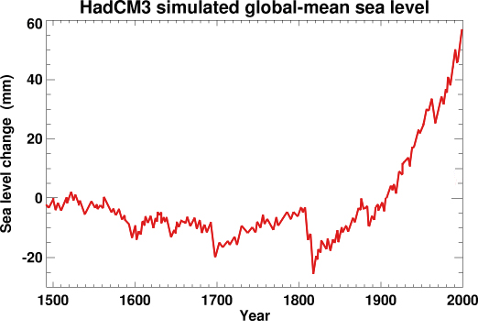

Figure 1 HADCM3 coupled atmospheric model of global sea level for the last 500 years. Hadley Centre, Met Office, UK 2004.

Sea level rise from the early 1800’s is explained by: recovery after cooling induced from the 1815 Tambora eruption (Gregory and others 2006), a prolonged negative phase of IPO from the 1850’s to 1890’s and possibly a small recovery after the 1883 Krakatao eruption.

In Figure 2 the trend of sea level for the Tasman Sea, based on geomorphic and climatic evidence (Helman 2007) is compared to HADCM 3 curve.
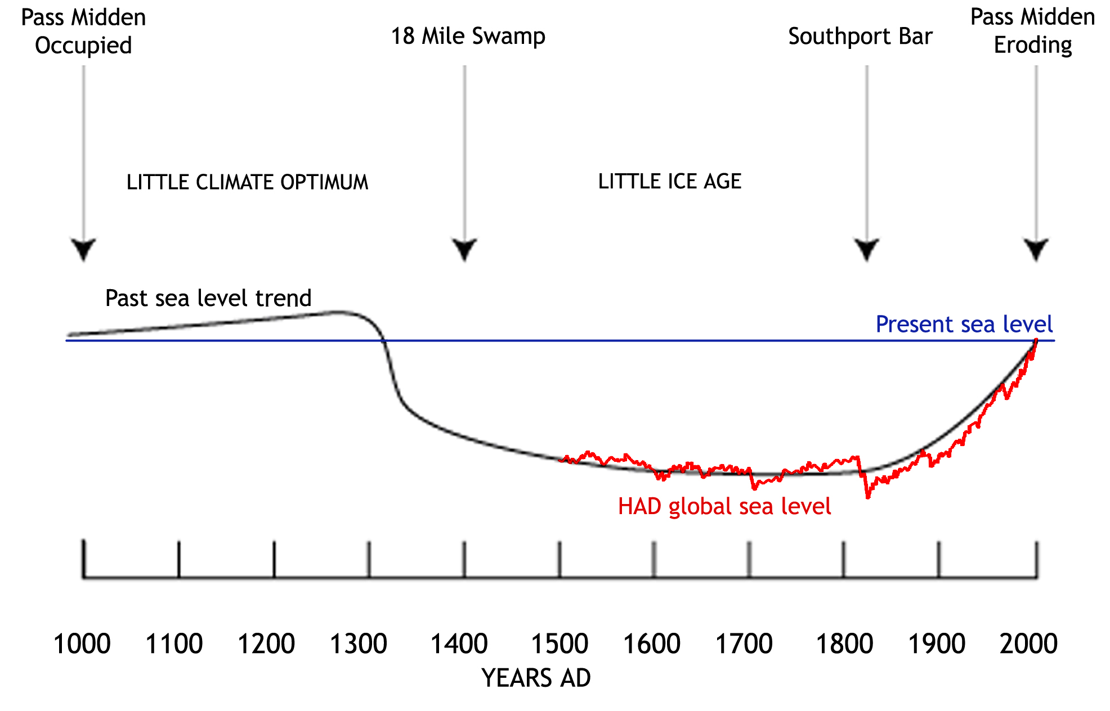
Figure 2 HADCM 3 global sea level overlaid over one thousand year sea level trend for the Tasman Sea. Derived from Aboriginal beach shell middens and geomorphic evidence, central east coast Australia, advance or retreat of New Zealand glaciers (Salinger 1976), and southwest Pacific coral reefs (Nunn and others 2001) after Helman 2007.

Several years of sea level observations in the early 1840’s have been analysed by Pugh and others (2002); Hunter and others 2003, showed that sea level was lower than when tide gauge observations commenced at Sydney in 1886 (Figure 3). The rising Tasman Sea is also reflected in tide gauge observations at Auckland from 1899.

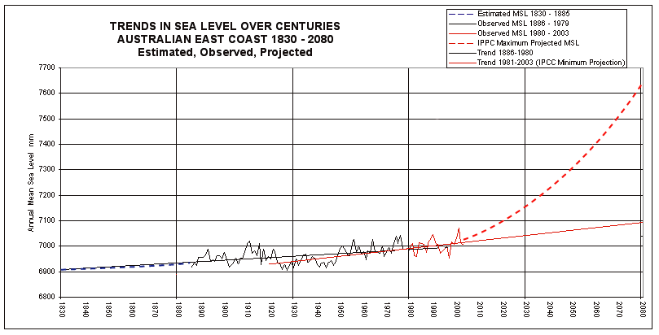
Figure 3 Estimated (blue dash), observed (black) and projected (between red solid and red dash lines) trends in east coast sea level over centuries (Helman 2007).
The rise at Auckland for the last century is 180mm, around the global mean, while at Sydney sea level rise follows, but has been below the global rates. The non-uniform distribution of sea level rise is attributed to different regional rates of thermal expansion (Cazenave and Nererm 2004).

The slowly rising sea level over the last two centuries has resulted in permanent coastal changes on the east coast of Australia. These include: breaching of coastal dunes, barrier island formation, loss of tombolos and growth of flood tide deltas. The coastline has been moving slowly inland but this has been largely unperceived as the rate of sea level rise has been low and well within the range of climatic variability. Little concern has been raised as most of the eroded land is public reserve that has acted as a defacto coastline buffer. As shown in Figure 3 this is unlikely to be the case in the future.

Climate variability and IPO phase
Recorded changes to the coastline were compared to available records of observed annual mean sea level, severe storms, interannual oscillations of the Southern Oscillation Index (SOI) and multi decadal oscillations of the Interdecadal Pacific Oscillation. Lombard and others (2005) demonstrate that interannual sea level variability is dominated by SOI and decadal variations by oceanic oscillations. The east coast of Australia is influenced by the oscillation of the Pacific Ocean in multi decadal phases, indicated by the IPO index (Figure 4).

For the 150 years of reliable records it was found that major energy periods on the coast were largely associated with negative phases of the IPO. During negative phases, sea level rises at faster rates (Goring and Bell 2001), and is higher than long term trend. The inverse correlation between multi decadal sea level variation and IPO is reflected in recorded coastline changes for the east coast of Australia.

Figure 4 Episodic oscillation of IPO (plotted inverse) and detrended Sydney sea level from 1886 (Helman 2007).

Despite multi decadal oscillations of climate and coastal response, an underlying long term erosion trend is indicated by an apparent loss of inshore sediment and a retreating inland storm face cut into stranded late Pleistocene dunes.

Records of climate variability – storms, floods and droughts
Significant weather events, calms, storms, droughts, floods and observations on coastal features such as river bars, marine deltas, beaches, dunes and erosion have been used in the compilation of the 200 year record. An example is provided in Appendix 1. The table, while compiled event by event, is used to consider climatic patterns for inter-annual and decadal assessment (Callagan and Helman in press).

Many types of records are reviewed as evidence of significant events before the preparation of daily weather maps around 1880. The maritime records are not a ‘shipwreck’ record.

While there is general agreement between authorities, some records demonstrate significant disagreements, due to inadequate or conflicting primary sources. Such records have been treated cautiously. Minor discrepancies between historical authorities have been ignored. Significant differences are noted after the citation.

Record Categories
1770 to 1788
Records are limited and a summary of events from available sources is included.

1788 to 1820
Prior to the exploration and establishment of Port Macquarie and Moreton Bay penal colonies, most records are from the early colonial settlement and shipping activities around Sydney. Records from limited voyages in the Coral and Tasman Seas, including some New Zealand records have been considered.

1820 to 1880
During this period, there was increased settlement and shipping, especially the cedar trade along the coast southern Queensland and New South Wales coasts. Historical accounts in maritime records are compiled from local coastal histories and Bureau of Meteorology records.

1881 to 2004
For NSW coast, storm events from 1881 onwards are classified by PWD 1985 and PWD 1986. For south east Queensland and severe storms to the north (Coral Sea) after, Beach Protection Agency (1989), Bureau of Meteorology records, especially those of severe storms compiled by Jeff Callaghan.

From 1880, accurate surveys (portions, harbour works and beach gold mining leases) give indicators of the position and in some cases the condition of the coast. Photographs of some coastal features commenced around 1890, with oblique aerial photographs from around 1920 and vertical aerial photography from the mid 1940’s.

Coastline records before aerial photography
Assessments from accurate surveys shows that over the last century the unconsolidated sections of the studied coastline are eroding and have moved inland between 50m to +300m, depending on compartment position. In some places the result has been the complete loss of the coastline public reserve.

Coastline erosion generally occurs in severe storm years, with positive SOI. These storm years generally occur within a storm period, lasting decades and associated with negative IPO and sea level above trend. Such periods are associated with major floods, erosion and coastline changes that last several decades, for example between 1950’s to 1970’s.

Conclusions
Analysis over long time periods provides a method for separating the influence of climate change from climatic variation in coastal dynamics.

Global sea level is projected to rise for several centuries and will continue as a major long term influence on the Australian coast.

Long term assessment demonstrates the variable and oscillating nature of coastal climatic events over years and decades (climate variability) allowing longer term analysis over centuries of sea level trends from climate change. When compared to the variability shown for the last 200 years, recent decades appear unrepresentative of long term patterns.

Over the next few decades, sea level rise from climate change is likely to be accompanied by a return of negative IPO. A period of higher than trend sea level, storm energy and severe erosion is probable, as suggested for the New Zealand coast (Goring and Bell 2001). The combination of underlying climate trend of sea level rise and the return of the storm energy associated with negative IPO phase suggests that the impacts of future erosion periods are likely to be far more severe than any experienced during the last 200 years. In future coastline planning an allowance for sea level rise from climate change and decadal climate variability will need to be made.

During storm periods many existing and proposed coastal developments will be placed under threat. The present legal and planning systems do not have procedures to deal with this eventuality.

References
Beach Protection Authority (BPA) 1989 Hervey Bay Beaches Report.

Callaghan and Helman in press Severe storms on the east coast of Australia 1770 to 2006 Griffith Centre for Coastal Management, Griffith University, Gold Coast, Qld.

Cazenave, A and Nerern, R S 2004 Present-day sea level change: observations and causes Review of Geophysics 42(3): doi:10.1029/2003RG000139

Engineers Australia (EA) 2004 Guidelines for Responding to the Effects of Climate Change in Coastal and Ocean Engineering, The National Committee on Coastal and Ocean Engineering 2004 Update

Gregory, L M, Lowe, J A and Tett, S F B 2006 Simulated global mean sea-level changes over the last half-millennium, Journal of Climate 19(18):4576–4591

Goring, D and Bell, R (2001) Sea level on the move? Water and Atmosphere 9(4): 20-21

Centre 2004 UK Met Office http://www.cru.uea.ac.uk/cru/projects/soap/pw/
data/model/hadcm3/hadcm3_sealevel.htm

Hannah, J 2004 An updated analysis of long term sea level change in New Zealand Geophysical Research Letters 31: doi:10.1029/2003GL019166

Helman, P. 2007 Two Hundred years of Coastline Change and Future Change, Fraser Island to Coffs Harbour, East Coast Australia, PhD Thesis, Southern Cross University

Helman, P. and Tomlinson, R. 2006 Planning principles for local government management of coastline erosion and beaches, with a changing climate. Project SC4 Milestone Report, Coastal CRC

Hunter, J., Coleman, R. & Pugh, D. (2003) The sea level at Port Arthur, Tasmania,
from1841 to the present; Geophysical Research Letters, 30:7, 1401, doi: 10.1029/2002GLO16813, p. 54-1 to 54-4.

Jones, P D and Mann, M E 2004 Climate Over Past Millennia Reviews of Geophysics 42, RG2002, 6 May 2004

Pittock, B. (ed.) 2003 Climate Change: An Australian Guide to the Science and
Potential Impacts Australian Greenhouse Office, Commonwealth of Australia.

Pugh, D, Hunter, J, Coleman, R, Watson, C 2002 A Comparison of Historical and Recent Sea Level Measurements at Port Arthur, Tasmania International Hydrological Review 3(3):27-46

Nunn, P D, Britton, D and James, M R 2001 Human-environment relationships in the Pacific Islands around AD 1300 Environment and History 7:3-22

Salinger, M J 1976 New Zealand temperatures since 1300 A.D Nature 260:310-311

Titus, J. (1998) Rising Seas, Coastal Erosion, and the Takings Clause: How to save
wetlands and beaches without hurting property owners. Maryland Law Review 57:4, pp 1279-400.

APPENDIX 1
Example of the records, for July to September 1857, of coastal climate and coastal response, from Helman 2007.

Late July 1857 | Severe winter gale | N to C NSW | ‘the wind sprang up from the east without warning’ and ‘a heavy gale destroyed several coastal traders north of Sydney in late July’ |  | Loney 1978:32
 | Gale | Broken Bay | 27 July Rapid schooner 44t lost north of Sydney in gale |  | Loney 1978:32,  Bateson 1972, Atlas
 | Gale | Broken Bay | 27 July Norna schooner 43t lost in gale at Broken Bay |  | Loney 1978:32, NSD  Bateson 1972, Atlas
 | Gale | Broken Bay | 27 July Harp schooner 72t ashore in gale central coast. Refloated and lost Richmond R 1863 |  | Loney 1978:32  NSD Broken Bay Aug or Sept
 | Gale | Newcastle | 28 June Chance ketch 39t driven ashore and lost on Oyster Bank in gale | Previously ashore in 1851 | Loney 1978:32, NSD  Bateson 1972, Atlas
 | Gale | Broken Bay | 30 July Ariel schooner 67t driven ashore in gale Broken Bay. Later salvaged and wrecked Cleveland Bay, Townsville 1865 |  | Loney 1978:32  NSD
 |  |  | Late July Anna Maria schooner 50t left Richmond R for Sydney 21 July and sank near Broken Bay, 7 lost |  | Loney 1978:32  NSD
 |  |  | Late July Blue Jacket schooner 74t last seen near Middleton Reef 14 July |  | NSD
20 Aug 1857 | DUNBAR STORM | NSW
 | Huge seas | Sydney | 20 Aug Dunbar full rigged ship clipper 1167t wrecked on cliffs south of Sydney Harbour, one survivor, 121 lost. Hurled almost broadside onto rocks. Huge seas swept over the starboard side sweeping away crew, boats and rigging.  Painting Wreck of Dunbar, South Head | Andrews (1916) considered Dunbar storm ‘the greatest storm’ at Sydney from 1850s to 1916 | NSD  Loney
 | First recorded shoreline erosion | Sydney | For the Sydney region Andrews (1916:170-1) describes three dune erosion faces further inland than the 1912 erosion face. The most inland face was considered to be this event (Dunbar Storm 1857), then the Dandenong Storm 1876 and the most seaward, the great storm of 1889 | Furthest inland erosion face | Andrews in Chapman and others 1982:116, 125
Early Sept | Gale | C NSW

