SWAN BAY SOUTHERN ENTRANCE, LAKE MACQUARIE: FROM HAZARD TO HAVEN

Haines P¹, Blumberg G², Jansson J³
¹BMT WBM Pty Ltd, Newcastle, NSW
²Gary Blumberg and Associates, Cammeray, NSW
³Office of the Lake Macquarie and Catchment Coordinator, Speers Point, NSW

Abstract

The southern entrance of Swan Bay in Swansea Channel, Lake Macquarie, was created during past extraction operations in an effort to improve tidal flushing of the bay. The opening, however, attracted significant tidal flows resulting in substantial erosion, a change to sediment transport processes, and the formation of a significant shoal within the main navigation passage of Swansea Channel (known as the ‘dog leg’). Using numerical modelling of hydrodynamics and sediment transport, a solution was found which balanced the need for safe navigation within the channel and the maintenance of tidal flushing within the bay. This solution involved the partial closure of the southern entrance, retaining a gap of 30 metres, and dredging of the adjacent navigational channel. The works were designed with the aim of retaining natural foreshores as much as possible, but ensuring failsafe measures during potential erosion episodes. Sand berms containing a core of sand-filled geotextile tubing were chosen, and anchored by rockwork. Sand used for construction, both for the berm and for the tubes, was sourced from the adjacent dredging exercise. Since construction in mid 2006, the new entrance area, containing protected sandy beaches and low profile rock walls, have become very popular recreational areas. The entrance area has been transformed from a navigational nightmare to a recreational haven.

History and Introduction

In the 1800’s, Swansea Channel was navigable to only the smallest of boats. In fact, the channel in the 1800’s did not go past Marks Point, but instead flowed westward from Naru Point (Figure 1).

Swansea Channel was first dredged for navigation following construction of the entrance breakwaters in the late 1800’s. Since that time, Swansea Channel has been in a state of on-going change. Ocean waves can now penetrate the entrance, and have caused more than 400 metres of foreshore recession at Salts Bay. The eroded sand has been transported upstream due to increased tidal currents, and has created a network of migrating shoals and sand spits throughout the channel. The sand is eventually deposited at the dropover at the upstream end of the channel, which has thus been migrating into the lake at an average rate of about 10 metres per year.

Throughout the 1900’s, navigation was maintained within Swansea Channel by a series of extensive dredging campaigns (including specific works to allow transportation of coal and power station equipment to lake-side facilities). The long history of navigation problems in Swansea Channel are probably best summarised in an article from the Newcastle Morning Herald on 11 May, 1972:

“In almost every generation since the first major works in the early 1880’s, there has been constant agitation for improvements, whether major or minor.”

“The constant demand has been for breakwater restoration, dredging and still more dredging.”

“…and the uniform reply has been lack of money to meet the cost of such works, sometimes with a variation that while proposals would improve the channel the cost could hardly be justified”.

Swan Bay forms a side embayment of Swansea Channel, near the drop-over into the main waterway of Lake Macquarie (refer Figures 1 and 2). During the straightening of the main navigation channel past Marks Point in 1958, spoil from the associated dredging activities was sidecast as a continuous low lying island extending northward from Naru Point in front of Swan Bay. Water exchange between Swan Bay and Swansea Channel was compromised, and limited to a small channel at the north end of the bay, next to Marks Point. Subsequent urban development of lands surrounding Swan Bay, combined with the reduced tidal flushing slowly degraded water quality within the Bay.

Private sand extraction works in Swan Bay during the late 1990s (based on development consent granted in the late 1980s) created a new southern entrance to the embayment. The extraction activities aimed to provide a navigable channel around the perimeter of the Bay, to encourage tidal flushing of Swan Bay (to improve water quality), and to provide a commercial source of sand. Overzealous extraction from within the bay and southern entrance area, however, resulted in a rapid expansion of the southern entrance from its design width of 120 metres, to over 250 metres.

The enlarged southern entrance of Swan Bay attracted a disproportionate amount of flow through Swan Bay, causing sediment deposition within Swansea Channel adjacent to the entrance, and the formation a ‘dog leg’ in the navigation route along the Channel (see Figure 3).

Based on recommendations made regarding channel maintenance in the Lake Macquarie Estuary Management Plan (WBM, 1997), and the Premier’s Taskforce investigation in the Lake Macquarie (1999), maintenance dredging of the navigation channel was carried out in the first half of 2003 to bypass the ‘dog-leg’ at the Southern Entrance to Swan Bay and restore safe navigation through the Channel. Whilst this dredging was successful, the separation of tidal flows resulting from the new southern entrance of Swan Bay meant that this particular location would always be susceptible to shoaling, thus limiting the potential effectiveness of such maintenance works.

In accordance with recommendations made by WBM (2003) and following consultation with the community, the Office of the Lake Macquarie and Catchment Coordinator decided to partially close the southern entrance to Swan Bay in order to minimise the potential for shoaling and thus improve the longevity of past and future maintenance dredging carried out in Swansea Channel. Partial closure of the southern entrance was recommended instead of full closure to maintain reasonable tidal flushing within Swan Bay (and thus maintain a reasonable level of water quality in the Bay). Limited vessel navigation through the southern entrance was also maintained. The appraisal, design and construction of the southern entrance partial closure works are discussed in the remainder of this paper.

Recent investigations of sediment transport processes

Hydrodynamics, sediment transport and navigation issues in Swansea Channel were investigated by WBM (2003). It was found that the main physical process driving the need for constant maintenance of the channel upstream of Swansea Bridge was the continual supply of sediment from downstream sources. The most likely source for sediment infeed to the upper reaches of Swansea Channel was found to be erosion of Salts Bay. Training and opening of the entrance in the late 1800s resulted in increased wave penetration into the Salts Bay area, which responded by receding by over 400 m (before stabilisation through physical works in the 1990s). Another potential source of sand is from offshore, however, studies reported in the Swansea Channel Waterway Planning Study (PWD, 1976) indicate that coastal processes have not changed significantly since construction of the breakwater, suggesting no major changes to marine sediment pathways (and hence limited sediment infeed into the lake from the coast).

Recent works in Salts Bay, including groyne construction and beach nourishment, have stabilised this foreshore and restricted the supply of sediment to the channel. However, intermediate reservoirs of sand within the channel are still being depleted, as demonstrated by the disappearance of ‘the splodge’ downstream of Swansea Bridge. The result is a slowly deepening channel profile, which has manifest in a range of problems in recent years, including loss of foundation under Swansea Bridge piers, and accelerated erosion of the Mats Point – Black Neds Bay foreshore.

Using sophisticated computer modelling (RMA-10), the impacts on sediment transport of the new Swan Bay southern entrance were able to be identified and quantified. A series of potential management options were assessed using the model. The preferred solution for navigation in Swansea Channel from a strict navigation perspective was found to be full re-closure of the southern entrance of Swan Bay. However, it was recognised that an open entrance would provide significant value to Swan Bay in terms of improved tidal flushing and good water quality. Therefore, using a combination of sediment transport and water quality modelling, the preferred solution was found to be partial re-closure of the Swan Bay southern entrance, with an indicative gap width of 30 metres.

Assessment of Options

A Design Assessment Report (WBM, 2004) was prepared to consider a range of options for partial closure of the southern entrance to Swan Bay. Numerical modelling was again used to refine the most effective gap location and gap width. Thirteen different configurations were modelled and assessed against two criteria; optimising sediment transport in the main navigation channel and maintaining reasonable tidal flushing within Swan Bay. From these criteria it was found that the favourable option was a gap of 30 m wide, located on the south side of the Swan Bay southern entrance.

A range of construction techniques were also assessed. Construction options considered included:

- Solid rock groyne / wall
- Sand-filled geotextile tubes and sand fill
- Sand-filled geotextile tubes with rock revetment (on western side only)
- Sheetpiling and sand fill
- Sand-filled groynes and mass sand placement
- Precast concrete panels between piles

A benefit / cost analysis was undertaken to identify the most viable options. Based on this analysis, Options 2, 3 and 5 were all considered to have merit, with the best two options being Options 3 and 5. Following further consultation with the Project Management Committee and government authorities, a hybrid of these three options was developed. The new hybrid option involved placement of sand filled geotextile tubes across the southern entrance, covered with sand. Beach compartments would be created on the western side of the structure, using rock covered geotextile tube groynes. Rock protection would also be used to define the gap, as well as being placed strategically on the western foreshore of Naru Point and Spoil Island to minimise further foreshore erosion. Use of rock covered sandtubes to define the width of the gap was considered favourable, as it allows for flexibility in the design should the gap need to be widened or reduced in the future. Sand would also be placed on the eastern (Swan Bay) side of the structure to form wide sandy beaches and provide space for vegetation of the structure.

Design of Preferred Option

Gary Blumberg & Associates prepared the detailed design and tender documentation for the preferred option. A mixed lump sum and rates tender was prepared with NPWC3 used as the General Conditions of Contract.

The main elements of the design included dredging, pumping and placement of dredge material, the supply and installation of the geotextile tubes and rock works. There was also a landscaping element. A total of 34,800 m³ of material was to be dredged from the channel, 32,000 m³ to form the northern sand fill and 2,800 m³ the southern sand fill. Three groynes were designed, the central beach groyne and the two entrance groynes. The original design had the trunk of the beach fill and groyne cores all incorporating geotextile tubes as requested by OLMCC. This design incorporated 550 linear metres of 8 m circumference geotextile tubes comprising 33 separate containers, generally placed in a triangular arrangement to achieve suitable foundation and crest level (two adjacent tubes at the base and a single central tube at the crest).

The design was modified during the tender process to reduce costs with the tubes forming the groyne cores replaced with rock. The groynes were also shortened. A total of 4,300 tonnes of rock was required to build the three groynes. The final General Arrangement drawing is reproduced in Figure 4.

Environmental Assessment Process

The works required for partial closure of the southern entrance of Swan Bay were separated into two components: (i) dredging of the main channel to supplement navigation and to supply material for construction, and (ii) construction of the entrance works. Dredging of the channel was subject to approval under the provisions of SEPP-35 Maintenance Dredging of Tidal Waterways. The entrance works (including placement of dredged sand), however, was subject to the Lake Macquarie Local Environment Plan (LEP) 2004 and assessment under Part 4 of the EP&A Act 1979 using standard S79C heads of consideration. Under the Lake Macquarie LEP 2004, the proposed works were to be located within Zone 11: Lake and waterways, and as such required development consent from Council. A formal Statement of Environmental Effects was prepared (WBM, 2005a) and submitted to Council in support of the Development Application, while a separate Review of Environmental Factors (WBM, 2005b) was prepared for the SEPP-35 application.

In addition to Council consent, construction of the works also required approval under the provisions of Crown Lands Act 1989, given that the waters of Swansea Channel, below high water, are Crown Land. Landowner consent from the Department of Lands was also required prior to submission of the Development Application with Council. Prior to the issuing of a Crown land licence, a land assessment was required, in accordance with Part 3 of the Crown Lands Act 1989, to ensure ecologically sustainable use, development and management of Crown Land in accordance with Sections 10 and 11 of the Act, and to provide the opportunity for public input and consideration of the views of other government authorities.

As there was a potential for the proposed works to cause water pollution in respect of placement of rock, sand and other fill within the waterway, licencing under the Protection of the Environment Operations Act 1997 was required (this was obtained by the contractor). A licence for dredging was not required under the provisions of the Fisheries Management Act 1994, as licencing was already required under the Crown Lands Act, while the proponent (Office of the Lake Macquarie and Catchment Co-ordinator) had a standing exemption for a Part 3A permit under the Rivers and Foreshores Improvement Act 1948.

Referral to most government agencies (including Fisheries, Maritime Authority and National Parks) was made during the assessment for both the Part 4 Entrance Works, and the Part 5 SEPP-35 dredging.

Construction of Works

Construction of the entrance works and its associated dredging commenced in February 2006 and was completed in 4 months. The work was carried out by Neumann Contractors. The construction method and sequence was broadly as follows (Lawrence Muddle, Neumann Contractors 11/9/07 pers comm):

- Approximately 40,000 m³ of sand was dredged from Swansea Channel using an 8” Neumann dredge (refer Figure 5). The dredge material was used to fully block off the southern entrance of Swan Bay.
- The sand tubes were then installed, starting from the northern end against Spoil Island.
- Sheetpiles were driven to form a slot along the length of each tubes. The top of the slot was then cleared with an excavator and then further sand was pumped out to achieve the tube base level.
- A 6” pump and a “sand buggy” arrangement were used to fill the geotubes (refer Figure 6). Essentially a jet pump fluidized and sucked sand into a 2” delivery line. The sand buggy was designed and built by Neumann and with its jet spray could be operated above the water table. In fact, the sand buggy worked better above the water table than below where the sand would become compacted.
- The geotextile used for the tubes was Tencate Nicolon, a black woven material. The conforming design comprised a needle-punched staple-fibre product, however this was replaced with the woven material which was significantly cheaper and still achieved design requirements.
- Except for the geotextile material, the tubes were supplied and installed exactly as per the design.
- Installation and filling of the tubes was essentially a trial-and-error exercise. Filling of the first tube proved difficult. The procedure was progressively streamlined and improved through the job.
- The sand excavated from the sheetpile slot was temporarily stockpiles alongside (refer Figure 6) and then re-pumped back into the tubes using the same sand buggy arrangement.
- The longer tubes (up to about 30 m) were much more difficult to fill that the shorter tubes (around 15m). The longer tubes had 3 filling ports approximately 10 m apart – it was difficult to push the sand into the tube between the ports. An extra filling port for the longer tubes would have been better.
- Basalt rock was used to construct the groynes, sourced from local quarries.
- A sieve bucket was used to remove smaller material from the rock supply.
- Construction plant comprised 2 x 6” pumps, the “sand buggy”, 2 x 20t excavators and a D6 dozer to spread the sand.
- During the installation of the tubes, the southern groyne was constructed. This was followed by the central beach groyne and finally the northern entrance groyne. The sand plug within the 30 m entrance was preserved until the groynes were built and the works on the northern side were certified, after which it was finally extracted.
- The northern spit was stabilised with Spinifex grass. Hydromulch was sprayed and spinifex planted.
- All design tolerances were achieved.
The total construction cost was approximately $1.5 million

Post-construction appraisal

Due to the on-going infilling of the channel, additional sand was extracted to achieve the design dredge profile, and hence additional sand required disposal. Slightly more sand was therefore placed on the entrance structures compared to the design drawings. As a result, some of the placed sand was mobilised under wind-generated wave and tidal action within the first few weeks of placement. This caused some concern for boaters as the sand was generally deposited within the middle of the gap channel between the entrance groynes. However, within a few months, this shoal had dispersed and was no longer a problem for local navigation. Also, within a few months, the foreshores had stabilised, and ground cover vegetation had established over the sand berm, further limiting the loss of sand under Aeolian processes.

Today, the northern and southern side of the Swan Bay southern entrance is a very popular recreational area (see Figures 7 to 9), while maintenance of safe navigation through Swansea Channel has been achieved (see Figure 10). Clean sandy beaches are uncommon in Lake Macquarie, so they have become well utilised by recreational boaters and fishers. The eastern side of the entrance structure is particularly popular given its sheltering from strong westerly winds. The rock walls are also popular with fishers, and complements the rocky habitats found on rock groynes along this section of channel foreshore.

Conclusions

Swansea Channel has been subjected to “hard-engineering” solutions for more than a century. In many cases, these works have altered tidal flows, redistributed sediment transport patterns and destabilised channel morphology. The training of the Swansea Channel entrance over 100 years ago, supplemented by on-going channel works since that time, is still having repercussions today for estuary management. Limiting further hard-engineering solutions within the channel was therefore a key requirement of the proponent.

The use of sand-filled geotextile tubes is proving an effective means at providing an erosion-resistant barrier. Having this barrier buried under a sand fill achieves a more ‘natural’ and softer structure, without compromising engineering function.

Whilst time will be the ultimate judge on the effectiveness of the works ath Swan Bay southern entrance in reducing shoaling within the main navigation channel, to date the progression of channel deposition in the vicinity of the former dog leg would appear to be slowed considerably (refer Figure 10). A previous navigational hazard has therefore been transformed into a new recreational haven.

The authors acknowledge the assistance of Neumann Contractors in preparing sections of this paper.

References

Lake Macquarie Taskforce (1999) “Lake Macquarie: A healthy sustainable lake for a quality lifestyle. Integrated estuary and catchment management framework”. Prepared by the NSW Government.

PWD (1976) “Swansea Channel Waterway Planning Study” prepared by the New South Wales Department of Public Works

WBM (1997) “Lake Macquarie Estuary Management Study, Volume 1 – Report on Entrance Channel Issues” Prepared for Lake Macquarie City Council, July

WBM (2003) “Investigation into Hydraulics, Sediment Transport and Navigation in Swansea Channel and Swan Bay” Prepared for the Office of the Lake Macquarie and Catchment Coordinator, March 2003

WBM (2004) “Improvement Works at the Swan Bay Southern Entrance: Design Assessment Report”, Prepared for The Office of the Lake Macquarie and Catchment Co-ordinator, September 2004.

WBM (2005a) “Partial Closure of Southern Entrance, Swan Bay Lake Macquarie. Statement of Environment Effects”, Prepared for OLMCC, WBM Oceanics Australia.

WBM (2005b) “Maintenance Dredging, Swansea Channel and Swan Bay Northern Entrance, Lake Macquarie. Review of Environmental Effects”, Prepared for OLMCC, WBM Oceanics Australia, Broadmeadow

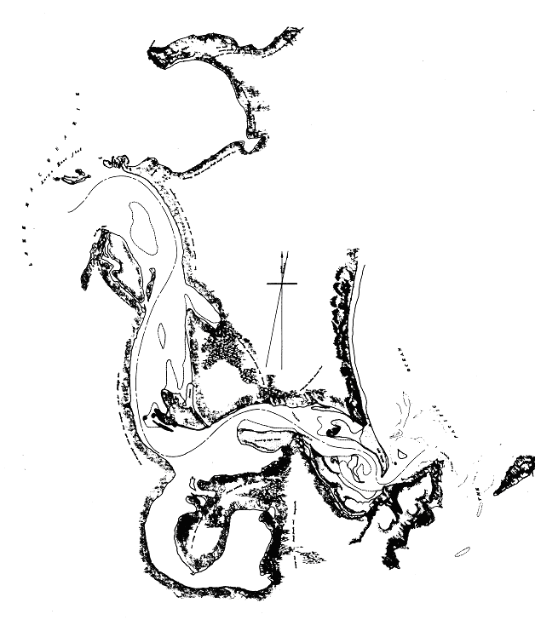
Swan Bay
Entrance shoals – no breakwaters
Figure 1 Swansea Channel, circa 1861

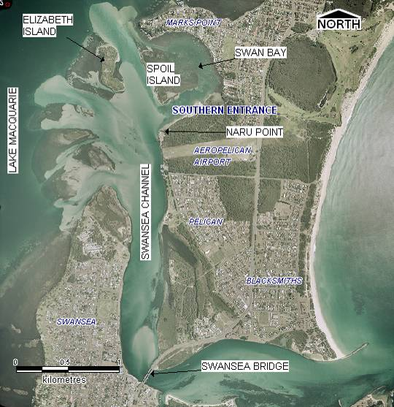
Figure 2 Swan Bay Locality (air photo circa 2002)

Swan Bay
Dog-leg
Figure 3 Shoaling of Swansea Channel and the notorious Swan Bay dog-leg (August 2001)

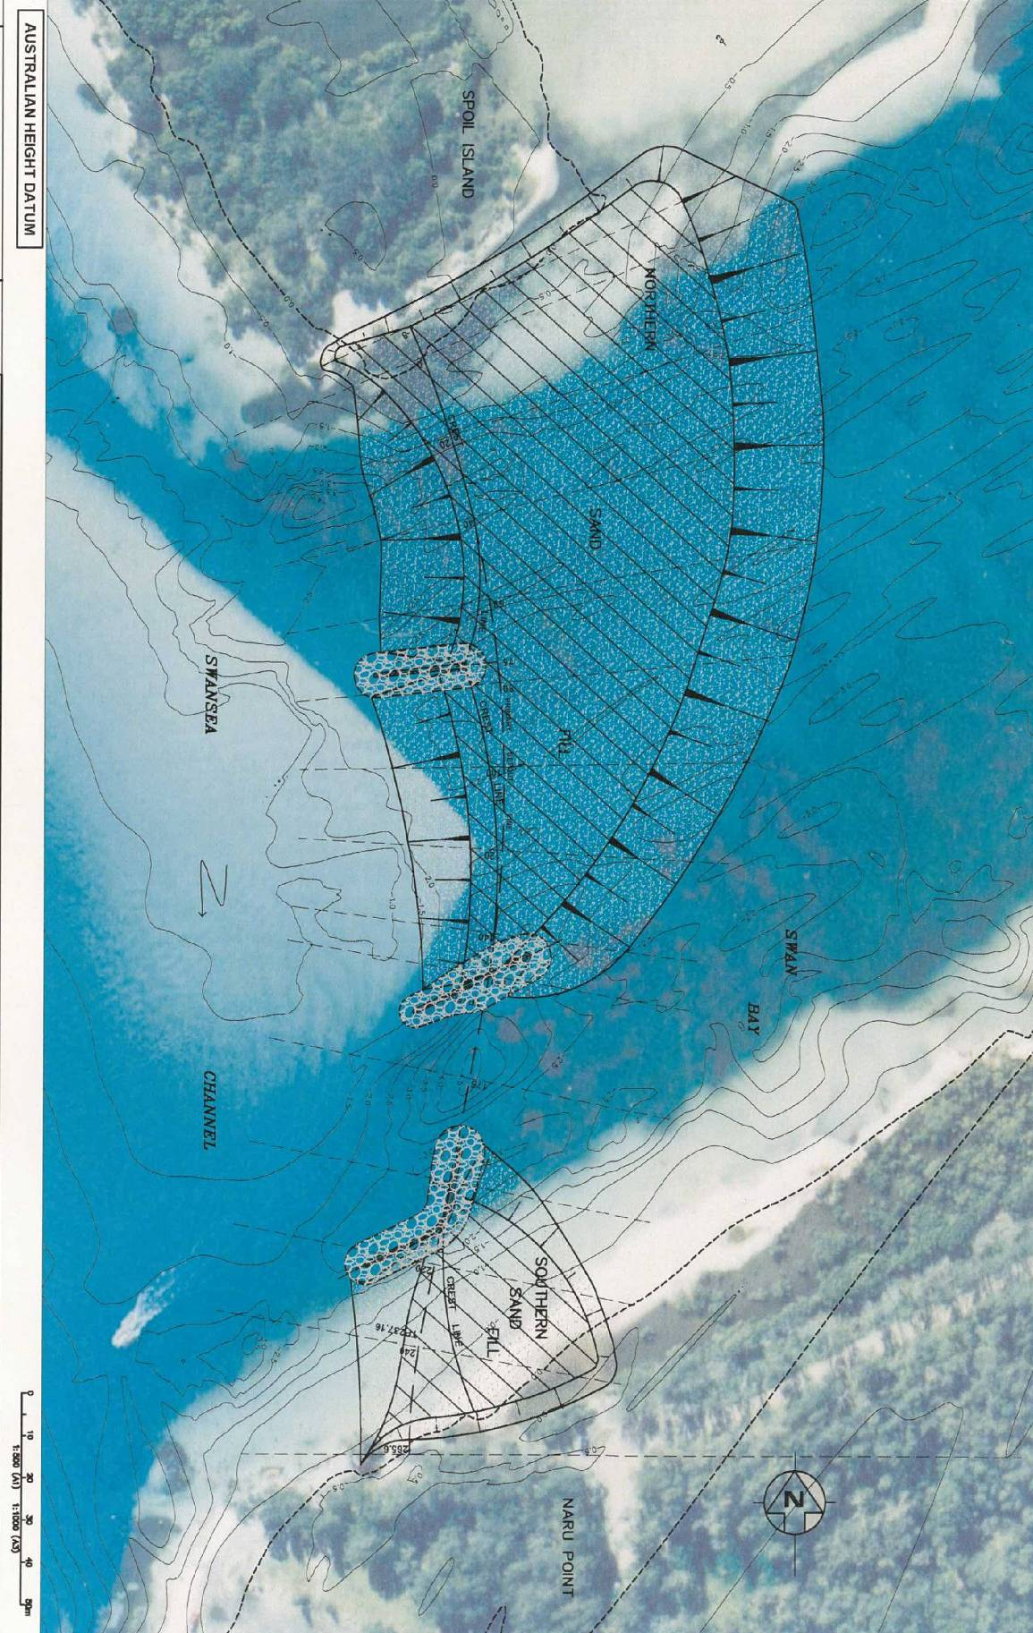
Figure 4 General Arrangement of Design Works

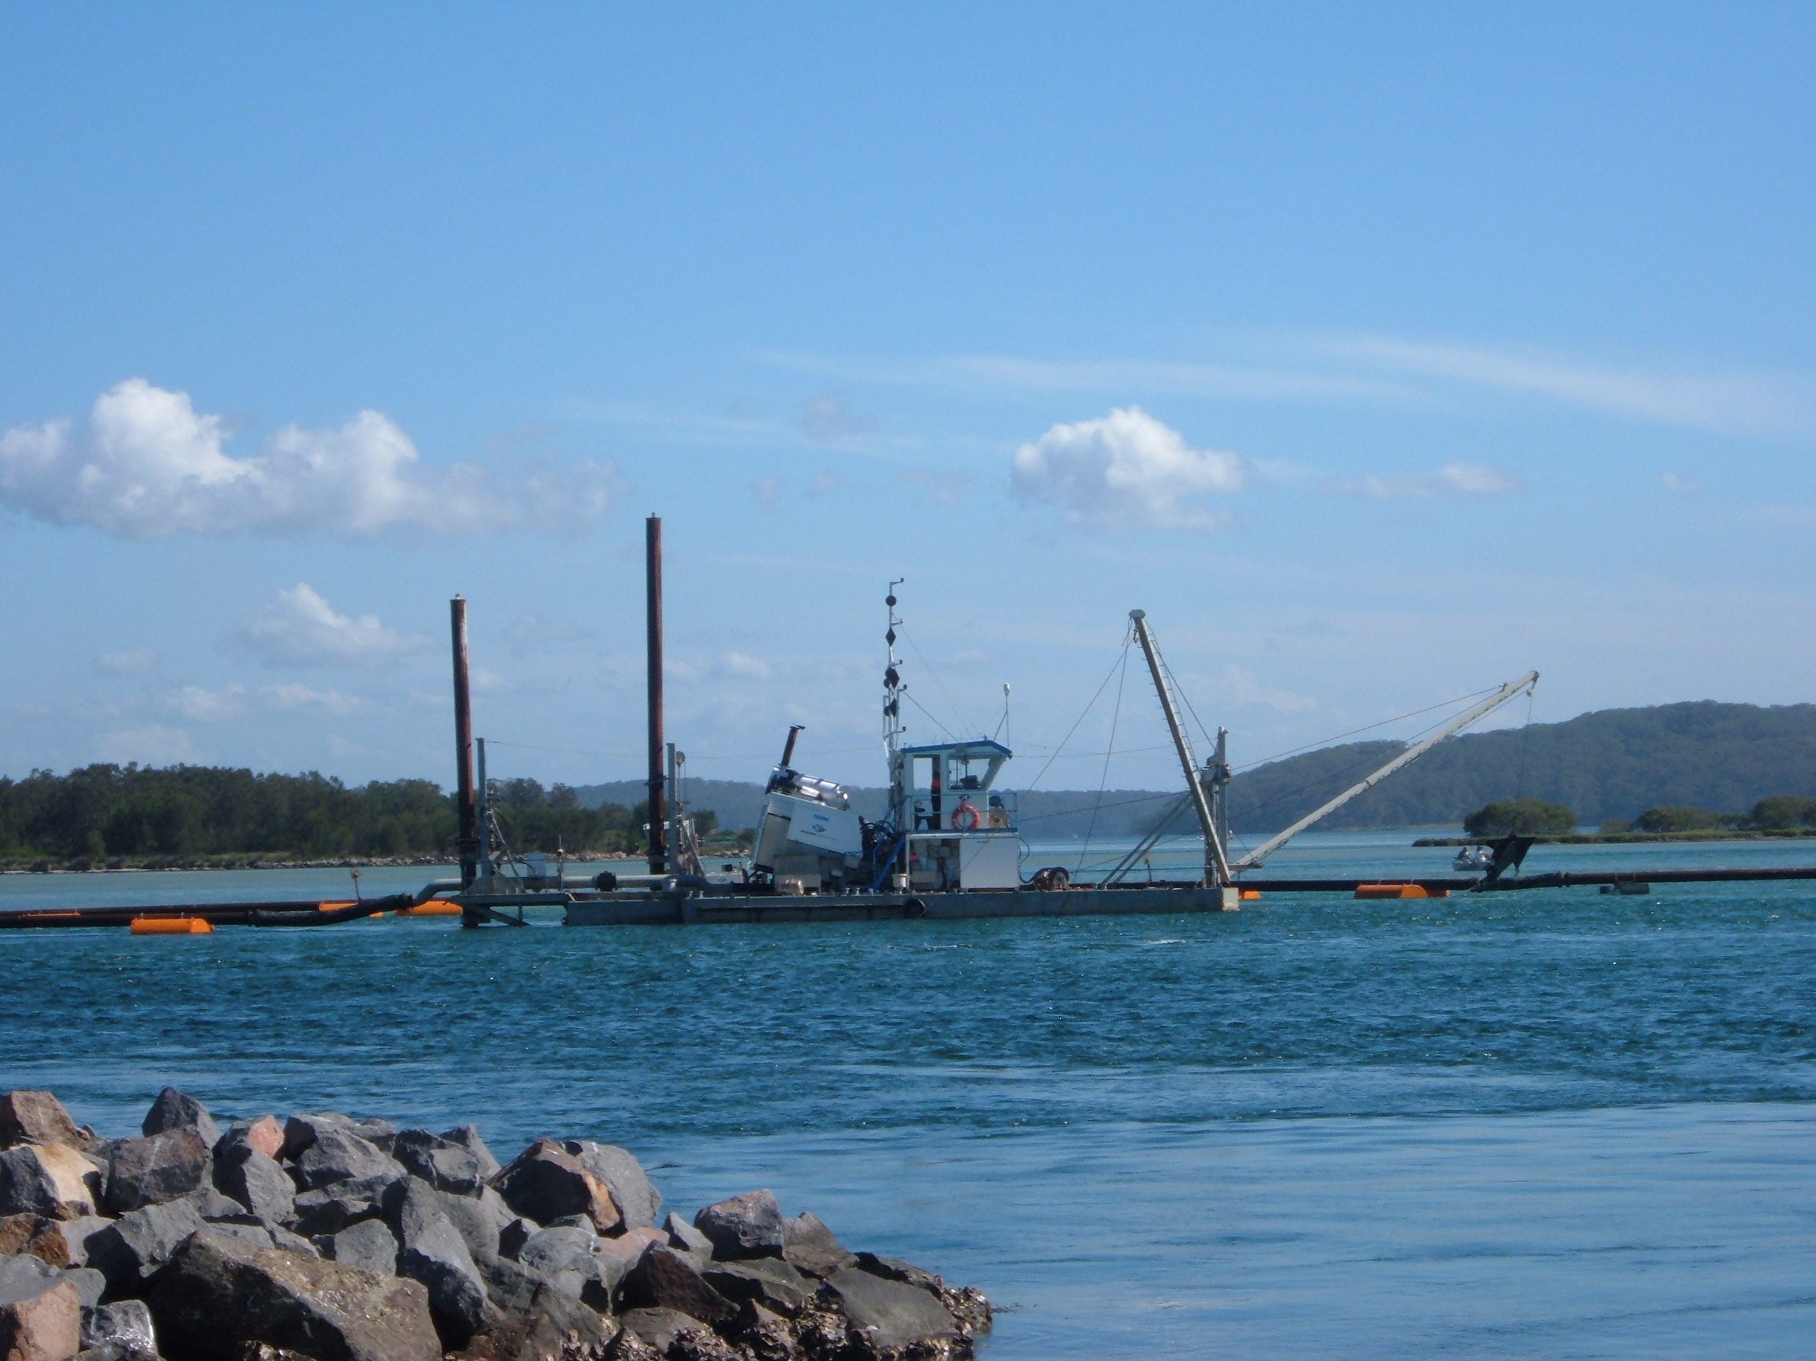
Figure 5 Neumann’s 8” dredge used to extract sand from the channel

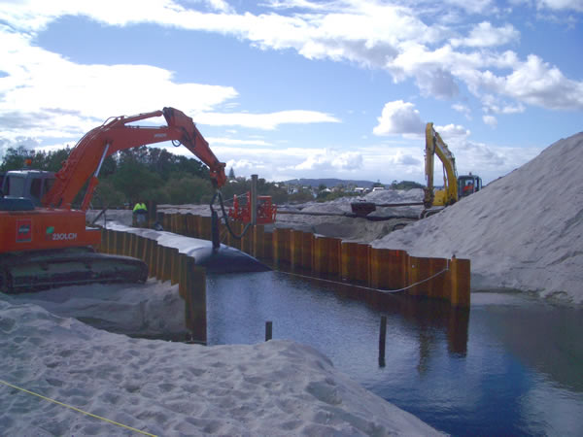
Figure 6 Filling of geotubes following excavation of slot between sheetpiles

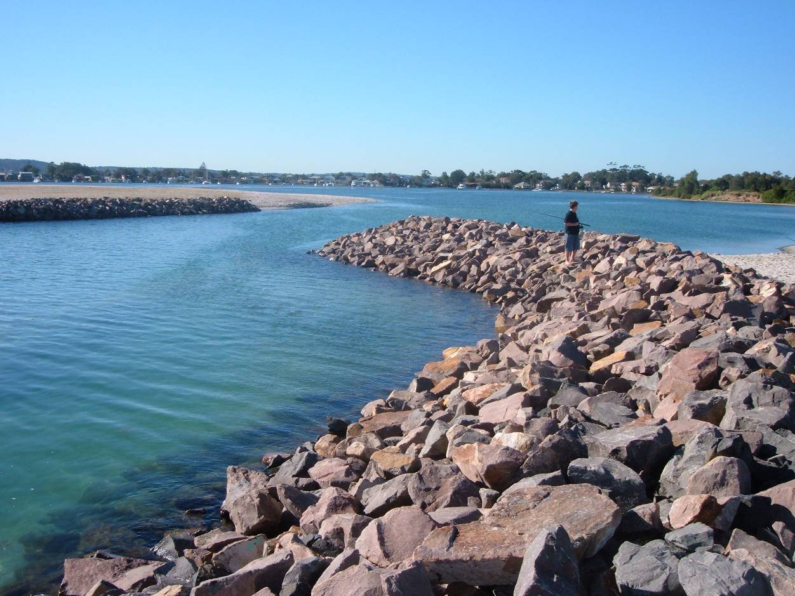
Figure 7 Finished groynes showing gap between north and south structures

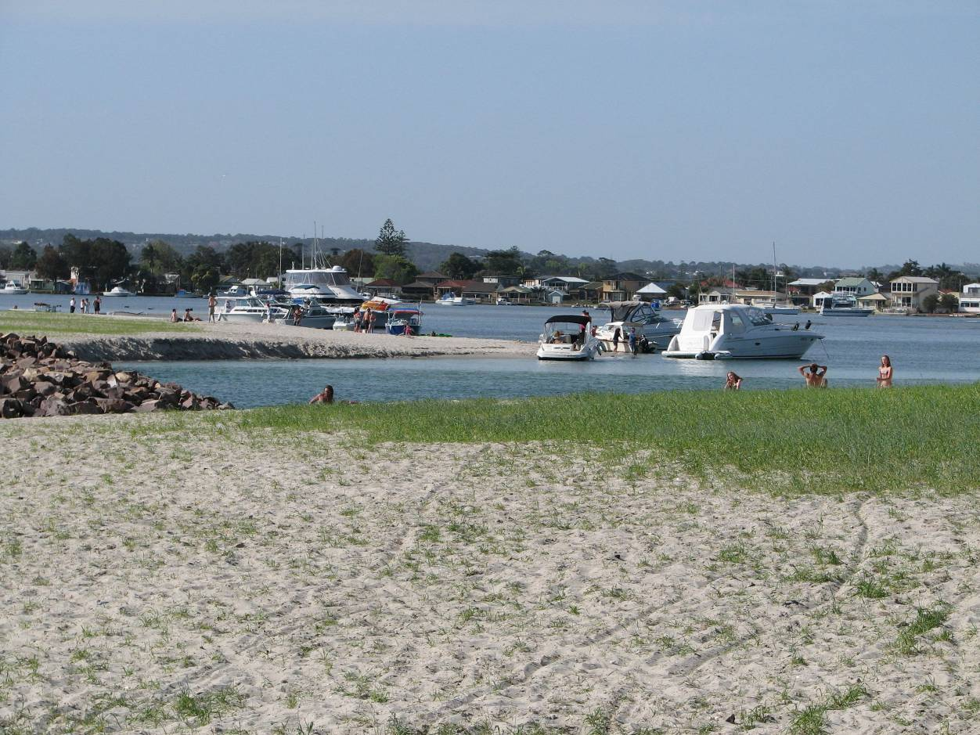
Figure 8 Recreational use of new vegetated sand spits, and temporary erosion scarp
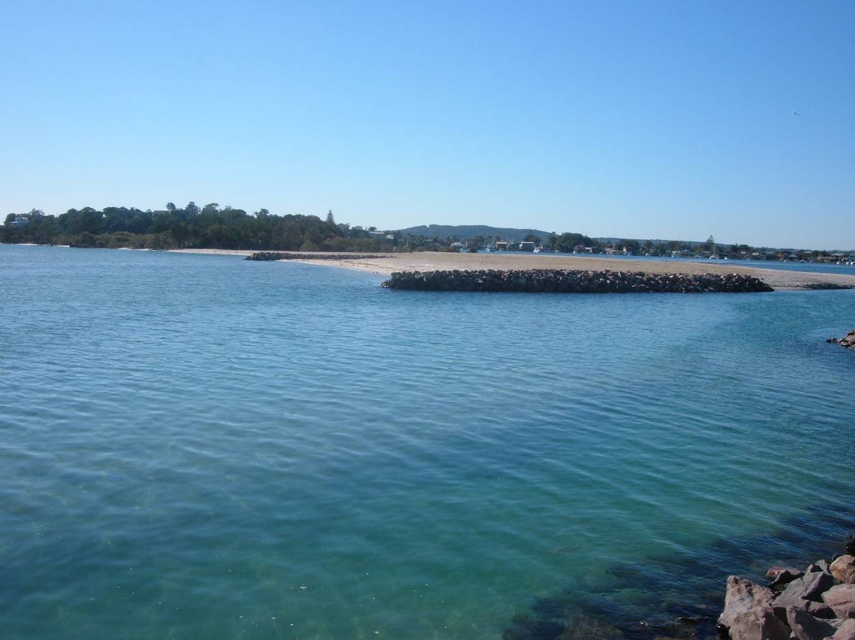
Figure 9 Oblique perspective of northern spit showing northern entrance groyne, mid beach groyne, and finished profile of beach / sand fill

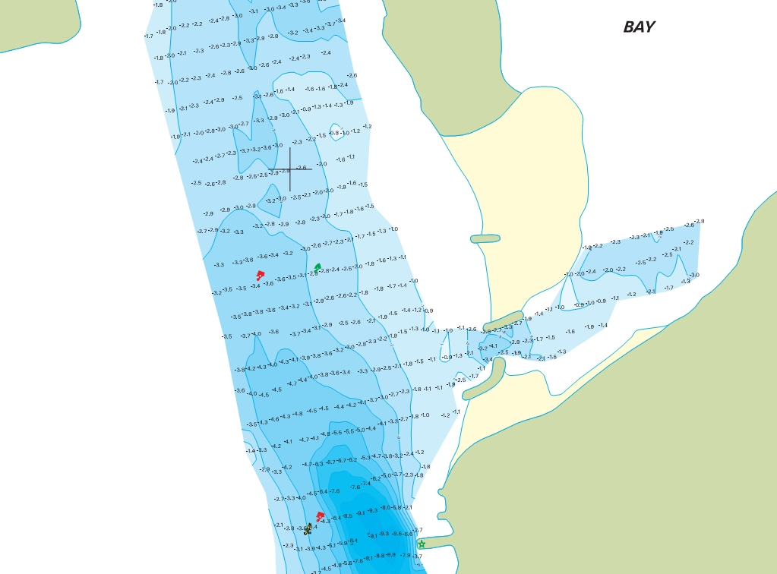
Figure 10 May 2007 hydrosurvey of Swansea Channel and Swan Bay southern entrance (source: NSW Maritime).

