ANALYSIS OF A STORM – JUNE 2007

PHIL WATSON B.E. (Hons)
Team Leader, Coastal Unit, Department of Environment and Climate Change
DOUG LORD B.E., MEng Sc., MBA (Tech Mgmt), MIEAust.
Manager Coastal, Department of Environment and Climate Change
MARK KULMAR B.E.
Wave Monitoring Specialist, Department of Commerce, Manly Hydraulics Laboratory
DUNCAN McLUCKIE M.E.(Water/Environmental) B.E. (Civil) Post Grad Dip (Mgt)
Flood Policy Specialist, Department of Environment and Climate Change
JOHN JAMES
Williamtown Meteorological Office, Australian Bureau of Meteorology

ABSTRACT: A series of storm systems impacted coastal regions between the Illawarra and the Hunter during June 2007. Although each separate storm was characteristically quite different, collectively, these storms resulted in widespread flooding and wind damage, coastal erosion, a record number of callouts for State Emergency Service assistance, grounding of the Pasha Bulker, (a 40,000 tonne bulk coal ship) on Nobbys Beach and the tragic loss of 9 lives.

The severity of the storm series was readily compared in the mainstream media to the May/June storms of 1974. Those storms which resulted in widespread devastation along the open coast of NSW, were similarly concentrated between the Illawarra and Hunter regions and also claimed a bulk carrier ship (Sygna) which ran aground along Stockton Bight.

This paper will look at the meteorological development of the June 2007 storm series and analyse a range of relevant statistical parameters (including flood and ocean water levels, wave heights, rainfall intensity, wind speeds and barometric pressures) and compare each to the historical record. The paper will provide a technical analysis of the June 2007 storms in order to separate the more sensational and emotive reporting from the factual statistics. Importantly, the paper will highlight what damage occurred and why. It will also discuss why other damage did not occur and so will provide a valuable guide to assist local government and emergency services in preparing for future storm events.

1. INTRODUCTION
Prior to the June storms of 2007, the Sydney and Central Coast regions, along with much of NSW had been experiencing unprecedented drought conditions. This extended drought had reduced water storage levels for Sydney’s main reservoir (Warragamba Dam) to a record low of 33.5% (SCMA, 2007) prompting the NSW Government to commit to a large scale desalination facility to augment Sydney’s water supply system. On the Central Coast (the largest growing region in the country behind Sydney), dam storage levels were at crisis point, with the largest reservoir (Mangrove Creek Dam) falling below 11% (GWCWA, 2007), prompting severe water restrictions and consideration of initiatives including several temporary emergency desalination plants.

Security of water had become one of the central issues in the March 2007 State elections. While good rain was desperately needed in these regions, few could have predicted the violent June weather that would wreak havoc across a broad area extending from the Illawarra, south of Sydney to the Hunter. Areas of the Central Coast and the Hunter were declared natural disaster zones, prompting the NSW Government to set up dedicated one-stop-shop disaster recovery centres at locations including Wyong, Newcastle, Cessnock and Maitland. By the end of the month, areas of Sydney and the Central Coast had recorded record monthly rainfall in excess of 600mm (BoM, 2007).

Although several low pressure cells during the month impacted the Greater Metropolitan Region, the key weather system was the initial storm which commenced in the early hours of the morning on Friday 8 June, running through the holiday long weekend until Monday 11 June. By the end of August, the Insurance Council of Australia had advised that insurance claims from the June long weekend storm would inevitably exceed $1BN, ranking 2nd in terms of insurance payout on the historical list of Australian natural disasters, behind only the 1999 Sydney hailstorm (ICA, 2007).

2. QUEENS BIRTHDAY WEEKEND STORM (8-11 JUNE)
The Queens Birthday weekend storm was the first of a series of East Coast Low (ECL) weather systems to affect the Hunter, Central Coast and Sydney Metropolitan areas during the month of June.

It developed in a pre-existing trough of low pressure over the northern Tasman Sea, moving south along the NSW coast, before moving out into the Tasman Sea on the 10th June 2007. This trough was directing a humid northeast to southeast air stream across northeast NSW and there was a weak low analysed just off the coast near Coffs Harbour on the Thursday morning. Several factors influenced the subsequent development of this low:

- during Friday and Saturday, a high pressure system moved through Bass Strait from the Bight and strengthened over the southern Tasman, deepening the humid easterly flow over eastern NSW;
- an upper cold pool and associated north westerly jet stream moved across the north of the state reaching the coast on Friday; and
- there was warmer than average (about 1 degree) sea surface temperatures off the coast with the strongest east to west gradient directly offshore from Newcastle.

On Thursday night (7th) the low deepened to 1009hPa just north of Newcastle. Gale force south easterly winds started about midnight and continued for 12 hours. It was during this timeframe that several bulk carrier ships waiting offshore of Newcastle Port encountered difficulties with dragging anchors. Three ships (Betis, Sea Confidence and Pasha Bulker) were in distress, but only the Pasha Bulker was unable to avoid catastrophe, running aground across the rocky reefs on Nobbys Beach around mid-morning. Fortunately, the 40,000 tonne bulk carrier was successfully salvaged from the beach at 9.40pm on Monday 2 July, after 25 days of being pounded by heavy seas which damaged the outer hull of the vessel (NPC, 2007).

Around noon on Friday 8th the low near the coast weakened and the winds eased, but from 3.30pm until 7.30pm a persistent line of thunderstorms over Newcastle and northern parts of Lake Macquarie resulted in severe rainfall and flash flooding in areas of the Central Coast, Newcastle and the Hunter Valley. Just after 4.00pm, two adults and three children were tragically killed when the car they were travelling in was swept away as a portion of the old Pacific Highway collapsed leaving a 10m wide abyss into the swollen Piles Creek below (DT, 2007).

At 5.30pm, the main north coast rail line was cut at Wondabyne due to stormwater discharging through the sandstone quarry causing a landslide. The Entrance and Newcastle experienced extensive localised flash flooding. Many of Newcastle’s suburbs rapidly went under water stranding thousands of motorists on their way home for the long weekend.

A second small-scale low formed late on Friday evening and crossed the coast directly over Newcastle in the early hours of Saturday morning, again bringing gale to storm force winds and the strongest observed wind gusts (135 km/h at Norah Head and 124 km/h at Newcastle). The lowest pressure officially recorded was 994hPa at Williamtown and the minimum central pressure of the low was estimated to be 990 hPa.
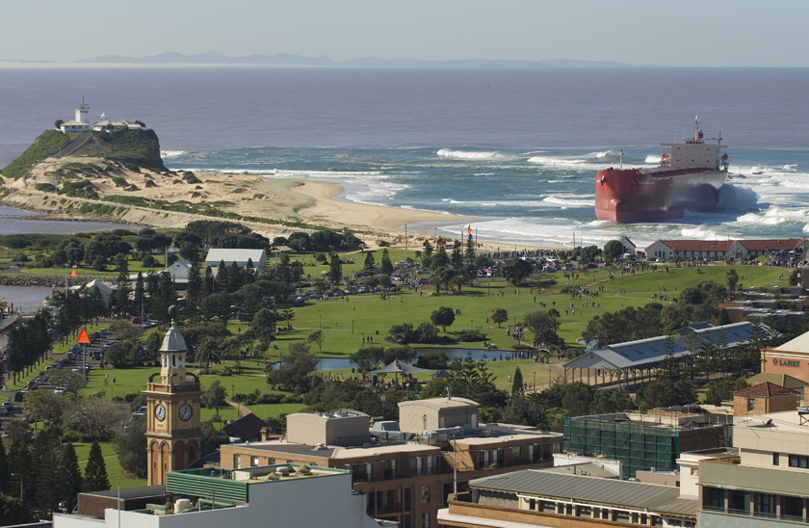
Figure 1: Bulk ore carrier “Pasha Bulker” which ran aground on Nobbys Beach during the wild weather on 8th June 2007. Photo courtesy Newcastle Morning Herald online news service.

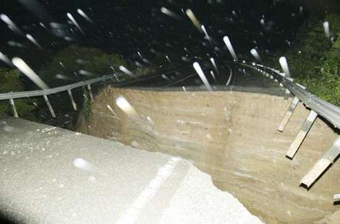
Figure 2: Old Pacific Highway road collapse at Somersby, NSW Central Coast, 8th June 2007. Photo: Courtesy Daily Telegraph online news service.
The low weakened as it moved inland, but a line of heavy showers and thunderstorms moved to the south bringing heavy rains along the Central Coast before weakening over the northern suburbs of Sydney during Saturday morning.

By Saturday morning up to 130,000 houses in the Newcastle area were without power and a further four people had lost their lives to the storm, bringing the death toll to nine (DT, 2007). The Greater Metropolitan Region braced itself for warnings that a second low pressure cell was forming off the coast and heading for already affected areas on Saturday afternoon. Driving rain and gale force winds persisted through Sunday, moderating into the early hours of Monday morning.

By Monday afternoon, the NSW State Emergency Service had logged 19,951 calls for assistance, triggering the second largest response operation in NSW history behind the 1999 Sydney hailstorm. In all, it would take a further 18 days to clear the backlog of calls for emergency assistance through a co-ordinated response from combat agencies and interstate crews (SES, 2007).

3. INDIVIDUAL STORM PARAMETERS
Extreme weather is often associated with several simultaneous processes which contribute to damage across broad areas. Amongst other things, these processes can include low barometric air pressure, intense wind speeds, high intensity rainfall, flash flooding and river/catchment flooding, extreme wave heights, elevated ocean water levels and storm surge. Several sources of data including Bureau of Meteorology weather data, DECC offshore deepwater wave data from Manly Hydraulics Laboratory’s Waverider buoys at Crowdy Head, Sydney, Port Kembla and Batemans Bay along with ocean tide records from Middle Head inside Sydney Harbour, have been used to analyse the various storm processes.

Newcastle University and BMT WBM consultants have also shared information on rainfall intensity and flash flooding within the Newcastle Region gathered for their separate analytical exercises as part of the post storm analyses.

3.1 Wind Strength
High wind speeds contribute to major property and infrastructure damage in urban environments. In particular, when coupled with substantial rain, these are the major contributory factors to widespread uprooting of trees. Wind also drives deep ocean swell and local wave climates which when directed predominantly onshore, can contribute to substantial elevation in ocean water levels at the shoreline and exacerbate beach erosion.

The Bureau of Meteorology advised that on the 8th June, storm force winds averaged 93 km/h and gusted to 135 km/h (Norah Head) causing widespread damage along the coast (BoM, 2007). At the Nobbys Signal Station, the average wind speed reached a maximum of 105km/h from a direction of 100°TN at 0133hrs on 9th June with a peak wind gust recorded at 124km/h. At the Williamtown RAAF base, the average wind speed reached a maximum of 68km/h from a direction of 290°TN at 0110hrs on 9th June with a peak wind gust recorded at 91km/h at 0900hrs on 8th June. At Sydney Airport, the average wind speed reached a maximum of 70km/h from a direction of 130°TN at 0650hrs on 9th June with a peak wind gust recorded at 91km/h at 0930hrs on the same day.

3.2 Rainfall and Flooding
The storm event from 8th -10th June, 2007 resulted in very high intensity rainfall and severe associated flooding throughout many areas in the Central Coast – Hunter Region. Gosford recorded peak hourly rainfall intensities of 53.8 mm and 61.4 mm on 8th and 9th, respectively. Norah Head recorded 123 mm in 3 hours on the 8th, whilst Newcastle (Nobbys Station) recorded 164.8 mm in 6 hours, one of the highest rainfall intensities ever recorded (BoM, 2007).

The high intensity rain resulted in widespread severe flooding, particularly throughout the Newcastle urban area where thousands of cars were stranded, abandoned or swept away. An estimated 10,000 – 15,000 private properties were affected by flooding with up to over floor flooding experienced by 1,000 – 2,000 of these properties. Flood depths were recorded up to 1.8m, with the commercial centres of Wallsend and Newcastle West some of the worst affected areas.

Newcastle University have analysed data from a network of 30 Hunter Water Corporation pluviographs throughout the Hunter Region to estimate the statistical significance of the rainfall event over the long weekend. Although not all pluviographs were operational during the event, those that were operating highlighted the wide variation in rainfall across the area. Whilst some pluviographs registered only relatively low amounts of rainfall in terms of average exceedance probability several indicated measured rainfall for 3, 6, 12 and 24 hour duration with an average recurrence interval significantly in excess of 100 years. It is acknowledged that these average recurrence intervals were referenced to Australian Rainfall and Runoff (Pilgrim et al, revised edition 2001). The relevant section was written in 1987, based on approximately 30 years of data and has not been subsequently updated. Whilst caution should be exercised in attempting to quantify and extrapolate recurrence intervals beyond such timeframes, nonetheless, these are quantitative measures of the relative rarity of the rainfall intensities experienced on 8th June.

BMT WBM consultants have been engaged by Newcastle City Council to analyse pluviograph data and collect flash flooding data and flood marks in order to verify existing stormwater and flood hydrodynamic models for the city. Some 1200 flood marks were recovered in the weeks immediately following the event. This information will be used to assess the adequacy of existing stormwater infrastructure, flood and related emergency management procedures and strategic planning initiatives. Their work identified several “hotspots” around Newcastle where flash flooding on the night of 8th June resulted in water depths greater than 1.0 m. Within many of these areas, residents were unaware they were at risk of flooding.

Preliminary analyses indicate that flash flooding was exacerbated by stormwater channel blockages from numerous abandoned vehicles at various locations and a shipping container wedged into a stormwater channel entrance to the harbour in the Newcastle CBD. Blockage of stormwater channels is not uncommon in major flood events and was also a major issue in Wollongong in 1998. It is an important factor to consider in determining design flood levels. Elevated sea levels in areas influenced by the ocean are also an important consideration in determining design flood levels. The joint probability of different design rainfall events and ocean levels can result in a range of potential flood levels and flow velocities (albeit less frequent) that need to be considered in managing flood risk.

The Hunter River at Singleton started to rise significantly on the 8th June and reached minor flood level around midday on the 9th June. The floodwaters continued to rise and peaked late evening on the 9th June (near the flood level reached in 1971) before receding to below minor flood level on the 11th June 2007.

At Maitland’s Belmore Bridge gauge the river reached minor flood levels early on 9th June and continued to rise until peaking in the afternoon of 11th June 2007 and receding over the following days. At Maitland, the Bureau of Meteorology’s flood warning system acted as the trigger for the SES to evacuate some 4,000 people from the CBD and Lorne as a precautionary measure in case the levees overtopped or failed.

Even though Singleton experienced a flood similar to the 1971 flood, the peak at Maitland’s Belmore Bridge was lower than the 1971 peak. The Department of Environment and Climate Change has subsequently engaged Webb McKeown and Associates to review the performance of the Hunter Valley Flood Mitigation Scheme in the vicinity of Maitland for this event.

Moderate flooding was also experienced in the Wyong, Colo and Nepean River systems. For the month of June, many of the Bureau of Meteorology’s pluviographs in the Central Coast – Hunter Region recorded the highest monthly rainfall since the commencement of data recording (Refer Table 1).

Table 1: Selected Highest Monthly Rainfall on Record for any Month (NSW)

Station | June 2007  (mm) | Previous  Highest (mm) | Year | Years of Record
Newcastle (Nobbys) | 495.8 | 485.7 | 1950 | 145
Williamtown | 414.2 | 324.5 | 1951 | 64
Ourimbah | 624.9 | 410.8 | 1964 | 54
Wisemans Ferry | 347.0 | 300.3 | 1964 | 104
Avoca Beach | 573.0 | 391.0 | 1978 | 37
Gosford North | 587.4 | 348.0 | 1989 | 35
Norah Head | 574.6 | 424.1 | 1978 | 38
Berowra | 433.8 | 401.0 | 1991 | 104
Source: Bureau of Meteorology “Significant Weather Summary – June 2007”

3.3 Wave Heights
Waves at the coast are generally defined as either ocean swell (generated from winds in the deep ocean) or seas (generated from local wind sources). Both can persist together and could be driven by the same extreme weather system. In most cases, wave fields approaching the coast are highly variable and random, consisting of a range of heights and speeds. It is more convenient to describe wave fields using statistical descriptions. The Significant Wave Height (H_{sig}) which is defined as the average of the highest one-third of the wave heights for a given sample period (usually 20 to 30 minutes), is one of the more commonly applied wave statistics.

Waves are a combination of kinetic and potential energy driven across the ocean surface toward a shoreline. The power contained in waves is predominantly expended at the shoreline through the action of breaking and is proportional to both the square of the wave height and the wave period (speed). Compared to ambient conditions, storm waves may have an elevation an order of magnitude greater and a wave speed almost double, effectively increasing the power of the shoreline approaching wave field by a factor of 200. Coupled with elevated ocean water levels, the turbulence and currents created by breaking waves at the shoreline can result in significant beach erosion. The potential for erosion is maximised when waves are directed shore normal and superimposed on high spring tides, particularly over several high tide cycles. This permits larger waves to travel further across the beach.
Manly Hydraulics Laboratory (MHL) on behalf of Department of Environment and Climate Change, maintains a network of seven deepwater Waverider buoys, to monitor wave conditions along the NSW coastline. A deepwater wave field approaching the shoreline, consists of a spectra of wave heights and periods (time between successive wave crests). The Significant Wave Height (H_{sig}) is widely used to characterise wave height for design purposes and wave classification. In the MHL wave database, wave events are commonly classified as a storm when H_{sig} exceeds 3.0 metres over a duration of a 1 hour. A storm severity classification used to classify historical storms is indicated at Table 2.

Table 2: Classification of Storm Severity

Storm  Category | Storm Description | Significant Wave Height (m)
X | Extreme | > 6 metres
A | Severe | 5.0 – 6.0 metres
B | Moderate | 3.5 – 5.0 metres
C | Low | 2.5 – 3.5 metres
Source: NSW Government (1990)

During the June long-weekend storm, the Sydney directional Waverider buoy recorded the maximum storm wave heights along the NSW coastline. The storm threshold (H_{sig}) was triggered at 2100hrs on 7th June, subsiding 65 hours later at 1400hrs on 10th June. The maximum H_{sig} recorded during the storm was 6.87 metres at 0200hrs on 9th June, coinciding with the maximum individual wave height (H_{max}) measured during the storm of 14.13 metres (refer Figure 3). During the storm, the wave direction varied between 135° and 150°TN with a corresponding significant wave period varying between 9.5 seconds and 10.5 seconds.

The second largest H_{sig} was recorded at the Port Kembla deepwater Waverider buoy, measuring 6.13 metres at 1400hrs on 9th June. The maximum wave height (H_{max}) measured was 11.01 metres at 0300hrs on 9th June. The storm threshold (H_{sig}) was triggered at 2200hrs on 7th June, subsiding 74 hours later at midnight on 10th June. During the peak of the storm, the significant wave period at Port Kembla varied between 8.5 and 10.5 seconds.

In the context of the historical record, the wave heights recorded at the Sydney directional Waverider buoy for the period 7th – 10th June 2007, were determined to have a recurrence interval in the order of 4 to 10 years (refer Figure 4) based on a storm wave height/duration analysis. By comparison, the devastating May 1974 oceanic storm event was determined to have a corresponding wave height recurrence interval in the order of 20 – 70 years (Lord and Kulmar, 2000). The highest H_{sig} determined during that event was 9.2m (Foster et al, 1975) using hindcasting techniques from 3 hourly synoptic charts. Similarly, the largest recorded H_{sig} at the Sydney buoy was 8.43 m on 11th May 1997. The maximum H_{sig} recorded during the June storm (6.87m) ranks 3rd on the list of storm measurements from the MHL Sydney deepwater Waverider buoy since it was installed in 1987 (Refer Table 3). The H_{max} of 14.13m recorded on 9th June 2007 is the largest hourly H_{max} recorded at Sydney.

Although the maximum wave height recorded at the Sydney deepwater Waverider buoy during June occurred during the long-weekend storm, the storm threshold was triggered on a further 14 occasions during the month. H_{sig} exceeded 3m for a total of 208 hours, some 29% of the month (Refer Figure 3).

Figure 3: Sydney deepwater directional Waverider buoy data (Source: Manly Hydraulics Laboratory)

Table 3: Ocean Storms Ranked by Peak H_{sig}
MHL Sydney Waverider Buoy (1987 – 2007)

Date | Duration  (Hrs, H_{sig} > 3m) | Peak H_{sig}  (m) | H_{max}  (m) | Peak Ocean Water Level  (m ISLW) | Wave Direction (Degrees N)
9–12 May 1997* | 79 | 8.43 | 13.79 | 2.03 | 151
1-3 August 1990 | 41 | 7.19 | 11.81 | 1.82 | 135
7-10 June 2007* | 65 | 6.87 | 14.13 | 1.84 | 135
11-13 November 1987 | 53 | 6.75 | 11.34 | 1.59 | 157
18-20 July 2004* | 49 | 6.66 | 10.28 | 1.83 | 167
22-24 March 2005* | 59 | 6.61 | 11.44 | 1.85 | 139
2-4 June 2006* | 49 | 6.46 | 11.22 | 1.64 | 173
24-27 August 1990 | 64 | 6.28 | 11.63 | 1.64
30 June – 2 July 2000* | 59 | 6.13 | 10.21 | 2.11 | 177
14 – 17 July 1999* | 68 | 6.07 | 11.01 | 2.10 | 117
30 Aug – 1 Sept 1996 | 53 | 6.04 | 11.20 | 1.87
28-29 October 2004* | 27 | 5.81 | 12.14 | 1.72 | 169

* Denotes data from MHL Sydney directional Waverider buoy.
Notes: 1. Data is a combination of largest events recorded from the MHL non-directional buoy which was in operation from 1987 to October 2000 and the MHL directional buoy which was commissioned in 1992.
2. Ocean water level data obtained from Middle Head, Sydney tide gauge facility.

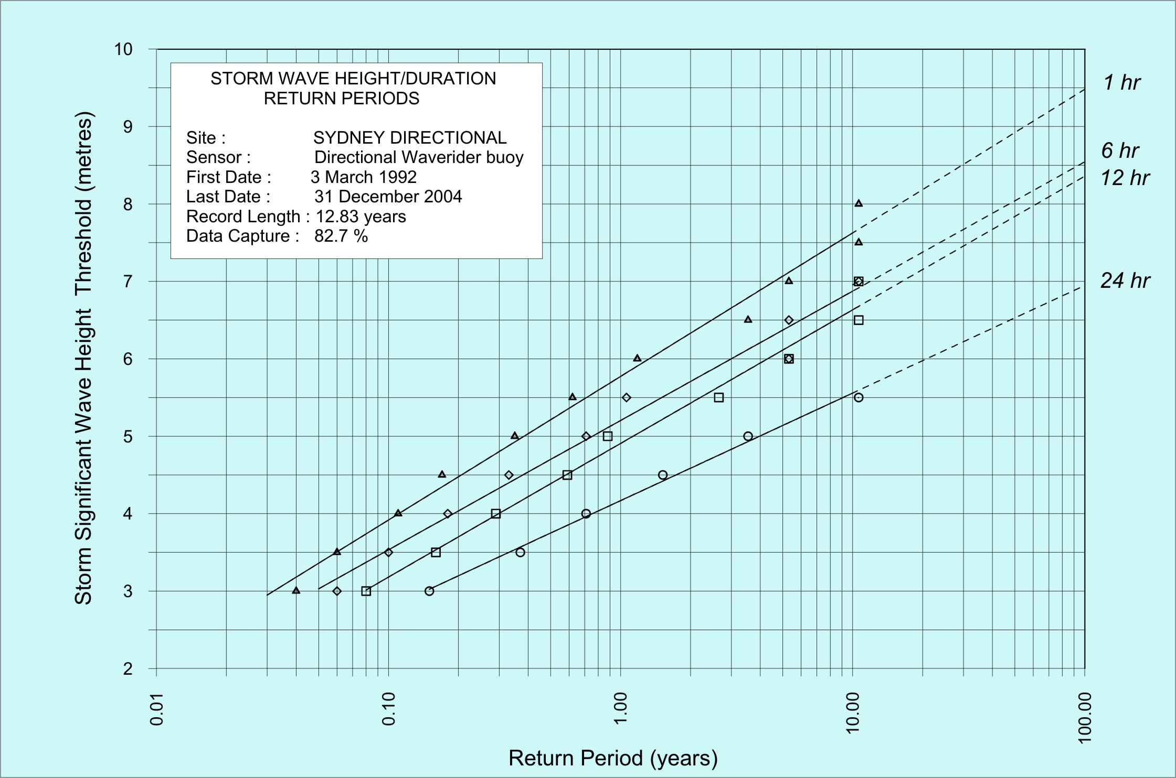
20
70
MAY 74
4
JUNE 07
Figure 4: Combined storm wave height duration return periods for Sydney directional Waverider buoy (Source: Manly Hydraulics Laboratory)

3.4 Ocean Water Levels and Storm Surge
During storm events the ocean surface can be elevated significantly above normal tidal conditions due to a combination of factors which include low atmospheric pressure (inverse barometer effect), strong onshore winds and wave effects. The combination of low atmospheric pressure and wind driven setup is termed “storm surge” and has been measured to elevate ocean water levels along the NSW coastline by as much as 0.3 to 0.6m. The breaking action of waves results in an increase in water level within the surf zone known as “wave setup” and has been estimated as high as 1.5m during extreme ocean storms along the NSW coastline (NSW Government, 1990).

Elevated ocean water levels during storms are the primary factor affecting the degree to which a beach will erode by enabling larger waves to penetrate closer toward back beach areas (Watson, 2005). Similarly elevated ocean water levels allow low lying areas along beaches and around estuaries to be inundated whilst also affecting the capacity of river and stormwater systems to discharge both storm and floodwater flows.

Over the June long-weekend, the peak ocean water level recorded at Middle Head (Sydney Harbour) was 1.84 m (ISLW), at 0200 hrs on 9th June 2007. This represented an increase of 23 centimetres above the predicted ocean tide which is likely attributable to storm surge. Based on analysis of the past 20 years of record at Middle Head, this 1.84m ISLW ocean water level is reached or exceeded on average approximately 50 times per year. For comparative purposes, the ocean water level encountered during the May 1974 storm was 53 centimetres higher at 2.37 m (ISLW), the highest recorded water level in Sydney Harbour since recording commenced over 100 years ago.

The co-incidence of 1.84 m ISLW tide level and H_{sig} of 6.87m was sufficient to deplete sand reserves and initiate erosion along many beaches in the Sydney – Central Coast region. There were 7 occasions in June when waves in excess of the storm threshold (H_{sig} = 3.0 metres) coincided with ocean water levels in excess of 1.7 m ISLW (Refer Figure 5). These events, summarised in Table 4, provided the impetus for considerable beach erosion throughout much of the Greater Metropolitan Region over the course of the month.

Table 4: Coincidence of Ocean Water Levels > 1.7 m (ISLW)
with Ocean Storm Wave Threshold (H_{sig} 3.0m)

Date | Time  (Hrs) | Peak Ocean Water Level  (m ISLW) | Peak H_{sig}  (m) | Wave Direction (Degrees TN)
9 June 2007 | 0100 to 0300 | 1.84 | 6.87 | 135
16 June 2007 | 2000 to 2300 | 2.04 | 4.41 | 133 to 147
17 June 2007 | 2100 to 2300 | 1.94 | 3.44 | 141 to 154
18/19 June 2007 | 2100 to 0000 | 2.02 | 3.68 | 180
20 June 2007 | 2300 | 1.72 | 3.04 | 156
27 June 2007 | 1800 | 1.73 | 3.10 | 80
28 June 2007 | 2000 | 1.71 | 3.32 | 165

Figure 5: Combined H_{sig} (Sydney directional Waverider buoy) and measured ocean water level from Middle Head, Sydney tide gauge facility (Source: Manly Hydraulics Laboratory).

4. DISCUSSION
The damages bill from the June storms will take some time to finalise, but, as of the end of August 2007, the Insurance Council of Australia (ICA) estimated losses to exceed $1BN.

In all, 9 lives were lost on the night of 8th June attributable primarily to flash flooding impacts. The extent and depth of flash flooding, particularly during the early evening hours across the City of Newcastle was unprecedented and for many in the community, unexpected. But for an extraordinary human response, the death toll could easily have been significantly higher.

All areas that suffered from flash flooding including the Narara Creek area (Gosford), Long Jetty, The Entrance, Newcastle CBD and suburbs, rely on stormwater drainage direct to tidal tributaries of the sea. During the storm 8th - 10th June, predicted ocean tides were in the neap (or smaller) range and the maximum recorded ocean water level of 1.84m (ISLW) at 0200 hrs on 9th represented a storm surge component of some 23cm above the predicted ocean tide level of 1.61m (ISLW). Had the storm event occurred either a week earlier or later it would have coincided with significantly higher spring ocean tide conditions. For example, a week prior to the storm, on the 2nd and 3rd, the base predicted maximum ocean tide levels were 1.81 and 1.80m (ISLW), respectively. Similarly, a week later, on the 14th, 15th and 16th, the base predicted maximum ocean tide levels were 1.94, 1.96 and 1.94m (ISLW), respectively.

A difference of some 30cm in base ocean tide levels would have significantly worsened the flash flooding impacts, riverine flooding and tailwater effects and dramatically heightened the likelihood of very severe coastal erosion, particularly between Sydney and Port Stephens. The ICA still ranked this particular storm the 2nd largest natural disaster in Australian history. The primary impacts over the long-weekend were felt from flash flooding and damage from fallen trees. However, sustained swell wave activity during the month of June also had a cumulative impact on eroding many NSW beaches, primarily south of Crowdy Head. Examples are shown in Figures 6a – 6h.

An important lesson from such disasters, all too often overlooked, is the opportunity to learn and improve public awareness strategies, emergency management procedures, relevant design codes, infrastructure capacities and strategic planning measures in order to alleviate, or mitigate (where possible) future losses or threat to human life. Our ability to deconstruct and analyse complex storm events and their impacts to achieve these aims, relies on sound, relevant, continuous long-term data sets. To this end, the Bureau of Meteorology weather data and Department of Environment and Climate Change wave and ocean water level recording network (managed by Manly Hydraulics Laboratory) have proven reliable and invaluable tools.

5. CONCLUSION
Following record drought conditions, the June long-weekend storms were a poignant reminder of the great variability in the Australian climate and the widespread devastation that can be associated with damaging storms. The intensity of the rainfall caused widespread chaos throughout Newcastle and the Central Coast with loss of life. By the end of the month many areas within the region had received record monthly rainfall.

Many press articles likened the long-weekend event to the devastating coastal storms of May/June 1974 which caused widespread and unprecedented coastal erosion and damage to beachfront development and infrastructure throughout much of the Greater Metropolitan Region. Although, there was significant beach erosion recorded in many locations in June 2007, the 1974 storms comprised offshore wave heights of far greater statistical significance superimposed on critical ocean water levels some 53 centimetres higher than that experienced over the June 2007 long-weekend.

The June 2007 storms did, however, expose a new generation of beachfront property owners to the dynamics and fragility of dunal systems that now support more intensive development than existed in 1974. Coastal storms can be highly complex and unpredictable, and while in this instance flash flooding and fallen tree damage have driven insurance losses to the 2nd highest in Australian history, one thing is certain. When (not if) storm conditions of 1974 are replicated or indeed exceeded, the damage to beachfront development and associated infrastructure that will occur will be unparalleled in NSW history. The June 2007 storms have provided a timely reminder of the necessity to develop and implement long-term coastline hazard management strategies for many of our highly developed beachfront margins as a matter of urgency.

6. ACKNOWLEDGMENTS
The authors acknowledge the use of data supplied by the Bureau of Meteorology (BoM) and Manly Hydraulics Laboratory. We would also like to acknowledge Julie Evans, Felicity Gamble and Louise Tilley (BoM) for their analyses and editorial contributions. Similarly, the authors thank Mark Thyer (Newcastle University) and Philip Haines (BMT WBM Consultants) for making available respective data analysis from rainfall gauges and flash flooding that significantly contributed to the broader discussion on these aspects within the paper.

7. REFERENCES

Bureau of Meteorology (BoM, 2007). Significant Weather Summary, June 2007. www.bom.gov.au.

Daily Telegraph Online News Service (DT, 2007). www.dailytelegraph.com.au.

Forster, D.N, Gordon, A.D and Lawson, N.V, (1975). “Storms of May-June 1974, Sydney, NSW”, Proceedings 2nd Australian Conference on Coastal and Ocean Engineering, Institution of Engineers, Australia, Publication 75/2, Gold Coast, Queensland, April 1975, pp 1-11.

Gosford Wyong Council’s Water Authority (GWCWA, 2007). Rainfall and Dam Figures. www.gwcwater.nsw.gov.au.

Insurance Council of Australia (ICA, 2007). Australia’s Catastrophe List. www.insurancecouncil.com.au.

Lord, D.B and Kulmar, M, (2000). “The 1974 Storms Revisited: 25 Years Experience in Ocean Wave Measurement Along South East Australian Coast”, Proceedings of the 27th International Conference on Coastal Engineering, Sydney, V1 pp 559-572, July.

Newcastle Port Corporation (NPC, 2007). “Media Releases”. www.newportcorp.com.au.

NSW Government (1990). Coastline Management Manual. ISBN 0 73057 506 3, September.

NSW State Emergency Service (SES, 2007). “SES Completes Mammoth Task”, Media Release, 26 June 2007. www.ses.nsw.gov.au.
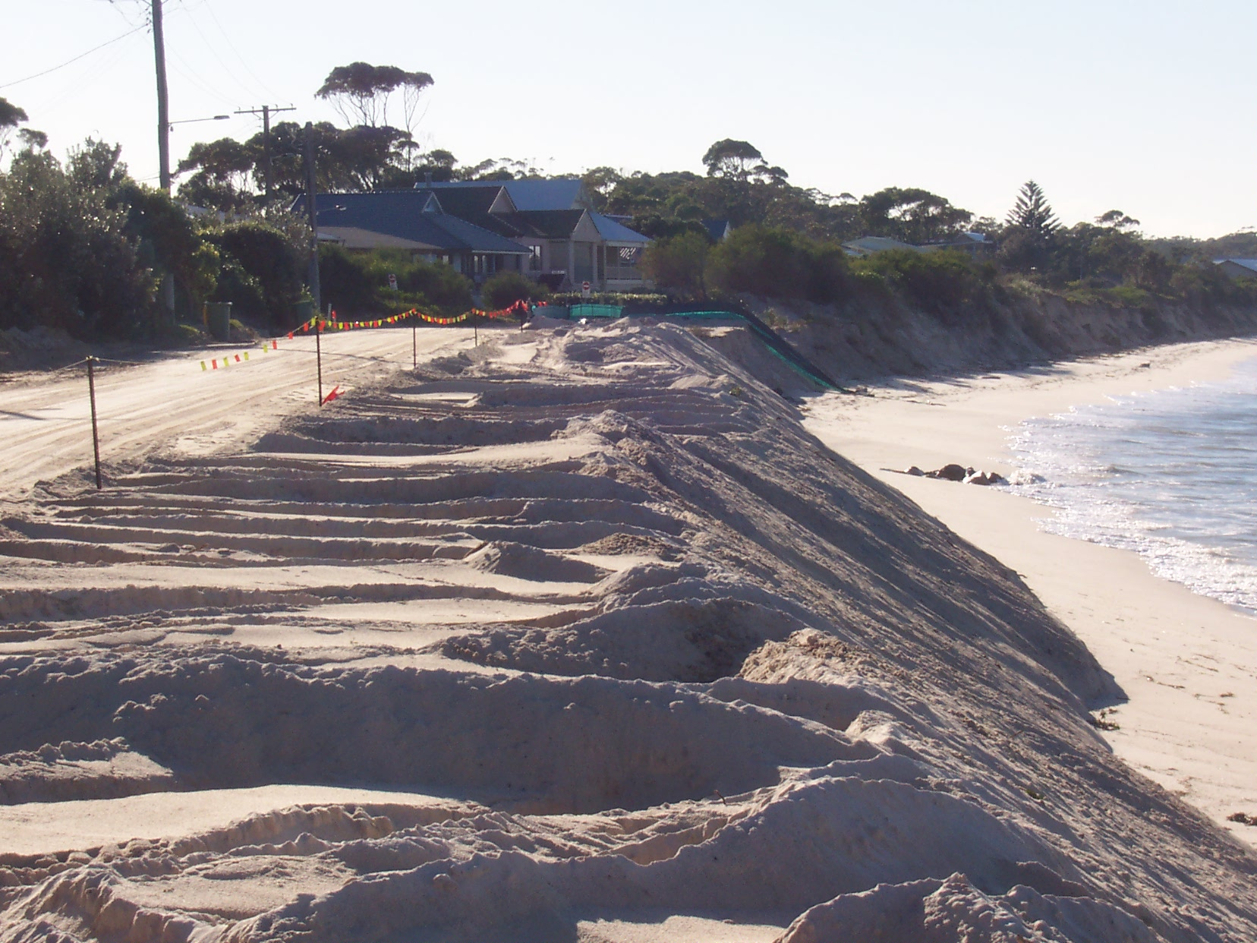
Sydney Catchment Management Authority (SCMA, 2007). Bulk Water Storage and Supply Reports. www.sca.nsw.gov.au.

Watson, P.J (2005). “Beach Erosion – The Immediate Hazard”. Proceedings of a Symposium “Planning for Natural Hazards – How can we Mitigate the Impacts?”, University of Wollongong, 2-5 February 2005. Published by GeoQuEST Research Centre, ISBN 1 74128 115 6, pp. 117-127.
Figure 6b: Jimmys Beach erosion 9th June 2007 (Courtesy ABC News Online)
Figure 6a: Emergency dumping of sand to save the road at Jimmys Beach during June long weekend (Courtesy Department Environment & Climate Change)
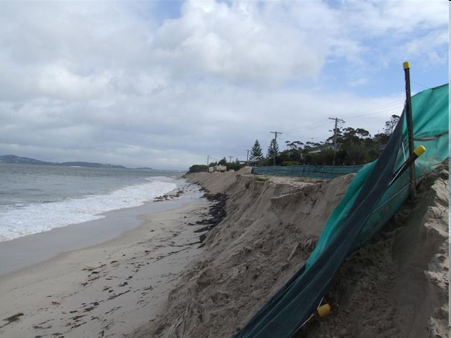

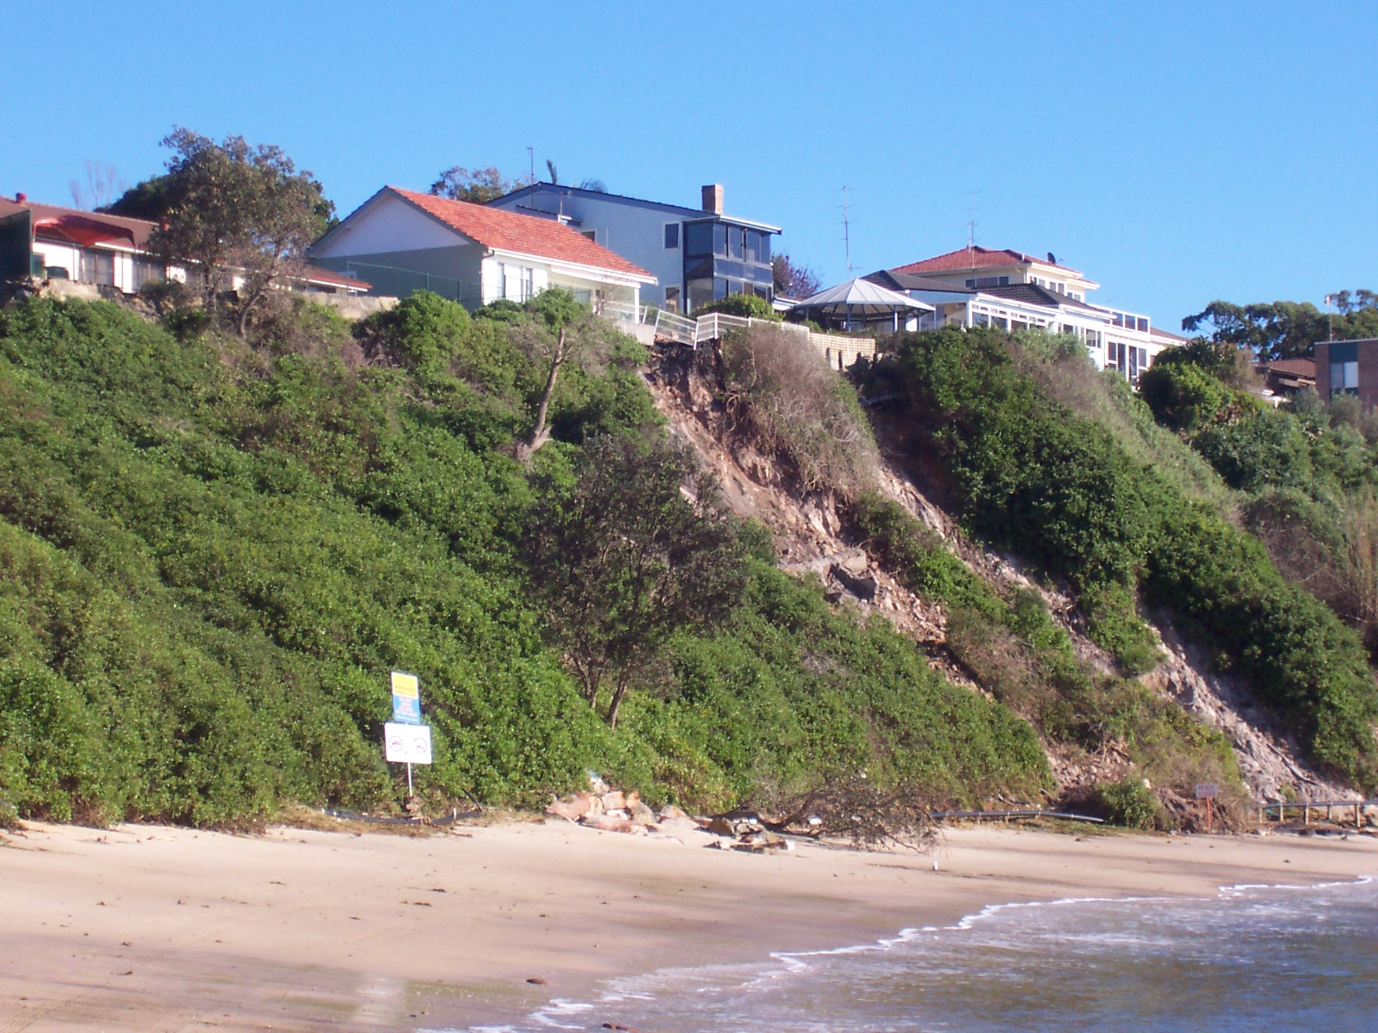
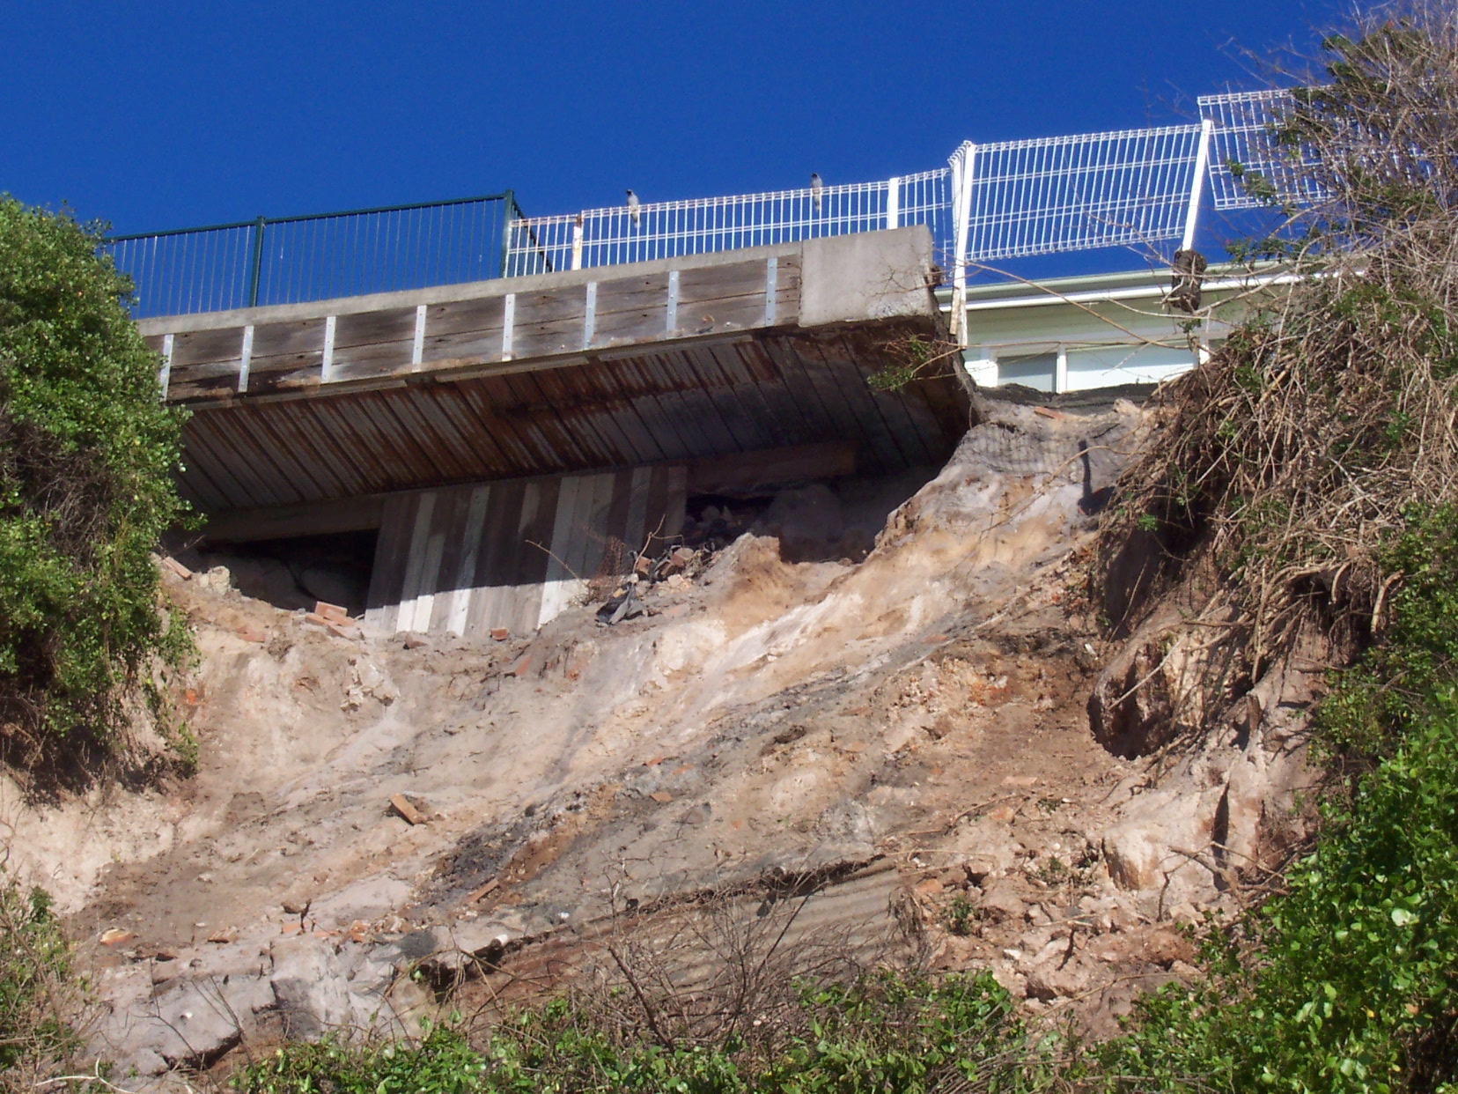
Figure 6d: Landslide at Cabbage Tree Harbour, Norah Head exposing overhanging deck structure on 22nd June 2007 (Courtesy Department Environment & Climate Change)

Figure 6c: Landslide at Cabbage Tree Harbour, Norah Head on 22nd June 2007 (Courtesy Department Environment & Climate Change)

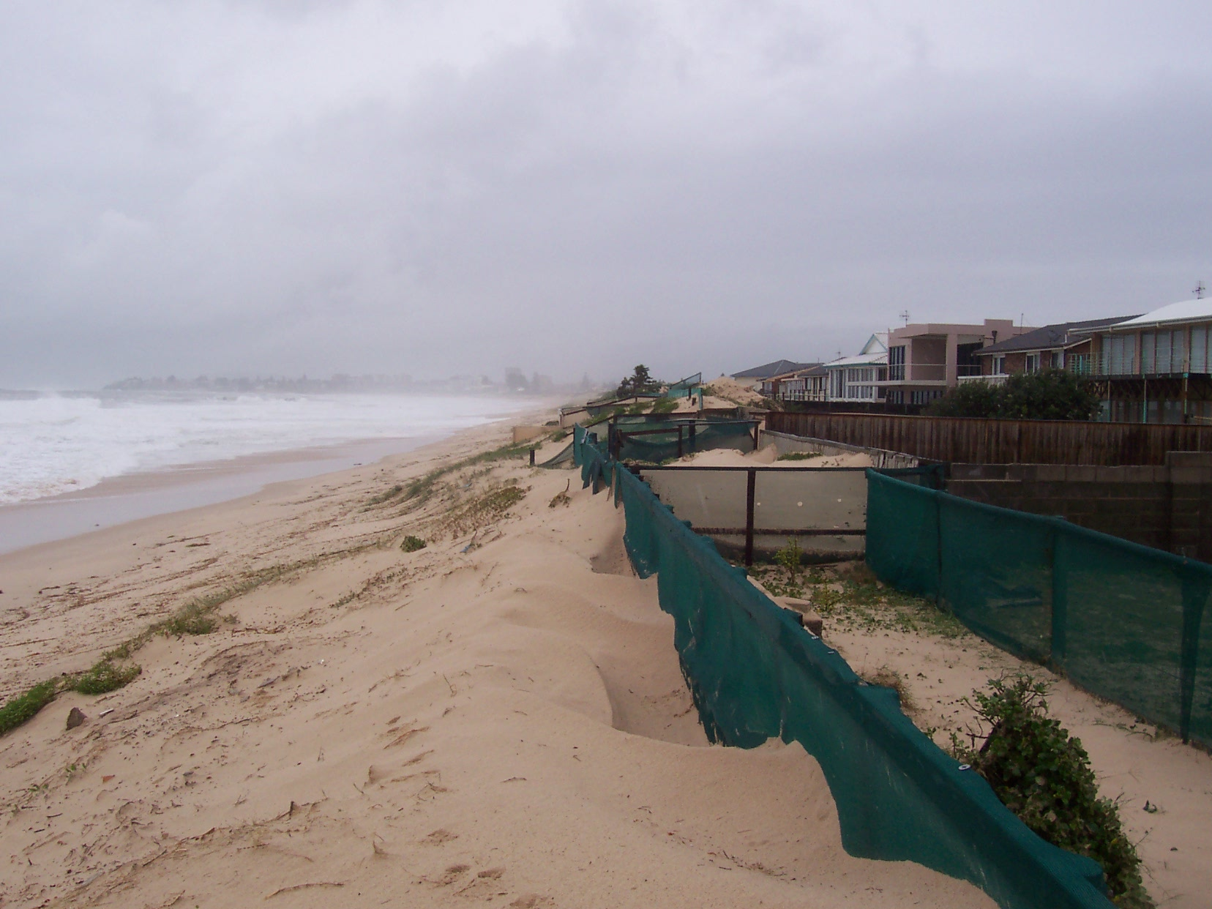
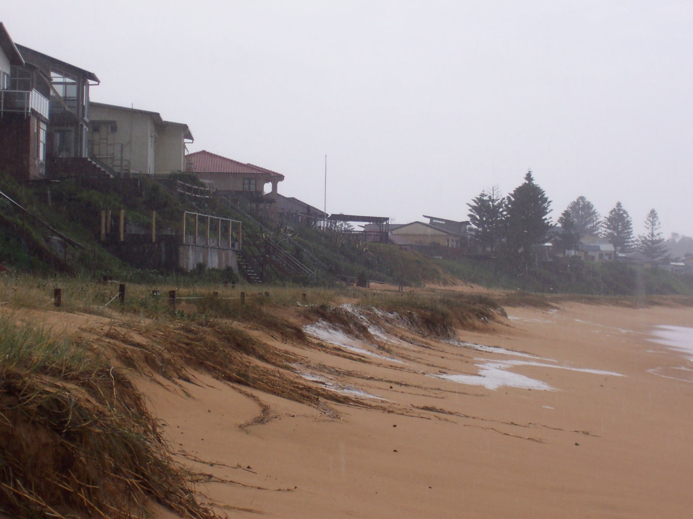
Figure 6e: Windblown sand burying backyards along Curtis Parade, North Entrance on 9th June 2007 (Courtesy Department Environment & Climate Change)

Figure 6f: Erosion along Wamberal Beach on 9th June 2007 (Courtesy Department Environment & Climate Change)

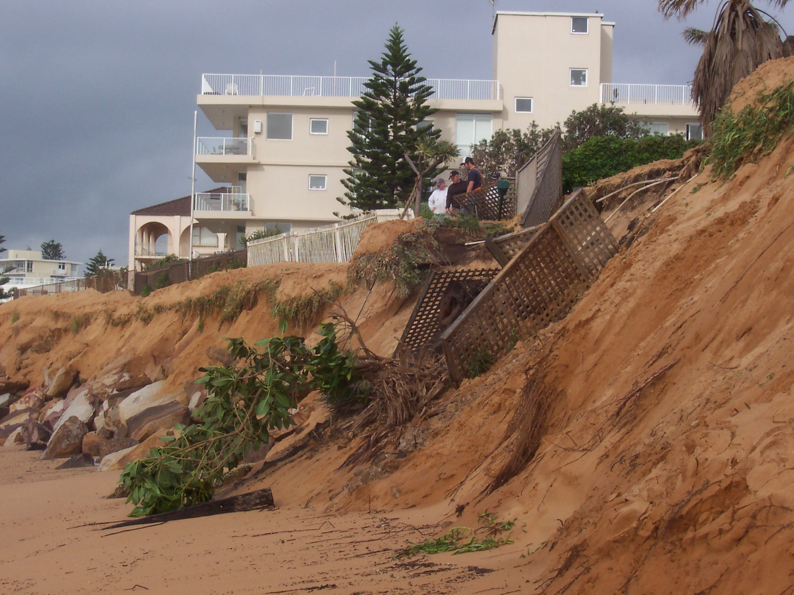
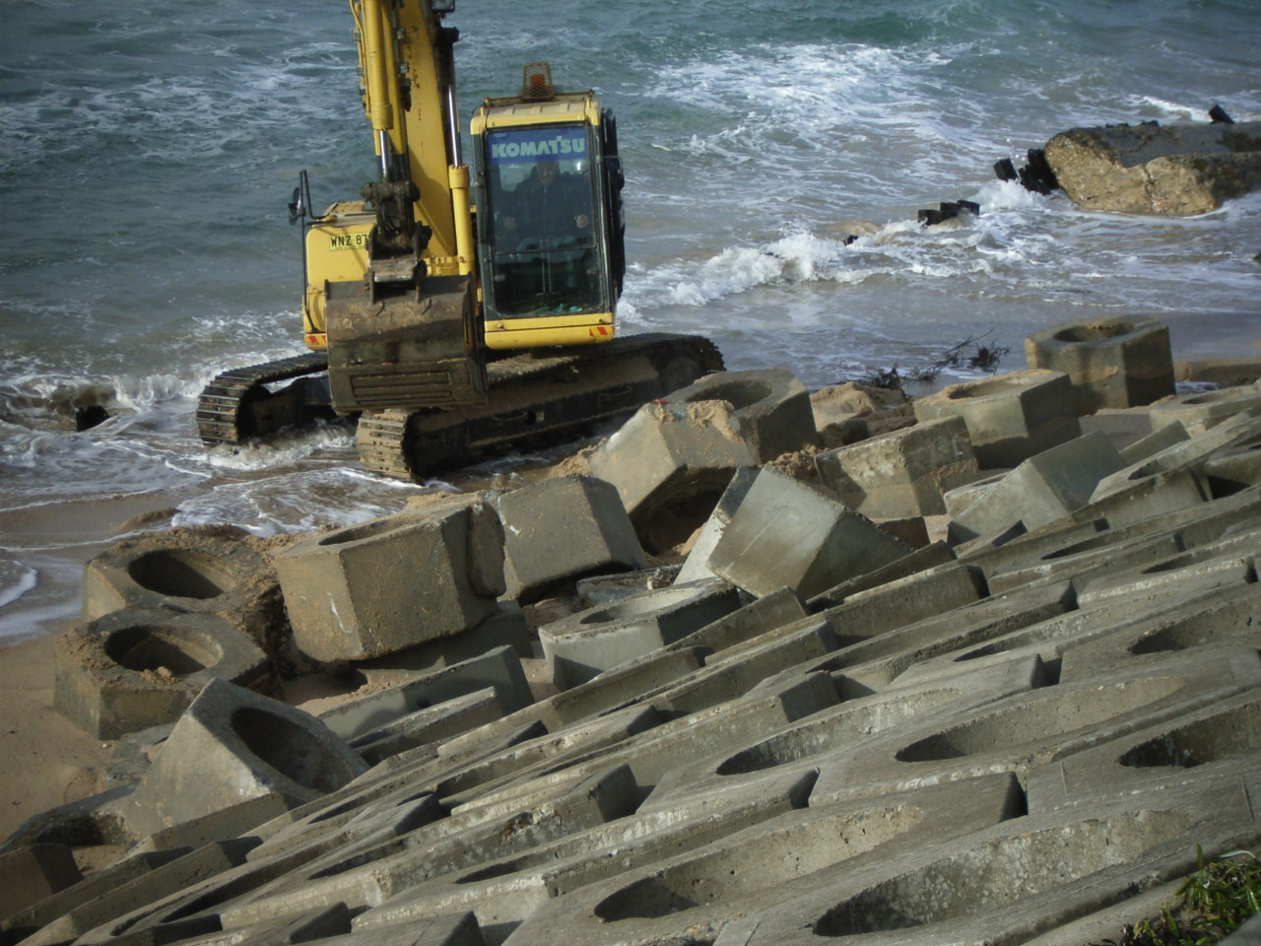
Figure 6g: Erosion along Collaroy/Narrabeen Beach on 18th June 2007 (Courtesy Department Environment & Climate Change)

Figure 6h: Repairs to damaged seawall at Prince Street, Cronulla (Courtesy Department Environment & Climate Change)

